W03 Project: Rafting Site – Planning Document

# Logo

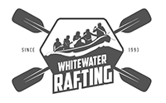

# Color Palette

Color Palette URL: https://coolors.co/505033-264969-cfcfb4-b4cde4

|  |  |
| --- | --- |
| Color Label | Hex Code |
| Primary Color | #505033 |
| Secondary Color | #264969 |
| Accent 1 Color | #cfcfb4 |
| Accent 2 Color | #b4cde4 |

# Typography

|  |  |
| --- | --- |
| Font Label | Font Name |
| Heading Font | Georgia |
| Text Font | Roboto |