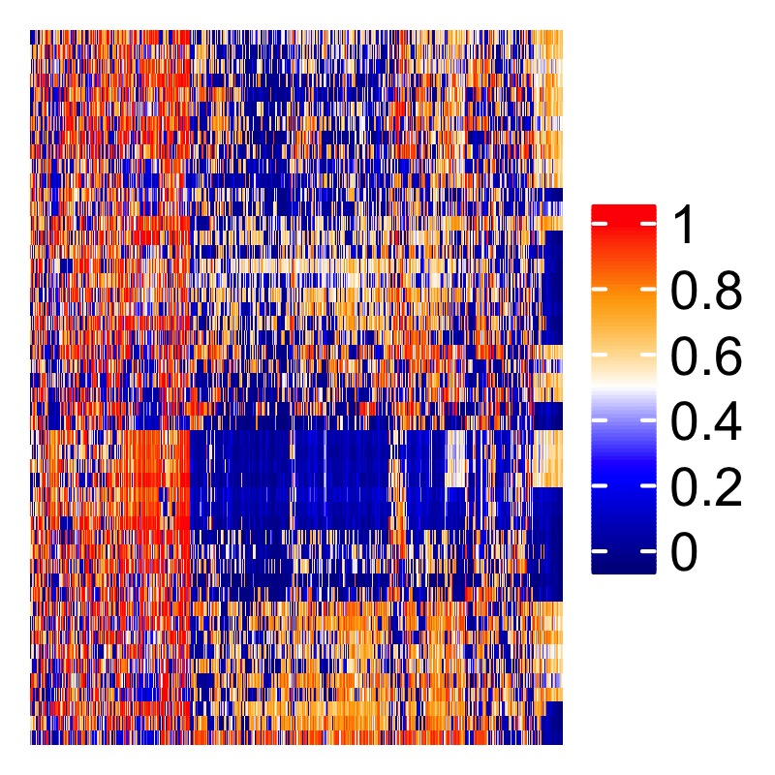

**Sean Maden**

Bioinformatician; Computational Biology Ph.D. Candidate

**Contact/Connect**

Phone:…………………………………………………………………………………...<(425)-205-0659>

E-mail:…………………..………………………….<maden@ohsu.edu>; <maden.sean@gmail.com>

GitHub:………………………………………………………………....<https://github.com/metamaden>

**Education**

Oregon Health & Science University, August 2018 - May 2021 (expected)

Computational Biology Program,

Department of Biomedical Engineering,

Portland, OR

Ph.D. Computational Biology, advised by Prof. Abhinav Nellore,

Comprehensive analysis of methylation arrays from public repositories; Imputation techniques for methylation arrays; Development of research software and server utilities; Multi-assay genomics analysis workflows; Novel consensus machine learning for cancer biomarker discovery; Collaborations in industry and research (Illumina, Johns Hopkins, and OHSU).

Reed College, September 2007 - May 2011

Biology Department,

Portland, OR

B.A. Biology, Advisor: Prof. Suzy Renn

Rigorous science and humanities curriculum; emphasis on population evolution, statistics, genetics; senior thesis quantifying genetic diversity in lab cichlids (*A. burtoni*) with microsatellites.

**Selected Research Experience**

Research Data Analyst Assistant October 2015 – June 2018

Fred Hutch, Seattle, WA

Principal Investigators: Prof. William Grady, Dr. Ming Yu

Gastroesophageal cancer epigenetics research position; Preprocessing and analysis pipelines for methylation arrays, and next-generation data; Collaborations across disciplines; Coauthor of original research manuscripts; Intellectual contributions to grants; Lectures and posters at conferences and meetings; Used R, Python, and related software for data science, biostatistics.

Bioinformatics Research Intern April – September 2015

Fred Hutch, Seattle, WA

Principal Investigator: Prof. William Grady; Postdoc project lead: Dr. Ming Yu

Analysis of colorectal cancer epigenetics with methylation arrays; Analytical programming training.

Laboratory Assistant January – October 2013

Principle Investigator/Advisor: Prof. Gail Jarvik

University of Washington Medical Genetics

Analyzed clinical population and epidemiologic data; Quantified gene-environment interactions; Used programming workflows for next-generation data; Co-authored original research manuscript.

**Scientific Memberships, Fellowships, and Funding**

Grad Student Travel Stipend May 2019

MOMACS Modeling the World’s Systems 2019

Washington, DC

Conference for statistical modeling hosted by University of Pittsburgh Dept. of Computer Science.

Affiliate Member, Fred Hutch, Seattle, WA June 2018 – September 2019

Collaborators: Grady Lab; Luebeck Lab

Affiliate Member of Fred Hutch, with ongoing collaborations with clinical epigenetics labs.

AAAS Member June 2018 – September 2019

Affiliation: OHSU Graduate School

American Association for the Advancement of Science (AAAS), nominated through OHSU.

2016 SAS-BWF Fellow, Fred Hutch, Seattle, WA May 2016 – 2017

Advisors: Prof. Bill Grady, Dr. Ming Yu

Fellowship hosted and funded by SAS Institute and Burroughs Wellcome Fund. Contributed to ongoing research of epigenetics of colorectal cancer and biomarker discovery for clinical screening. Worked closely with JMP developers, recommended software features based on research needs.

AACR Associate Member, Fred Hutch, Seattle, WA Jan 2016 – 2017

Recognized and supported by Association for Cancer Research (AACR) as promising early-career cancer investigator. AACR is one of the largest cancer research organizations in the US, and it hosts numerous annual meetings and workshops to network and learn from colleagues.

Undergraduate Research Grant, Reed College, Portland, OR Winter 2010

Advisor: Prof. Suzy Renn

Granted funding to extend research for undergraduate senior thesis studying genetic diversity of *A. burtoni* fishes (see Publications), awarded by Reed College Biology Department based on submission of original research overview.

Fischer Memorial Fellow, Reed College, Portland, OR Summer 2010

Advisor: Prof. Robert Kaplan

Designed and conducted habitat field survey experiment of native at-risk frog *Rana aurora*, constructed breeding habitat and compiled a literature review of amphibian ecology. Authored and coauthored extensive reports presented as contributions to canon of Fisher Fellows.

**Peer-reviewed Publications and Preprints (+ first author)**

+1. **Sean K. Maden**, Kasper D. Hansen, Abhi Nellore. *Human methylome variation across*

*Infinium 450K raw data on the Gene Expression Omnibus*. 2019 (preprint in preparation).

+2. **Sean K. Maden**\*, Jenny Smith*, David Lee*, Ronald Buie, Vikas Peddu, Ryan Shean, Ben

Busby. *Consensus Machine Learning for Gene Target Selection in Pediatric AML Risk.* 2019 BioRxiv, 632166. *first authors (manuscript in preparation).

3.Julianne K. David, **Sean K. Maden**, Benjamin R. Weeder, Reid F. Thompson, Abhi Nellore.

*“Cancer-specific” exon-exon junctions appear in embryological and other normal cells.* 2019 (under review).

4. Ting Wang, **Sean K. Maden**, Georg Luebeck, Chris Li, Polly Newcomb, Cornelia Ulrich, Kelly

Carter, Michael Luo, Ming Yu, William M. Grady. *Dysfunctional epigenetic aging of the normal colon in association with colorectal adenoma and cancer risk.* 2019 (under review).

5. Yuna Guo, Kelly Carter, Ming Yu, **Sean K. Maden**, Darwin Edmonds, Polly Newcomb P,

Christopher Li, Neli Ulrich, William M. Grady. *Senescence-associated tissue microenvironment promotes colon cancer formation through the secretory factor GDF15.* 2019 Aging Cell.

6. Georg E. Luebeck, William D. Hazelton, Kit Curtius, **Sean K. Maden**, Ming Yu, Kelly T.

Carter, Wynn Burke, Paul D. Lampe, Christopher I. Li, Cornelia M. Ulrich, Polly A. Newcomb, Maria Westerhoff11, Andrew M. Kaz, Yanxin Luo, John M. Inadomi, William M. Grady. *Implications of epigenetic drift in colorectal neoplasia.* 2019 Cancer Res. 1;79(3):495-504

+7. Ming Yu*, **Sean K. Maden**\*, Matthew Stachler*, Andrew M. Kaz, Tai J. Heinzerling, Rachele M

O’Leary, Xinsen Xu, Adam Bass, Amitabh Chak, Joseph E. Willis, Sanford D. Markowitz, William M. Grady. *Subtypes of Barrett’s Esophagus and Esophageal Adenocarcinoma Based on Genome-wide Methylation Analysis*. 2019 Gut 68:389-399 *first authors.

8. Ludovic Barault, Alessio Amatu, Giulia Siravegna, Agostino Ponzetti, Sebastian Moran, Andrea

Cassingena, Benedetta Mussolin, Chiara Falcomatà, Alexandra Binder, Carmen Cristiano, Daniele Oddo, Carlotta Cancelliere, Sara Bustreo, Katia Bencardino, **Sean Maden**, Alice Vanzati, Patrizia Zavattari, Mauro Truini, William M. Grady, Patrizia Racca, Karin B. Michels, Salvatore Siena, Manel Esteller, Alberto Bardelli, Andrea Sartore-Bianchi, Federica Di Nicolantonio. *Discovery of methylated circulating DNA biomarkers for comprehensive non-invasive monitoring of treatment response in metastatic colorectal cancer*. 2017 Gut; PMCID: PMC5897187.

9. Georg E. Luebeck, Kit Curtius, William D Hazelton, **Sean Maden**, Ming Yu, Prashanthi N Thota,

Deepa T Patil, Amitabh Chak, Joseph E Willis, William M Grady. *Identification of a key role of widespread epigenetic drift in Barrett’s esophagus and esophageal adenocarcinoma*. 2017 Clinical Epigenetics; PMCID: PMC5644061.

10. (**Acknowledgement**) Kit Curtius, Chao-Jen Wong, William D. Hazelton, Andrew M. Kaz,

Amitabh Chak, Joseph E. Willis, William M. Grady, Georg E. Luebeck. *A Molecular Clock Infers Heterogeneous Tissue Age Among Patients with Barrett's Esophagus*. May 11, 2016 PLoS Comput Bio.; PMID: 27168458

11. Daniel Seung Kim, **Sean K. Maden**, Amber A Burt, Jane E Ranchalis, Clement E Furlong and

Gail P Jarvik. *Dietary fatty acid intake is associated with paraoxonase 1 activity in a cohort-based analysis of 1,548 subjects*. 2013 Lipids in Health and Disease; PMCID: PMC3878825.

+12. **Sean Maden**, Advisor: Suzy P Renn. *Observed Declines in Genetic Diversity Across*

*Successive Generations of a Captive Astatotilapia burtoni Lineage, Using Microsatellite Molecular Markers*. Senior Thesis, 2011 Reed College.

**Scientific Lay Press Works**

1. (**Acknowledgement**) Anne-Sophie Kuhlman. “Esophageal adenocarcinoma: when DNA

methylation informs the treatment”. Fred Hutch Science Spotlight July 16, 2018.

**Selected Bioinformatics Skills and Interest**

Scientific software development

R, Python, and Bash coding languages;

Python and Bioc software libraries;

Dply, data.table, data coercion

Graphics with ggplot2, ComplexHeatmap;

Shiny apps, reactive programming;

GitHub, version control;

Nix and Windows operating systems;

Embarrassingly parallel processing;

TCGA, GEO, and public genomics datasets; MySQL, PostgreSQL, MongoDB databases;

Statistical modeling and regression;

Statistical prediction;

Machine learning;

ROC and AUC analysis;

Biomarker discovery;

DNA methylation array analysis;

Epigenetic regulation;

Enhancers, insulators, super-enhancers;

Metadata mining and cleaning

**Selected Science Presentations**

1. (poster/abstract) **Sean K. Maden**, Kasper D. Hansen, Abhi Nellore. *Human methylome variation*

*across Infinium 450K raw data on the Gene Expression Omnibus.* 2019 CEEHRC/IHEC Annual Meeting, Banff, AB.

2. (poster/abstract) **Sean K. Maden**, Kasper D. Hansen, Abhinov Nellore. *Comprehensive*

*Reanalysis of DNA Methylation Array Data.* 2019 MOMACS Modeling the World’s Systems Conference, Washington, DC.

2. (poster) Mitra Barahimi, **Sean Maden**, et. al. *Sa1617-Discovery and Validation of Potential*

*Field Cancerization Molecular Markers that Associate with Metachronous Polyp Formation. Gastro. 154 (6), S-331*

3. (poster) Erik J. Snider, E. Georg Luebeck, Ming Yu, Kelly T. Carter, **Sean K. Maden,** et. al.

*Medication effects on methylation-related biological aging in Barrett’s esophagus.* 2018. Gastroenterology 156 (6), S-509

4. (lecture) **Sean Maden**. "Recount Methylation: A generalizable platform for re-analysis of array-

based epigenetic data". Biophysics Journal Club meeting, October 2018.

5. (poster) Mitra Barahimi, **Sean Maden,** et. al. *Discovery and*

*Validation of Potential Field Cancerization Molecular Markers That Associate With Metachronous Polyp Formation*. Presented at 2018 Digestive Disease Week.

6. (lecture) **Sean Maden**. *Identification of Novel Molecular Characteristics of Methylation Subtypes*

*in Esophageal Adenocarcinoma by Integrated Analysis*. Cancer Epigenetics Affinity Group meeting. Fred Hutch campus. Nov. 7, 2017.

7. (poster) **Sean Maden\*** and Georg Luebeck*, et. al. *first authors. *Scope and Significance of*

*Epigenetic Drift in Barrett’s Esophagus.* Cancer Systems Biology Consortium (CSBC) Annual Meeting, Broad Institute MIT, Cambridge, MA. Oct 3, 2017.

8. (lecture) **Sean Maden**. *Spatial and temporal epigenetic pattern gradients differentiate normal*

*and progressed tissues in esophagus.* Cancer Intervention and Surveillance Modeling Network (CISNET) 2017 meeting, Esophageal Cancer projects, June 6, 2017.

9. (poster) **Sean Maden**\*, Ming Yu*, Matthew Stachler*, et. al. (*first authors). *Genome-wide*

*methylation analysis reveals methylator subtypes of Barrett’s esophagus and esophageal adenocarcinoma*. 2016 AACR Annual Meeting.

**Graduate Level Science Courses Completed**

Oregon Health and Science University, Ph.D. Computational Biology, Biomedical Engineering

Summer 2018 – Spring 2021 (expected)

**BMI 550/650**: Bioinformatics and

Computational Biology I: Algorithms

**CS 545**: Machine Learning

**CONJ 650:** Practice and Ethics of Science

**BME 601:** Prequalifying PhD Research

University of Washington, M.Sc. Genetic Epidemiology, Public Health Genetics

Fall 2012 - Fall 2013 (no degree obtained)

**PHG 536:** Bioinformatics and

Sequence Analysis

**BIOSTAT 517/518:** Applied Biostatistics I and II

**EPI 512/513:** Epidemiological

Methods I and II

**PHG 512:** Law and Ethics in Public

Health Genetics

**PHG 513:** Pharmacogenetics and Toxicogenomics

**BIOST 580:** Biostatistics Seminar

**EPI 583:** Epidemiology Seminar

**GENOME 525:** Topics in Human Genetics

**PHG 511:** Genetic Epidemiology

**PHG 521:** Culture and Societal Genomics

**PHG 523:** Genetics and the Law

**Undergraduate Level Science Courses Completed**

Shoreline Community College, Biotechnology Lab Specialist Certificate

Fall 2014 - Winter 2015 (no degree obtained)

**BIOL 270:** Molecular Biology

**BIOL 285:** Basics of Bioinformatics

**BIOL 286:** Molecular Diagnostics

**BIOL 265/266:** Solution and Media

Prep I and II

**BIOL 275:** Recombinant DNA

Reed College, B.A. Biology, Fall 2007 - Spring 2011

**MATH 111:** Calculus

**MATH 112:** Intro to Analysis

**PHYS 100:** General Physics I

**HIST 315:** Medieval/Renaissance Science and Religion

**BIOL 332:** Vascular Plant Diversity

**BIOL 101/102:** Introductory Biology

**CHEM 101/102:** Introductory

Chemistry

**BIOL 361:** Genetics

**BIOL 431:** Seminar: Ecology and

Evolution of Plant-Human Interactions

**BIOL 358:** Microbiology

**BIOL 366:** Population Ecology and

Evolution

**CHEM 201/202:** Organic Chemistry I

and II

**PHIL 201:** Logic

**BIOL 351:** Developmental Biology

(lecture only)

**BIOL 431:** Seminar: Chromosome

Structure

**PHIL 316:** Philosophy of Science

**BIOL 431:** Seminar: Gene

Duplication/Overexpression

**Find Me Online**

Website (*Topics*) URL

GitHub (*programming and bioinformatics*).…...…………………….…https://github.com/metamaden

Personal Site and Blog (*programming and data science*)..…….,……..https://metamaden.github.io/

ResearchGate (*bioinformatics*)..…….………...https://www.researchgate.net/profile/Sean_Maden3

LinkedIn (*career profile*).…….…………………………..…….linkedin.com/in/sean-maden-41623640

Twitter (*bioinformatics, science news, programming*)...……………..https://twitter.com/MadenSean