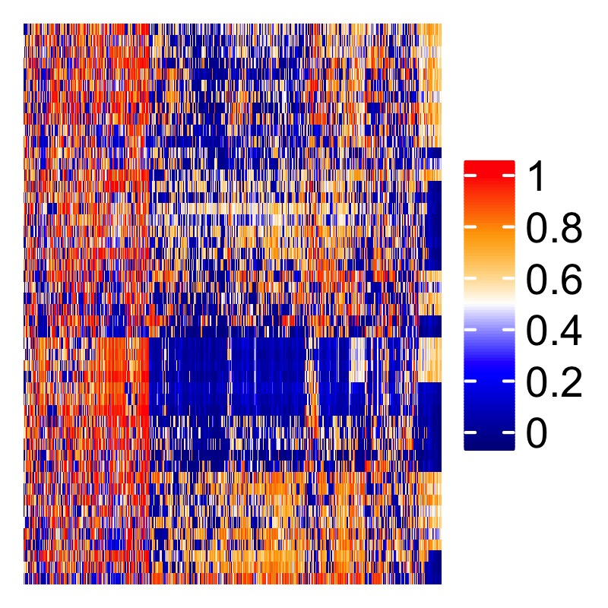

**Sean Maden**

Computationalist, bioinformatician, rock climber, coffee lover

***Contact information***

Phone:…………………………………………………………………………………...<(425)-205-0659>

E-mail:…………………..…………………………………………………….<maden.sean@gmail.com>

GitHub:………………………………………………………………....<https://github.com/metamaden>

***Education__*______________________________________________________**

Oregon Health & Science University, August 2018 – May 2022

Department of Biomedical Engineering,

Portland, OR

Ph.D. Computational Biology, Advisor: Prof. Abhinav Nellore,

Dissertation title: *Applications of public omics data*

Compiled public DNA methylation array data; published recountmethylation Bioconductor package; characterized epigenetic variation across tissues; performed novel cross-study analyses; conducted independent validation of biomarker candidates; studied retained introns in long-read and short-read RNA-seq data; quantified splice junction expression in cancer and normal tissues; mined and plotted population HLA allele frequencies related to SARS-CoV-2 risk

Reed College, September 2007 – May 2011

Biology Department,

Portland, OR

B.A. Biology, Advisor: Prof. Suzy Renn

Rigorous science and humanities curriculum; research focus in evolution, statistics, and population genetics; fellowship in field and ecology survey research; thesis quantifying genetic diversity with microsatellite molecular markers.

***Selected research experience_*______________________________________**

Postdoctoral research fellow (current) June 2022 – 2024

Dept of Biostatistics

Johns Hopkins Bloomberg School of Public Health

Baltimore, MD

Advisor: Prof. Stephanie Hicks

Gene expression in normal and diseased brain cells; single-cell sequencing; spatial transcriptomics; development of analytical tools for research; development of open-access bookdown documents for data science and analysis; utilization of public sequencing data from the Sequence Read Archive for independent validation; collaborations with the Lieber Institute.

Research Data Analyst Assistant October 2015 – June 2018

Fred Hutch, Seattle, WA

Principal Investigators: Prof. William Grady, Dr. Ming Yu

Epigenetic markers of gastroesophageal cancer risk and progression; preprocessing and analysis of DNA methylation arrays; integrative analysis of epigenetics and RNA-seq data; wrote R scripts to conduct research; made a shiny dashboard to analyze epigenetic data and genome annotations.

Bioinformatics Research Intern April – September 2015

Fred Hutch, Seattle, WA

Principal Investigator: Prof. William Grady; Postdoc project lead: Dr. Ming Yu

Analysis of colorectal cancer epigenetics; trained data science and R programming.

Laboratory Assistant January – October 2013

Principle Investigator/Advisor: Prof. Gail Jarvik

University of Washington Medical Genetics

Analyzed clinical population and epidemiologic data; Quantified gene-environment interactions; Used programming workflows for next-generation data; Co-authored original research manuscript.

***Scientific memberships, fellowships, and funding*_____________________**

Grad Student Travel Stipend May 2019

MOMACS Modeling the World’s Systems 2019

Washington, DC

Conference for statistical modeling hosted by University of Pittsburgh Dept. of Computer Science.

2016 SAS-BWF Fellow, Fred Hutch, Seattle, WA May 2016 – 2017

Advisors: Prof. Bill Grady, Dr. Ming Yu

Fellowship hosted and funded by SAS Institute and Burroughs Wellcome Fund. Contributed to ongoing research of epigenetics of colorectal cancer and biomarker discovery for clinical screening. Worked closely with JMP developers, recommended software features based on research needs.

AACR Associate Member, Fred Hutch, Seattle, WA Jan 2016 – 2017

Recognized and supported by Association for Cancer Research (AACR) as promising early-career cancer investigator. AACR is one of the largest cancer research organizations in the US, and it hosts numerous annual meetings and workshops to network and learn from colleagues.

Undergraduate Research Grant, Reed College, Portland, OR Winter 2010

Advisor: Prof. Suzy Renn

Granted funding to extend research for undergraduate senior thesis studying genetic diversity of *A. burtoni* fishes (see Publications), awarded by Reed College Biology Department based on submission of original research overview.

Fischer Memorial Fellow, Reed College, Portland, OR Summer 2010

Advisor: Prof. Robert Kaplan

Designed and conducted habitat field survey experiment of native at-risk frog *Rana aurora*, constructed breeding habitat and compiled a literature review of amphibian ecology. Authored and coauthored extensive reports presented as contributions to canon of Fisher Fellows.

***Skills and expertise*_______________________________________________**

R/Bioconductor (recountmethylation)

Python for analysis (pandas, numpy, scipy)

R for data science (data.table, dplyr)

Plots for publication (ggplot2, UpsetR)

Data dashboards (shiny and plotly)

Version control (git, GitHub)

Public omics data mining (GEO, SRA, Entrez programming utilities)

Omics consortia (TCGA, CCLE, GTEx)

Relational databases (MySQL, SQLite)

Statistical tests (lm(), ANOVA, cor.test(), Chi Squared, Fisher Exact, etc.)

Model training (SVM, LASSO, random forests, AIC, discovery/validation)

Machine learning (neural networks, tensors)

Biomarker discovery (ROC, AUC, precision)

DNA methylation arrays (HM450K, EPIC)

RNA-seq analysis (long-read, short-read)

***Peer-reviewed journal publications (+ first author)*______________________**

**+1. Sean K Maden**, Reid F Thompson, Kasper D Hansen, Abhinav Nellore. *Human methylome*

*variation across Infinium 450K data on the Gene Expression Omnibus*. (2021) NAR Genomics and Bioinformatics, Volume 3, Issue 2, lqab025, <https://doi.org/10.1093/nargab/lqab025>

**2.** Julianne K. David, **Sean K. Maden**, Benjamin R. Weeder, Reid F. Thompson, Abhi Nellore.

*Putatively cancer-specific exon–exon junctions are shared across patients and present in developmental and other non-cancer cells.* (2019) NAR Cancer, Volume 2, Issue 1, zcaa001, [https://doi.org/10.1093/narcan/zcaa001](https://academic.oup.com/narcancer/article/2/1/zcaa001/5717177)

**3.** Ting Wang, **Sean K. Maden**, et. al. *Dysfunctional epigenetic aging of the normal colon in*

*association with colorectal adenoma and cancer risk.* (2020) Clin Epigenet 12, 5 <https://doi.org/10.1186/s13148-019-0801-3>

**4.** Yuna Guo, Kelly Carter, Ming Yu, **Sean K. Maden**, et. al. *Senescence-associated tissue*

*microenvironment promotes colon cancer formation through the secretory factor GDF15.* (2019) Aging Cell e13013 <https://doi.org/10.1111/acel.13013>

**5.** Georg E. Luebeck, William D. Hazelton, Kit Curtius, **Sean K. Maden**, et. al. *Implications of*

*epigenetic drift in colorectal neoplasia.* (2019) Cancer Res. 1;79(3):495-504 [doi:10.1158/0008-5472.CAN-18-1682](https://pubmed.ncbi.nlm.nih.gov/30291105/)

**+6.** Ming Yu*, **Sean K. Maden**\*, Matthew Stachler*, et. al. *Subtypes of Barrett’s Esophagus and*

*Esophageal Adenocarcinoma Based on Genome-wide Methylation Analysis*. (2019) Gut 68:389-399, [doi: 10.1136/gutjnl-2017-314544](https://gut.bmj.com/content/68/3/389) *first authors.

**7.** Ludovic Barault, Alessio Amatu, Giulia Siravegna, Agostino Ponzetti, Sebastian Moran, Andrea

Cassingena, Benedetta Mussolin, Chiara Falcomatà, Alexandra Binder, Carmen Cristiano, Daniele Oddo, Carlotta Cancelliere, Sara Bustreo, Katia Bencardino, **Sean Maden**, et. al. *Discovery of methylated circulating DNA biomarkers for comprehensive non-invasive monitoring of treatment response in metastatic colorectal cancer*. (2017) Gut, 67(11):1995-2005, [doi: 10.1136/gutjnl-2016-313372](https://gut.bmj.com/content/67/11/1995.long)

**8.** Georg E. Luebeck, Kit Curtius, William D Hazelton, **Sean Maden**, et. al. *Identification of a key*

*role of widespread epigenetic drift in Barrett’s esophagus and esophageal adenocarcinoma*. (2017) Clinical Epigenetics, [https://doi.org/10.1186/s13148-017-0409-4](https://clinicalepigeneticsjournal.biomedcentral.com/articles/10.1186/s13148-017-0409-4)

**9.** Kit Curtius, et. al. *A Molecular Clock Infers Heterogeneous Tissue Age Among Patients with*

*Barrett's Esophagus*. May 11, 2016 PLoS Comput Bio.,  [10.1371/journal.pcbi.1004919](https://journals.plos.org/ploscompbiol/article?id=10.1371/journal.pcbi.1004919)(acknowledgement)

**10.** Daniel S Kim, **Sean K Maden**, et. al. *Dietary fatty acid intake is associated with paraoxonase*

*1 activity in a cohort-based analysis of 1,548 subjects*. (2013) Lipids in Health and Disease, 12, 183, [https://doi.org/10.1186/1476-511X-12-183](https://lipidworld.biomedcentral.com/articles/10.1186/1476-511X-12-183#Abs1)

***Additional articles (preprints, lay press pieces, etc.)____________________***

**+1.** Julianne K David, **Sean K Maden**, et. al. *Retained introns in long RNA-seq reads are not reliably*

*detected in sample-matched short reads.* (2022) BioRxiv 2022.03.11.484016; [doi: https://doi.org/10.1101/2022.03.11.484016](doi:%20https://doi.org/10.1101/2022.03.11.484016)

**+2.** Jenny Smith*, **Sean K. Maden**\*, David Lee*, et. al. *Consensus Machine Learning for Gene*

*Target Selection in Pediatric AML Risk.* (2019) BioRxiv, 632166 <https://doi.org/10.1101/632166> *first authors

**3.** Anne-Sophie Kuhlman. *Esophageal adenocarcinoma: when DNA methylation informs the*

*treatment.* (2018) Fred Hutch Science Spotlight, [link](https://www.fredhutch.org/en/news/spotlight/2018/07/crd_ming_gut.html) (acknowledgement)

***Selected scientific presentations____________________________________***

1. (poster/abstract) **Sean K. Maden**, Kasper D. Hansen, Abhi Nellore. *Human methylome variation*

*across Infinium 450K raw data on the Gene Expression Omnibus.* 2019 CEEHRC/IHEC Annual Meeting, Banff, AB.

2. (poster/abstract) **Sean K. Maden**, Kasper D. Hansen, Abhinov Nellore. *Comprehensive*

*Reanalysis of DNA Methylation Array Data.* 2019 MOMACS Modeling the World’s Systems Conference, Washington, DC.

2. (poster) Mitra Barahimi, **Sean Maden**, et. al. *Sa1617-Discovery and Validation of Potential*

*Field Cancerization Molecular Markers that Associate with Metachronous Polyp Formation. Gastro. 154 (6), S-331*

3. (poster) Erik J. Snider, E. Georg Luebeck, Ming Yu, Kelly T. Carter, **Sean K. Maden,** et. al.

*Medication effects on methylation-related biological aging in Barrett’s esophagus.* 2018. Gastroenterology 156 (6), S-509

4. (lecture) **Sean Maden**. "Recount Methylation: A generalizable platform for re-analysis of array-

based epigenetic data". Biophysics Journal Club meeting, October 2018.

5. (poster) Mitra Barahimi, **Sean Maden,** et. al. *Discovery and*

*Validation of Potential Field Cancerization Molecular Markers That Associate With Metachronous Polyp Formation*. Presented at 2018 Digestive Disease Week.

6. (lecture) **Sean Maden**. *Identification of Novel Molecular Characteristics of Methylation Subtypes*

*in Esophageal Adenocarcinoma by Integrated Analysis*. Cancer Epigenetics Affinity Group meeting. Fred Hutch campus. Nov. 7, 2017.

7. (poster) **Sean Maden\*** and Georg Luebeck*, et. al. *first authors. *Scope and Significance of*

*Epigenetic Drift in Barrett’s Esophagus.* Cancer Systems Biology Consortium (CSBC) Annual Meeting, Broad Institute MIT, Cambridge, MA. Oct 3, 2017.

8. (lecture) **Sean Maden**. *Spatial and temporal epigenetic pattern gradients differentiate normal*

*and progressed tissues in esophagus.* Cancer Intervention and Surveillance Modeling Network (CISNET) 2017 meeting, Esophageal Cancer projects, June 6, 2017.

9. (poster) **Sean Maden**\*, Ming Yu*, Matthew Stachler*, et. al. (*first authors). *Genome-wide*

*methylation analysis reveals methylator subtypes of Barrett’s esophagus and esophageal adenocarcinoma*. 2016 AACR Annual Meeting.

***Graduate level scientific coursework_________________________________***

Oregon Health and Science University, Ph.D. Computational Biology, Biomedical Engineering

Summer 2018 – Spring 2021 (expected)

**BMI 550/650**: Bioinformatics and

Computational Biology I: Algorithms

**CS 545**: Machine Learning

**CONJ 650:** Practice and Ethics of Science

**BME 601:** Prequalifying PhD Research

University of Washington, Public Health Genetics, Fall 2012 - 2013 (no degree obtained)

**PHG 536:** Bioinformatics and

Sequence Analysis

**BIOSTAT 517/518:** Applied Biostatistics I and II

**EPI 512/513:** Epidemiological

Methods I and II

**PHG 512:** Law and Ethics in Public

Health Genetics

**PHG 513:** Pharmacogenetics and Toxicogenomics

**BIOST 580:** Biostatistics Seminar

**EPI 583:** Epidemiology Seminar

**GENOME 525:** Topics in Human Genetics

**PHG 511:** Genetic Epidemiology

**PHG 521:** Culture and Societal Genomics

**PHG 523:** Genetics and the Law

***Undergraduate scientific coursework_________________________________***

Shoreline Community College, Biotech training, Fall 2014 - Winter 2015 (no degree obtained)

**BIOL 270:** Molecular Biology

**BIOL 285:** Basics of Bioinformatics

**BIOL 286:** Molecular Diagnostics

**BIOL 265/266:** Solution and Media

Prep I and II

**BIOL 275:** Recombinant DNA

Reed College, B.A. Biology, Fall 2007 - Spring 2011

**MATH 111:** Calculus

**MATH 112:** Intro to Analysis

**PHYS 100:** General Physics I

**HIST 315:** Medieval/Renaissance Science and Religion

**BIOL 332:** Vascular Plant Diversity

**BIOL 101/102:** Introductory Biology

**CHEM 101/102:** Introductory

Chemistry

**BIOL 361:** Genetics

**BIOL 431:** Seminar: Ecology and

Evolution of Plant-Human Interactions

**BIOL 358:** Microbiology

**BIOL 366:** Population Ecology and

Evolution

**CHEM 201/202:** Organic Chemistry I

and II

**PHIL 201:** Logic

**BIOL 351:** Developmental Biology

(lecture only)

**BIOL 431:** Seminar: Chromosome

Structure

**PHIL 316:** Philosophy of Science

**BIOL 431:** Seminar: Gene

Duplication/Overexpression

***Find me online____________________________________________________***

Website (topics)_ URL

GitHub (programming and bioinformatics).…...……………………<https://github.com/metamaden>

Personal site and blog (programming and data science)..…………<https://metamaden.github.io/>

Twitter (bioinformatics, science news, programming)...…………..<https://twitter.com/MadenSean>

ResearchGate (scientific profile)..…….…...<https://www.researchgate.net/profile/Sean_Maden3>

LinkedIn (career profile).…….……………………………..<linkedin.com/in/sean-maden-41623640>