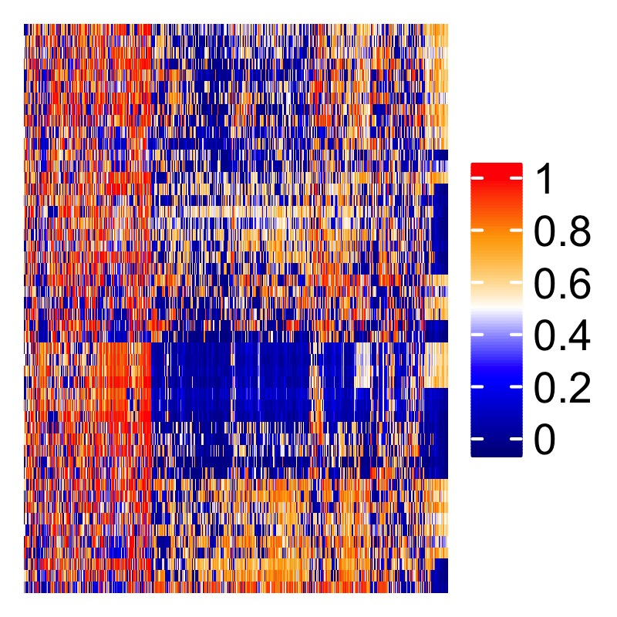

**Sean Maden**

*Bioinformatician; Quantitative Oncologist;*

*Computational Biology Ph.D. Student*

**Contact and Connect**

Phone:…………………………………………………………………………………...<(425)-205-0659>

E-mail:…………………..………………………….<maden@ohsu.edu>; <maden.sean@gmail.com>

GitHub:………………………………………………………………....<https://github.com/metamaden>

**Education**

Oregon Health & Science University, August 2018 - May 2021 (expected)

Department of Biomedical Engineering,

*Portland, OR*

Doctorate of Philosophy (Ph.D), Computational Biology, advised by Prof. Abhi Nellore Lab, with PDXGX (Nellore & Thompson Labs); Dissertation researching pan-tissue and disease epigenetics, emphasis on server software design for auto-compilation and analysis of tens of thousands of methylation array clinical samples; Investigating inter-experiment biases, novel normalization techniques, and holistic assay quality assessment across samples; Workflows for multi-assay integration; Application of machine learning for cancer biomarker discovery.

Reed College, September 2007 - May 2011

*Portland, OR*

Bachelor of Arts (B.A.), Biology, emphases: population genetics, evolutionary ecology

Rigorous liberal arts curriculum in the humanities and sciences; Population biology and statistical genetics research; Thesis characterizing genetic diversity declines from inbreeding in captive laboratory cichlid fishes (*A. burtoni*) with microsatellite molecular markers; Advisor Prof. Suzy Renn.

**Selected Research Experience**

Research Data Analyst Assistant October 2015 – June 2018

Fred Hutch, Seattle, WA

Principal Investigators: Dr. William Grady, Dr. Ming Yu

Study of gastroesophageal cancer epigenetics; Application of preprocessing and analysis pipelines for methylation arrays and next-generation technologies; Research collaborations across labs, departments, and campuses; Coauthor and editor of original research manuscripts; Significant intellectual contributions to grant applications; Presented lectures, posters at conferences and lab meetings; Learned and applied R, Python, and related programming languages and software for data science and biostatistical analysis; Implemented organized lab repositories for big data.

Bioinformatics Research Intern April - September 2015

Fred Hutch, Seattle, WA

Principal Investigator: Dr. William Grady; Postdoc project lead: Dr. Ming Yu

Carried out original analyses of cancer epigenetic data; Self-taught analytical programming; Presentation of findings and research discussion at lab meetings.

Laboratory Assistant January – October 2013

Principle Investigator/Advisor: Dr. Gail Jarvik

University of Washington Medical Genetics

Analyzed clinical population and epidemiologic data; Quantified gene-environment interactions with modeling and regression techniques; Programmed preprocessing workflows for next-generation genomics; Coauthored and edited published manuscript of findings (see Publications).

Undergraduate Thesis Researcher September 2010 - May 2011

Advisor: Dr. Suzy Renn

Reed College, Biology Department

Quantified effects of laboratory breeding on genetic diversity in cichlid fishes (*A. burtoni*) using microsatellites; Authored thesis studying genetic diversity of lab cichlid fishes with microsatellites, and defended thesis before professorial board; Attained department grant funding (see Research Awards).

**Scientific Memberships, Fellowships, and Funding**

Affiliate Member, Fred Hutch, Seattle, WA June 2018 - present

Collaborators: Grady Lab; Luebeck Lab

Affiliate Member of Fred Hutch, with ongoing affiliation and collaboration with epigenetics labs in Clinical Research and Computational Biology divisions.

AAAS Member June 2018 - present

Affiliation: OHSU Graduate School

American Association for the Advancement of Science (AAAS), student member nominated by OHSU leadership.

2016 SAS-BWF Fellow, Fred Hutch, Seattle, WA May 2016 - 2017

Advisors: Dr.’s Bill Grady and Ming Yu

Fellowship hosted and funded by SAS Institute and Burroughs Wellcome Fund. Contributed to ongoing research of epigenetics of colorectal cancer and biomarker discovery for clinical screening. Worked closely with JMP developers and recommended new software features based on real research needs.

AACR Associate Member, Fred Hutch, Seattle, WA Jan 2016 - 2017

Recognized and supported by Association for Cancer Research (AACR) as promising early-career cancer investigator. AACR is one of the largest cancer research organizations in the US, and it hosts numerous annual meetings and workshops to help cancer researchers network and learn from colleagues.

Undergraduate Research Grant, Reed College, Portland, OR Winter 2010

Advisor: Dr. Suzy Renn

Granted funding to extend research for undergraduate senior thesis studying genetic diversity of *A. burtoni* fishes (see Publications), awarded by Reed College Biology Department based on submission of original research overview.

Fischer Memorial Fellow, Reed College, Portland, OR Summer 2010

Advisor: Dr. Robert Kaplan

Designed and conducted habitat field survey experiment of native at-risk frog *Rana aurora*, constructed breeding habitat and compiled a literature review of amphibian ecology. Authored and coauthored extensive reports presented as contributions to canon of Fisher Fellows past and present.

**Peer-reviewed Research Publications**

1. Yuna Guo, Kelly Carter, Ming Yu, **Sean K. Maden**, Darwin Edmonds, Polly Newcomb P,

Christopher Li, Neli Ulrich, William M. Grady. *Senescence associated secreted factors are candidate drivers of the age related risk of colorectal cancer.* 2018 (*under peer review*).

2. Georg E. Luebeck, William D. Hazelton, Kit Curtius, **Sean K. Maden**, Ming Yu, Kelly T. Carter,

Wynn Burke, Paul D. Lampe, Christopher I. Li, Cornelia M. Ulrich, Polly A. Newcomb, Maria Westerhoff11, Andrew M. Kaz, Yanxin Luo, John M. Inadomi, William M. Grady. *Implications of epigenetic drift in colorectal neoplasia.* 2018 Cancer Research (accepted for publication).

3. Ming Yu*, **Sean K. Maden**\*, Matthew Stachler*, Andrew M. Kaz, Tai J. Heinzerling, Rachele M

O’Leary, Xinsen Xu, Adam Bass, Amitabh Chak, Joseph E. Willis, Sanford D. Markowitz, William M. Grady. *Subtypes of Barrett’s Esophagus and Esophageal Adenocarcinoma Based on Genome-wide Methylation Analysis*. 2017, Gut. *co-first authors.

4. Ludovic Barault, Alessio Amatu, Giulia Siravegna, Agostino Ponzetti, Sebastian Moran, Andrea

Cassingena, Benedetta Mussolin, Chiara Falcomatà, Alexandra Binder, Carmen Cristiano, Daniele Oddo, Carlotta Cancelliere, Sara Bustreo, Katia Bencardino, **Sean Maden**, Alice Vanzati, Patrizia Zavattari, Mauro Truini, William M. Grady, Patrizia Racca, Karin B. Michels, Salvatore Siena, Manel Esteller, Alberto Bardelli, Andrea Sartore-Bianchi, Federica Di Nicolantonio. *Discovery of methylated circulating DNA biomarkers for comprehensive non-invasive monitoring of treatment response in metastatic colorectal cancer*. 2017 Gut; PMCID: PMC5897187.

5. Georg E. Luebeck, Kit Curtius, William D Hazelton, **Sean Maden**, Ming Yu, Prashanthi N Thota,

Deepa T Patil, Amitabh Chak, Joseph E Willis, William M Grady. *Identification of a key role of widespread epigenetic drift in Barrett’s esophagus and esophageal adenocarcinoma*. 2017 Clinical Epigenetics; PMCID: PMC5644061.

6. (**Acknowledgement**) Kit Curtius, Chao-Jen Wong, William D. Hazelton, Andrew M. Kaz,

Amitabh Chak, Joseph E. Willis, William M. Grady, Georg E. Luebeck. *A Molecular Clock Infers Heterogeneous Tissue Age Among Patients with Barrett's Esophagus*. May 11, 2016 PLoS Comput Bio.; PMID: 27168458

7. Daniel Seung Kim, **Sean K. Maden**, Amber A Burt, Jane E Ranchalis, Clement E Furlong and

Gail P Jarvik. *Dietary fatty acid intake is associated with paraoxonase 1 activity in a cohort-based analysis of 1,548 subjects*. 2013 Lipids in Health and Disease; PMCID: PMC3878825.

8. **Sean Maden**, Advisor: Suzy P Renn. *Observed Declines in Genetic Diversity Across Successive*

*Generations of a Captive Astatotilapia burtoni Lineage, Using Microsatellite Molecular Markers*. Senior Thesis, 2011 Reed College.

**Scientific Lay Press Works**

1. (**Acknowledgement**) Anne-Sophie Kuhlman. “Esophageal adenocarcinoma: when DNA

methylation informs the treatment”. Fred Hutch Science Spotlight July 16, 2018.

**Selected Bioinformatics Skills and Interests**

R, JMP, STATA, statistical software;

Bioconductor/Bioc;

Tibbles, tidyverse, dply, Rstudior;

R modules, ggplot2, Gviz;

R-shiny apps, reactive programming;

GitHub, version control;

Python and shell scripting;

Windows and nix interfaces;

Compute clusters/kernels;

Parallel programming/computing;

Amazon Web Services (AWS);

Cloud optimization;

TCGA, GEO, and GDAC repos;

PostgreSQL clinical records db;

SQL queries;

Sweave, knitr, LaTeX typesetting;

Statistical modeling and regression;

Machine learning, automation;

SVM, elastic net, glmnet;

ROC/AUC and predictive analyses;

Biomarker discovery;

Next-generation sequencing;

Methylation array data mining;

Gene network analysis;

Epigenetic regulation of expression;

Medical and genomic informatics;

Biomedical data science;

Gene Ontology/KEGG enrichment;

Hi-C and TAD 3d assays;

Comparative epigenetics;

ChIP-seq, enhancer activity;

Super-enhancers, ROSE algorithm;

VELs/Disease histone activation;

Metadata mining and cleaning;

Structured ontologies;

Controlled vocabulary databases

**Selected Science Presentations**

1. (poster) Erik J. Snider, E. Georg Luebeck, Ming Yu, Kelly T. Carter, Sean K. Maden, Amitabh

Chak, Joseph E. Willis, John M. Inadomi, Michael D. Saunders, Adam W. Templeton, William M. Grady. *Medication effects on methylation-related biological aging in Barrett’s esophagus.* 2018. Abstract submitted for Digestive Disease Week 2019 conference.

2. (lecture) Sean Maden. "Recount Methylation: A generalizable platform for re-analysis of array-

based epigenetic data". Biophysics Journal Club meeting, October 2018.

3. (poster) Mitra Barahimi, **Sean Maden,** Ming Yu, Kelly Carter, William Grady. *Discovery and*

*Validation of Potential Field Cancerization Molecular Markers That Associate With Metachronous Polyp Formation*. Presented at 2018 Digestive Disease Week.

4. (lecture) **Sean Maden**. *Identification of Novel Molecular Characteristics of Methylation Subtypes*

*in Esophageal Adenocarcinoma by Integrated Analysis*. Cancer Epigenetics Affinity Group meeting. Fred Hutch campus. Nov. 7, 2017.

5. (poster) **Sean Maden\*** and Georg Luebeck*, Kit Curtius, William Hazelton, Ming Yu, Prashanti

Thota, Deepa Patil, Amitabh Chak, Joseph Willis, William Grady *co-first authors. *Scope and Significance of Epigenetic Drift in Barrett’s Esophagus.* Cancer Systems Biology Consortium (CSBC) Principal Investigator Meeting, Broad Institute MIT, Cambridge, MA. Oct 3, 2017.

6. (lecture) **Sean Maden**. *Spatial and temporal epigenetic pattern gradients differentiate normal*

*and progressed tissues in esophagus.* Cancer Intervention and Surveillance Modeling Network (CISNET) 2017 meeting, Esophageal Cancer projects, June 6, 2017.

7. (poster) **Sean Maden**\*, Ming Yu*, Matthew Stachler*, Andrew M. Kaz, Tai J. Heinzerling,

Rachele M O’Leary, Xinsen Xu, Adam Bass, Amitabh Chak, Joseph E. Willis, Sanford D. Markowitz, William M. Grady (*co-first authors). *Genome-wide methylation analysis reveals methylator subtypes of Barrett’s esophagus and esophageal adenocarcinoma*. 2016 AACR Annual Meeting, Abstract: #3192, Session: DNA Methylation 1.

**Graduate Science Courses Completed**

Oregon Health and Science University, Ph.D. Computational Biology, Biomedical Engineering

Summer 2018 – Spring 2021 (expected)

**BMI 550/650**: Bioinformatics and

Computational Biology I: Algorithms

**CS 545**: Machine Learning

**CONJ 650:** Practice and Ethics of Science

**BME 601:** Prequalifying Phd Research

University of Washington, M.Sc. Genetic Epidemiology, Public Health Genetics

Fall 2012 - Fall 2013 (no degree obtained)

**PHG 536:** Bioinformatics and

Sequence Analysis

**BIOSTAT 517/518:** Applied Biostatistics I and II

**EPI 512/513:** Epidemiological

Methods I and II

**PHG 512:** Law and Ethics in Public

Health Genetics

**PHG 513:** Pharmacogenetics and Toxicogenomics

**BIOST 580:** Biostatistics Seminar

**EPI 583:** Epidemiology Seminar

**GENOME 525:** Topics in Human Genetics

**PHG 511:** Genetic Epidemiology

**PHG 521:** Culture and Societal Genomics

**PHG 523:** Genetics and the Law

**Undergraduate Science Courses Completed**

Shoreline Community College, Biotechnology Lab Specialist Certificate

Fall 2014 - Winter 2015 (no degree obtained)

**BIOL 270:** Molecular Biology

**BIOL 285:** Basics of Bioinformatics

**BIOL 286:** Molecular Diagnostics

**BIOL 265/266:** Solution and Media

Prep I and II

**BIOL 275:** Recombinant DNA

Reed College, B.A. Biology, Fall 2007 - Spring 2011

**MATH 111:** Calculus

**MATH 112:** Intro to Analysis

**PHYS 100:** General Physics I

**HIST 315:** Medieval/Renaissance Science and Religion

**BIOL 332:** Vascular Plant Diversity

**BIOL 101/102:** Introductory Biology

**CHEM 101/102:** Introductory

Chemistry

**BIOL 361:** Genetics

**BIOL 431:** Seminar: Ecology and

Evolution of Plant-Human Interactions

**BIOL 358:** Microbiology

**BIOL 366:** Population Ecology and

Evolution

**CHEM 201/202:** Organic Chemistry I

and II

**PHIL 201:** Logic

**BIOL 351:** Developmental Biology

(lecture only)

**BIOL 431:** Seminar: Chromosome

Structure

**PHIL 316:** Philosophy of Science

**BIOL 431:** Seminar: Gene

Duplication/Overexpression

**Find Sean Maden Online**

Website (*Topics*) URL

GitHub (*programming and bioinformatics*):…...…………………….…https://github.com/metamaden

Personal Site and Blog (*programming and data science*): …….,……..https://metamaden.github.io/

ResearchGate (*bioinformatics*):.…….………...https://www.researchgate.net/profile/Sean_Maden3

LinkedIn (*professional profile*):…….………………………….linkedin.com/in/sean-maden-41623640

Twitter (*bioinformatics, science news, programming*):..……………..https://twitter.com/MadenSean