

Design Space Exploration Tool

“DESERT”

Endre Magyari, ISIS
2002 June

Interface models

The DESERT defines two APIs, one for submitting the data into DESERT, the Input Interface, and another one for dumping the output, the pruned Design Space, the Output or Back Interface. These interfaces and APIs are provided by the UDM Framework. The DESERT expects an input data network based on the input interface model, and outputs an output data network based on the output interface model. The input and the output data networks may persist on any of the supported UDM backends. Both the input and the output interface are defined in form of UML class diagrams.

Input Interface model
There are three different basic terms: Space, Domain, and Property.

Spaces

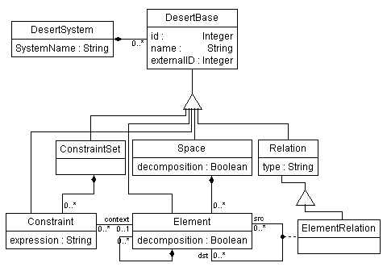
Figure 1 Input Interface Model - Hierarchical space

By space we mean an AND-OR-LEAF tree of elements. This, from the constraint satisfaction tool's point of view means that the OR nodes are variables, and their possible values are their children. The type of the node it's controlled by it's decomposition (Boolean) attribute and the number of sub-elements(children) of a node in the following way:}

- If the number of children is = 0, then the type is LEAF.
- If the number of children is > 0 and decomposition, then the type is AND
- If the number of children is > 0 and not decomposition, then the type is OR
All the nodes may have Constraints. Each constraint has a context associated, which is a node of any type, and the Constraints are contained in Constraintset.
Constraintsets are there just for the reason to provide a mechanism for grouping the Constraints in several categories, which are specific to application. Well, partially true: There is one special Constraintset, the one with name “Implicit Constraints”. The Constraints in this constraint set are automatically applied and not shown on the DESERT user interface. The expression attribute is the constraint expression, in an extended OCL language. This will be discussed later in this document.

ElementRelations are permitted between the element to pass some extra information to the tool. These relations might be used when composing Properties.

DesertBase is an abstract base class; each class in the input interface model is directly or indirectly inherited from this class. The value of the id attribute should be unique for each UDM object passed to DESERT. The name attribute is used in the constraint expression; so, they should be unique as well at a certain level in the hierarchy. The externalID attribute may carry extra information throughout DESERT about the object, which is application specific. The values if these attributes are preserved through DESERT, so this is how the application can identify and match the objects when reading them back from DESERT.
DesertSystem is just a container for everything in the input model. This is needed because of the nature of the UDM, which require everything to be contained in a “RootObject'”.

Properties
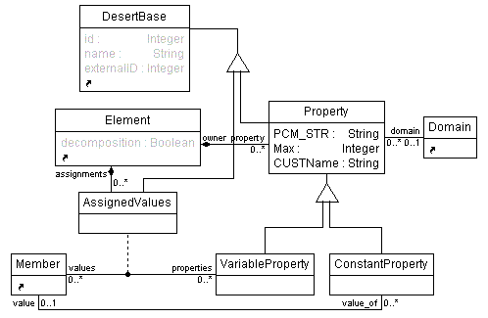
Figure 2 Input Interface Model - Properties

As mentioned above, leaf nodes can have Properties. These Properties then can be used to express constraints. A property is owned by an element and always belongs to a domain. This is the set of members that can be assigned to properties as values. The property values can be composed in the AND-OR-LEAF tree, if the Property to be composed is defined for all the leaf nodes in the sub-tree rooted at the node at which the property should be evaluated.
The PCM_STR attribute specifies how a Property should be composed, when the constraint engine needs to evaluate it at an AND or an OR compound node. The possible values for this attribute are:

PCM_ADD - specifies that the property is additive.
PCM_MUL - specifies that the property is multiplicative.
PCM_AMED - specifies that the property value of the compound node is equal to the arithmetic median of the same property values of the children.
PCM_GMED - specifies that the property value of the compound node is equal to the geometric median of the same property values of the children.
PCM_MIN - specifies that the property value of the compound node is equal to the minimum of the same property values of the children.
PCM_MAX - specifies that the property value of the compound node is equal to the maximum of the same property values of the children.
PCM_NONE - specifies that the property is it not a composable property. Thus, forcing the constraint engine to evaluate it at a compound node by adding such a constraint at a compound node will generate an error.
PCM_CUST - specifies that there will be a custom function linked against DESERT, which will compose this property whenever is needed. The CUSTName attribute will hold the name of the custom function.

There are two kinds of properties: Variable property and Constant property.

As one would easily guess, Variable Properties will be the variables of the constraint engine, thus, they may be assigned to more than one member. The assignments are done by the association class Assigned values, which are contained in elements. Each Assigned value object points to a member with it's values pointer and to a Variable property with it's properties pointer.
Constant properties are there to define Properties that are constant for a leaf node. Even if this is not used directly by the constraint engine, it's still needed when one needs to evaluate a property at a compound node, which implies that a certain property must be defined for each leaf node in the sub tree.
Again, everything is derived from the DesertBase abstract base class. One should pay extra attention to the id and externalID attributes of the Assigned values, because DESERT will return with set of Configurations which will contain a set of valid Assignments. In most of the cases the application will need to match the Assignment objects in the output data network with the Assigned Values objects in the input data network. This will be possible, since the Assignment object will preserve the ids of the Assigned values objects.
The abstract base class Property captures the common functionalities in Variable properties and Constant Properties, that these are contained in the owner Element, they operate on a Domain.

Domains
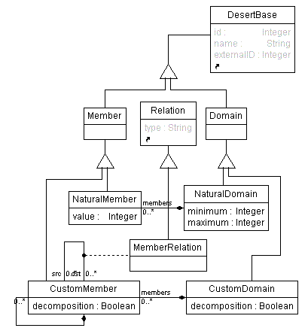
Figure 3 Input Interface Model - Domains

A domain is basically a set of values, which properties may be assigned to. There are two kinds of domains: Custom domains and Natural Domains.

The Custom Domain is again an AND-OR-LEAF tree and it has the same syntax as Space. However, the decomposition attribute is currently not used in the DESERT. The nodes of this tree are the Custom members, which act exactly the same way as elements in the space.
Member relations are there for the same reason element relations are there. One could use this information in a custom function when composing properties.
The Natural Domain is a set of natural numbers, which is defined by its attributes minimum and maximum. However, if one wants to actually assign a value from a natural domain, then one would need to create a natural member with that value in the natural domain.

The abstract base class member captures the common functionality of Custom members and Natural members. Members can be assigned as values to Properties.

The abstract base class Domain captures the common functionality of Custom domains and Natural domains that there are Properties assigned to them.

Output Interface model

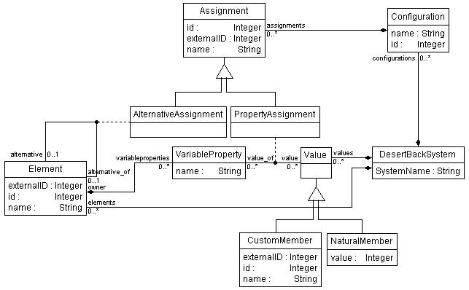
Figure 4 Output Interface Model

The above class diagram was designed based on the idea that DESERT outputs valid configurations that satisfy the applied constraints. Each configuration will have exactly one Natural member or Custom member assigned to each Variable property, and exactly one node (=Element) for each compound node of type OR in space.
The DesertBackSystem is a class that contains everything. This will be the type of the root object of the output data network. DesertBackSystem contains values, elements, and configurations that are objects of type value, element, and configuration, respectively. Further, the elements contain Variable properties. Elements and Variable properties have exactly the same semantics as in the input interface model.
A Configuration object identifies a particular configuration in the design space. The valid configurations are numbered, beginning from 1, and these are the values of their id attribute. The name attribute value will be set to “Conf. no. x”, where x is the id of the configuration. A configuration contains assignments, which can be of two kinds: Property Assignment and Alternative Assignment. Alternative assignments assign a compound OR node (alternative_of) to a child node (alternative). Property assignments assign a Value to a Variable Property. However, if there are multiple Assigned value objects in the input data network assigning the same member to the same Variable property, for each such Assigned value object there will be a Property Assignment object in the output data network.
The Value objects, and it's derivates, Custom member and Natural member correspond to the member, custom member and natural member objects, respectively, defined in the input interface model.
The values of the id, externalID attributes of the objects in the output data network are equal to the values of the id and externalID attributes of the corresponding objects defined in the input interface model.

The Constraint Language

The constraint language in DESERT is an extended OCL.

Command Reference for the extensions:

Global functions:
project() - returns the DESERT project

Project functions:
name() - returns the Space or Custom domain named “name”

Space and Custom domain functions:
children() - returns the collection of children(not recursive) nodes of a Space or a Custom domain
children(“name'') - returns the node named “name” from the children of a Space or a Custom domain

Custom member and Element (node) functions:

children() - returns the collection of children(not recursive) nodes of a node
children(“name'”) - returns the node named “name” from the children of a node

Element functions:
implementedBy() - for an OR type node returns the selected alternative(:=the value) from its children.
name() - returns the value of the property named “name” for the node. If this property operates on a Custom domain, it will return a Custom member, if it operates on a Natural domain, it will return with an arithmetic value. If the context is a leaf node, it will directly read its property value, if it's not, it will return a composed value.

PCM property evaluation

Properties that are specified with type “PCM_CUST” are evaluated by DESERT by a custom function, which resides in an application extension. (DLL)

The rules for doing this are:
- The DLL must be named PCM_<Property>D.dll (Debug version) or PCM_<Property>.dll where “<Property>” is the name of the custom property.
- The DLL must export a function with this signature and this name:

__declspec(dllexport) CBdd PCM_Eval_<Property>(int limit, ClRelExpr::RelOp op, CDynElement *p_this);

- <Property> is the name of the custom property,
- p_this is a pointer to the CDynElement in which this property is being evaluated
- op is the relation expression operator
- limit is the maximum value which should be considered when composing values
the function should return an mtbdd which maps its encoding to terminal values

How to use it?

Desert is available in a binary distribution.

It contains the following files:

DesertTool.exe - application executable
Desert.dll - application extension
DesertD.dll - application extension(DEBUG)
PCM_latency.dll - application extension – latency custom property
PCM_latencyD.dll - application extension – latency custom property(DEBUG)
DesertIface.xml - input interface model class diagram
DesertIfaceBack.xml - output interface model class diagram
Xerces-c_1_2D.dll - 3rd party dll
Xerces-c_1_2.dll - 3rd party dll debug
Desert.pdf - this documentation

DesertTool.exe is a standalone MFC application.
When invoking without command line parameters, it starts with a file open dialog for the input data network. Once the data read, a GUI comes up, where the constraints can be applied one by one. By exiting this application, another file open dialog comes up for the output data network. The configurations are saved.
DesertTool.exe also can be invoked with a single command line parameter, which would specify the input data network skipping thus the file open dialog for the input. After exiting, the output is also generated automatically and saved using the same UDM backend technology as the input data network, in a file with the same name as the input data network, but a “_back” is suffixed.
DesertTool also registers itself in the system registry, so you can invoke and make it auto-magically generate the output.
The code for this:

HKEY hKey;
DWORD dwSize = _MAX_PATH;
DWORD dwDataType = REG_SZ;
DWORD dwValue = 0;
char desert_path[_MAX_PATH];

if(::RegOpenKeyEx(HKEY_CURRENT_USER, "Software\\ISIS\\DesertTool\\Data", 0, KEY_QUERY_VALUE,&hKey) == ERROR_SUCCESS)
{
if(::RegQueryValueEx(hKey,"Path", NULL, &dwDataType, (unsigned char *)desert_path,&dwSize) != ERROR_SUCCESS)
{
// Close key
::RegCloseKey(hKey);
//hanfle registry error
return;
}
// Close key
::RegCloseKey(hKey);
}//eo if RegOpenKeyEx is ok
else
{ //handle registry error
return;
}

//invoke DesertTool, and wait until it finishes
_spawnl(_P_WAIT, desert_path, desert_path, (LPCTSTR)str, NULL);

How to compile it?

Case Study: Desert in MILAN

