ESMoL Scheduler Rework

Functional Spec

Last modified: 12/3/2010

Overview
The scheduler analyzes timing specifications for partitioned and time-triggered controller designs. This includes the integration of different execution and communication paradigms.

Scenarios

- The ESMoL development team has a working time-triggered controller for a quadrotor helicopter using the inner loop/outer loop architecture. They want to add two new features:
  - A time-triggered yaw control function for the inner loop.
  - An on-demand streaming data collection function for video data from the helicopter. The data packets should be collected and streamed at a lower priority than the controller functions.
Each of these functions should be integrated into the existing schedule. The scheduler should be able to use an abstraction of the existing design, along with the specifications for the new functions to determine schedulability and then calculate start times for the yaw control function.
- The other scheduling paradigm comes from the ARINC-653 Component Model. In this model, two types of tasks exist: Periodic and rate constrained sporadic tasks. All tasks are clustered into different partitions.
  - Partitions are scheduled cyclically within a hyper period.
  - Within the partition, the tasks are scheduled in a priority preemptive manner.
  - Problem: Given task properties and messaging schedules, determine the partition schedules, and offsets for periodic processes. It should be possible to plugin different transport semantics.
See GPS data collection example below.

Issues/Questions
Should this really be two backends for the same spec language? The two scheduling paradigms have similarities, but are they mostly at the front end or back end? Putting details into this spec should help resolve that question.

Specification Language Explanation

Example Lines | Explanation
Resolution 100ms | Resolution <time value>  For nodes with a finer resolution, use this as the minimum resolution when discretizing the search space to prevent the solution space from exploding.
Proc N1 100us EDF | Proc <str name> <time tick resolution> <str sched policy>  Processor/Node/Module (type) followed by its name and its fundamental tick resolution. Proc provides scope for all succeeding declarations until a Proc/Bus/Latency line. Scheduling policy is one of Static, EDF, RM, DM.
Partition P1 =50Hz 10ms policy=RM jitter=1us | Partition <str name> =<freq strict frequency> <time duration> [policy =<str sched policy> jitter=<time max jitter>]  Partitions provide limited hierarchy in the scheduling model. They contain tasks and local messages. Partitions are not preemptible, run at a strict period, and have a fixed duration. All partitions on the same node must be harmonic. The policy is the scheduling algorithm that is used inside the partition.
TTask T1 =50Hz 1ms | TTask <str name> =<freq strict frequency> <time WCET>  Time-triggered (strictly periodic) task – highest-priority and non-preemptible. Assumes that message input/output copy times are included in the WCET. Lowest jitter, but hardest to schedule. TTasks must be harmonic to the partition frequency.
PTask T2 =50Hz 1ms 2ms | PTask <str name> =<freq strict freq> <time WCET> <time deadline>  Periodic preemptible task (standard real-time with deadline). Offset is a free variable determined by the scheduler. These are scheduled at a lower priority than the time-triggered tasks.
ATask T3 <50Hz 1ms 2ms | ATask <str name> < <freq max freq> <time WCET> <time deadline>  Aperiodic preemptible task. We assume these can occur anywhere in the schedule, but no more frequently than the specified frequency. When a triggering event occurs, it is buffered until the handler can be invoked. We have to guarantee that it is handled by the deadline in the worst case.
 | Note regarding the task types – from the point of view of periodicity and scheduling, their differences may seem somewhat superficial. From the point of view of triggering and possible message communication semantics, their differences are significant. We will cover the differences in the sequel.
SyncMsg S1 | SyncMsg <str name>  Synchronization message reference. Message must be fully defined in a connected bus (with parameters).
Msg M1 5B N1/P1/T1 N1/P1/T2 | Msg <str name> <size msg length> <str sender path> <str receiver paths>*  Non-blocking message. In this scope it is local to the partition.
Partition P2 =50Hz 10ms
TTask T4 =50Hz 1ms
Global | Special declaration for specifying messages that are local to the processor node, but between partitions. Synchronization messages could go here, if the runtime partition scheduler uses a global message to synchronize the partition times.
BMsg MB1 32B 4B 5ms N1/P1/T2 N1/P2/T4 | BMsg <str name> <size fwd msg length> <size reverse msg length> <time deadline> <str sender path> <str receiver path>  Blocking message. A time-triggered task can not send a blocking message, but it can receive and respond to one. The return message is not blocking for the receiver.
Bus note | Bus <params> <str node name>*  For any bus type, the default is to have the bus visible to all nodes. An optional list of nodes can be added to restrict the connectivity of the bus.
TBus B1 100Mb 1ms | TBus <str name> <bitrate bus capacity> <time bus resolution>  Timed bus.
SyncMsg S1 1ms 0ms 3ms | SyncMsg <str name> <time duration> (<time min> <time max>)?  Declare a synchronization message for a communication medium. The time min/max parameters specify an optional absolute time range within which the message must occur. If the specified endpoints are outside the hyperperiod then the spec is invalid.
TTBus TB1 100Mb 1ms 10ms | TTBus <str name> <bitrate bus capacity> <time bus resolution> <time slot length>  Time-triggered TDMA bus, with one-sender-per-slot semantics.
AFDXBus AB1 100Mb 100kb 100 | AFDXBus <str name> <bitrate bus cap> <bitrate min chan cap> <num max channels>  AFDX-style bus – what parameters are needed? Channel bandwidth gap?
EthBus EB1 100Mb | EthBus <str name> <bitrate bus cap>  Ethernet-style bus.
TTEBus TTEB1 1ms 10ms 100Mb | TTEBus <str name> <time bus resolution> <time slot size> <bitrate bus cap>
LatencyBound N1/P1/T1 N1/P2/T2 12ms | LatencyBound <str start task path> <str end task path> <time max latency>  Simple time bound constraint between a pair of tasks.
LatencyChain N1/P1/T1 TTEB1/M1 N1/P2/T2 TTEB1/M2 N2/P1/T3 TTEB1/M3 N1/P1/T2 50ms | LatencyChain <str start task path> (<str msg path elt> <str task path elt)+ <time max latency>  Latency bound with an explicit specification of a chain of tasks. The tasks should be ordered by the scheduler and a sequential traversal of the tasks and their intervening messages should lie within the specified latency bound.

GPS Example

Resolution 1ms

Proc N1 1us

Partition Part1 =500Hz 1ms policy=RM jitter=11us
PTask SensorDataOut =250Hz 155us 4ms

Partition Part2 =500Hz 1ms policy=RM jitter=23us
PTask GPSDataIn =250Hz 171us 4ms
ATask NavDisplayDataIn <250Hz 231us 4ms
ATask NavDisplayGetGPSData <250Hz 177us 4ms
ATask GPSGetGPSData <250Hz 48us 4ms

Msg GPSDataIn1_Msg Part1/SensorDataOut Part2/GPSDataIn 36B
Msg GPSDataIn2_Msg Part2/GPSDataIn Part2/NavDisplayDataIn 36B
BMsg NavDisplayMsg Part2/NavDisplayDataIn Part2/NavDisplayGetGPSData 0B 0B 8ms
BMsg GPSDataMsg Part2/NavDisplayGetGPSData Part2/GPSGetGPSData 40B 40B 8ms

1. maxexSensor_data_out = 1.540184020996094e-004 seconds
2. maxexGPS_data_in = 1.702308654785156e-004 seconds
3. maxexP_GPS_getGPSData = 4.744529724121094e-005 seconds
4. maxexNavDisplay_data_in = 2.305507659912109e-004 seconds
5. maxexU_NavDisplay_getGPSData = 1.769065856933594e-004 seconds

Quadrotor Example

Resolution 1ms

Proc Gumstix 400MHz 0s 0s
TTask OuterLoop =50Hz 1.6ms
TTask ReferenceHandler =50Hz 1ms
PTask SensorDataCollector =10Hz 1.1ms
Msg ReferenceHandler.Pos_Ref_msg_out 17B Gumstix/ReferenceHandler Gumstix/OuterLoop

Proc Robostix 16MHz 0s 0s
TTask DataHandler =50Hz 200us
TTask InnerLoop =50Hz 600us
PTask UARTIn1 =50Hz 1us
PTask UARTOut =50Hz 1.1ms
PTask Streaming =10Hz 1ms
ATask WarningSensor <2Hz 1ms
Msg DataHandler.PL_Data 61B Robostix/UARTIn1 Robostix/DataHandler
Msg InnerLoop.Thrust_Cmd_msg 17B Robostix/InnerLoop Robostix/UARTOut
Msg DataHandler.Att_Data_msg 25B Robostix/DataHandler Robostix/InnerLoop

TTEBus TTEBus 100kb 1.3ms Gumstix Robostix
Sync TTBusSync 1.25ms 0s
Msg DataHandler.Pos_Data_msg 37B Robostix/DataHandler Gumstix/OuterLoop
Msg OuterLoop.Att_Ref_msg 17B Gumstix/OuterLoop Robostix/InnerLoop
Msg Streaming.Audio_Data_msg 4B Robostix/Streaming Gumstix/SensorDatCollector
Msg WarningSensor.Alert 10B Robostix/WarningSensor Gumstix/SensorDataCollector

Constraints

Model Constraints
- No tasks may be specified at the top level if partitions are also present on that node? (Does this make sense? – it may make it easier to do control tasks). We can mix time-triggered and other kinds of tasks in the same partition, as we have a fixed priority relationship between the different kinds of tasks.

Dependency Constraints
- All dependency graphs on a processor must be cycle-free.
- Remote blocking messages must be cycle-free.

Interaction Constraints
- Time-triggered tasks can not issue blocking messages, but they can receive blocking messages.

Parameter Constraints
- Periods of partitions on the same node, and time-triggered tasks within those partitions, must be harmonic.
- The frequency of a time-triggered task must be less than or equal to the frequency of the partition it runs in.

Bus and Communication Models

Figure 1: Message semantics: Blocking calls from TTasks do not make sense, as messages are not permitted within the execution bounds of the task.
TTask
All inbound messages precede the start of the task.
Outbound messages leave after the task.
TTask → Logical Execution Time
A/PTask
A/PTask → Arbitrary Message Arrival/Departure

From Graham:

When we consider bus models (in terms of representing their behavior with constraints), we may be able to get away with the following set of abstractions:

Bus vs. Switched
Buffered vs. Unbuffered
Half vs. Full Duplex
Time-triggered vs. non time-triggered
Slots or not

Bus Protocol | Characteristics | Limitations / Notes
AFDX  Avionics Full-DupleX switched ethernet  (from AFDX tutorial) | Switched, Buffered, Full Duplex, non time-triggered, no slots | Each node has a full connection to the switch both for transmit and for receive, eliminating the possibility of collisions  Buffer overflow is possible at the switch, but buffers can be configured if maximum size requirements are known.  Congestion in the switch leads to jitter on delivery times.  Virtual link allows the configuration of a communication partition with a fixed sender and set of receivers. Each is given a bandwidth allocation time (BAG) which determines the max frequency for messages on the link, and each also has a maximum ethernet frame length.  Sequence numbers tag messages per virtual link so that redundant copies can be identified by voters.
TDMA (TTP/C or Flexray)  (see sources below) | Bus, unbuffered, half duplex?, time-triggered, slots | Logical execution time.  Clock sync required.  One slot per sending node in the hyperperiod (bus period).  Bus periods are harmonic with possible mode switch periods.
Timed (FRODO) | Bus, unbuffered, half duplex, time-triggered, no slots | Logical execution time  Clock sync required  Arbitrary send/receive

AFDX Scheduling

is the maximum jitter
is the max frame length (largest message) for virtual link j
is the total link bandwidth (100 Mbps)
500 us is the maximum jitter allowable by the AFDX protocol (we should check to make sure that the configuration for the virtual links meets this requirement)

In LaTex:
J_{max} \leq 40 us + \frac{ \sum_{j \in VL} 8 \times ( 20 + Lmax_j ) } { N_{bw} } \leq 500 us

TDMA Scheduling models

E. Farcas, W. Pree, J. Templ. Bus Scheduling for TDL Components, Dagstuhl conference
on Architecting Systems with Trustworthy Components, published as Springer Lecture
Notes in Computer Science, July 2006.

Messages have release constraints (earliest sending time) and deadline constraints (latest completion time). The message release constraint is later than the sending task release time + the worst-case exec time of the task. The deadline constraint is determined by the deadline of the sending task.

Logical execution time – messages sent by a particular task must complete their transfer before the deadline of the task. This is not strictly necessary – logical execution time only requires the transfer after the sender has completed execution, and before the release of any receiving task. Other models assume the transfer occurs after the deadline.

Bus period is divided into frames. Messages are scheduled to particular frame windows based on an overlap metric between the message window and the frame window, determined as follows:
Each window is characterized by its release (*.r) and its deadline (*.d):

They use a variation of Reversed EDF (Latest Release Time) to clean up conflicts in the windows.

Timed Scheduling Models

Klaus Schild, Jörg Würtz: Scheduling of Time-Triggered Real-Time Systems. Constraints 5(4): 335-357 (2000)

Porter et al (based mostly on Schild, Würtz):

Constraint | Description
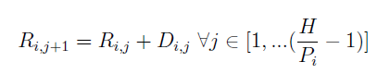 | Periodicity constraint for tasks.
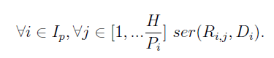 | Disjunction constraint for tasks on the same node. Serializes their execution intervals.
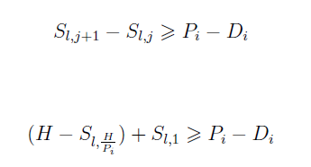 | Message spacing constraints. Make sure two messages never get scheduled into the same “gap”.
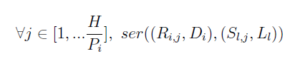 | Serializes all messages on the same bus.
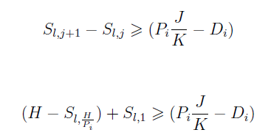 | Multi-rate version of message spacing  constraint.
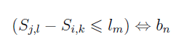 | Impose a spacing constraint on two start times (should be for tasks, unfortunately).
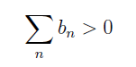 | Reify the constraints.

Zheng, Chong, et al. Extensible and Scalable Time Triggered Scheduling. Application of Concurrency to System Design, 2005. ACSD 2005. p. 132-141. June 2005.
Start with the dependency graph (DAG), and the physical architecture. Allow preemption.
Loose TDMA model (like our timed message model) – each node can have multiple sending slots, and the slots can have arbitrary sizes.

Notation:
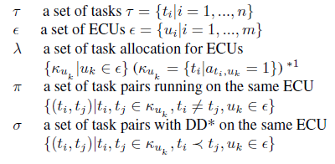
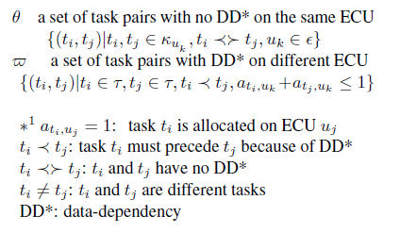
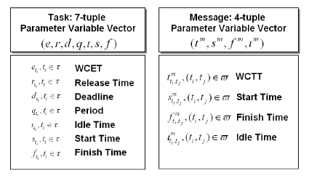

Binary control variables
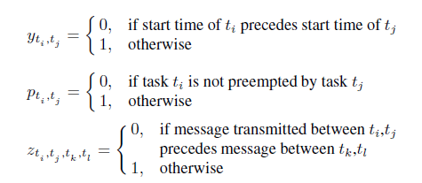
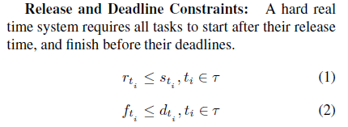
Constraints
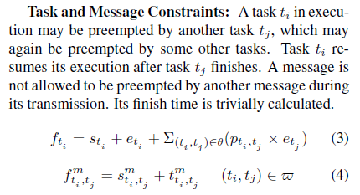

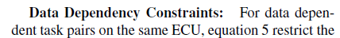
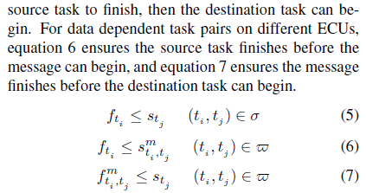
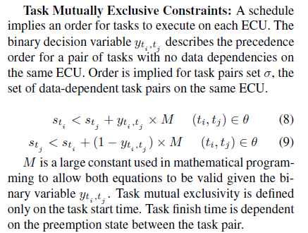
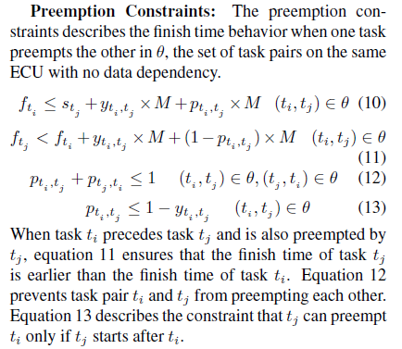
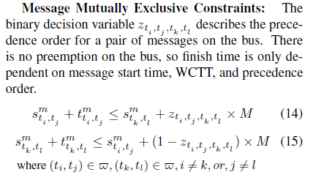

See also:
P. Pop, P. Eles, T. Pop, and Z. Peng. An approach to incremental design of distributed embedded systems.
DAC ’01: Proceedings of the 38th conference on Design automation, pages 450–455, 2001.

P. Pop. Analysis and synthesis of communication-intensive heterogeneous real-time systems. Ph. D. Thesis
No. 833, Dept. of Computer and Information Science, Linkoping University, June 2003.

Scheduling for Task Chains

Sun, Bettati, et al. An End-to-End Approach to Schedule Tasks with Shared Resources in Multiprocessor Systems. Proc. of the 11th IEEE Workshop on Real-Time Operating Systems and Software.

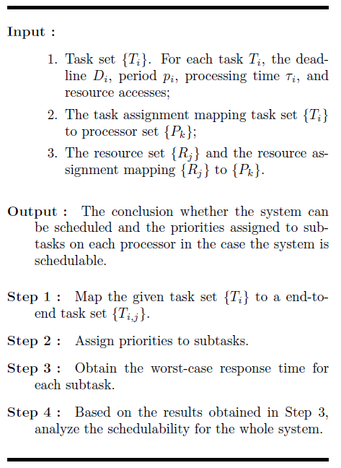

Step 1: Break each task into a chain of subtasks in the corresponding end-to-end task set as follows:

- Each subtask is either a critical section that requires remote resources or a segment requiring no resources or local resources. If a task has nested resource accesses, each outermost critical section is mapped to a subtask.
- A subtask that requires no resources or only local resources is on the local processor of . A subtask that requires remote resources is on the synchronization processor of those resources.
- For j=1,2,...,ni-1, consecutive subtasks and are on different processors.

Step 2: Assign priorities to subtasks – use rate monotonic assignment, or one of the following:

- Global deadline-monotonic assignment.
- Effective deadline-monotonic – effective deadline is , where is the number of subtasks of , and is the processing time of instance .

Step 3: Determine the worst-cast response time for subtasks:

are the subtasks that are (1) on the same processor as , (2) come from different tasks than , and (3) have priorities equal to or higher than . is the subset of in which every subtask has a higher priority than . is the maximum blocking time that can experience.

In LaTeX:
c_{i,j} = \frac{ \sum_{T_{k,l} \in H_{i,j}} \tau_{k,l} + \beta_{i,j} } { 1 - \sum_{T_{k,l} \in H^{'}_{i,j} u_{k,l}}

Step 4: Check schedulability for the whole system.

,

Also look at:
Z. Deng, J. W.-S. Liu, and J. Sun. A scheme for scheduling hard real-time applications in open system environment. In Proceedings of the Ninth Euromicro Workshop on Real-Time Systems, pages 191-199, Toledo, Spain, June 1997. IEEE.
Jun Sun, Mark K. Gardner, and Jane W. S. Liu. Bounding completion times of jobs with arbitrary release times, variable execution times, and resource sharing. IEEE Transactions on Software Engineering, 23(10):603-615, October 1997.
Jun Sun. Fixed-Priority End-to-End Scheduling in Distributed Real-Time Systems. PhD thesis, University of Illinois at Urbana-Champaign, 1997. Available as Technical Report UIUCDCS-R-97-1973.

Scheduling Heuristics

Schild and Wurtz:
- Global constraints are single computational agents that constrain up more than a thousand variables simultaneously. These global constraints significantly reduce the number of constraints that are active at a given time (p. 337).
- Recognize that the shared data bus is the biggest scheduling bottleneck, even though utilization is lower than for processors (p. 353). Therefore, branch on message assignments first.
- Enforce relative ordering first (by branching order), and then continue to search for concrete start times.
- Cheap ordering – for any collection (of tasks or messages S), do the following:
  - Select s and post constraints to order its first start before all of the other instances in S.
  - If it fails, pick a different s and try again (removing the posted constraints).
  - If it succeeds, remove s (keeping the posted constraints). Repeat from (1) for another s.
  - This technique should take |S|-1 steps in the best case.

Cited from Pop (an approach to incremental design of distributed embedded systems):

W. Wolf, “An Architectural Co-Synthesis Algorithm for Distributed,
Embedded Computing systems”,IEEE Transactions
on VLSI Systems, June 1997, pp. 218 -229.

C. Lee, M. Potkonjak, W. Wolf, "Synthesis of Hard Real-
Time Application Specific Systems", Design Automation for
Embedded Systems, V4, N4, 1999, pp. 215-241.

T. Y. Yen, W. Wolf, "Hardware-Software Co-Synthesis of Distributed
Embedded Systems", Kluwer Academic Publ., 1997.

B.P. Dave, G. Lakshminarayana, N.K. Jha, “COSYN: Hardware-
Software Co-Synthesis of Heterogeneous Distributed
Embedded Systems”, IEEE Transactions on VLSI Systems,
March 1999, pp. 92 -104.

J.E. Beck, D.P. Siewiorek, “Automatic Configuration of
Embedded Multicomputer Systems”, IEEE Trans. on CAD,
v17, n.2, 1998, pp. 84-95.

T. Blicke, J. Teich, L. Thiele, “System-Level Synthesis Using
Evolutionary Algorithms”, Design Automation for Embedded
Systems, V4, N1, 1998, pp. 23-58.

Performance

Extensibility Metrics
Extensibility
Scalability

Design Metrics

Bandwidth/throughput
Latency

From
- Schwarz., “Implementation of a ttp/c cluster based on commercial gigabit ethernet com- ponents.” Master’s thesis, Vienna University of Technology, Real-Time Systems Group, 2002.

He measures propagation delay and jitter through a Gb ethernet switch while trying to do TTP-style synchronized communications. Here is the relevant measurement chart (p. 71):
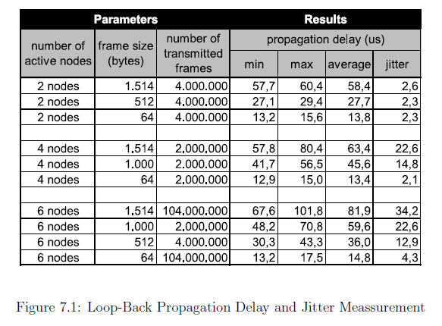
Poor TTP performance (measured by the sparsity of the TDMA schedule and the coarse time resolution of the implementation) is attributed to the jitter in the switch, which is due data buffering, internal reconfigurations, and to the lack of support for synchronized broadcast (p. 79).

Matic (ref [62]) mentions another critique of TTP:
[62] K. Richter, M. Jersak, and R. Ernst. A formal approach to mpsoc performance verification. IEEE Computer, 36(4):60–67, 2003.

Incremental Profile Extension

Profile Element | Description
Hyperperiod 20ms | Hyperperiod <time hp>  Stored hyperperiod from the previous run.
NProfile Gumstix/TTask/P1 | Profile <str node name>/<str task type name>/<str profile name>  This is the TTask profile definition.
Extensibility 10 | Extensibility <int ticks>  Largest available slot.
OuterLoop (12,14) | <str task name> (<int tick start>,<int tick end>)+  Stored execution time bound for the listed task. The bounds are start <= t < end
ReferenceHandler (7,8)
IFace Gumstix/PTask/P2 20 4 (15,19) | IFace <str node name>/<str type>/<str name> <num period> <num deadline> <tick start> <tick end>  Periodic interface within a timed task set. The description is below, with the two additional parameters describing the scheduled start and end times of the interface task.
NProfile Gumstix/PTask/P2 | Profile <str node name>/PTask
Extensibility (40,2.5) (20,4) (10,1.2) | Incremental schedulability profile for the PTasks. The data points are (period, capacity) for possible frequencies.
IFace Gumstix/PTask/P3 20 4 | IFace <str node>/<str type>/<str profile name> <num period> <num deadline>  Interface description for a lower task (specified by profile name). The period and deadline refer to an entry in the referred schedulability profile. This case represents a periodic profile within a periodic task set.
BProfile TTBus/Msg/P4
Extensibility 15
DataHandler.Pos_Data_msg 1 (13,16) | <str msg name> <tick length> (<tick window start>, <tick window end>)+  For the specified message (name and tick length), the pairs represent possible placements for the message. The assumption is that the bus is harder to schedule than the nodes, so allowing existing messages some wiggle room should make it easier to schedule the new messages.

What information needs to be kept in the profile for incremental analysis?

Easwaran's profile based on supply abstraction. TODO: copy notes from area paper.

Slack representation from Zheng and Chong. We need an incremental analysis model (either based on demand or supply and demand) to abstract the capacity and load of the various partitions on a single processor.

Look at Pop's work on incremental techniques for our problems. He also has references to good heuristics.
P. Pop, P. Eles, T. Pop, and Z. Peng. An approach to incremental design of distributed embedded systems.
DAC ’01: Proceedings of the 38th conference on Design automation, pages 450–455, 2001.

P. Pop. Analysis and synthesis of communication-intensive heterogeneous real-time systems. Ph. D. Thesis
No. 833, Dept. of Computer and Information Science, Linkoping University, June 2003.

Pop, P.; Eles, P.; Zebo Peng; Pop, T.; , "Scheduling and mapping in an incremental design methodology for distributed real-time embedded systems," Very Large Scale Integration (VLSI) Systems, IEEE Transactions on , vol.12, no.8, pp. 793- 811, Aug. 2004
doi: 10.1109/TVLSI.2004.831467
URL: http://ieeexplore.ieee.org/stamp/stamp.jsp?tp=&arnumber=1316895&isnumber=29191

Assumes that each application is made up of (possibly) multiple process graphs, each of which is polar (single source and sink), directed, and acyclic. Each of these process graphs runs at a single frequency – that seems like a reasonable assumption, though the graphs within an application may have different rates. Each process graph also has a deadline.
Inter-application messages are assumed to be non-time-critical, and so are not scheduled within this framework. Application process graphs are mapped to the distributed architecture, so intra-process messages are time-critical in order for deadlines to be met.
The actual problem described is that of both mapping and scheduling: determining the deployment of application process graphs onto processors, and determining the schedule as well. Pop assumes that incremental design changes will take place at the application level, where new applications are added to the mix, and their constituent processes must be added to the individual nodes.
Their incremental interface includes all of the start times and durations for the existing tasks, their deadlines, and an application modification dependency graph. Nodes in the dependency graph can be frozen (i.e. closed to changes). Edges in the graph indicate at a course level which applications may need modification based on changes to other applications. The graph itself contains a single number which estimates the cost of modifying that particular application, so the cost of modifying an application includes the sum of the cost of its dependent applications.
Notes: This cost model may be too simple – what makes more sense, or do we want to deal with modification costs at all? Pop makes the valid point that hours required to test/evaluate a particular application would work well for this metric.
Pop's incremental framework assumes some a priori knowledge regarding probabilities of future application configurations as well. This is reasonable for short- and medium-term design revisions, where sets of deferred system features may actually be available. For changes farther in the future, we are probably guessing.
Extensibility is characterized by the distribution and size of slack segments in individual node schedules. To characterize the worst-case future configuration, we use the probability distributions for future tasks together with the total slack in order to create a fictional future task set. For a given schedule configuration, they also try to schedule this fictional future task set using a bin-packing algorithm. The total execution time of tasks unscheduled is used as the slack size metric (smaller is better). That seems like a very expensive metric, and it is based on data which may not be reliable nor even available (i.e. the future task distribution). This approach also ignores extensibility with respect to the communication bus. Most often the bus causes the bottlenecks in a design, so characterizing the extensibility of the data movement is probably much more important. In their technique a single bandwidth reservation parameter is used to characterize future extensions to the application messaging.
The second ingredient of their extensibility formula is more interesting. This is more consistent with Easwaran's approach – for a given period (of a future task set), we characterize the largest task that could fit in the existing schedule. This is also repeated for the bus, using message size. Over the network, we take the sum of those tasks, and the minimum of the largest messages per TDMA slot.
The main difference here is that Pop is trying to minimize recomputation, but not trying to maintain a compositional structure using interfaces. What does that mean from the perspective of scalability and search performance?

Slobodan Matic. Compositionality in Deterministic Real-Time Embedded Systems. EECS Department
University of California, Berkeley. Technical Report No. UCB/EECS-2008-12. February 11, 2008

Matic PhD. From chapter 3. Component Resource Abstraction and Tradeoffs.

Task models – real-time workshop (RTW) vs. logical execution time (LET) semantics.
RTW offers lower latency in general
LET offers separation/composability
separation = minimal interface between levels in the scheduling hierarchy
compositionality = properties established at lower levels also hold in higher levels

    - Given a periodic resource (as in Shin/Lee) – (T = period, C = capacity), and a program (G = task graph, S = scheduling policy).

Program abstraction (i.e. supply abstraction (T,C) ) is a function c : Q->R which tightly abstracts (G,S) if c(T) = C is the smallest capacity such that (G, T, C, S ) is schedulable. Define abstraction utilization u(T) = c(T) / T.

Lemma 2. Let V be the vertex set for G (i.e. task set without dependencies).
    - (G, T, C, S) schedulable with S in { RTW, LET } implies (V, T, C, EDF) schedulable.
    - (V, T, C, EDF) schedulable implies ( G, T, C, LET ) schedulable.

Part 2 seems like a very weak condition, since we can say nothing about the resulting latency. It may be that we can find a precedence ordering which satisfies all of the dependencies within a single global cycle, but that may not be the case.
- How can we determine the best possible latency for LET and the specified dependencies?
- Can we use the results on logical latency from Tripakis et al to provide a meaningful bound?

Proposition 3. If there exists a function c_RTW(T) that tightly abstracts (G, RTW), then there exists a function c_LET(T) that tightly abstracts (G, LET) and u_RTW – u_LET >= 0.

Proposition 4. There exists a task graph G such that in prop. 3 strict inequality holds.

This is stated somewhat awkwardly. Maybe a better statement would be: given a set of tasks V and a precedence graph G on V, can we find an adjustment of the edges of G to get strict inequality? I think we could say yes based on his result – maybe not. Would we want to relax edges, or add more edges?

How do we store the profile information with the spec?

We could put a “do not edit” section in at the bottom of the file. Compress the old file, and store the data in a string along with some compressed data strings that represent the profiles for the existing nodes. When the file has changed, diff the old and new file elements to see the changes and use the profile to check admissibility.

