MICTES Report Outline
Title: Model-Integrated Computing Tools for Exploration Systems
Introduction – Gabor
Description of the toolchain
- Figure
- Explanation of design flow
- Elements of the toolchain, with limitations documented
How to use the toolchain?
- Dependencies on external tools
- Installation
- Operation
Examples
- Simulink example, code generated
- Stateflow example, code generated
- Simulink+Stateflow integration example, code generated
- Stateflow → JPF/Java example
- Embedded Matlab script example

Model-Integrated Tools for Exploration Systems

Harmon Nine, Gabor Karsai
Institute for Software-Integrated Systems
Vanderbilt University
Nashville, TN 37235

Last edited by | When | What
Gabor | 2/13/08 | Basic layout, intro
Harmon | 2/22/08 | Added description of toolchain
Gabor | 2/26/08 | Minor edits, clarification
Harmon | 2/27/08 | Added toolchain usage example
Gabor | 2/28/08 | Some more minor edits
Harmon | 2/28/08 | Added ECSL_DP2Java example
Harmon | 2/29/08 | Added description of Embedded MatLab translator and program code generated from SL_CodeGen and SF_CodeGen
Gabor | 2/29/08 | Minor edits/fixes
Harmon | 3/18/08 | Added information about 32-bit MatLab on 64-bit Windows XP

Introduction

This report describes the elements of a Model-Integrated Computing (MIC) [1] Toolchain developed for supporting verification and validation (V&V) activities on Simulink/Stateflow [2] models. The toolchain was designed to serve as a vehicle for integrating the Simulink/Stateflow environment with various V&V tools, but it can also be used for the model-based development of embedded software, including generation of executable code from the graphical and textual models.
The toolchain is based on the MIC toolset, including the metaprogrammable Generic Modeling Environment (GME), as well as other tools, like UDM (a universal data layer for model access), and GReAT (a graph transformation language and engine) [3]. GME is a generic, programmable model editor tool, UDM is a package that provides access to models stored in various formats (GME binaries, called .mga files, or XML files) using various ‘back-ends’, and GReAT is tool for developing model transformation tools using graph transformation techniques. These MIC tools have been instantiated and configured to support the domain-specific language(s) used in the toolchain, but, through their open API-s, further extensions to the toolchain are possible.
The toolchain includes the following major elements.
- A visual modeling language and dedicated editing environment (based on GME) for storing and manipulating models imported from the Simulink/Stateflow environment. The visual modeling language is a superset of the Simulink/Stateflow and it has extensions for the componentization of functional models, for the modeling of software architecture that will utilize the functional blocks, as well as for the allocation of components to tasks on a real-time platform.
- An import translator that allows importing the Simulink/Stateflow models into the GME tool. This tool is the gateway towards Simulink/Stateflow and it builds a GME representation of those models.
- Code generators that generate C and Java code from the visual models. These tools generate executable code from the models that could be subjected to various V&V analysis. The generators have an open back-end and the generation of executable code in other language(s) (e.g. Ada) is also feasible. A separate code generator that generates code from Embedded Matlab scripts (using the same back-end) is also available.
- A number of utility tools for converting models between various (intermediate) formats, as well performing other analysis and model manipulation activities.
In this document, first we describe the architecture of the toolchain, its elements, what they do, and what their input and output formats are. Then, using a simple example, we describe how the toolchain should be operated.

Description of the Toolchain

Figure 1 below outlines the elements of the MICTES toolchain, including files consumed and produced by the various tools, and the modeling paradigms used. The following sections describe the tools and files used in the toolchain.
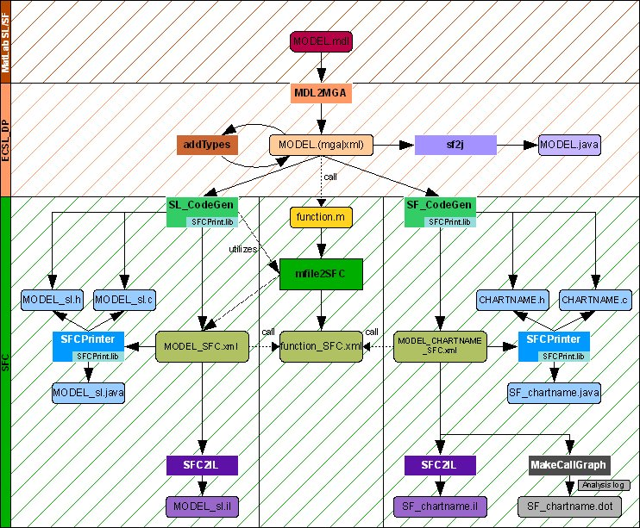
Figure 1: The MICTES toolchain.
Executables are depicted by rectangular boxes, and files produced/consumed are depicted by boxes with rounded corners. Alternative, but equivalent, file formats are indicated by an ‘or’ expression, i.e. (x|y), in a filename’s extension. Modeling paradigms used by the tools are indicated along the left border of the figure. Tools and files that are in the hashed area adjacent to the paradigm indicators operate or store models in that paradigm. Tools along the top border of a hashed area translate from the paradigm of the upper hashed area to that of the lower hashed area.

  - MDL2MGA
MDL2MGA translates a Simulink/Stateflow (SL/SF) model in an .mdl file into an equivalent model in ECSL_DP, a superset of the SL/SF modeling language as mentioned in item (1) of the introduction.
MDL2MGA does not parse the .mdl file directly. Rather, it executes a thread in the MatLab engine (that must be installed on the computer running the toolchain), directing it to read (and parse) the .mdl file. The advantage of this comes from the fact that the .mdl file format changes frequently. If the parsing were performed directly by MDL2MGA, it would need to be modified just as frequently to keep up with the changes in the file format, making it more difficult to maintain. By having MatLab parse it, no such maintenance is necessary, as MatLab will always be able read the current format.
Once MatLab has read in the .mdl file, and internally constructs the SL/SF model contained within it, MDL2MGA queries MatLab about the model using a special MatLab API (see http://www.mathworks.com/access/helpdesk/help/toolbox/stateflow/api/f13-6010.html for more information). This API allows MDL2MGA to acquire all information necessary for it to build an equivalent model in ECSL_DP. MDL2MGA uses UDM package to construct the ECSL_DP model, and so can use either an XML backend to store the model in an .xml file, or a GME backend to store the model in an .mga file. This is depicted in the figure 2 below. The .mga file is suitable for viewing using GME, although the positioning of graphical elements must currently be done manually.
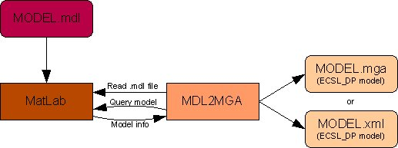
Figure 2: The operation of MDL2MGA.

Important Note: ECSL_DP stores a model, such as that translated from SL/SF by MDL2MGA, by separating the signal-flow (Simulink) and state-machine (Stateflow) portions into different “folders.” That is, the signal-flow portion is placed in a folder called “Dataflow”, while the state-machine portion is placed in the “Stateflow” folder. You can see this by using the GME backend with MDL2MGA, and viewing the resulting .mga file using GME.
Prerequisites for the use of MDL2MGA:
  - Because MDL2MGA uses MatLab to glean information about a model in an .mdl file, MatLab must be installed on the system on which MDL2MGA is run.
IMPORTANT: For MDL2MGA to run on Microsoft Windows XP 64-bit edition, the 32-bit version of MatLab must be installed. In particular the following two files must be present on the system:
    - <DRIVE>:\Program Files (x86)\MATLAB\<VERSION>\bin\win32\libeng.dll
    - <DRIVE>:\Program Files (x86)\MATLAB\<VERSION>\bin\win32\libmx.dll

  - In order for MDL2MGA to use the GME backend, GME must be installed, and the ECSL_DP paradigm must be registered with GME. Note that this latter step is typically taken care of by the installer that installs the toolchain.
An example SL/SF model and its ECSL_DP translation as created by MDL2MGA are shown in figure 3 below.
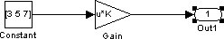
(a)

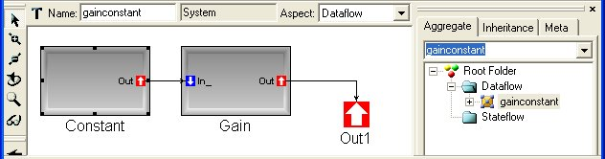
(b)
Figure 3. Example SL/SF model translated to ECSL_DP by MDL2MGA.
(a) The SL/SF model. (b) The same model translated into ECSL_DP by MDL2MGA, and rendered by GME.
Note that the ECSL_DP model separates the translated SL (Simulink) and SF (StateFlow) portions of the SL/SF model into its Dataflow and Stateflow folders. There is no StateFlow portion in this SL/SF model, so the Stateflow folder in the equivalent ECSL_DP model is empty.

  - addTypes
The “addTypes” utility program adds data-typing information to the “Dataflow” portion of an ECSL_DP model. This information is important for translating the model into program form, as a program needs it to construct and generate code that performs the proper operations on its data. The utility effectively performs type-inferencing on the dataflow graph and annotates it with the computed type information.
As the Dataflow portion of the model was translated from Simulink, it consists of a hierarchy of “blocks,” each of which has zero or more input and output ports. An example of this is shown in figure 3(b) above. A particular block performs a given function to render data on its output ports based on the data fed to its input ports. The typing information for such a model consists of the types of data input to and output from each block though its ports. Each such type could be a scalar, array (e.g. vector or matrix), or structure consisting of any combination of types supported by MatLab, e.g. integers, fixed-point numbers, or double-precision reals.
It is the job of addTypes to determine the type of data that each port on each block carries. The type of data a port carries is called its “port-type.” Because each kind of block, e.g. “constant,” “gain,” and “sum,” can require and render distinct types of data, addTypes must use the kind of the block in determining its port-types. Consequently, there is a separate function in addTypes to determine the port-types for each kind of block, and addTypes supports only those blocks for which it has such a function.
The operation of addTypes is shown in figure 4 below. addTypes modifies the ECSL_DP model, adding a separate folder called “Types” which contains all of the port-types determined for the model. The port-types in the Types folder are kept unique, i.e. no two types are identical, and every port in the model contains a reference (i.e. pointer) to its port-type in the Types folder. This is shown in the figure 5 below. In the figure, the port-type names are derived from the port-type, i.e. MdoubleC1C3M is a 1x3 matrix of doubles.
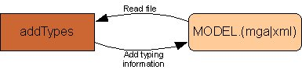
Figure 4: The operation of addTypes.
Note that addTypes does not create a new file – it modifies the model on which it is executed.

AddTypes works by making multiple passes over the model, looking for blocks that have all of their input port-types determined. For these blocks, it can unequivocally determine the output port-types. Once this is done, the input port-types are known for the blocks to which these output ports are connected, and, on the next pass, the output port-types for these latter blocks can be determined (provided all of their input port-types have been determined).
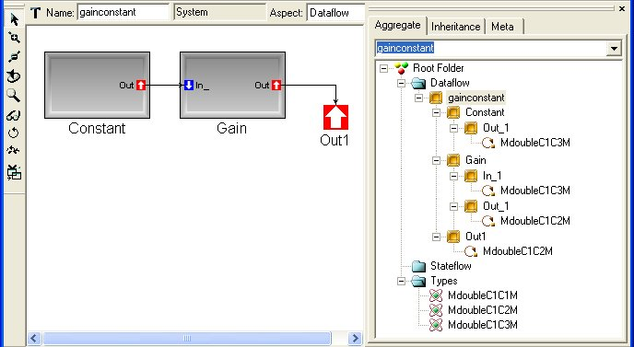
Figure 5: The result of executing addTypes on the ECSL_DP model of figure 3(b), as rendered by GME.
Some of the actual display of GME for this model has been removed for brevity and clarity.

In the example in figure 5 above, addTypes can determine on the first pass the output port-type for the “Constant” block. This is because it knows the port types of all its input ports (there aren’t any). The output port-type of “Constant” is the same as the input port-type for “Gain”, and so, as all the input port-types for “Gain” are now known, addTypes can determine its output port-type on the next pass. As the output port of “Gain” is connected to the output of the model as a whole, in this same pass addTypes determines the output port-type of the model, and so completes its task.
In the case that no additional output port-types can be determined in a particular pass, addTypes will attempt to determine the output port-types for blocks that have only a subset of their input port-types determined. This can be done, for example, on a multiport-switch, as all inputs to such a switch should have identical dimensions, so if the input port-type for one port is known, it can be assumed that the remaining input ports have this same port-type. If addTypes cannot determine the output port-types for any block, even using partial input port-type information, it fails with an error message describing the blocks for which it could not determine the output port types.
Important Note: For models in which there are input ports in the topmost block of the block-hierarchy, the types of these inputs ports must be specified before addTypes is run. Without this information, addTypes will not be able to determine all of the input port-types for any block that takes input from these input ports, and so will fail. If the model has been translated from MatLab Simulink, Simulink provides a means of specifying the types of such ports, and this information will be brought over into the ECSL_DP model by MDL2MGA.
To specify the type of such an input port in Simulink, do the following:
- Double-click on the port
- In the resulting pop-up window, click in the "Signal Specification" tab
- Specify the dimensions of the port in the "Port Dimensions" textbox
- Specify the base type of the port using the "Data type" selection box

A pop-up window Simulink uses for specifying the type of a toplevel input port is shown in figure 6 .

  - sf2j
sf2j is a specialized Java code generator that produces highly stylized Java code that represents a Stateflow diagram. Importantly, sf2j only operates on the Stateflow portion of the ECSL_DP model, i.e. it translates only state-machines into Java source code. The class hierarchy of the source code produced from a state-machine resembles the machine’s state hierarchy. That is, every state in the state-machine has a corresponding class in the Java source, and if a state contains other states as substates, the class corresponding to the former contains internal classes that correspond to the latter. This source can be used to verify the operation of the state machine.
An example state machine from an SL/SF model is shown in figure 7 on the following page. This model was run through MDL2MGA, and the resulting ECSL_DP model was run through sf2j. The resulting Java code follows figure 7. Note how the class-hierarchy in the Java code parallels the state-hierarchy in the state-machine.

  - The Code Generators
The key components in the MICTES toolchain are the code-generators. These programs are responsible for translating models in the ECSL_DP language into executable programs. These executable programs are specified in SFC, which is a UDM paradigm that models an imperative computer language similar to “C.” A portion of the SFC paradigm (data model) is shown in figure 8.
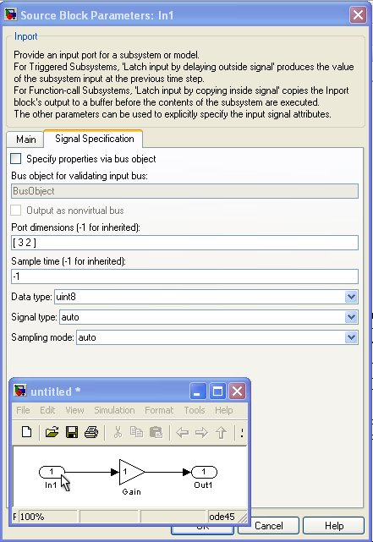

Figure 6: Specifying the port-type of an input port in Simulink.
The inset window shows a SL/SF model with a top-level input port. By double-clicking on this port, the pop-up shown in larger window appears. The “Port dimensions” and “Data type” must be specified here. When the model is translated to ECSL_DP by MDL2MGA, MDL2MGA will include this port-type information in the ECSL_DP model. This port-type is required by addTypes in order that it may determine the port-types of this model.

As shown, an SFC model consists of a number of “Statements,” which can be “CompoundStatements” or “SimpleStatements.” “CompoundStatements” contain other “Statements” and can be a “Function,” “IterativeBlock,” “ConditionalBlock,” etc. Note: SFC is implemented only in UDM (not MetaGME), so an SFC model cannot be visualized using GME.
A program specified as an SFC model is in a form similar to an abstract syntax tree. From this form, the program can be easily interpreted to render C, Java, or other program code capable of being compiled and executed.

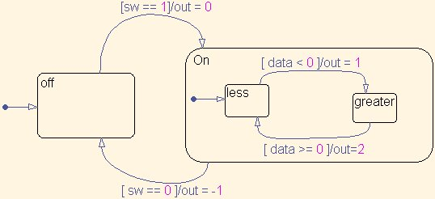
Figure 7: Example state-machine from SL/SF to be translated into Java by ECSL_DP2Java.
public class Chart1 extends State {

double sw; // INPUT
double data; // INPUT
double out; // OUTPUT

class off2 extends State {
public void completion() {
if ( sw == 1 ) {
out = 0;
setNextState( _On2 );
}
}
} off2 _off2 = (off2)makeInitial( new off2() );

class On2 extends State {

class less3 extends State {
public void completion() {
if ( data < 0 ) {
out = 1;
setNextState( _greater3 );
}
}
} less3 _less3 = (less3)makeInitial( new less3() );

class greater3 extends State {
public void completion() {
if ( data >= 0 ) {
out=2;
setNextState( _less3 );
}
}
} greater3 _greater3 = new greater3();

public void completion() {
if ( sw == 0 ) {
out = -1;
setNextState( _off2 );
}
}

} On2 _On2 = new On2();
}

SL_CodeGen
SL_CodeGen is a program that translates the portion of an ECSL_DP model in the “Dataflow” folder (i.e. the portion translated from Simulink) into an SFC model. It accomplishes this through a GReAT transform in combination with the Embedded MatLab translator (see section 2.4.3). When executed on an ECSL_DP model file named MODEL.(mga|xml), SL_CodeGen produces an SFC model file called MODEL_SFC.xml (see figure 9 below). SL_CodeGen also implicitly invokes the SFCPrint library to produce a “C”-code interpretation of the program represented by the SFC model. The resulting “C”-code is placed in the files “MODEL_sl.c” and “Model_sl.h”.
Very Important Note: It is imperative that addTypes be successfully run (i.e. run without error) on an ECSL_DP model before it is specified as input to SL_CodeGen. If the ECSL_DP model does not have the typing information provided by addTypes, SL_CodeGen could suffer a segmentation fault and abort execution when applied to this model.

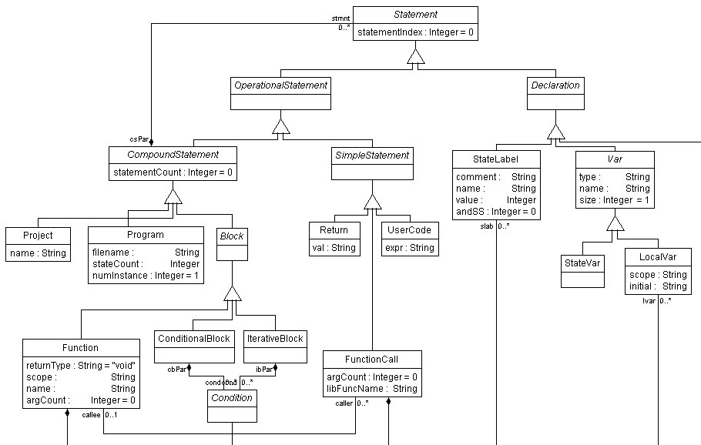
Figure 8. A portion of the SFC paradigm.

    - SF_CodeGen
Using a separate GReAT transform, SF_CodeGen, like SL_CodeGen, translates a portion of an ECSL_DP model into an SFC model. The difference is that SF_CodeGen translates the portion of the model under the “Stateflow” folder (i.e. the portion translated from MatLab Stateflow) rather than the “Dataflow” folder. The translations are kept distinct due to the differences between the structure and semantics of Simulink and Stateflow.
SF_CodeGen, when executed on the ECSL_DP model file MODEL.(mga|xml) produces an SFC model file called MODEL_CHARTNAME_SFC.xml (see figure 9 below), where CHARTNAME is the name of the topmost state of the (Stateflow) state-machine in the ECSL_DP model. SF_CodeGen also implicitly invokes the SFCPrint library to produce “C”-code interpretations of the SFC model, placing the code in files CHARTNAME.c and CHARTNAME.h.
    - The Embedded MatLab Translator
Embedded MatLab Translator, called “mfile2SFC”, translates a program from Embedded MatLab source into an equivalent SFC model (see http://www.mathworks.com/products/featured/embeddedmatlab for a description of the Embedded MatLab language). This is a necessary ability of the toolchain for two reasons. Firstly, there is a block type in Simulink called “Embedded MatLab” which, rather than having fixed operation such as “Gain” or “Product”, allows the user to specify its function using procedural Embedded MatLab code. For SL_CodeGen to convert a model containing such a block into SFC (after it has been translated to ECSL_DP by MDL2MGA), it must be able to parse the Embedded MatLab code and translate it to SFC. It uses mfile2SFC to do this (see figure 9 -- this feature is not yet complete as of the writing of this paper, 2/29/08).
Secondly, both the Stateflow portion of an ECSL_DP model, through actions on states and transitions, and the Dataflow portion, through an “Embedded MatLab” block, may contain calls to an Embedded MatLab function that is encoded in a file (i.e. “m-file”) that is separate from the ECSL_DP model file (see figure 9). The function is still part of the overall model and thus, for completeness, must be translated to an SFC model along with the ECSL_DP model. This can be done separately from SL_CodeGen and SF_CodeGen using mfile2SFC. If the m-file is called “function.m,” its SFC model equivalent generated by mfile2SFC is placed in file “function_SFC.xml.” The SFC models built by SL_CodeGen and SF_CodeGen contain calls to the function in this file.
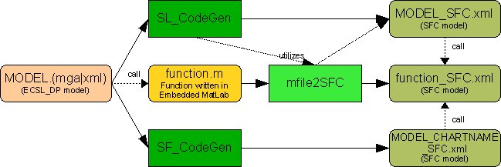

Figure 9: The operation of the SL_CodeGen, SF_CodeGen, and mfile2SFC translators.

  - SFCPrinter
SFCPrinter interprets an SFC model to produce a program-file capable of being compiled and executed. Current target languages supported are C and Java. SFCPrinter is a front-end to the SFCPrint library, which performs the actual interpretation. SL_CodeGen and SF_CodeGen incorporate the SFCPrint library as well, as in section 2.3, but SFCPrinter can be executed on their output files (*_SFC.xml) to reproduce the “C” files that they generate, if necessary.
  - SFC2IL
“IL” (“Intermediate Language”) is a prolog-like language that is specialized for performing code verification. The SFC2IL tool translates an SFC model into IL. This IL is used by various program synthesis and analysis tools, developed by NASA ARC.
  - MakeCallGraph
MakeCallGraph is another tool that will calculate the function-call graph for SFC models that are produced from the SF_CodeGen only. The graph can be programmatically checked to make sure no recursion, and therefore no infinite recursion, occurs in the SFC model.

How to use the toolchain

This section describes how to use the toolchain to translate an SL/SF model into program code that, when compiled and executed, renders the same output as the SL/SF model. Using the toolchain involves executing the tools described in section 2 in either a Windows command-prompt or Cygwin bash-shell. For the rest of this section, it is assumed your current directory is where the files being operated on by the toolchain reside. Also, it is assumed that the directory or directories where the tool executables reside are in your PATH variable. If they are not, you will need to append the appropriate path to each of the executables to get them to run.
Because an example of how to use ECSL_DP2Java was given in section 2.3, it is omitted from this section.
To use the complete toolchain, first construct a model in MatLab Simulink/Stateflow (SL/SF). Such a model is shown in figure 10 below. Save the model in an .mdl file.
The Simulink model in 10(a) consists of a finite-state machine called “Counter”, three constants, a multiport switch, and a top-level output port. The operation of the Counter block is specified using a finite-state machine in StateFlow, which is shown in figure 10(b).
The output of the counter block, as shown in 10 (a), is a variable called “ctr” (the “data” output is not used). From figure 10 (b), it can be seen that when ctr < 3, it is incremented by 1, and when ctr >=3, it is reset to 1. Not shown, the initial value of ctr is 1. Therefore, the output of the Counter block is the progression 1, 2, 3, 1, 2, 3, 1, 2, 3, …
At the heart of the model is the multiport-switch. The block uses the input to its first (uppermost) port (its “control port”) to determine which its remaining input ports (its “data ports”) shall be connected to its output port. In particular, let the data ports be numbered from top-to-bottom starting at 1. Then the number of the data port that is connected to the output port is the same as the value received on the control port. That is, if the control port receives a value of “1”, then data port “1” is connected to the output port. A value of “2” connects data port “2” to the output, etc. The output of the multiport-switch is connected to the output of the model as a whole, so whatever value the switch outputs, the model outputs.
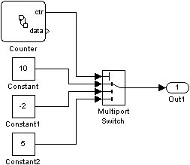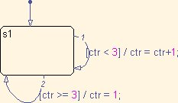
(a) (b)
Figure 10. An example SL/SF model to be run through the toolchain.
Depicted are the (a) Simulink and (b) StateFlow portion of the model.

The constant blocks convey the values “10,” “-2,” and “5,” to the data ports of the multiport-switch. Thus, given the Counter’s input to the control port of the same, the output of the model is the progression 10, -2, 5, 10, -2, 5, …
The purpose of the toolchain is to render a set of programs that implement the model, and thus, when compiled, render the same output as the model.
  - Running MDL2MGA
MDL2MGA takes 1 or 2 arguments. The first argument is the .mdl file that contains an SL/SF model to be translated to ECSL_DP (e.g. “MODEL.mdl”). The second argument is the name of the file that is to contain this ECSL_DP model. This argument MUST end in either “.xml” (to use the DOM backend of UDM) or “.mga” (to use the GME backend of UDM). If the second argument is not specified, it defaults to a value that is the same as the first argument, but ends in “.xml” (e.g. “MODEL.xml”). Note that the DOM backend of UDM is used by default.
The SL/SF model shown in figure 10 is stored in a file called “multiportswitch.mdl”. To translate this model to ECSL_DP using MDL2MGA, execute the following:
MDL2MGA multportswitch.mdl
This results in the ECSL_DP model file “multiportswitch.xml”. To get a file in GME format, execute:
MDL2MGA multportswitch.mdl multiportswitch.mga
“multiportswitch.mga” can be rendered using GME, is shown in figure 11 below.
  - Running addTypes
To run addTypes on an ECSL_DP model file, simply specify the model file as an argument.
addTypes multiportswitch.mga
This adds the typing information to the Dataflow portion of the ECSL_DP model so that it may be translated to SFC. The results of running the above command are shown in figure 12 below. As can be seem from the figure, this model has a very simple typing scheme – the only type appearing in the “Types” folder is double-scalar (i.e. MdoubleC1C1M – a 1x1 matrix of double, with translates to scalar double). Thus all ports carry data of this type.
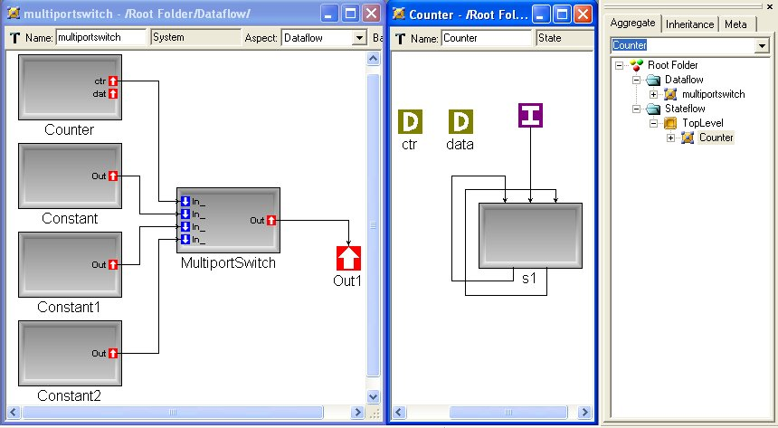

Figure 11: ECSL_DP model translated from the SL/SF model in figure 9, rendered with GME.
In the leftmost window is the “Dataflow” portion of the model (translated from Simulink). In the middle window is the “Stateflow” portion (translated from StateFlow). The rightmost window shows a “tree view” of the ECSL_DP model.

  - SL_CodeGen and SF_CodeGen
The “SL_CodeGen” and SF_CodeGen executables take the name of an ECSL_DP model file as input, and render an SFC model as described in section 2.3. Here is a directory listing before running either SL_CodeGen or SF_CodeGen:
multiportswitch.mdl multiportswitch.mga

Here is a listing after running SL_CodeGen:
multiportswitch.mdl multiportswitch_SFC.xml multiportswitch_sl.h
multiportswitch.mga multiportswitch_sl.c

Note the addition of “multiportswitch_SFC.xml”, the file which holds the SFC model translation of the “Dataflow” portion of the ECSL_DP model in file “multiportswitch.mga”. Also shown are the files holding the “C” code interpretations of the “multiportswitch_SFC.xml”, called “multiportswitch_sl.c” and “multiportswitch_sl.h”. The code for these files is shown in the appendix.
Here is a listing after running SF_CodeGen:
Counter.c multiportswitch.mga multiportswitch_sl.c
Counter.h multiportswitch_Counter_SFC.xml multiportswitch_sl.h
multiportswitch.mdl multiportswitch_SFC.xml sfunc_wrapper_Counter.c

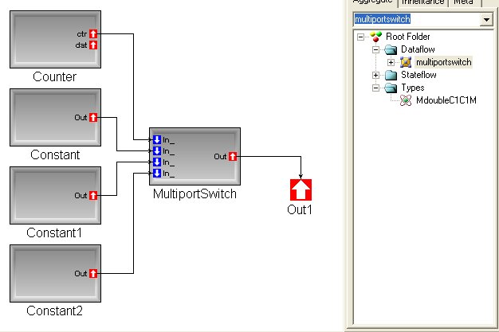
Figure 12: Result of running addTypes on ECSL_DP model of figure 10, rendered with GME.
Note that the only type in the “Types” folder is scalar double (MdoubleC1C1 – 1x1 matrix of double). Therefore, all ports in the model must carry data of this type.

Note the addition of “multiportswitch_Counter_SFC.xml”, which contains the SFC model translation of the “Stateflow” portion of the ECSL_DP model. “Counter.c” and “Counter.h” are the “C” language interpretations of this SFC model. The code for these files is shown in the appendix. “sfunc_wrapper_Counter.c” is used to run the generate stateflow “C” code from MatLab, and is not relevant to this example.

  - Executing the generated code.
To compile the generated “C” source files into an executable, an additional source file is needed that contains a “main” function. This function must contain the appropriate function calls to initialize and run the model encoded in the generated files. For this example, such a program, called “modelmain.c,” is shown below.
#include "multiportswitch_sl.h"
int main( int argc, char *argv[] )
{
multiportswitch_100000001_context context;
int i;
multiportswitch_100000001_init( &context );
i = 0;
while( i < 11 )
{
double Out1_2;
++i;
multiportswitch_100000001_main( &context, &Out1_2 );
printf( "%.4lf, ", Out1_2 );
printf( "\n" );
}

}

The names of functions to be called and special structures to be used are readily discernable from the “multiportswitch_sl.h” header file (see appendix). The “context” variable, of type “multiportswitch_100000001_context”, holds values needed for various portions of the model, e.g. the values of constants. The “multiportswitch_100000001_init” performs needed initialization of the model before it is executed, and the “multiportswitch_100000001_main” function executes the model for one time-step. Note that this latter function is called within a loop in order to execute multiple time-steps of the model.
Any ANSI “C” compiler may be used to compile the source files into an executable. For this example, the “gcc” compiler that comes with Cygwin was used:
gcc –o modelmain modelmain.c multiportswitch_sl.c Counter.c

In running the resulting “modelmain” executable, the following output is produced:
./modelmain
10.0000,
-2.0000,
5.0000,
10.0000,
-2.0000,
5.0000,
10.0000,
-2.0000,
5.0000,
10.0000,
-2.0000,

Note that the output of the program for this example is that same that for the SL/SF model from which it was produced, as described at the beginning of this section.

Appendix

A.1 Program code for “multiportswitch_sl.h”

#ifndef _multiportswitch_sl_H_

#define _multiportswitch_sl_H_

#include <math.h>

#define min(x,y) (x>y ? y : x)

#include "Counter.h"

typedef struct {

double Value27;

double Value31;

double Value35;

Counter_context Counter_class_member3;

} multiportswitch_100000001_context;

void multiportswitch_100000001_main( multiportswitch_100000001_context *context, double *Out1_2 );

void multiportswitch_100000001_init( multiportswitch_100000001_context *context );

#endif

A.2 Program code for “multiportswitch_sl.c”
#include "multiportswitch_sl.h"

void multiportswitch_100000001_main( multiportswitch_100000001_context *context, double *Out1_2 )
{
double sig_0;
double sig_1;
double sig_2;
double sig_3;
double sig_4;

Counter_main( &( *context ).Counter_class_member3, &sig_3, &sig_4 );
sig_2 = ( *context ).Value27;
sig_1 = ( *context ).Value31;
sig_0 = ( *context ).Value35;
if ( sig_3 == 1 )
{
*Out1_2 = sig_0;
}
else if ( sig_3 == 2 )
{
*Out1_2 = sig_1;
}
else if ( sig_3 == 3 )
{
*Out1_2 = sig_2;
}

}

void multiportswitch_100000001_init( multiportswitch_100000001_context *context )
{
( *context ).Value35 = 10;
( *context ).Value31 = -2;
( *context ).Value27 = 5;
Counter_init( &( *context ).Counter_class_member3 );
}

A.3 Program code for “Counter.h”
#ifndef _Counter_H_
#define _Counter_H_

#include <math.h>

#define min(x,y) (x>y ? y : x)

typedef struct {
int activeSubStates[ 1 ];
double TopLevel_Counter_ctr;
double TopLevel_Counter_data;
int _execute_at_initialization_58;
} Counter_context;

typedef struct {
Counter_context *context;
} Counter_thread_context;

void Counter_100000031_exit( Counter_thread_context *thread_context );
void Counter_main( Counter_context *context, double *ctr_, double *data_ );
void Counter_init( Counter_context *context );

A.4 Program code for “Counter.c”
#include "Counter.h"

void Counter_100000031_enter( Counter_thread_context *thread_context, int entryMode, int tpp );
void Counter_100000031_exec( Counter_thread_context *thread_context );
void s1_100000032_enter( Counter_thread_context *thread_context, int entryMode, int tpp );
void s1_100000032_exec( Counter_thread_context *thread_context );
void s1_100000032_exit( Counter_thread_context *thread_context );

const int COUNTER0 = 0x0;
const int S11 = 0x1;

void Counter_100000031_enter( Counter_thread_context *thread_context, int entryMode, int tpp )
{
if ( entryMode > -2 && entryMode <= 0 )
{
if ( 1 )
{
s1_100000032_enter( thread_context, 0, COUNTER0 );
}
}
}

void Counter_100000031_exec( Counter_thread_context *thread_context )
{
if ( thread_context->context->activeSubStates[ COUNTER0 & 0xFFFF ] == S11 )
{
s1_100000032_exec( thread_context );
}
}

void Counter_100000031_exit( Counter_thread_context *thread_context )
{
if ( thread_context->context->activeSubStates[ COUNTER0 & 0xFFFF ] == S11 )
{
s1_100000032_exit( thread_context );
}
}

void s1_100000032_enter( Counter_thread_context *thread_context, int entryMode, int tpp )
{
if ( entryMode <= 0 )
{
thread_context->context->activeSubStates[ COUNTER0 & 0xFFFF ] = S11;
}
}

void s1_100000032_exec( Counter_thread_context *thread_context )
{
if ( thread_context->context->TopLevel_Counter_ctr < 3 )
{
s1_100000032_exit( thread_context );
thread_context->context->TopLevel_Counter_ctr = thread_context->context->TopLevel_Counter_ctr + 1;
s1_100000032_enter( thread_context, 0, S11 );
}
else if ( thread_context->context->TopLevel_Counter_ctr >= 3 )
{
s1_100000032_exit( thread_context );
thread_context->context->TopLevel_Counter_ctr = 1;
s1_100000032_enter( thread_context, 0, S11 );
}
}

void s1_100000032_exit( Counter_thread_context *thread_context )
{
thread_context->context->activeSubStates[ COUNTER0 & 0xFFFF ] = -S11;
}

void Counter_main( Counter_context *context, double *ctr_, double *data_ )
{
Counter_thread_context thread_context_base;
Counter_thread_context *thread_context = &thread_context_base;
thread_context->context = context;

if ( thread_context->context->_execute_at_initialization_58 == 1 )
{
Counter_100000031_exec( thread_context );
}

thread_context->context->_execute_at_initialization_58 = 1;
*ctr_ = thread_context->context->TopLevel_Counter_ctr;
*data_ = thread_context->context->TopLevel_Counter_data;
}

void Counter_init( Counter_context *context )
{
int i;

Counter_thread_context thread_context_base;
Counter_thread_context *thread_context = &thread_context_base;
thread_context->context = context;

i = 0;
while( i < 1 )
{
thread_context->context->activeSubStates[ (int)( i ) ] = 0;
++i;
}

thread_context->context->TopLevel_Counter_ctr = 1;
thread_context->context->TopLevel_Counter_data = -1;
thread_context->context->_execute_at_initialization_58 = 0;
Counter_100000031_enter( thread_context, -1, 0 );
}

References

- Sztipanovits, J.; Karsai, G., "Model-integrated computing," Computer , vol.30, no.4, pp.110-111, Apr 1997
- Simulink/Stateflow are products of the Mathworks, Inc. www.mathworks.com
- Karsai, G.; Ledeczi, A.; Neema, S.; Sztipanovits, J., "The Model-Integrated Computing Toolsuite: Metaprogrammable Tools for Embedded Control System Design," Computer-Aided Control Systems Design, 2006 IEEE International Symposium on , vol., no., pp.50-55, 4-6 Oct. 2006

