High Confidence Embedded Software Design:
A Quadrotor Helicopter Case Study

Abstract
Traditional design methodology hardly efficiently and effectively yields the implementations of more and more complex control systems.
1. Introduction

An embedded system contains two parts: hardware and software. However, the boundary between these two parts becomes obscurer and obscurer. One function implemented in hardware today may be replaced by using software in the future. Due to this interchangeability and the flexibility and efficiency of software design and implementation, nowadays, embedded software development becomes the center of embedded system development. [7] says that more than 80% of embedded system development is occupied by embedded software development in recent market analysis.

1. What problem(s) are we trying to solve?
2. What did we contribute towards solving those problems?
3. Give a short summary of other research work that we used in our work (like ESMoL, synchronous data flow, etc...).
4. Give the details of our solution (cover the Hummingbird and our model-based design flow)
5. Describe our status and results so far.
6. Give a brief description of other related projects.

However, embedded software is not just software on small computers. Embedded software’s principal role is to interact with the physical world [3]. Physical world’s complex dynamics and timing requirements make the traditional software design method not suitable for embedded software design. Furthermore, the tight coupling to the underlying hardware makes embedded software full of hardware details. In addition, traditional manual embedded software development is tedious and error prone [1]. Thus, the development of software for embedded systems is difficult and demands a new design method.

Model-based embedded software design and automatic code generation is proposed to increase productivity and to meet the demands [1][4]. Regarding the model-based embedded software design, several approaches are proposed, among which we think Transaction-Level Model (TLM)-centric method [1][5] is more systematic and more appealing to us.

In our embedded software design approach, we start with modeling the specification model (SM) of the control system using Simulink. After validation of this SM by simulation, we import the model into an embedded software development environment consisting of a suite of tools. The tools use a suite of domain-specific modeling languages (DSMLs) called Embedded System Modeling Language (ESMoL). In the ESMoL environment, we establish a TLM based on the imported SM. The TLM captures the hardware platform of the system, the mapping of tasks to the processors and messages to the communication ports, and the scheduling information of the tasks. Based on this TLM, we do the embedded software synthesis which consists of code generation and binary generation. The generated target binary is downloaded onto the platform to evaluate if this embedded software’s functionality and performance meet the requirements.

In this case study, we use the above approach to design and implement the embedded software for a Quadrotor helicopter. Quadrotor helicopters are agile aircraft which are lifted and propelled by four rotors. Because they do not have attitude control systems, it is difficult if not impossible for a human to successfully fly and maneuver such vehicles [6]. Thus, these aircraft need an advanced high confidence embedded control system to help them fly. However, controller, software and hardware design domains are highly specialized and often conceptually incompatible [2]. This makes effectively and efficiently implementing such a high confidence embedded control system significantly difficult. Our embedded software design approach gives a state-of-the-art solution to this.

The rest of this paper is organized as follows: Section 2 presents the related work; Section 3 states what the problem is; Section 4 introduces our design methodology; Section 5 gives the modeling of the Quadrotor’s control system; Section 6 focuses on code generation in our method; Section 7 evaluates this design and finally Section 8 gives the conclusion.
2. Related Work
[9] presents a platform-based design methodology for embedded controller design via a challenging example of automatic control: a helicopter-based UAV.

Component technology, in which a design consists of pieces of components exposing interfaces to interconnect to these components, is proven suitable for the embedded software design [3], so [3] proposes an “Actor-oriented Design” approach, where the actors are the computational components. Ports and parameters define the interface of an actor. An actor has state, which carries from one reaction to another. The state is internal, so it can not be directly accessible by anything outside the actor. An actor may be directly associated with a thread of control, in which case the actor is a process.
[3] also outlines several models of computation for embedded software, according to which actors interact with each other.

[7] and [8] depict the platform-based design for embedded systems. They give the definition of the “platform”. A platform can be defined as an abstraction layer that hides the details of several possible low-level refinements [7][8]. A platform instance can be derived from the platform by choosing architecture components from the library.

[1] gives an embedded software synthesis approach which can generate C code from system models described in a System-Level Design Language (SLDL). The system TLM is the base of the approach of [1]. The TLM contains a representation of application, consisting of a module hierarchy and a set of channels. Code generation produces flat C code out of the TLM captured in SLDL. [5] summarizes different TLMs and gives the design flow and major design tasks for generation of each model. According to [5], there are four kinds of TLMs, which are component-assembly model, bus-arbitration model, bus-functional model and cycle-accurate computation model, respectively.

3. Problem Statement
This case study aims to generate the high confidence embedded software for the Quadrotor. The generated software should ensure stability and desirable behavior of the Quadrotor. There are some assumptions needed to fulfill this task: 1) The Simulink model is given and it works. 2) The hardware platform is known. 3) ESMoL is used as the System-Level Design Language to model the whole system.
4. Design Methodology

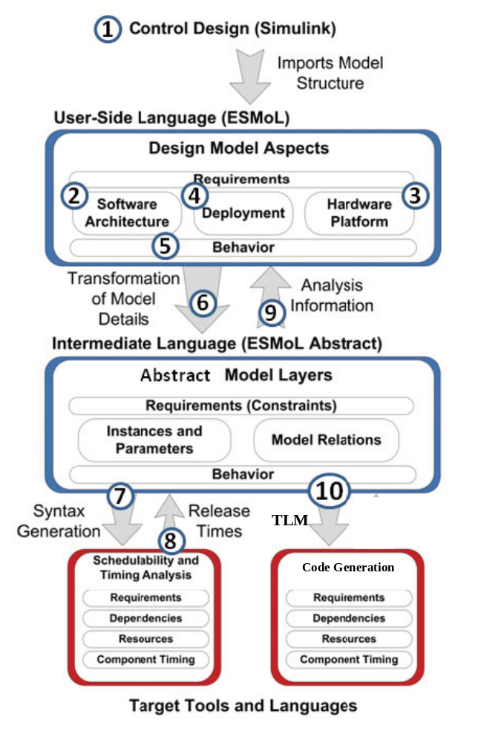
Figure 1: Design Flow

5. Modeling
5.1 Simulink model of the Quadrotor’s control system
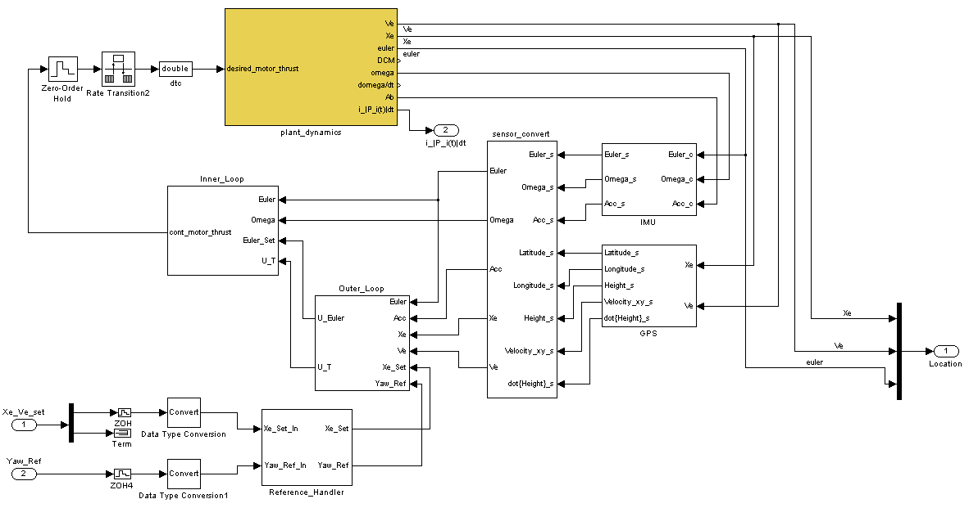
Figure 2: Simulink model

5.2 ESMoL logical software architecture of the control system
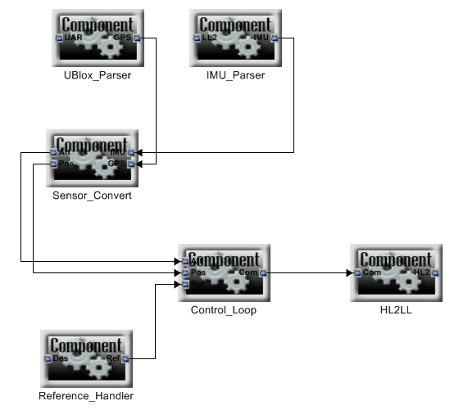
Figure 3: The logical software architecture

5.3 Hardware platform model
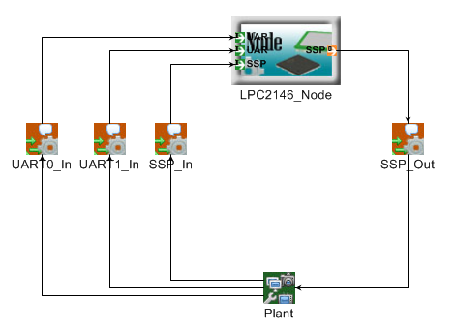
Figure 4: The hardware platform model

5.4 Deployment model
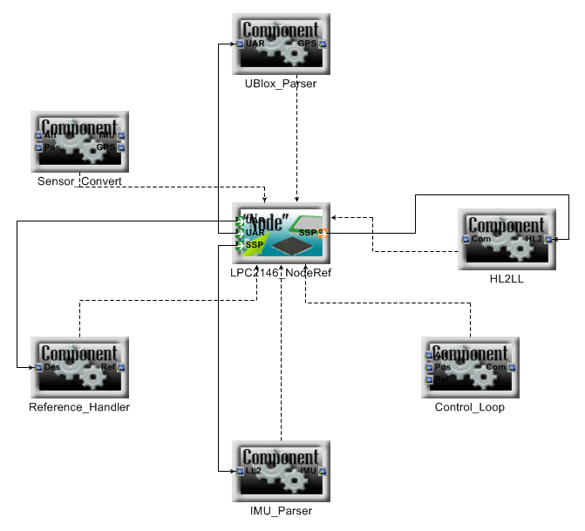
Figure 5: The deployment model

5.5 Timing model
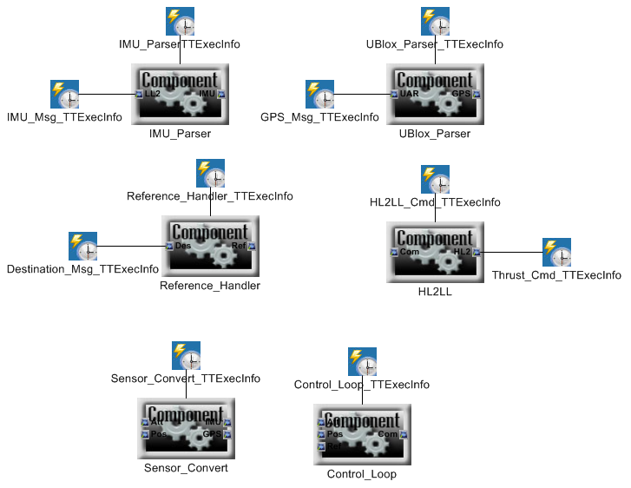
Figure 6: The timing model

6. Code Generation

7. Evaluation

8. Conclusion
In this paper, we show a model-based high confidence embedded software design approach which belongs to meet-in-the-middle methodology. The approach mainly uses Simulink, ESMoL and its tools, and combines with the TLM concepts to generate the C code automatically. Using this approach, we mainly concentrate on how to produce the high confidence embedded software for the Quadrotor helicopter. The experimental results …

Our future work includes: multi-Quadrotor control algorithm design and corresponding embedded software desgin and fixed-point function generation.
Reference
[1] D. Gajski, S. Abdi, A. Gertslauer and G. Schirner, “Embedded System Design: Modeling, Synthesis and Verification,” Springer, 2009.
[2] J. Porter, G. Hemingway, H. Nine, C. vanBuskirk, N. Kottenstette, G. Karsai, and J. Sztipanovits, “The ESMoL Language and Tools for High-Confidence Distributed Control Systems Design. Part 1: Language, Framework, and Analysis,” Nashville, TN, Vanderbilt University, 09/2010.
[3] E.A. Lee, “Embedded Software,” Advances in Computers (E. Zelkowitz, ed.), vol. 56, 2002.
[4] G. Karsai, J. Sztipanovits, A. Ledeczi, T. Bapty, “Model-integrated development of embedded software,” Proceedings of the IEEE, 91 (1) 145–164, 2003.
[5] L. Cai and D. Gajski, “Transaction Level Modeling: An Overview,” in Proc. of the Int. Conference on HW/SW Codesign and System Synthesis (CODES-ISSS), Oct. 2003, pp. 19–24.
[6] N. Kottenstette and J. Porter, “Digital passive attitude and altitude control schemes for quadrotor aircraft,” Technical Report, ISIS-08-911, Institute For Software Integrated Systems Vanderbilt University, 2008.
[7] A. Sangiovanni-Vincentelli and G. Martin, “Platform-based design and software design methodology for embedded systems,” IEEE Design and Test of Computers, vol. 18, no. 6, pp. 23–33, 2001.
[8] L. P. Carloni, F. D. Bernardinis, C. Pinello, A. L. Sangiovanni-Vincentelli, and M. Sgroi, “Platform-Based Design for Embedded Systems,” in The Embedded Systems Handbook, (R. Zurawski, ed.) CRC Press, 2005.
[9] B. Horowitz, J. Liebman, C. Ma, T. J. Koo, A. Sangiovanni-Vincentelli, and S. Sastry. "Platform-based embedded software design and system integration for autonomous vehicles,” Proceedings of the IEEE 91, 1 (Jan.), 2003.
[10]
[11] AscTec Hummingbird with AutoPilot User’s Manual

