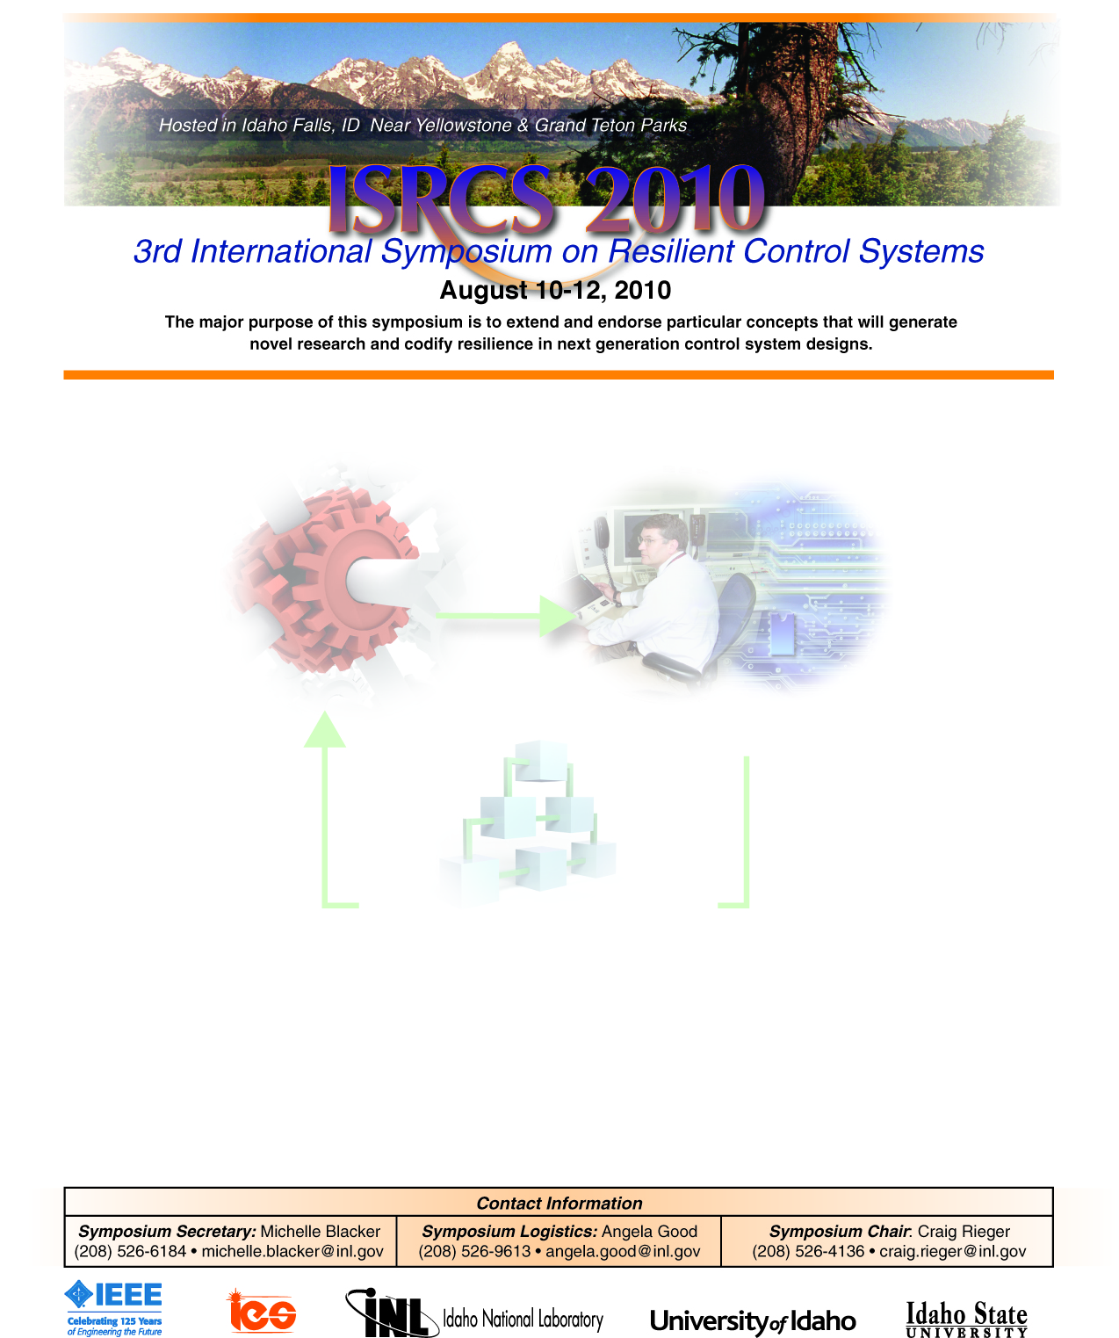
Special/Invited Session Announcement & Call for Papers
Session S/I-XX: Resilient (Vehicle) Coordination Over Sensing & Communication Networks.
Session Abstract: Numerous examples studying (vehicle) coordination problems such as those which address effective (vehicle) deployment and rendezvous problems abound in the literature. Typically, these problems either: i) assume communication of individual sensor information (such as position and/or velocity) over networks in order to maintain coordination (spacing) amongst subsystems (neighbors) or ii) assume that each subsystem (vehicle) can sense relative (position and/or velocity) measurements amongst their immediate neighbors. Papers which rely on communication networks can typically achieve faster convergence rates than those which rely on only local sensing information. However the decentralized approaches which rely on local sensing information are not prone to networked attacks. Attacks on communication networks can include: i) standard denial of service (DOS) attacks which introduce time delay and data loss; or ii) more sophisticated man in the middle (MITM) attacks; for example. MITM attacks are considerably worrisome because they can negate sensor information and potentially destabilize the entire system. Resilient (vehicle) coordination is concerned with: i) specifically identifying types of attacks which can adversely affect given group coordination control problems (DOS, MITM) ii) clearly identifying how performance will degrade (system becomes unstable, collisions occur, etc.) iii) identifying potential countermeasures and control structures (combine networked control solutions with decentralized control approaches) which can better withstand a given attack/ system fault iv) developing improved network attack/ fault detection algorithms.
Topics: Resilient (vehicle) deployment, resilient (vehicle) rendezvous and other related coordination problems are of interest. General problems concerned with resilient networked coordination such as (but not limited to) telemanipulation, synchronization and (decentralized) process control are also of interest.
Chairs:
- Nicholas Kottenstette (ISIS, Vanderbilt University) nkottens@isis.vanderbilt.edu
Authors’ Schedule:
- Paper submission deadline: April 5, 2010
- Notification of acceptance: June 7, 2010

Chairs:
- Nicholas Kottenstette (ISIS, Vanderbilt University) nkottens@isis.vanderbilt.edu
Authors’ Schedule:
- Paper submission deadline: April 5, 2010
- Notification of acceptance: June 7, 2010
- Final Paper Submission: July 12, 2010

Submission of Papers:
Papers must be submitted electronically through the electronic submission system. For further details please consult the conference web pages for the paper template.

