**The Generic Adapter Component**

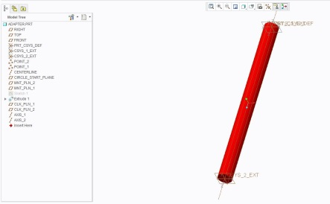

The Adapter Component is a surrogate component that assists in defining conceptual designs. The Adapter component is designed to physically support an AVM component from a connector on another component. The Adapter itself is a cylindrical extrusion of fixed diameter steel between two coordinate systems. The positioning of one coordinate system, referred to as the “variable mount”, is parametrically positioned in relation to the reference coordinate system. The Adapter component contains a series of connectors that are able to connect to any connector interface with the same datum definition. See below:

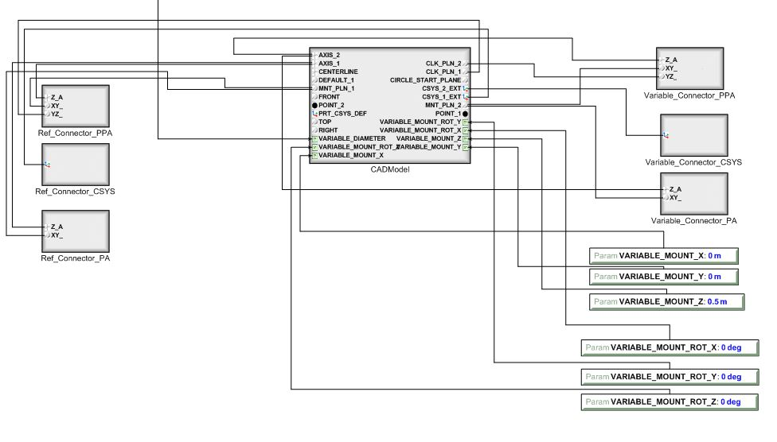

To use an Adapter:

1. First choose a reference component with a defined CyPhy connector. Attach the appropriate reference connector of the adapter to the desired connector on the reference component. The definition of these two connectors must be compatible, meaning they must contain the same number of datum with matching types and names. The second component should be connected in the same manner to the appropriate “variable connector” of the Adapter.

In the example below the connector of the stainless steel panel is connected to the Adapter’s reference CSYS connector and oil can is connected to the Adapter’s variable PPA connector. 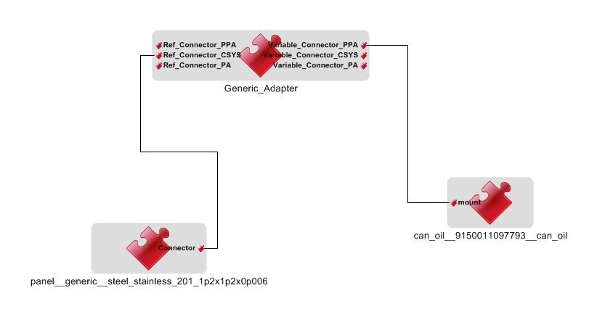

1. Next create design parameters in order to modify the adapter’s default parameter settings. These design (component assembly) parameters can be named anything that makes sense within the context of the design. However they must be typed appropriately with units.

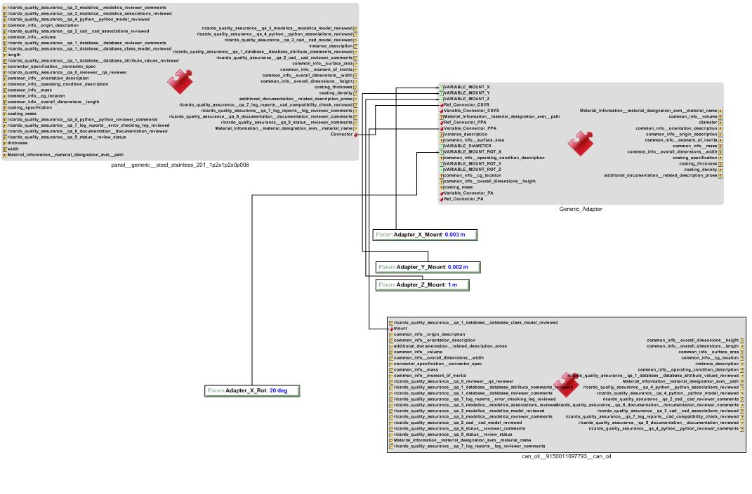

1. By modifying the parameters being fed to the adapter, one can effectively position a component by its connector with respect to another component’s connector. This can be done using the Meta-Link functionality of the tools or by running CyPhy2CAD test benches. Note the example assembly below.

