**Evaluation**

A screenshot of the confusion matrix can be seen below:

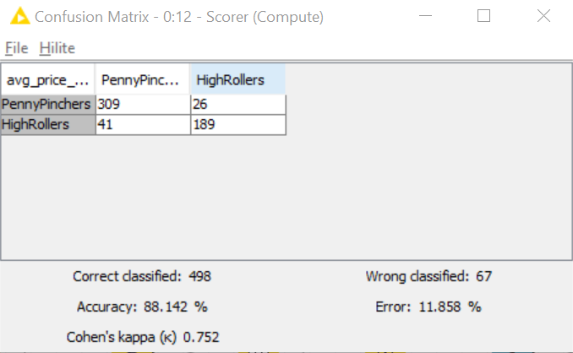

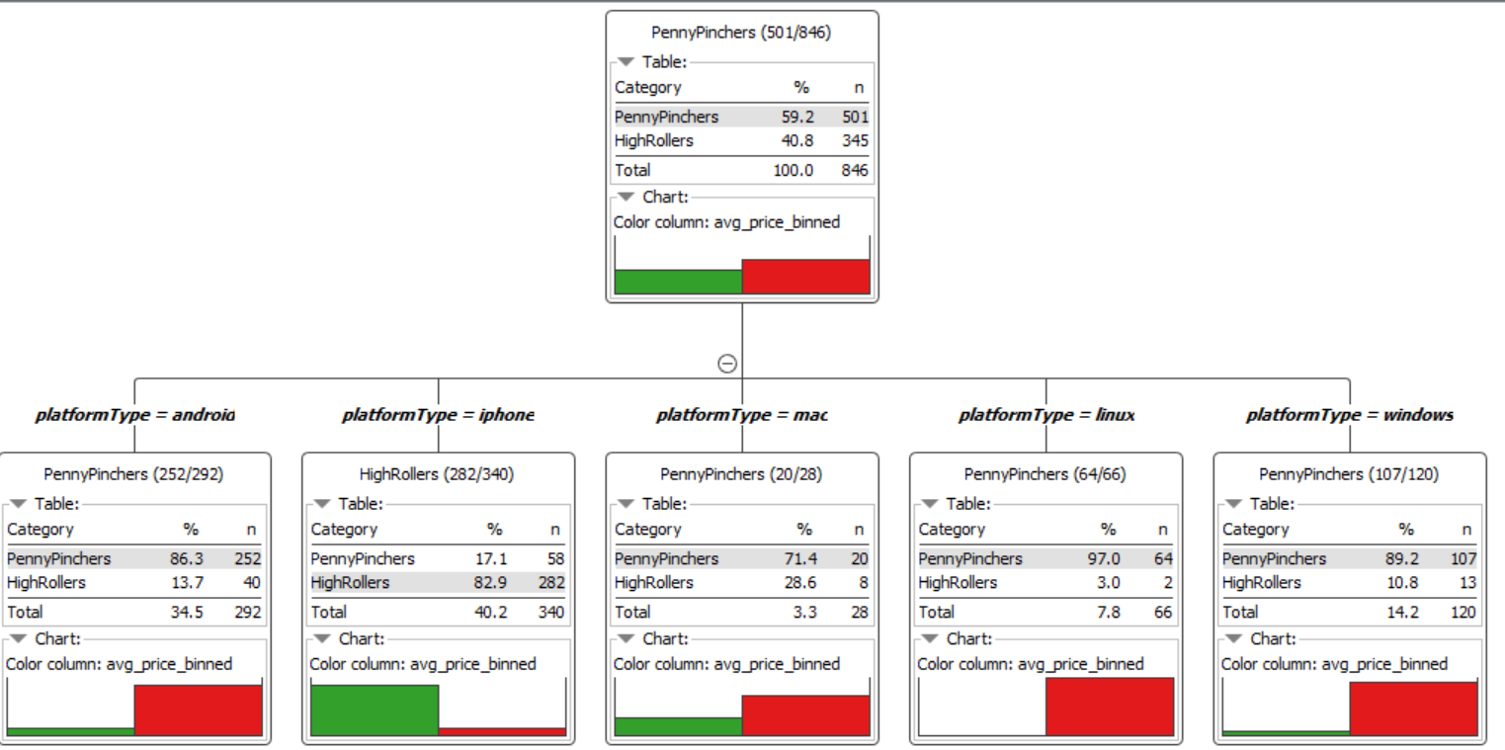

As seen in the screenshot above, the overall accuracy of the model is **88.142%**

<Fill In: Write one sentence for each of the values of the confusion matrix indicating what has been correctly or incorrectly predicted.>

**309 PennyPinchers were correctly classified, and 26 were wrongly classified.**

**189 HigRollers were correctly classified, and 41 were wrongly classified.**