**Analysis Conclusions**

The final KNIME workflow is shown below:

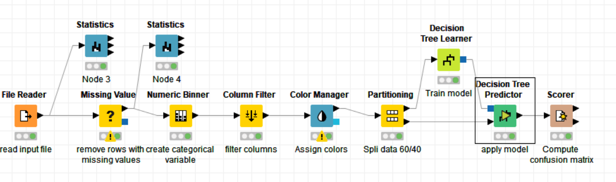

What makes a HighRoller vs. a PennyPincher?

<Fill In 2-3 sentences answering this question based on insights from your analysis.>

**We notice players on iphone are high HighRollers. Other platforms players are PennyPichers.**

**User on Linux are high PennyPinchers.**

|  |
| --- |
| **Specific Recommendations to Increase Revenue** |
| 1. <Fill In 1-2 sentences describing 1 recommended action>   **Show more advert to iphone users**. |
| 1. <Fill In 1-2 sentences describing a 2nd recommended action>   **Increase advert price for iphone platform.** |