|  |  |  |  |  |
| --- | --- | --- | --- | --- |
| Fond-Rec_e | | **International Telecommunication Union** | | |
|  | |  | | |
| **ITU-T** | **E.119** | |
| TELECOMMUNICATION STANDARDIZATION SECTOR OF ITU | | (04/2017) |
|  | SERIES E: OVERALL NETWORK OPERATION, TELEPHONE SERVICE, SERVICE OPERATION AND HUMAN FACTORS  International operation – General provisions concerning Administrations | | | |
|  | **Requirements for safety confirmation and broadcast message service for disaster relief** | | | |
|  | Recommendation ITU‑T E.119 | | | |



ITU-T E-SERIES RECOMMENDATIONS

**OVERALL NETWORK OPERATION, TELEPHONE SERVICE, SERVICE OPERATION AND HUMAN FACTORS**

|  |  |
| --- | --- |
|  |  |
| INTERNATIONAL OPERATION |  |
| Definitions | E.100–E.103 |
| **General provisions concerning Administrations** | **E.104–E.119** |
| General provisions concerning users | E.120–E.139 |
| Operation of international telephone services | E.140–E.159 |
| Numbering plan of the international telephone service | E.160–E.169 |
| International routing plan | E.170–E.179 |
| Tones in national signalling systems | E.180–E.189 |
| Numbering plan of the international telephone service | E.190–E.199 |
| Maritime mobile service and public land mobile service | E.200–E.229 |
| OPERATIONAL PROVISIONS RELATING TO CHARGING AND ACCOUNTING IN THE INTERNATIONAL TELEPHONE SERVICE |  |
| Charging in the international telephone service | E.230–E.249 |
| Measuring and recording call durations for accounting purposes | E.260–E.269 |
| UTILIZATION OF THE INTERNATIONAL TELEPHONE NETWORK FOR NON-TELEPHONY APPLICATIONS |  |
| General | E.300–E.319 |
| Phototelegraphy | E.320–E.329 |
| ISDN PROVISIONS CONCERNING USERS | E.330–E.349 |
| INTERNATIONAL ROUTING PLAN | E.350–E.399 |
| NETWORK MANAGEMENT |  |
| International service statistics | E.400–E.404 |
| International network management | E.405–E.419 |
| Checking the quality of the international telephone service | E.420–E.489 |
| TRAFFIC ENGINEERING |  |
| Measurement and recording of traffic | E.490–E.505 |
| Forecasting of traffic | E.506–E.509 |
| Determination of the number of circuits in manual operation | E.510–E.519 |
| Determination of the number of circuits in automatic and semi-automatic operation | E.520–E.539 |
| Grade of service | E.540–E.599 |
| Definitions | E.600–E.649 |
| Traffic engineering for IP-networks | E.650–E.699 |
| ISDN traffic engineering | E.700–E.749 |
| Mobile network traffic engineering | E.750–E.799 |
| QUALITY OF TELECOMMUNICATION SERVICES: CONCEPTS, MODELS, OBJECTIVES AND DEPENDABILITY PLANNING |  |
| Terms and definitions related to the quality of telecommunication services | E.800–E.809 |
| Models for telecommunication services | E.810–E.844 |
| Objectives for quality of service and related concepts of telecommunication services | E.845–E.859 |
| Use of quality of service objectives for planning of telecommunication networks | E.860–E.879 |
| Field data collection and evaluation on the performance of equipment, networks and services | E.880–E.899 |
| OTHER | E.900–E.999 |
| INTERNATIONAL OPERATION |  |
| Numbering plan of the international telephone service | E.1100–E.1199 |
| NETWORK MANAGEMENT |  |
| International network management | E.4100–E.4199 |
|  |  |

*For further details, please refer to the list of ITU-T Recommendations.*

|  |
| --- |
| Recommendation ITU-T E.119  Requirements for safety confirmation and broadcast message service  for disaster relief |

|  |
| --- |
| Summary  Recommendation ITU-T E.119 describes the requirements for safety confirmation and broadcast messaging for disaster relief, which can realize public organizations' business continuity plans (BCP) and can, to the best of their ability, help protect lives and property during a disaster.  In the event of a disaster, it is very important that public organizations, such as telecommunication companies, electric power companies, hospitals, fire departments and local governments continue to operate and help save the lives of victims. Confirmation of the safety of officials or company staff is important in order to continue operating their necessary tasks. In addition, to be effective, broadcast message systems should automatically confirm the status of officials or staff. |

|  |  |  |  |  |  |  |  |  |  |  |
| --- | --- | --- | --- | --- | --- | --- | --- | --- | --- | --- |
| History   |  |  |  |  |  | | --- | --- | --- | --- | --- | | Edition | Recommendation | Approval | Study Group | Unique ID[[1]](#footnote-1)\* | | 1.0 | ITU-T E.119 | 2017-04-07 | 2 | [11.1002/1000/13074](http://handle.itu.int/11.1002/1000/13074) | |

|  |
| --- |
|  |

FOREWORD

The International Telecommunication Union (ITU) is the United Nations specialized agency in the field of tele­com­mu­ni­ca­tions, information and communication technologies (ICTs). The ITU Telecommunication Standardization Sector (ITU-T) is a permanent organ of ITU. ITU-T is responsible for studying technical, operating and tariff questions and issuing Recommendations on them with a view to standardizing telecommunications on a worldwide basis.

The World Telecommunication Standardization Assembly (WTSA), which meets every four years, establishes the topics for study by the ITU‑T study groups which, in turn, produce Recommendations on these topics.

The approval of ITU-T Recommendations is covered by the procedure laid down in WTSA Resolution 1.

In some areas of information technology which fall within ITU-T's purview, the necessary standards are prepared on a collaborative basis with ISO and IEC.

NOTE

In this Recommendation, the expression "Administration" is used for conciseness to indicate both a telecommunication administration and a recognized operating agency.

Compliance with this Recommendation is voluntary. However, the Recommendation may contain certain mandatory provisions (to ensure, e.g., interoperability or applicability) and compliance with the Recommendation is achieved when all of these mandatory provisions are met. The words "shall" or some other obligatory language such as "must" and the negative equivalents are used to express requirements. The use of such words does not suggest that compliance with the Recommendation is required of any party.

INTELLECTUAL PROPERTY RIGHTS

ITU draws attention to the possibility that the practice or implementation of this Recommendation may involve the use of a claimed Intellectual Property Right. ITU takes no position concerning the evidence, validity or applicability of claimed Intellectual Property Rights, whether asserted by ITU members or others outside of the Recommendation development process.

As of the date of approval of this Recommendation, ITU had not received notice of intellectual property, protected by patents, which may be required to implement this Recommendation. However, implementers are cautioned that this may not represent the latest information and are therefore strongly urged to consult the TSB patent database at <http://www.itu.int/ITU-T/ipr/>.

© ITU 2017

All rights reserved. No part of this publication may be reproduced, by any means whatsoever, without the prior written permission of ITU.

**Table of Contents**

**Page**

1 Scope 1

2 References 1

3 Definitions 1

3.1 Terms defined elsewhere 1

3.2 Terms defined in this recommendation 2

4 Abbreviation and acronyms 2

5 Conventions 2

6 Concept 2

7 Requirements 4

7.1 High-reliability/availability 4

7.2 Security and integrity 4

7.3 Easy operation 5

7.4 Interoperability for safety confirmation 5

7.5 Functions for safety confirmation 5

7.6 Functions for broadcast message 6

7.7 Language 6

Bibliography 7

Introduction

In the event of a disaster, it is very important that public organizations such as telecommunication companies, electric power companies, hospitals, fire departments and local governments, continue to operate and help save the lives of victims. For example, telecommunication companies should provide telecommunication services to enable safety confirmation and emergency telecommunication immediately after a disaster, and local governments should aggregate information about disaster victims and the situations in affected areas. Confirming the safety of officials or company staff is important because managers need to organize officials or staff members in order to continue operations. In addition, managers need to communicate with officials or staff to ensure the continuity of operations and to share accurate information, which is essential in emergency situations. Broadcast message systems are required to accomplish this.

Recommendation ITU-T E.119

Requirements for safety confirmation and broadcast message service   
for disaster relief

# 1 Scope

This Recommendation describes the requirements for safety confirmation and broadcast messaging services for disaster relief.

During and after a disaster, public organizations such as hospitals, local governments and telecommunication service providers need to continue their business as best as possible, in order to help save the lives of victims. Most public organizations have put in place business continuity plans (BCP) for use during a disaster, and it is important to implement the BCP in order to provide as many public services as possible. In the event of a disaster, the safety confirmation system is used to confirm staff status, such as their availability, and the broadcast message system communicates directives to available staff in order to enable them to continue functioning effectively. Public organizations can implement their BCP by using the safety confirmation and broadcast message system, and can protect the lives and property of victims to the best of their ability.

NOTE – The word ''victim'' in this Recommendation is used to denote a person affected by a disaster.

# 2 References

The following ITU-T Recommendations and other references contain provisions which, through reference in this text, constitute provisions of this Recommendation. At the time of publication, the editions indicated were valid. All Recommendations and other references are subject to revision; users of this Recommendation are therefore encouraged to investigate the possibility of applying the most recent edition of the Recommendations and other references listed below. A list of the currently valid ITU-T Recommendations is regularly published. The reference to a document within this Recommendation does not give it, as a stand-alone document, the status of a Recommendation.

[ITU-T E.108] Recommendation ITU-T E.108 (2016), *Requirements for disaster relief mobile message service*.

[ITU-T Y.2001] Recommendation ITU-T Y.2001 (2004), *General overview of NGN.*

[ITU-T Y.2205] Recommendation ITU-T Y.2205 (2011), *Next Generation Networks –Emergency telecommunications – Technical considerations.*

[ITU-T Y.4102] Recommendation ITU-T Y4102/Y.2074 (2015), *Requirements for Internet of things devices and operation of Internet of things applications during disaster.*

# 3 Definitions

## 3.1 Terms defined elsewhere

This Recommendation uses the following terms defined elsewhere:

**3.1.1 delay tolerant network (DTN)** [b-FG-NRR]: DTN technology stores the information when it is connected to the source (e.g., mobile terminal), and delivers the information to the destination when it finds the end-user.

**3.1.2 disaster** [b-UNISDR]: A serious disruption of the functioning of a community or a society involving widespread human, material, economic or environmental losses and impacts, which exceeds the ability of the affected community or society to cope using its own resources.

**3.1.3 disaster relief** [ITU-T E.108].

**3.1.4 disaster relief system** [ITU-T E.108].

**3.1.5 next generation network** (NGN) [ITU-T Y.2001].

## 3.2 Terms defined in this Recommendation

This Recommendation defines the following terms:

**3.2.1 business continuity plan (BCP)**: A plan that enables businesses to continue to operate even during a disaster. The plans are made before a disaster and are used by public organizations mainly to save the lives of victims.

**3.2.2 safety confirmation**: Information about the safety of users who might be affected by a disaster to be collected and managed at more than one site, and to be reported to specified person.

**3.2.3 victim**: A person affected by a disaster.

# 4 Abbreviations and acronyms

This Recommendation uses the following abbreviations and acronyms:

BCP Business Continuity Plan

DTN Delay Tolerant Networks

IoT Internet of Things

NGN Next Generation Network

UNISDR United Nations International Strategy for Disaster Reduction

# 5 Conventions

None.

# 6 Concept

To save the lives of victims in the event of a disaster, public organizations such as local governments, fire departments, hospitals and telecommunication companies need to be able to continue to operate as normal as possible. For such public organizations, using a cloud-based safety confirmation and broadcast message service is a suitable way to check on the status of members of these organizations to confirm their safety and dispatch available people to appropriate work sites. This service is divided into two parts. The first is safety confirmation, as shown in Figure 1, and the second is broadcast messages, as shown in Figure 2.

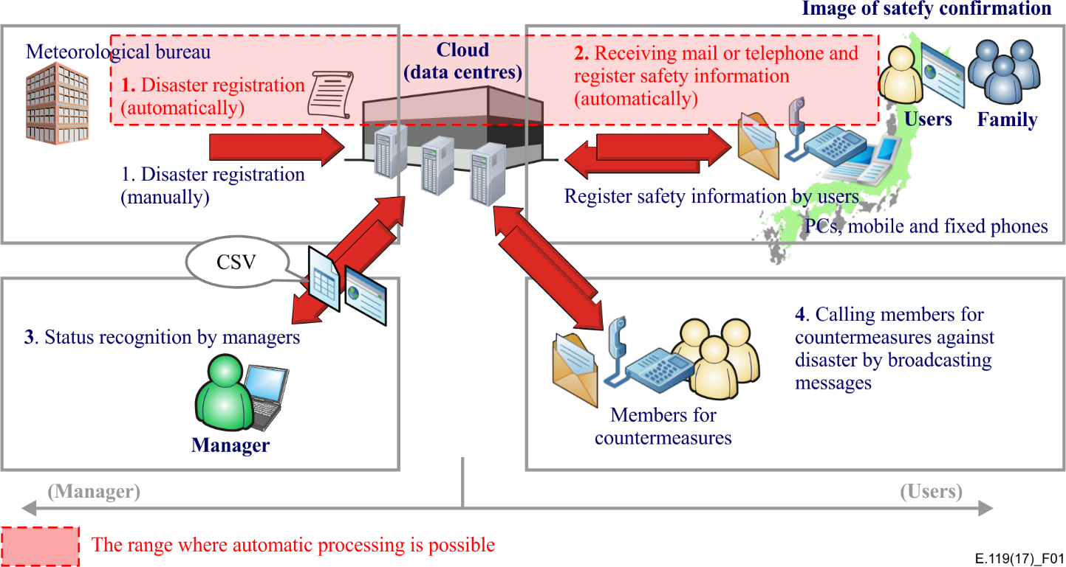

Figure 1 – Concept of safety confirmation

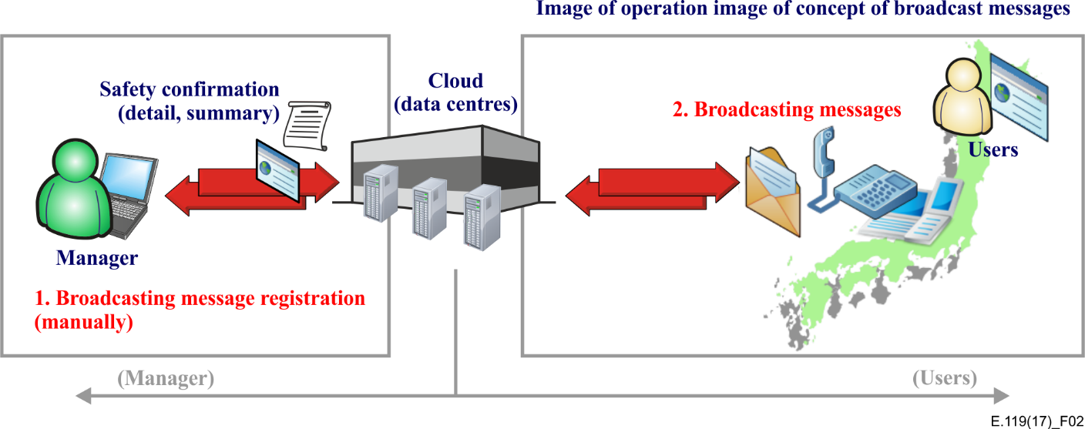

Figure 2 – Concept of broadcast message operations

In order to continue working effectively during disasters, the managers of public organizations must first confirm the safety of the people working in their organization, and then dispatch available staff to appropriate work sites to continue operations. In this sense, the flow direction of the notification is ''Public organization to staff of the organization''.

Figure 1 shows the procedure of safety confirmation. When disaster information is notified by the meteorological bureau, safety confirmation can be started even if managers cannot operate the system as registration of disaster and sending safety confirmation requests run automatically (step 1). After requesting safety confirmation requests, the staffs of the organizations send their status to the manager (step 2). The managers recognize status of staffs and their family (step 3). Then, in order to dispatch available persons to appropriate work sites in order to keep the businesses running, the managers call disaster countermeasures staff by broadcasting messages (step 4). In this case, the direction of flow of information is also ''Staff of the public organization to the organization,'' so the direction ''Public organization to the staff of the organization'' is bidirectional.

# 7 Requirements

Safety confirmation and broadcasting message service for disaster relief must provide the following functions:

## 7.1 High-reliability/availability

The system itself must be highly reliable and readily available, since the system is used during and after a disaster. The following six elements are considered for the system:

1) Data redundancy

Data synchronization and redundant server configurations are needed for storing users' contact information in the case of an emergency.

2) Geographical distribution of data centres

Several secure data centres located in geographically diverse locations are required to prevent the damage at one data centre from impacting the overall service, enabling services to continue in the case of an emergency.

3) Stable telecommunication network

It is recommended that a stable telecommunication network, including the Internet, be used for communication between end users and data centres. For next generation network (NGN) emergency telecommunications, which include the operation of Internet of things (IoT) applications, technical considerations during disasters are described in [ITU-T Y.2205] and [ITU-T Y.4102].

4) Multiple telecommunication techniques

Several telecommunication techniques, such as e-mail, fixed telephony, mobile telephony and web access, are recommended for communication use.

5) Delay tolerant network-based communication (optional for mobile terminal)

In cases where the Internet becomes unavailable, it is effective for a wider area service to utilize multi-hop Wi-Fi communication for mobile terminals (e.g., smartphones) based on delay tolerant network (DTN) considerations.

6) Web-based implementation (optional)

In cases where the system is implemented as a web-application that works only with a web browser, the service is available from other devices where a separate application is not required to be installed.

## 7.2 Security and integrity

The safety confirmation and broadcasting message service deals with data that have security requirements, such as vital data related to officials in public organizations. As such, the following four elements are considered for the system:

1) Secure telecommunication network

A secure telecommunication network is necessary to prevent malicious access. Also, the system itself must be protected against malicious access.

2) Privacy policy

Private information about individuals, such as their private contact information, must be managed securely and handled in accordance with prior permissions received from individuals. A privacy policy statement must be published before a disaster. This is important because the information stored by this cloud service is one form of personally identifiable information such as the private contact information of officials or staff. In some organizations, permissions are required to be given by individuals (e.g., officials or staff) when they sign a contract with the organization.

3) Data integrity

Data integrity is required even when data are stored at several data centres and frequently updated.

4) Identify data source

It is recommended that the sources of data be identified (e.g., who, when and why) to allow traceability and confirmation.

## 7.3 Easy operation

A safety confirmation system must be as easy as possible to operate, especially during a disaster. Regarding the terminal, a victim can select a relief location, such as an evacuation shelter or hospital, if his or her own terminal is inoperable. As such, the following four elements are considered for the system:

1) Easy registration

Ease of registration, updating and deletion of individual data and information are recommended.

2) Easy registration method

A simple registration method is recommended so that staff can store safety confirmation information even in an emergency situation.

3) Unified operation

It is recommended that the operation of registering safety information be unified for different terminal types.

4) Push service for smart phones

An application for smart phones can optionally be provided for pushing safety confirmation requests from the cloud data centre to smart phones.

## 7.4 Interoperability for safety confirmation

A safety confirmation system should perform as automatically as possible in order to shorten the operation time, because organizations have to make decisions with the aim of continuing to operate in the event of a disaster. The following two elements are considered for the system:

1) Connection with other agencies

Connection information with a metrological organization system for automatic disaster registration is required.

2) Connection within internal systems

Interoperability with a mail server is needed to send e-mail to users.

## 7.5 Functions for safety confirmation

The safety confirmation system requires the following four core functions:

1) Retry function

A safety confirmation request must be re-sent to users who have not responded to previous requests.

2) Family option

Confirmation of the safety of the user's family should optionally be able to be facilitated.

3) Search function

It is recommended that safety confirmation information be searchable by employing search terms such as area and organization.

4) Selection function

Safety confirmation information should optionally be able to be sent to selected users, for example, as categorized by organizations, regions or countries, and can be sent across countries.

## 7.6 Functions for broadcast message

The broadcast message system requires the following function:

1) Selection function

It is recommended that messages be able to be broadcasted to selected users, for example, as categorised by organizations, regions or countries, to collect additional information.

## 7.7 Language

1) Local languages (required)

2) English (recommended as a lingua franca)

3) Other languages (optional)

Bibliography

[b-FG-NRR] ITU-T Focus Group on Disaster Relief Systems, Network Resilience and Recovery, Focus Group Technical Report (2014), *Requirements for network resilience and recovery.*

[b-UNISDR] UNISDR (2009), *UNISDR Terminology on disaster risk reduction*.  
<<http://www.unisdr.org/we/inform/publications/7817>>

|  |  |
| --- | --- |
| **SERIES OF ITU-T RECOMMENDATIONS** | |
| Series A | Organization of the work of ITU-T |
| Series D | Tariff and accounting principles and international telecommunication/ICT economic and policy issues |
| **Series E** | **Overall network operation, telephone service, service operation and human factors** |
| Series F | Non-telephone telecommunication services |
| Series G | Transmission systems and media, digital systems and networks |
| Series H | Audiovisual and multimedia systems |
| Series I | Integrated services digital network |
| Series J | Cable networks and transmission of television, sound programme and other multimedia signals |
| Series K | Protection against interference |
| Series L | Environment and ICTs, climate change, e-waste, energy efficiency; construction, installation and protection of cables and other elements of outside plant |
| Series M | Telecommunication management, including TMN and network maintenance |
| Series N | Maintenance: international sound programme and television transmission circuits |
| Series O | Specifications of measuring equipment |
| Series P | Telephone transmission quality, telephone installations, local line networks |
| Series Q | Switching and signalling, and associated measurements and tests |
| Series R | Telegraph transmission |
| Series S | Telegraph services terminal equipment |
| Series T | Terminals for telematic services |
| Series U | Telegraph switching |
| Series V | Data communication over the telephone network |
| Series X | Data networks, open system communications and security |
| Series Y | Global information infrastructure, Internet protocol aspects, next-generation networks, Internet of Things and smart cities |
| Series Z | Languages and general software aspects for telecommunication systems |
|  |  |

1. \* To access the Recommendation, type the URL http://handle.itu.int/ in the address field of your web browser, followed by the Recommendation's unique ID. For example, <http://handle.itu.int/11.1002/1000/11830-en>. [↑](#footnote-ref-1)