|  |  |  |  |  |
| --- | --- | --- | --- | --- |
| Fond-Rec_e | | **International Telecommunication Union** | | |
|  | |  | | |
| **ITU-T** | **Series J** | |
| TELECOMMUNICATION STANDARDIZATION SECTOR OF ITU | | **Supplement 6**  (09/2016) |
|  | SERIES J: CABLE NETWORKS AND TRANSMISSION OF TELEVISION, SOUND PROGRAMME AND OTHER MULTIMEDIA SIGNALS | | | |
|  | **Transmission of ultra high definition television over cable with functions defined in Recommendations ITU-T J.183, ITU-T J.288 and ITU-T J.94** | | | |
|  | ITU‑T J-series Recommendations  – Supplement 6 | | | |



|  |
| --- |
| Supplement 6 to ITU-T J-series Recommendations  Transmission of ultra high definition television over cable with functions defined in Recommendations ITU-T J.183, ITU-T J.288 and ITU-T J.94 |

|  |
| --- |
| Summary  Supplement 6 to ITU-T J-series Recommendations describes a combination example of functions defined in Recommendations ITU‑T J.183, ITU-T J.288 and ITU-T J.94 in order to achieve high speed transmission by channel bonding technology for 4K/8K ultra high definition television (UHDTV) distribution over an existing transmission system compliant with Annex C to Recommendation ITU‑T J.83. |

|  |  |  |  |  |  |  |  |  |  |  |
| --- | --- | --- | --- | --- | --- | --- | --- | --- | --- | --- |
| History   |  |  |  |  |  | | --- | --- | --- | --- | --- | | Edition | Recommendation | Approval | Study Group | Unique ID[[1]](#footnote-1)\* | | 1.0 | ITU-T J Suppl. 6 | 2016-09-02 | 9 | [11.1002/1000/13241](http://handle.itu.int/11.1002/1000/13241) | |

|  |
| --- |
| Keywords  Cable TV, channel bonding technology, ultra high definition television (UHDTV). |

FOREWORD

The International Telecommunication Union (ITU) is the United Nations specialized agency in the field of tele­com­mu­ni­ca­tions, information and communication technologies (ICTs). The ITU Telecommunication Standardization Sector (ITU-T) is a permanent organ of ITU. ITU-T is responsible for studying technical, operating and tariff questions and issuing Recommendations on them with a view to standardizing telecommunications on a worldwide basis.

The World Telecommunication Standardization Assembly (WTSA), which meets every four years, establishes the topics for study by the ITU‑T study groups which, in turn, produce Recommendations on these topics.

The approval of ITU-T Recommendations is covered by the procedure laid down in WTSA Resolution 1.

In some areas of information technology which fall within ITU-T's purview, the necessary standards are prepared on a collaborative basis with ISO and IEC.

NOTE

In this publication, the expression "Administration" is used for conciseness to indicate both a telecommunication administration and a recognized operating agency.

Compliance with this publication is voluntary. However, the publication may contain certain mandatory provisions (to ensure, e.g., interoperability or applicability) and compliance with the publication is achieved when all of these mandatory provisions are met. The words "shall" or some other obligatory language such as "must" and the negative equivalents are used to express requirements. The use of such words does not suggest that compliance with the publication is required of any party.

INTELLECTUAL PROPERTY RIGHTS

ITU draws attention to the possibility that the practice or implementation of this publication may involve the use of a claimed Intellectual Property Right. ITU takes no position concerning the evidence, validity or applicability of claimed Intellectual Property Rights, whether asserted by ITU members or others outside of the publication development process.

As of the date of approval of this publication, ITU had not received notice of intellectual property, protected by patents, which may be required to implement this publication. However, implementers are cautioned that this may not represent the latest information and are therefore strongly urged to consult the TSB patent database at <http://www.itu.int/ITU-T/ipr/>.

© ITU 2017

All rights reserved. No part of this publication may be reproduced, by any means whatsoever, without the prior written permission of ITU.

**Table of Contents**

Page

1 Scope 1

2 References 1

3 Definitions 1

3.1 Terms defined elsewhere 1

3.2 Terms defined in this Supplement 1

4 Abbreviations and acronyms 1

5 Conventions 1

6 System concept 2

7 Trial for 8K UHDTV cable TV distribution 2

Bibliography 6

Supplement 6 to ITU-T J-series Recommendations

Transmission of ultra high definition television over cable with functions defined in Recommendations ITU-T J.183, ITU-T J.288 and ITU-T J.94

# 1 Scope

This supplement provides UHDTV cable transmission with functions defined in [ITU-T J.183], [ITU‑T J.288] and [ITU-T J.94].

# 2 References

[ITU-T J.94] Recommendation ITU-T J.94 (2016), *Service information for digital broadcasting in cable television systems.*

[ITU-T J.183] Recommendation ITU-T J.183 (2016), *Time-division multiplexing of multiple MPEG-2 transport streams and generic formats of transport streams over cable television systems.*

[ITU-T J.288] Recommendation ITU-T J.288 (2016), *Encapsulation of type length value (TLV) packet for cable transmission systems.*

# 3 Definitions

None.

## 3.1 Terms defined elsewhere

None.

## 3.2 Terms defined in this Supplement

None.

# 4 Abbreviations and acronyms

This Supplement uses the following abbreviations and acronyms:

CNR Carrier-to-Noise Ratio

HFC Hybrid Fibre and Coaxial

NIT Network Information Table

QAM Quadrature Amplitude Modulation

TLV Type-Length-Value

TS Transport Stream

TSMF Transport Streams Multiplexing Frame

UHDTV Ultra High Definition Television

# 5 Conventions

None.

# 6 System concept

The system concept of UHDTV transmission with functions defined in [ITU-T J.183], [ITU-T J.288] and [ITU-T J.94] is shown in Figure 1.

At the cable TV headend, an MPEG-2 transport stream (TS) and/or type-length-value (TLV) is input into a transmitter. The network information table (NIT) specified in [ITU‑T J.94] is inserted into the input MPEG-2 TS while the TLV-NIT specified in [ITU‑T J.94] is inserted into the input TLV stream. After that, TLV packets are fragmented and encapsulated into a fixed-length packet called a fragmented TLV packet, in accordance with [ITU-T J.288]. The fragmented TLV packets and/or MPEG-2 TS are multiplexed into the transport streams multiplexing frame (TSMF) specified in [ITU‑T J.183]. Multiple QAM carriers transmission system, based on Annex C of [b-ITU-T J.83], are used for transmitting them.

At the home receiver, each carrier is demodulated. After that, the fragmented TLV packets and/or MPEG-2 TS are de-multiplexed from TSMF. Then, the fragmented TLV packets are restored to the original TLV packets in accordance with [ITU-T J.288].

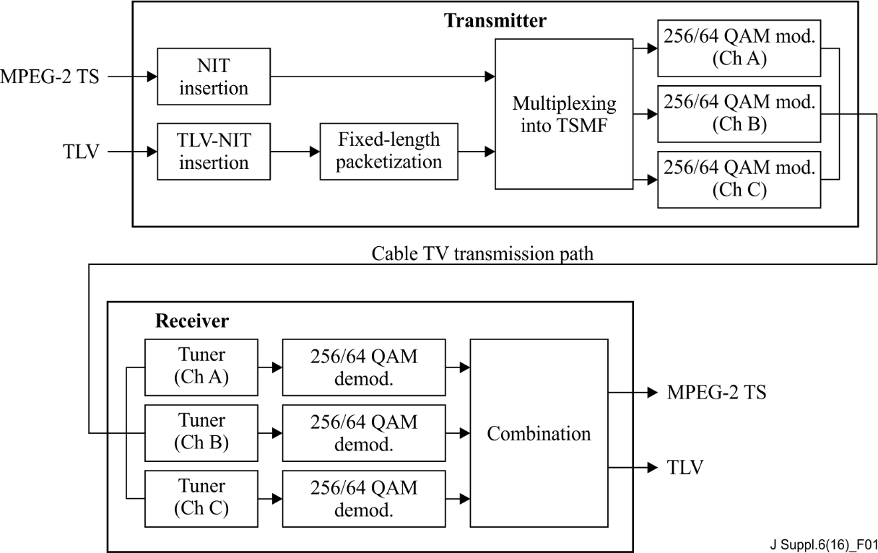

Figure 1 – System concept

# 7 Trial for 8K UHDTV cable TV distribution

8K UHDTV cable TV distribution was demonstrated and stably played on an 85-inch 8K LCD display through a commercial large-scale cable network in Tokyo in May 2016.

The trial was conducted in the hybrid fibre and coaxial (HFC) network shown in Figure 2. Table 1 lists the parameters applied to the transmitted signal of 8K UHDTV. In total, 95 channels, including three channels carrying the 8K UHDTV signal, were frequency division multiplexed and transmitted from the headend.

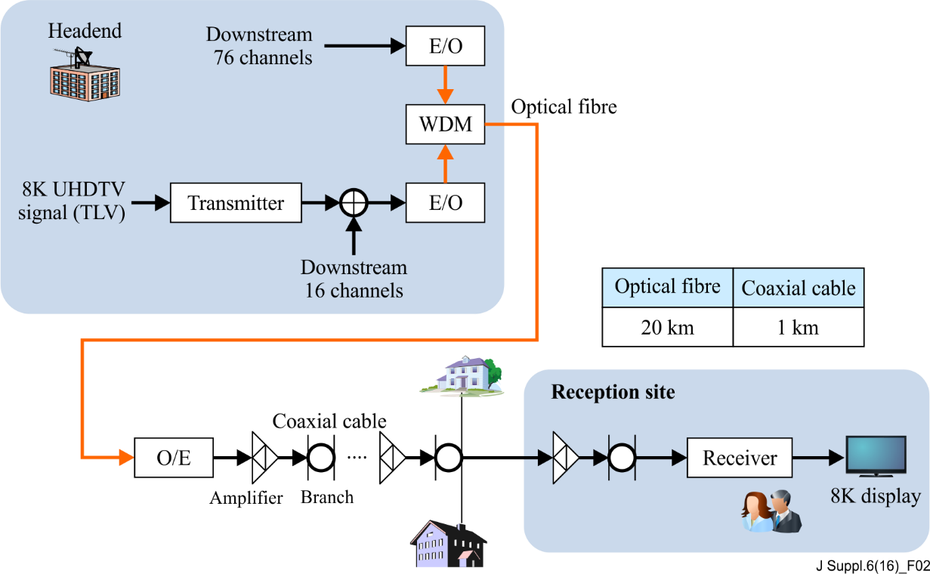

Figure 2 – Experimental set-up

Table 1 – Parameters for transmitted signal

|  |  |
| --- | --- |
| TLV stream rate | 100 Mbit/s |
| Video coding | HEVC / H.265 |
| Audio coding | MPEG-4 AAC |
| Bandwidth per channel | 6 MHz |
| Symbol rate | 5.274 Mbaud |
| Bit rate per channel  w/o parity bits for FEC | 256 QAM: 38.88 Mbps  64 QAM: 29.16 Mbps |
| No. of channels | Two channels with 256 QAM and one channel with 64 QAM |
| Freq. of multiple QAM channels  (Centre frequency (MHz)) | 256 QAM: 273 MHz, 447 MHz  64 QAM: 635 MHz |

Figure 3 shows the spectrum of FDM signals measured at the reception site. Figure 4 shows a transmitter based on [ITU-T J.183], [ITU-T J.288] and [ITU-T J.94]. Table 2 lists the carrier-to-noise ratio (CNR) of three signals carrying 8K UHDTV in this trial. The required CNR is 25 dB for 64 QAM and 31.5 dB for 256 QAM before error correction (BER is around 10−4) in a receiver. The received signals had enough margin of CNR to distribute more at the subscriber's site. As shown in Figures 5 and 6, UHDTV transmission was achieved successfully in a large scale cable TV network in Tokyo.



Figure 3 – FDM signals at reception site

Table 2 – CNR of three channels for transmitting 8K UHDTV signal

|  |  |  |
| --- | --- | --- |
| Center freq. (MHz) | Modulation | CNR (dB) |
| 273 | 256 QAM | 37.0 dB |
| 447 | 256 QAM | 36.0 dB |
| 635 | 64 QAM | 33.4 dB |

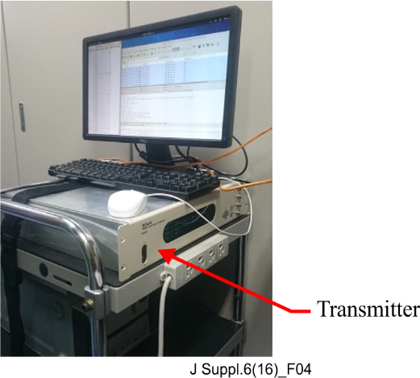

Figure 4 – Transmitter at the headend

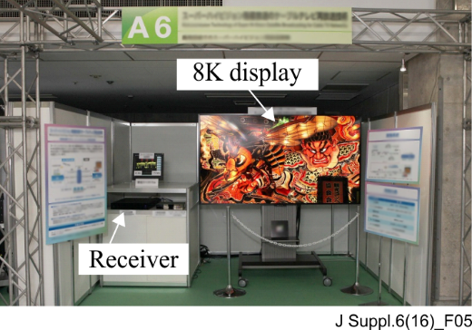

Figure 5 – Received UHDTV on 85-inch 8K LCD display

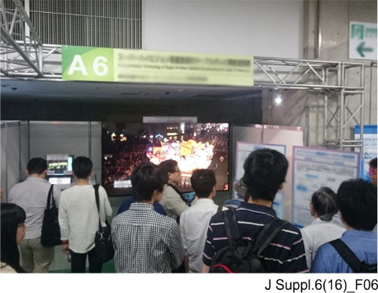

Figure 6 – Demonstration

Bibliography

[b-ITU-T J.83] Recommendation ITU-T J.83 (2007), *Digital multi-programme systems for television, sound and data services for cable distribution*.

|  |  |
| --- | --- |
| **SERIES OF ITU-T RECOMMENDATIONS** | |
| Series A | Organization of the work of ITU-T |
| Series D | Tariff and accounting principles and international telecommunication/ICT economic and policy issues |
| Series E | Overall network operation, telephone service, service operation and human factors |
| Series F | Non-telephone telecommunication services |
| Series G | Transmission systems and media, digital systems and networks |
| Series H | Audiovisual and multimedia systems |
| Series I | Integrated services digital network |
| **Series J** | **Cable networks and transmission of television, sound programme and other multimedia signals** |
| Series K | Protection against interference |
| Series L | Environment and ICTs, climate change, e-waste, energy efficiency; construction, installation and protection of cables and other elements of outside plant |
| Series M | Telecommunication management, including TMN and network maintenance |
| Series N | Maintenance: international sound programme and television transmission circuits |
| Series O | Specifications of measuring equipment |
| Series P | Telephone transmission quality, telephone installations, local line networks |
| Series Q | Switching and signalling, and associated measurements and tests |
| Series R | Telegraph transmission |
| Series S | Telegraph services terminal equipment |
| Series T | Terminals for telematic services |
| Series U | Telegraph switching |
| Series V | Data communication over the telephone network |
| Series X | Data networks, open system communications and security |
| Series Y | Global information infrastructure, Internet protocol aspects, next-generation networks, Internet of Things and smart cities |
| Series Z | Languages and general software aspects for telecommunication systems |
|  |  |

1. \* To access the Recommendation, type the URL http://handle.itu.int/ in the address field of your web browser, followed by the Recommendation's unique ID. For example, <http://handle.itu.int/11.1002/1000/11830-en>. [↑](#footnote-ref-1)