|  |  |  |  |  |
| --- | --- | --- | --- | --- |
| Fond-Rec_e | | **International Telecommunication Union** | | |
|  | |  | | |
| **ITU-T** | **M.3372** | |
| TELECOMMUNICATION STANDARDIZATION SECTOR OF ITU | | (08/2018) |
|  | SERIES M: TELECOMMUNICATION MANAGEMENT, INCLUDING TMN AND NETWORK MAINTENANCE  Telecommunications management network | | | |
|  | **Requirements for resource management in cloud-aware telecommunication management systems** | | | |
|  | Recommendation ITU‑T M.3372 | | | |



ITU-T M-SERIES RECOMMENDATIONS

**TELECOMMUNICATION MANAGEMENT, INCLUDING TMN AND NETWORK MAINTENANCE**

|  |  |
| --- | --- |
|  |  |
| Introduction and general principles of maintenance and maintenance organization | M.10–M.299 |
| International transmission systems | M.300–M.559 |
| International telephone circuits | M.560–M.759 |
| Common channel signalling systems | M.760–M.799 |
| International telegraph systems and phototelegraph transmission | M.800–M.899 |
| International leased group and supergroup links | M.900–M.999 |
| International leased circuits | M.1000–M.1099 |
| Mobile telecommunication systems and services | M.1100–M.1199 |
| International public telephone network | M.1200–M.1299 |
| International data transmission systems | M.1300–M.1399 |
| Designations and information exchange | M.1400–M.1999 |
| International transport network | M.2000–M.2999 |
| **Telecommunications management network** | **M.3000–M.3599** |
| Integrated services digital networks | M.3600–M.3999 |
| Common channel signalling systems | M.4000–M.4999 |
|  |  |

*For further details, please refer to the list of ITU-T Recommendations.*

|  |
| --- |
| Recommendation ITU-T M.3372  Requirements for resource management in cloud-aware telecommunication management systems |

|  |
| --- |
| Summary  Recommendation ITU-T M.3372 introduces a functional framework and functional requirements for resource management in cloud-aware telecommunication management systems. It provides the composition of the functional framework and the functions of each component in the framework. In this Recommendation, the general background and status of cloud computing management are also analysed. The benefit of introducing a functional framework and functional requirements for resource management in cloud-aware telecommunication management systems is also explained. |

|  |  |  |  |  |  |  |  |  |  |  |
| --- | --- | --- | --- | --- | --- | --- | --- | --- | --- | --- |
| History   |  |  |  |  |  | | --- | --- | --- | --- | --- | | Edition | Recommendation | Approval | Study Group | Unique ID[[1]](#footnote-1)\* | | 1.0 | ITU-T M.3372 | 2018-08-29 | 2 | [11.1002/1000/13687](http://handle.itu.int/11.1002/1000/13687) | |

|  |
| --- |
| Keywords  Cloud-aware, cloud computing, management system. |

FOREWORD

The International Telecommunication Union (ITU) is the United Nations specialized agency in the field of tele­com­mu­ni­ca­tions, information and communication technologies (ICTs). The ITU Telecommunication Standardization Sector (ITU-T) is a permanent organ of ITU. ITU-T is responsible for studying technical, operating and tariff questions and issuing Recommendations on them with a view to standardizing telecommunications on a worldwide basis.

The World Telecommunication Standardization Assembly (WTSA), which meets every four years, establishes the topics for study by the ITU‑T study groups which, in turn, produce Recommendations on these topics.

The approval of ITU-T Recommendations is covered by the procedure laid down in WTSA Resolution 1.

In some areas of information technology which fall within ITU-T's purview, the necessary standards are prepared on a collaborative basis with ISO and IEC.

NOTE

In this Recommendation, the expression "Administration" is used for conciseness to indicate both a telecommunication administration and a recognized operating agency.

Compliance with this Recommendation is voluntary. However, the Recommendation may contain certain mandatory provisions (to ensure, e.g., interoperability or applicability) and compliance with the Recommendation is achieved when all of these mandatory provisions are met. The words "shall" or some other obligatory language such as "must" and the negative equivalents are used to express requirements. The use of such words does not suggest that compliance with the Recommendation is required of any party.

INTELLECTUAL PROPERTY RIGHTS

ITU draws attention to the possibility that the practice or implementation of this Recommendation may involve the use of a claimed Intellectual Property Right. ITU takes no position concerning the evidence, validity or applicability of claimed Intellectual Property Rights, whether asserted by ITU members or others outside of the Recommendation development process.

As of the date of approval of this Recommendation, ITU had not received notice of intellectual property, protected by patents, which may be required to implement this Recommendation. However, implementers are cautioned that this may not represent the latest information and are therefore strongly urged to consult the TSB patent database at <http://www.itu.int/ITU-T/ipr/>.

© ITU 2018

All rights reserved. No part of this publication may be reproduced, by any means whatsoever, without the prior written permission of ITU.

**Table of Contents**

Page

1 Scope 1

2 References 1

3 Definitions 1

3.1 Terms defined elsewhere 1

3.2 Terms defined in this Recommendation 1

4 Abbreviations and acronyms 1

5 Conventions 2

6 Introduction 2

7 General requirements for resource management in cloud-aware telecommunication management system 2

8 Functional framework for resource management in cloud-aware telecommunication management system 3

9 Functional requirements for resource management in cloud-aware telecommunication management system 4

9.1 Resource order management 4

9.2 Resource performance management 4

9.3 Resource fault management 6

9.4 Resource test management 7

9.5 Resource catalogue management 8

9.6 Resource inventory management 9

9.7 Resource usage collection and distribution 9

Appendix I – Background 10

I.1 Background 10

Bibliography 14

Recommendation ITU-T M.3372

Requirements for resource management in cloud-aware telecommunication management systems

# 1 Scope

This Recommendation provides the functional framework and functional requirements for resource management in cloud-aware telecommunication management system, describes the composition of the functional framework, and explains the functions of each component in the framework.

# 2 References

The following ITU-T Recommendations and other references contain provisions which, through reference in this text, constitute provisions of this Recommendation. At the time of publication, the editions indicated were valid. All Recommendations and other references are subject to revision; users of this Recommendation are therefore encouraged to investigate the possibility of applying the most recent edition of the Recommendations and other references listed below. A list of the currently valid ITU-T Recommendations is regularly published. The reference to a document within this Recommendation does not give it, as a stand-alone document, the status of a Recommendation.

[ITU-T M.3371] Recommendation ITU-T M.3371 (2016), *Requirements for service management in cloud-aware telecommunication management system.*

[ITU-T Y.3521] Recommendation ITU-T Y.3521/M.3070 (2016), *Overview of end-to- end cloud computing management*.

# 3 Definitions

## 3.1 Terms defined elsewhere

This Recommendation uses the following terms defined elsewhere:

**3.1.1 cloud service customer** [b-ITU-T Y.3500]: Party that is in a business relationship for the purpose of using cloud services.

**3.1.2 cloud service provider** [b-ITU-T Y.3500]: Party that makes cloud services available.

**3.1.3 management system** [b-ITU-T M.60]: A system with the capability and authority to exercise control over and/or collect management information from another system.

## 3.2 Terms defined in this Recommendation

This Recommendation does not define any new terms.

# 4 Abbreviations and acronyms

This Recommendation uses the following abbreviations and acronyms:

B/S Byte per second

BSS Business Support System

CPU Central Processing Unit

CSC Cloud Service Customer

CSP Cloud Service Provider

E2E End-to-End

GB Giga Bytes

KPI Key Performance Indicator

MB Mega Bytes

N/A Not Applicable

OSS Operation Support System

vCPU virtual Central Processing Unit

VM Virtual Machine

# 5 Conventions

None.

# 6 Introduction

Currently, cloud computing is one of the mainstream technologies in telecommunication networks as well as for Internet services. Many cloud computing applications are used in various domains. To better provide cloud applications to the cloud service customer (CSC) there should be an effective management to the cloud service and cloud resource.

With the development of cloud computing technology, some achievements have been done in cloud computing management. Among them, the conceptual view of management layering as defined in [ITU-T Y.3521]. Cloud computing management layering includes customer, product, service and resource management. Customer management and product management are mapped to the business support system (BSS) functional component, while service management and resource management are mapped to the operation support system (OSS) functional component. A common management model for end-to-end (E2E) management of cloud computing is introduced, which illustrates the concept of E2E cloud integrated telecommunications management. From the viewpoint of a telecommunication operator, service management in the cloud-aware telecommunication management system, mapped to the service management layer in the management layering in [ITU‑T Y.3521], has been defined in [ITU-T M.3371]. Resource management in the cloud-aware telecommunication management system, mapped to the resource management layer in the management layering in [ITU-T Y.3521], is defined in this Recommendation.

This Recommendation describes both the functional framework and functional requirements of cloud computing resource management in a cloud-aware telecommunication management system to provide assurance and support to the cloud services.

# 7 General requirements for resource management in cloud-aware telecommunication management system

With the development of cloud computing technology, effective management of cloud computing is becoming increasingly important. From a resource management perspective, a telecommunication management system should not only provide management to traditional telecommunication resources, but also to cloud computing resources.

The general requirements of a cloud-aware telecommunication management system include:

– It is required that resource management support the fulfilment of management of resources in support of cloud services, including the management of E2E lifecycle of a resource order request;

– It is required that management support assurance management of resources in support of cloud services, including monitoring, analysing, reporting, testing functionalities, etc.;

– It is required that resource management provide resource catalogue and resource inventory management functionalities for cloud resources; and

– It is recommended that resource management support resource usage management of services.

This Recommendation focuses on computing and storage resources in the cloud computing environment. This focus covers both virtualized and physical infrastructures for the support of cloud services, such as physical machine, virtual machine (VM), resource pool, template, VM image, physical storage, virtual storage (volume), network interface and software resources. Networking related physical/virtualized resources such as network, link, network node, port and network addresses are outside the scope of this Recommendation.

# 8 Functional framework for resource management in cloud-aware telecommunication management system

The high-level organization of a resource management functional framework in a cloud-aware telecommunication management system includes:

– Resource order management

– Resource performance management

– Resource fault management

– Resource test management

– Resource catalogue management

– Resource inventory management

– Resource usage collection and distribution

Descriptions of resource management functions in a cloud-aware telecommunication management system are as follows:

– Resource order management: provides the functions to manage the E2E lifecycle of a resource order request. This includes validating the resource availability as well as the resource order request.

– Resource performance management: provides the functions to monitor, analyse, and report on the performance of the resources, as well as the performance measurements management and performance threshold management.

– Resource fault management: provides the functions to manage the faults associated with the resources of a cloud service provider (CSP), to include fault monitoring, alarm collecting, alarm storage and retrieval, alarm statistics, fault analysis, fault correction and restoration and fault reporting.

– Resource test management: provides the functions to ensure that resources are working properly, such as resource test strategy and policy management, resource test lifecycle management, resource test command and control, resource test services and so on.

– Resource catalogue management: provides the functions to manage the resource list within a CSP.

– Resource inventory management: provides the functions to manage the information of all CSP resources, including resource management, resource template management, resource data import management, resource statistics management, and resource relationship management.

– Resource usage collection and distribution: provides the functions that cover resource usage service management.

# 9 Functional requirements for resource management in cloud-aware telecommunication management system

This clause provides the detailed functional requirements for resource management in a cloud-aware telecommunication management system.

## 9.1 Resource order management

In a cloud-aware telecommunication management system, the resource order management requirements include:

– Resource order creation: this functionality provides the ability to create resource order requests. When a CSC orders resource services, it creates resource order requests that satisfy the order relationship.

– Resource order orchestration and distribution: this functionality provides workflow and orchestration capability across resource order management. This functionality has the ability to distribute the resource order. It also provides the functionality to track and manage the overall resource order as well as to track the overall order.

– Resource order validation: this functionality validates the resource order request based on contract, catalogue, and provisioning rules.

– Resource assignment: this functionality addresses the resource configurations needed to support a service order.

– Resource order change: this functionality provides the ability to change the resource order. When the resource service ordered by the CSC changes, resources need to also be changed to support the resource service. Major changes include: adjustment of computing resources, adjustment of storage resources, new virtual machines and adjustment of cluster strategies. Accordingly, after the change, the status, date, resource and other information of the resource instance are updated, as is the association between the resource instance and the actual allocated resource.

– Resource order cancellation: this functionality provides the ability to cancel a resource order when the resource service ordered by the CSC is withdrawn, the resource order is cancelled.

– Resource order renewal or termination: when a resource service ordered by the CSC expires, the resource order supporting the resource service can be renewed or terminated.

– Resource order tracking: this functionality issues valid and complete resource orders, and stores the order into an appropriate repository.

– Resource order inquiry and statistics: this functionality provides the ability to query detailed information of orders, statistics of orders and real-time status of orders.

## 9.2 Resource performance management

In a cloud-aware telecommunication management system, it is required that resource performance management include the following:

– Resource performance monitoring: support to monitor and collect the performance data of the cloud resources.

– Resource performance measurements: supports measurements on the performance of cloud computing resources, including to create, suspend, resume, query, stop and delete a measurement job, etc.

– Resource performance threshold management: sets the resource performance thresholds and report threshold-crossing alarms. It supports setting, querying and modifying threshold values, etc.

– Resource performance data present: supports the presentation of performance data from the monitored resources, and displays the real-time performance and historical performance data of the resources. It also supports querying and showing the detailed performance information for a single resource, as requested, and supports filtration of the resource list.

– Resource performance analysing: supports an intelligent analysis of performance data of the CSP resources. It also supports the statistical analysis of the load and network traffic of the central processing unit (CPU), memory and hard disk of the basal software and hardware resources.

– Resource performance reporting: supports generating reports about the performance of the resource.

– Resource performance predict: supports predicting CPU usage, memory, disk capacity.

The commonly used key performance indicators (KPIs) are as given in Table 1.

Table 1 – Commonly used KPIs for resource performance management

|  |  |  |
| --- | --- | --- |
| Objects | KPI | Unit |
| VM | number of vCPU | N/A |
| rate of CPU utilization | N/A |
| rate of memory utilization | N/A |
| disk reading rate | B/S |
| disk writing rate | B/S |
| disk available capacity | GB |
| Host | number of VM | N/A |
| number of vCPU | N/A |
| number of idle vCPU | N/A |
| available memory size | MB |
| memory size | MB |
| available disk size | GB |
| disk size | GB |
| rate of CPU utilization | N/A |
| rate of memory utilization | N/A |
| disk reading rate | B/S |
| disk writing rate | B/S |
| Physical server | rate of CPU utilization | N/A |
| rate of memory utilization | N/A |
| memory size | MB |
| disk size | GB |
| available disk size | GB |
| Virtual server | rate of CPU utilization | N/A |
| rate of memory utilization | N/A |
| memory size | MB |
| disk size | GB |
| available disk size | GB |
| Storage | total management space size | GB |
| remaining management space size | GB |

## 9.3 Resource fault management

In a cloud-aware telecommunication management system, resource operation status needs to be detected. The resource fault management requirements include:

– Resource fault monitoring: provides the function needed to monitor the operational status of the resources in cloud computing and to report the alarm when faults are detected, such as it should when system hardware or payload are exceptional.

– Resource alarm collecting: collects alarm information based on resource monitoring items. Each alarm should be uniquely identified. The alarm sent should be filtered by resources. It also supports the enablement or the suppression of alarm reporting by setting filters on any combination of attributes.

– Resource alarm display: provides the function needed to display an alarm, such as displaying current active alarms, ongoing alarms, and historical alarms, and can view alarm details, processing status, and other information. It supports setting filter conditions, and only alarms that meet the filter conditions are presented. Automatic refreshing of the alarm list is also one of its functions.

– Resource alarm storage and retrieval: provides the function to store and retrieve the alarm information of resources optionally using filters (active or historical).

– Resource alarm mask: unimportant alarms can be masked, and masked alarms are not displayed.

– Resource alarm redefinition: supports redefining the category and level of alarms.

– Resource alarm statistics: statistics of the system’s current alarm distribution can be performed according to the alarm level, resource category, resource location or time period. Supports storing or printing the statistical results of the alarms.

– Resource fault analysis: analyses various alarm events and localizes fault position combined with fault analysis strategy. Shows and supports the analysis of services affected by faulty resources.

– Resource fault correction and restoration: repairs or replaces faulty resources. The alarms originating from faults need to be cleared. To clear an alarm, it is generally necessary to restore the corresponding fault.

– Resource fault reporting: supports generating reports about the faults of the resources. Commonly used faults or alarms are noted in Table 2.

| Table 2 – Commonly used faults or alarms for resource fault management | |
| --- | --- |
| Objects | Faults or alarms |
| physical machine | card fault |
| physical port fault |
| virtual machine | virtual machine failure |
| virtual machine CPU occupancy rate exceeds the threshold |
| virtual machine memory usage exceeds the threshold |
| virtual machine disk occupancy rate exceeds threshold |
| the system has unmanaged virtual machines |
| virtual machine blue screen |
| virtual machine cannot be restored normally |
| virtual machine virtual disk exception |
| virtual storage (volume) | host storage link interrupt |
| storage resource management link interruption |
| storage usage capacity exceeds threshold |
| host associated data storage exception |
| host fibre channel interrupts |

## 9.4 Resource test management

In a cloud-aware telecommunication management system, the resource test management requirements include:

– Resource test strategy and policy management: this functionality manages the rules that define the strategies for conducting various resource tests.

– Resource test lifecycle management: this functionality manages the E2E lifecycle of a test to a particular resource.

– Resource test command and control: this functionality provides access, commands and controls the resource testing environment.

– Resource test services: this functionality provides the means to access testing capabilities.

The commonly used test items are as listed in Table 3.

| Table 3 – Commonly used test items for resource test management | | |
| --- | --- | --- |
| Test classification | Test item | Test purpose |
| Resource test management | Resource data cycle | Tests whether the resource data file generation cycle meets the requirements. |
| Resource data file format | Tests whether the resource data file format meets the requirements. |
| Resource data field integrity | Tests whether the resource data field integrity meets the requirements. |
| Physical resources view | Tests the usage statistics of physical resources and quickly counts the total number of physical resource online, offline, in fault or in other states and views detailed information lists. |
| Virtual machine resources view | Tests the usage statistics of virtual machine resources. Views the list of virtual machines, and quickly counts the total number of virtual machines that are running, shutting down, halting and in other states, and views detailed information lists. |
| Virtual resource change | Tests whether the virtual resources can be properly allocated, updated and deleted. |
| Correspondence between virtual machines and physical servers | Tests whether the correspondence between the VM and the physical server can be verified. |
| Storage management | Tests whether the management of the storage devices can be completed, such as a query of the basic information and status of storage devices, configures storage devices, and so on. |
| Performance test management | Performance data cycle | Tests whether the performance data file generation period meets the requirements. |
| Performance data file format | Tests whether the performance data file format meets the requirements. |
| Performance data field integrity | Tests whether the integrity of the performance data field meets the requirements. |
| Measurement indicator management | Tests whether the measurement indicators can be managed, such as to create, enable, disable, modify and/or delete measurement indicators. |
| Physical resource performance management | Tests whether the performance data of the physical resources can be counted in statistics. |
| Virtual resource performance management | Tests whether virtual resources performance data can be counted in statistics. |
| Performance data view | Tests whether the results of the performance measurement indicators are displayed. |
| Performance threshold alarm management | Tests whether KPI performance thresholds can be configured, such as setting, activating, deactivating performance thresholds; enabling indicators to trigger alarm thresholds and testing real-time alarms related to virtual resources and physical resources. |
| Alarm test management | Real-time alarm message reporting | Tests whether real-time alarm reporting message meets the requirements. |
| Real-time alarm message body format | Tests whether the real-time alarm reporting message format meets the requirements. |
| Alarm integrity | Tests whether the integrity of the alarm meets the requirements. |
| Alarm display | Tests whether all alarm information can be displayed. |
| Alarm processing | Tests whether operations such as filter alarm, export alarm, confirm alarm, clear alarm and so on can be performed. |
| Alarm association | Tests whether service software alarms, virtual resource alarms, and physical hardware alarms can be associated. |
| Physical machine fault processing | Tests the impact of the physical machine fault on the service and the automatic recovery time of the corresponding virtual machine. The key indicator is the fault recovery time of the virtual machine. |
| Virtual machine fault processing | Tests the impact of the VM fault on the service, the main observation indicator is the service interruption time. Also tests whether the VM can be automatically recovered and tests the corresponding fault recovery time. |

## 9.5 Resource catalogue management

In a cloud-aware telecommunication management system, the resource catalogue management requirements include:

– Resource catalogue management: manage the list of resources within the CSP, which includes the ability to design, create, augment and map new entities and supporting data.

– Resource discovery and update: support the automatic discovery of resources and updates the related resource catalogue.

– Resource usage record: store data usage of the resources.

– Resource catalogue initialization: initialize the resource catalogue.

## 9.6 Resource inventory management

In a cloud-aware telecommunication management system, the resource inventory management requirements include:

– Resource data management: manages the resource data of all the CSPs, including resource objects add, delete, modify and query, as well as the detailed information management of the resources available for the implementation of services and products. For add, modify, and delete functions, supports operation in single or batch mode. The modification function should support the recording modification log. The log includes the modification contents, amendments, modification time, etc. It also supports the reminder function before a resource item is deleted, especially when deleted resource items are related to other resource items.

– Resource template management: supports the customization of the resources template.

– Resource data import: supports importing the resource data in single or batch mode.

– Resource data export: supports exporting the resource data.

– Resource statistics: supports multi-dimensional resources statistics, supports the present, release and export of statistical results, and supports the query of historical statistical results by months or days. Common statistical indicators include the number of servers, number of virtual machines, number of business systems, CPU capacity, CPU usage, memory capacity, memory usage, storage capacity, storage usage, and so on.

– Resource relationship management: manages the mapping of the relationship between virtual resources and physical resources, and supports the automatic discovery and update of the related relationships.

## 9.7 Resource usage collection and distribution

In a cloud-aware telecommunication management system, this set of functionalities is used to channel usage events from the resources to various processes such as billing, compliance and service assurance. The resource usage collection and distribution requirements include:

– Resource usage collection: collects the resource usage and generates resource usage event records, such as, among others, the physical resource usage, VM usage or resource pool usage.

– Resource usage event records management: The resource usage event records supports the processing, editing, correlating, enriching and formatting of records.

– Resource usage event record distribution: supports the distribution of the resource usage event record to upstream functionalities.

Appendix I  
  
Background

(This appendix does not form an integral part of this Recommendation.)

## I.1 Background

Cloud computing is currently one of the mainstream technologies in telecommunication networks as well as for Internet services. Many cloud computing applications are used in various domains. In order to better provide cloud applications to the cloud service customer (CSC), there should be an effective management of the cloud service and cloud resource. In the cloud computing management domain, some achievements have already been seen, such as "Overview of end-to-end cloud computing management", "Requirements for Service Management in Cloud-aware Telecommunication Management System", "Cloud computing framework for end to end resource management". New research considers describing the functional requirements of cloud computing resource management in cloud-aware telecommunication management system, and then providing the assurance and support to the cloud services. With this background, it is necessary to study the functional framework and requirements of cloud computing resource management in cloud-aware telecommunication management system.

Cloud computing technology is maturing and is also more widely applied. With the development of cloud computing technology, its effective management is becoming increasingly important. There are already some achievements regarding cloud computing management. Among them, is the conceptual view of management layering as defined in [ITU-T Y.3521]. Figure I.1 illustrates this management layering framework.

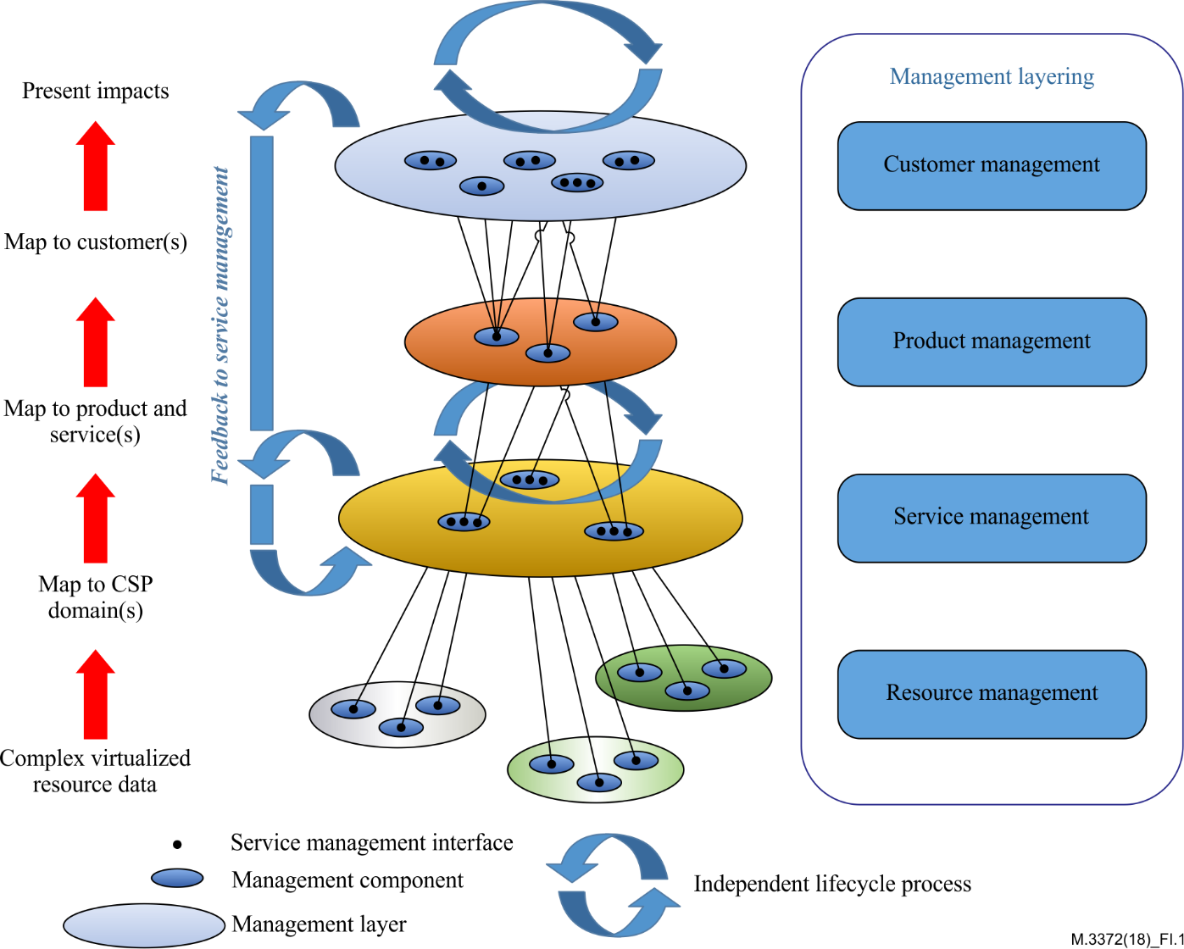

Figure I.1 – Cloud computing management layering

As shown in Figure I.1, cloud computing management layering includes customer management, product management, service management and resource management. The relationship between the management layering and the OSS/BSS in cloud computing reference architecture is also described in [ITU-T Y.3521].

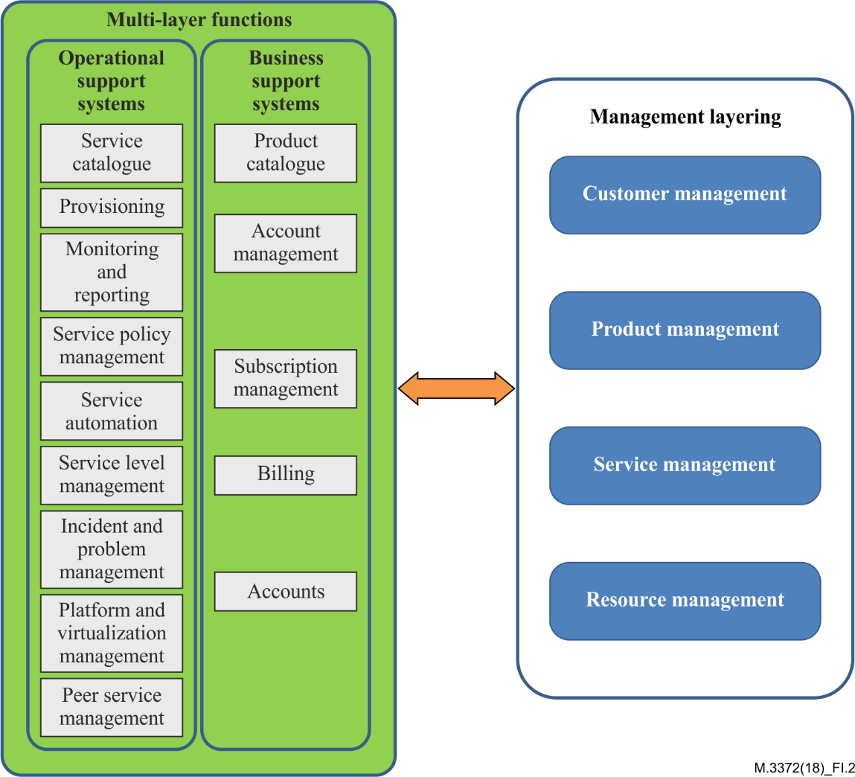

Figure I.2 – Relationship of cloud computing management layering and OSS/BSS   
in cloud computing reference architecture

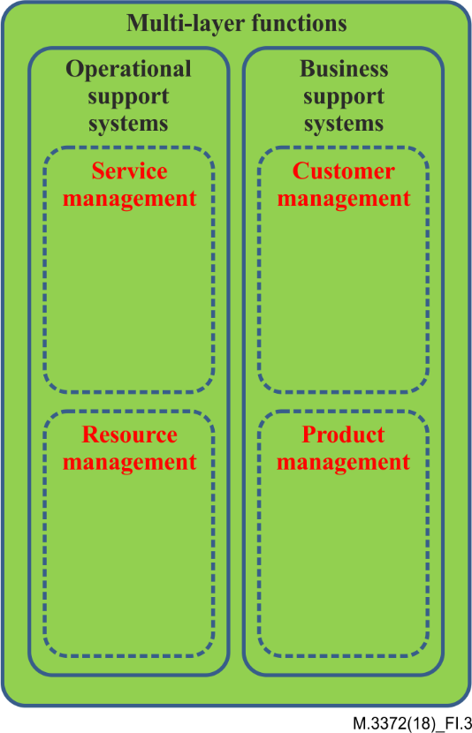

Figure I.3 – Split of OSS/BSS components according to management layers

As shown in Figure I.2 and Figure I.3, customer management and product management are mapped to the BSS functional component, and the service management and resource management are mapped to the OSS functional component.

A common model is introduced to realize the end-to-end management of cloud computing.

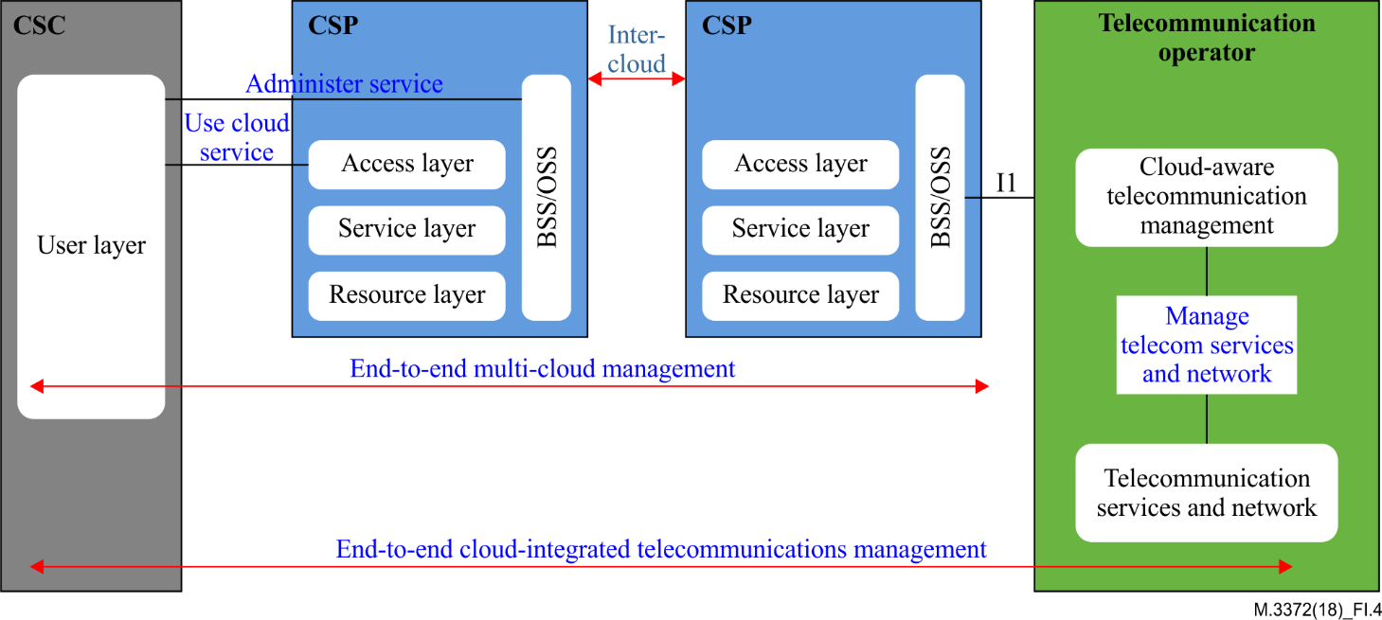

Figure I.4 – Common model for E2E cloud computing management

As shown in Figure I.4, this common management model shows the concept of E2E cloud integrated telecommunications management. Of course, the telecommunication operator may also act as a cloud service provider. From the perspective of a telecommunication operator, the service management in the cloud-aware telecommunication management system was defined in [ITU-T M.3371]. Although the overview of the resource management is defined in [ITU-T Y.3521], to date, there is still no detailed definition of resource management in cloud-aware telecommunication management system. So, it is important to define the functional requirements of resource management in cloud-aware telecommunication management system

From a resource management perspective, a telecommunication management system should not only provide management to the traditional telecommunication resources, but also should provide management to the cloud computing resources.

Defining the functional requirements of resource management in cloud-aware telecommunication management system has the following benefits:

– Implements cloud computing resource management in cloud-aware telecommunication management system;

– Implements resource management of multi-CSP environment;

– Supports the interaction of information between the OSS of CSP and the cloud-aware telecommunication management system;

– Guides the development, design and implementation.

These benefits make it necessary to introduce the functional framework and functional requirements of cloud computing resource management in cloud-aware telecommunication management system.

Bibliography

[b-ITU-T M.60] Recommendation ITU-T M.60 (1993), *Maintenance terminology and definitions*.

[b-ITU-T M.3371] Recommendation ITU-T M.3371 (2016), *Requirements for service management in cloud-aware telecommunication management system.*

[b-ITU-T Y.3500] Recommendation ITU-T Y.3500 (2014), *Information technology – Cloud computing – Overview and vocabulary*.

[b-ITU-T Y.3502] Recommendation ITU-T Y.3502 (2014), *Information technology – Cloud computing – Reference architecture.*

|  |  |
| --- | --- |
| **SERIES OF ITU-T RECOMMENDATIONS** | |
| Series A | Organization of the work of ITU-T |
| Series D | Tariff and accounting principles and international telecommunication/ICT economic and policy issues |
| Series E | Overall network operation, telephone service, service operation and human factors |
| Series F | Non-telephone telecommunication services |
| Series G | Transmission systems and media, digital systems and networks |
| Series H | Audiovisual and multimedia systems |
| Series I | Integrated services digital network |
| Series J | Cable networks and transmission of television, sound programme and other multimedia signals |
| Series K | Protection against interference |
| Series L | Environment and ICTs, climate change, e-waste, energy efficiency; construction, installation and protection of cables and other elements of outside plant |
| **Series M** | **Telecommunication management, including TMN and network maintenance** |
| Series N | Maintenance: international sound programme and television transmission circuits |
| Series O | Specifications of measuring equipment |
| Series P | Telephone transmission quality, telephone installations, local line networks |
| Series Q | Switching and signalling, and associated measurements and tests |
| Series R | Telegraph transmission |
| Series S | Telegraph services terminal equipment |
| Series T | Terminals for telematic services |
| Series U | Telegraph switching |
| Series V | Data communication over the telephone network |
| Series X | Data networks, open system communications and security |
| Series Y | Global information infrastructure, Internet protocol aspects, next-generation networks, Internet of Things and smart cities |
| Series Z | Languages and general software aspects for telecommunication systems |
|  |  |

1. \* To access the Recommendation, type the URL http://handle.itu.int/ in the address field of your web browser, followed by the Recommendation's unique ID. For example, <http://handle.itu.int/11.1002/1000/11830-en>. [↑](#footnote-ref-1)