|  |  |  |  |  |
| --- | --- | --- | --- | --- |
| Fond-Rec_e | | **International Telecommunication Union** | | |
|  | |  | | |
| **ITU-T** | **X.609.5** | |
| TELECOMMUNICATION STANDARDIZATION SECTOR OF ITU | | (01/2018) |
|  | SERIES X: DATA NETWORKS, OPEN SYSTEM COMMUNICATIONS AND SECURITY  OSI networking and system aspects – Networking | | | |
|  | **Managed P2P communications: Multimedia streaming overlay management protocol** | | | |
|  | Recommendation ITU‑T X.609.5 | | | |



ITU-T X-SERIES RECOMMENDATIONS

**DATA NETWORKS, OPEN SYSTEM COMMUNICATIONS AND SECURITY**

|  |  |
| --- | --- |
|  |  |
| PUBLIC DATA NETWORKS |  |
| Services and facilities | X.1–X.19 |
| Interfaces | X.20–X.49 |
| Transmission, signalling and switching | X.50–X.89 |
| Network aspects | X.90–X.149 |
| Maintenance | X.150–X.179 |
| Administrative arrangements | X.180–X.199 |
| OPEN SYSTEMS INTERCONNECTION |  |
| Model and notation | X.200–X.209 |
| Service definitions | X.210–X.219 |
| Connection-mode protocol specifications | X.220–X.229 |
| Connectionless-mode protocol specifications | X.230–X.239 |
| PICS proformas | X.240–X.259 |
| Protocol Identification | X.260–X.269 |
| Security Protocols | X.270–X.279 |
| Layer Managed Objects | X.280–X.289 |
| Conformance testing | X.290–X.299 |
| INTERWORKING BETWEEN NETWORKS |  |
| General | X.300–X.349 |
| Satellite data transmission systems | X.350–X.369 |
| IP-based networks | X.370–X.379 |
| MESSAGE HANDLING SYSTEMS | X.400–X.499 |
| DIRECTORY | X.500–X.599 |
| OSI NETWORKING AND SYSTEM ASPECTS |  |
| **Networking** | **X.600–X.629** |
| Efficiency | X.630–X.639 |
| Quality of service | X.640–X.649 |
| Naming, Addressing and Registration | X.650–X.679 |
| Abstract Syntax Notation One (ASN.1) | X.680–X.699 |
| OSI MANAGEMENT |  |
| Systems management framework and architecture | X.700–X.709 |
| Management communication service and protocol | X.710–X.719 |
| Structure of management information | X.720–X.729 |
| Management functions and ODMA functions | X.730–X.799 |
| SECURITY | X.800–X.849 |
| OSI APPLICATIONS |  |
| Commitment, concurrency and recovery | X.850–X.859 |
| Transaction processing | X.860–X.879 |
| Remote operations | X.880–X.889 |
| Generic applications of ASN.1 | X.890–X.899 |
| OPEN DISTRIBUTED PROCESSING | X.900–X.999 |
| INFORMATION AND NETWORK SECURITY | X.1000–X.1099 |
| SECURE APPLICATIONS AND SERVICES (1) | X.1100–X.1199 |
| CYBERSPACE SECURITY | X.1200–X.1299 |
| SECURE APPLICATIONS AND SERVICES (2) | X.1300–X.1499 |
| CYBERSECURITY INFORMATION EXCHANGE | X.1500–X.1599 |
| CLOUD COMPUTING SECURITY | X.1600–X.1699 |
|  |  |

*For further details, please refer to the list of ITU-T Recommendations.*

|  |
| --- |
| Recommendation ITU-T X.609.5  Managed P2P communications: Multimedia streaming overlay  management protocol |

|  |
| --- |
| Summary  Recommendation ITU-T X.609.5 specifies a multimedia streaming overlay management protocol (MSOMP) that runs on the interface among entities of managed P2P communications. The management functionalities covered in this Recommendation include overlay network management and peer management. This Recommendation provides protocol operations and message formats. |

|  |  |  |  |  |  |  |  |  |  |  |
| --- | --- | --- | --- | --- | --- | --- | --- | --- | --- | --- |
| History   |  |  |  |  |  | | --- | --- | --- | --- | --- | | Edition | Recommendation | Approval | Study Group | Unique ID[[1]](#footnote-1)\* | | 1.0 | ITU-T X.609.5 | 2018-01-13 | 11 | [11.1002/1000/13494](http://handle.itu.int/11.1002/1000/13494) | |

|  |
| --- |
| Keywords  Managed P2P, multimedia streaming, overlay network management. |

FOREWORD

The International Telecommunication Union (ITU) is the United Nations specialized agency in the field of tele­com­mu­ni­ca­tions, information and communication technologies (ICTs). The ITU Telecommunication Standardization Sector (ITU-T) is a permanent organ of ITU. ITU-T is responsible for studying technical, operating and tariff questions and issuing Recommendations on them with a view to standardizing telecommunications on a worldwide basis.

The World Telecommunication Standardization Assembly (WTSA), which meets every four years, establishes the topics for study by the ITU‑T study groups which, in turn, produce Recommendations on these topics.

The approval of ITU-T Recommendations is covered by the procedure laid down in WTSA Resolution 1.

In some areas of information technology which fall within ITU-T's purview, the necessary standards are prepared on a collaborative basis with ISO and IEC.

NOTE

In this Recommendation, the expression "Administration" is used for conciseness to indicate both a telecommunication administration and a recognized operating agency.

Compliance with this Recommendation is voluntary. However, the Recommendation may contain certain mandatory provisions (to ensure, e.g., interoperability or applicability) and compliance with the Recommendation is achieved when all of these mandatory provisions are met. The words "shall" or some other obligatory language such as "must" and the negative equivalents are used to express requirements. The use of such words does not suggest that compliance with the Recommendation is required of any party.

INTELLECTUAL PROPERTY RIGHTS

ITU draws attention to the possibility that the practice or implementation of this Recommendation may involve the use of a claimed Intellectual Property Right. ITU takes no position concerning the evidence, validity or applicability of claimed Intellectual Property Rights, whether asserted by ITU members or others outside of the Recommendation development process.

As of the date of approval of this Recommendation, ITU had not received notice of intellectual property, protected by patents, which may be required to implement this Recommendation. However, implementers are cautioned that this may not represent the latest information and are therefore strongly urged to consult the TSB patent database at <http://www.itu.int/ITU-T/ipr/>.

© ITU 2018

All rights reserved. No part of this publication may be reproduced, by any means whatsoever, without the prior written permission of ITU.

**Table of Contents**

Page

1 Scope 1

2 References 1

3 Definitions 1

3.1 Terms defined elsewhere 1

3.2 Terms defined in this Recommendation 2

4 Abbreviations and acronyms 2

5 Conventions 2

6 Overview 2

7 Protocol operation 4

7.1 Overlay network management 4

7.2 Peer management 6

8 Messages 8

8.1 Resource element type 8

8.2 Message format 12

Bibliography 24

Recommendation ITU-T X.609.5

Managed P2P communications: Multimedia streaming overlay   
management protocol

# 1 Scope

This Recommendation specifies overlay management protocol for providing multimedia streaming services over managed peer-to-peer infrastructure. This Recommendation describes following details:

– overview of multimedia streaming overlay protocol;

– protocol elements;

– protocol messages and its parameters;

– protocol behaviours including information flows.

# 2 References

The following ITU-T Recommendations and other references contain provisions which, through reference in this text, constitute provisions of this Recommendation. At the time of publication, the editions indicated were valid. All Recommendations and other references are subject to revision; users of this Recommendation are therefore encouraged to investigate the possibility of applying the most recent edition of the Recommendations and other references listed below. A list of the currently valid ITU-T Recommendations is regularly published. The reference to a document within this Recommendation does not give it, as a stand-alone document, the status of a Recommendation.

[ITU-T X.609] Recommendation ITU-T X.609 (2015), *Managed P2P communications: Functional architecture*.

[ITU-T X.609.1] Recommendation ITU-T X.609.1 (2016), *Managed P2P communications: Peer activity management protocol (PAMP)*.

[ITU-T X.609.2] Recommendation ITU-T X.609.2 (2016), *Managed P2P communications: Overlay resource control protocol (ORCP)*.

[ITU-T X.609.3] Recommendation ITU-T X.609.3 (2017), *Managed P2P communications: Multimedia streaming signalling requirements*.

[ITU-T X.609.4] Recommendation ITU-T X.609.4 (2017), *Managed P2P communications: Multimedia streaming peer protocol*.

[IETF RFC 7159] IETF RFC 7159 (2014), *The JavaScript Object Notation (JSON) Data Interchange Format*.

[IETF RFC 7231] IETF RFC 7231 (2014), *Hypertext Transfer Protocol (HTTP/1.1): Semantics and Content*.

# 3 Definitions

## 3.1 Terms defined elsewhere

This Recommendation uses the following terms defined elsewhere:

**3.1.1 overlay network** [b-ITU-T X.1162]: An overlay network is a virtual network that runs on top of another network. Like any other network, the overlay network comprises a set of nodes and links between them. Because the links are logical ones, they may correspond to many physical links of the underlying network.

**3.1.2 peer** [b-ITU-T X.1161]: Communication node on P2P network that functions simultaneously as both "client" and "server" to the other nodes on the network.

**3.1.3 peer-to-peer (P2P)** [b-ITU-T Y.2206]: A system is considered to be P2P if the nodes of the system share their resources in order to provide the service the system supports. The nodes in the system both provide services to other nodes and request services from other nodes.

NOTE – Peer is the node in a P2P system.

**3.1.4 managed P2P** [b-ISO/IEC TR 20002]: P2P with manageability features to manage the P2P-based service and P2P network by the P2P participants such as P2P service provider, ISP and peer.

**3.1.5 fragment** [ITU-T X.609]: A piece of the shared content.

## 3.2 Terms defined in this Recommendation

This Recommendation defines the following terms:

**3.2.1 peer list**: A list of peer IDs which identifies the peers participating in an overlay network.

**3.2.2 peer ID**: An identifier of a peer. Each peer can be identified by own peer ID.

**3.2.3 overlay ID**: An identifier of an overlay network. Each overlay network can be identified by own overlay ID.

# 4 Abbreviations and acronyms

This Recommendation uses the following abbreviations and acronyms:

CS Cache Server

JSON Javascript Object Notation

MP2P Managed Peer-to-Peer

MSOMP Multimedia Streaming Overlay Management Protocol

OMS Overlay Management Server

PAMS Peer Activity Management Server

REST Representational State Transfer

P2P Peer-to-Peer

RS Relay Server

UMS User Management Server

UNIS Underlying Network Information Server

# 5 Conventions

See clause 8.1 for the grammar used in object representation.

# 6 Overview

The framework of managed peer-to-peer (P2P) communication is defined in [b-ISO/IEC TR 20002], and the details of the entities and the reference points among the entities are defined in [ITU-T X.609].

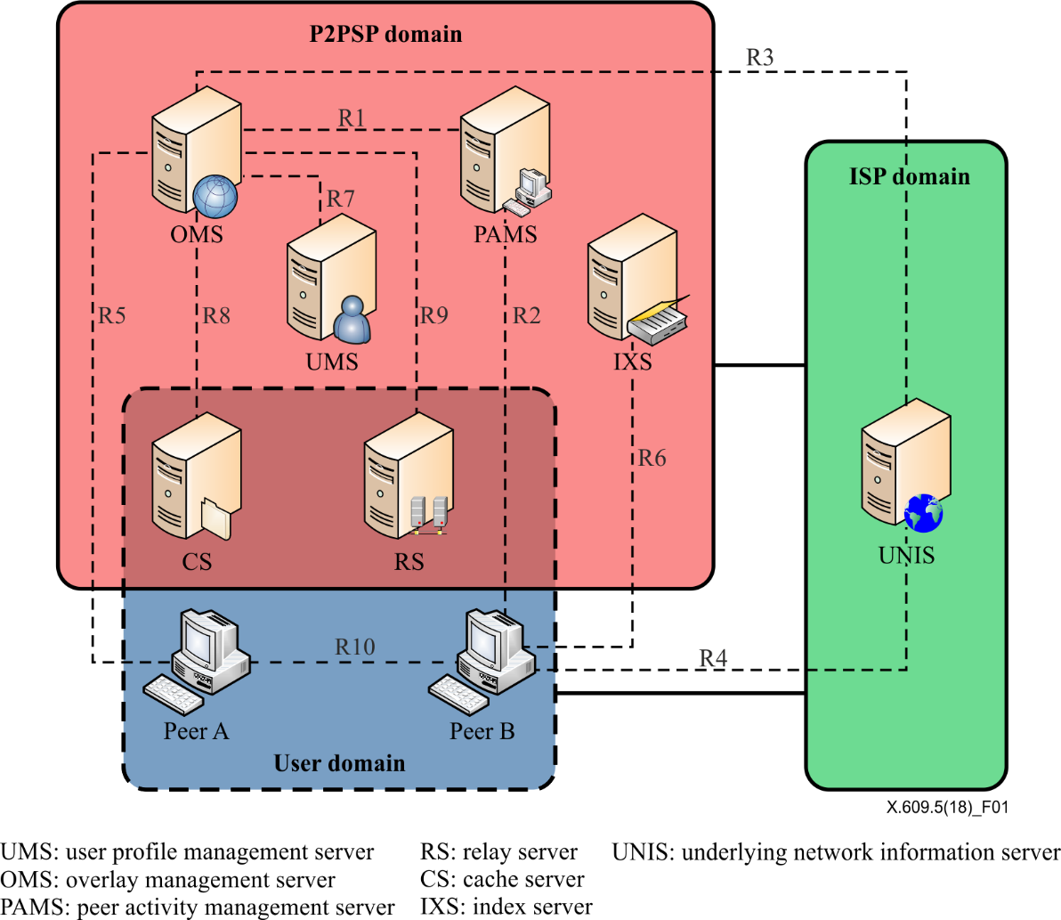

Figure 1 – Framework and reference points of MP2P [ITU-T X.609]

Figure 1 shows the framework and reference points of managed P2P (MP2P) communication. From the management point of view, the overlay management server (OMS) manages the information of established overlay networks and controls resources such as cache server (CS) and relay server (RS). A peer interacts with OMS to join a specific overlay network. The peer can also interact with OMS when it leaves the joined overlay network. This Recommendation defines a multimedia streaming overlay management protocol (MSOMP) running over reference point R5, which is used for management related to overlay network. OMS can interact with other entities such as peer activity management server (PAMS), underlying network information server (UNIS), and user management server (UMS) to form a well-organized overlay network, but those interactions are not part of this Recommendation.

The basic service flow for overlay network management in MP2P communication is shown in Figure 2.

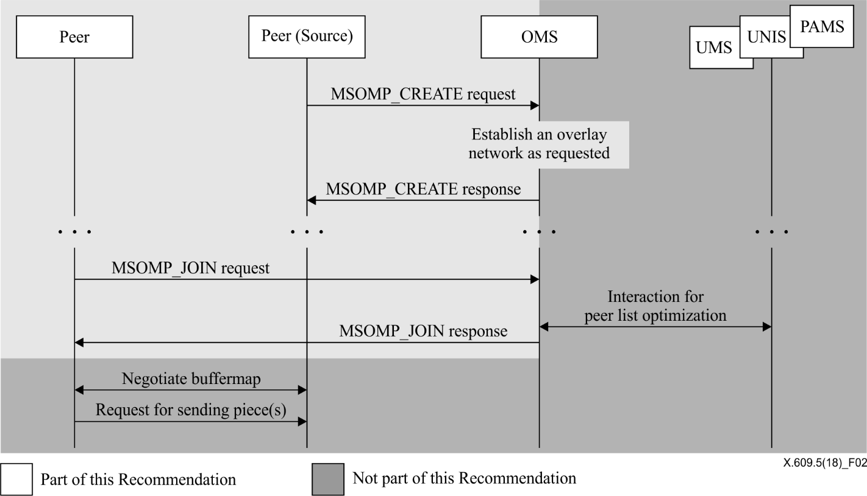

Figure 2 – Basic service flow of overlay network management

A peer can request OMS to create a new overlay network. If the request is valid, OMS establishes a new overlay network as requested. After an overlay network is created, peers can join the overlay network by interacting with OMS. A peer can request OMS to join a specific overlay network; each overlay network corresponds to a distinct multimedia content. As a response, OMS provides a peer list that contains contact information of peers participating in the overlay network. The peer list can be generated by OMS itself, or OMS can interact with other servers such as UMS, UNIS and PAMS to generate the optimized peer list. Upon receiving response including peer list, the peer contacts other peers in the overlay network and conducts REST processes to receive multimedia streams.

As depicted in Figure 2, this Recommendation covers the interaction between peer and OMS, which runs over reference point R5 shown in Figure 1. The interaction can be classified into two categories. One category is overlay network management. Overlay network management is about creation, modification and termination of an overlay network. The second category is peer management. Peer management is about joining and leaving a specific overlay network. Both categories additionally have an information query function. For instance, a peer can query the information of a specific overlay network or the peer list of a specific overlay network.

# 7 Protocol operation

This clause describes the protocol operations of MSOMP. The operations are classified into two types: overlay network management and peer management. The messages for each operation are defined in clause 8.

## 7.1 Overlay network management

### 7.1.1 Creation of overlay network

A peer can request OMS to create a new overlay network. The request may specify options such as peer ID of the peer that sent the request or a list of peer IDs for closed group communication. Upon receiving the request, OMS checks whether the request is valid. If the request is valid, OMS creates an overlay network as requested. When OMS creates the overlay network, it should also generate a unique overlay ID for the overlay network since each overlay network is distinguished by own overlay ID. After completing creation, OMS responds with the overlay ID. This process is depicted in Figure 3. This Recommendation does not specify how the identifier is generated.

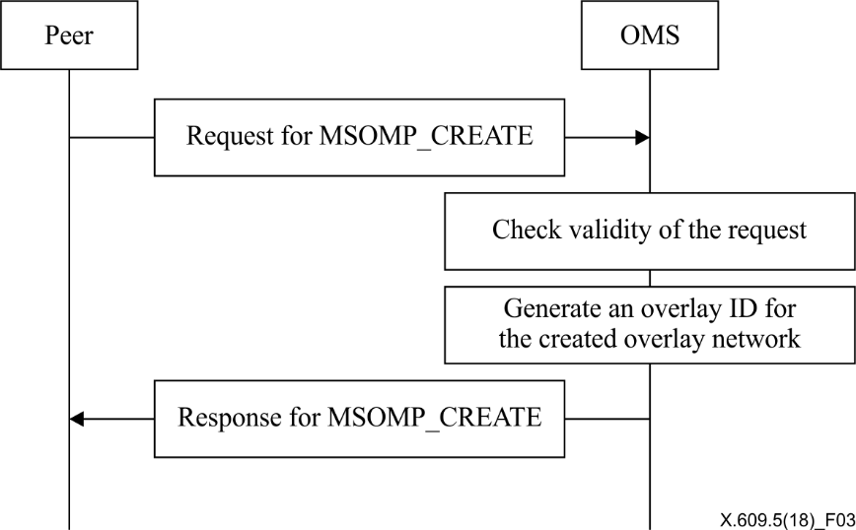

Figure 3 – Operations for overlay network creation

### 7.1.2 Modification of overlay network

A peer can request OMS to modify information of the overlay network created by the requesting peer. Any option configured when the overlay network is created can be modified, and new options can be newly configured by the modification operations. OMS checks validity of the request upon receiving the request and performs modifications as requested. When OMS completes the requested modification, it responds that modification has been successful. This process is depicted in Figure 4.

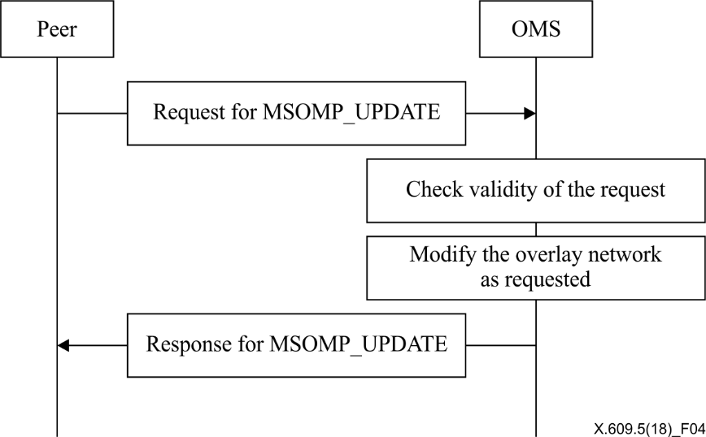

Figure 4 – Operations for overlay network modification

### 7.1.3 Termination of overlay network

A peer can request OMS to terminate the overlay network created by the requesting peer. To prevent unauthorized termination, OMS accepts the request only if the request is issued by the peer that requested OMS to create the overlay network. After checking validity of the request, OMS removes all data related to the overlay network from itself. When OMS completes the requested termination, it responds that termination has been successful. This process is depicted in Figure 5.

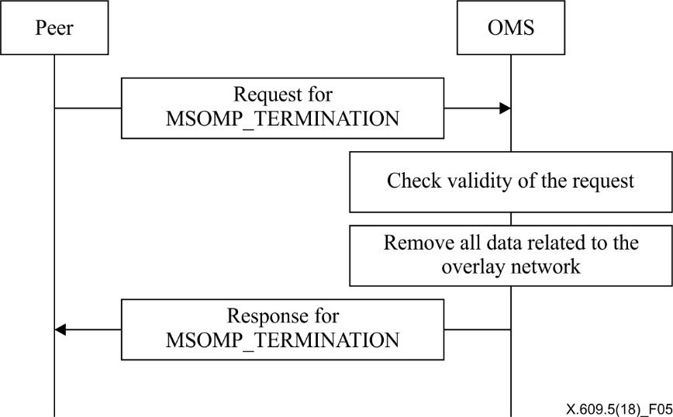

Figure 5 – Operations for overlay network termination

### 7.1.4 Query of overlay network

A peer can send OMS a query about the status of overlay networks. When the query includes a specific overlay ID, OMS responds with the status information of the corresponding overlay network. If the query does not specify any overlay network, OMS responds with the information of all the overlay networks that it manages. The query may also specify the peer ID of a specific peer. In such case, OMS responds with the information about the overlay network that the specified peer had created. This process is depicted in Figure 6.

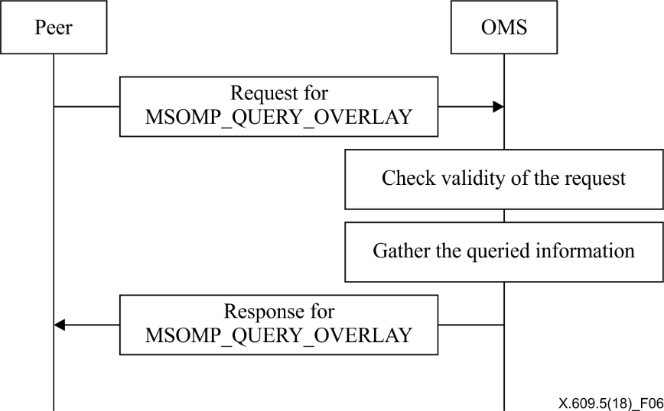

Figure 6 – Operations for overlay network query

## 7.2 Peer management

### 7.2.1 Overlay network join

A peer can join an overlay network. To join a specific overlay network, a peer sends OMS a request to join the target overlay network. If the request is valid, OMS responds with a peer list that contains the contact information and peer ID of peers already participating in the overlay network. The request may include network information of the requesting peer so that OMS can manage peer list. In addition, an authentication key may additionally be included in the request if authentication is needed to join the overlay network. This process is depicted in Figure 7.

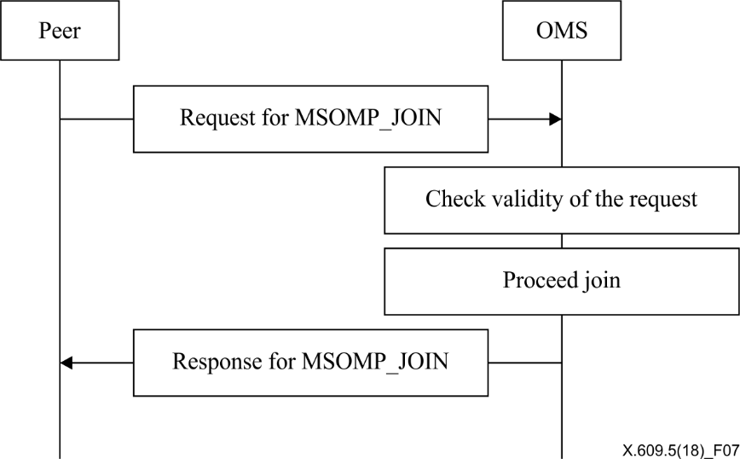

Figure 7 – Operations for overlay network joining

### 7.2.2 Peer information update

After joining an overlay network, a peer can send a request for updating its information. The request can be considered as renewing the subscription so that OMS can keep the status of the requesting peer alive. As a response, OMS sends the latest version of the peer list so that the requesting peer can communicate with valid peers in the corresponding overlay network. This process is depicted in Figure 8.

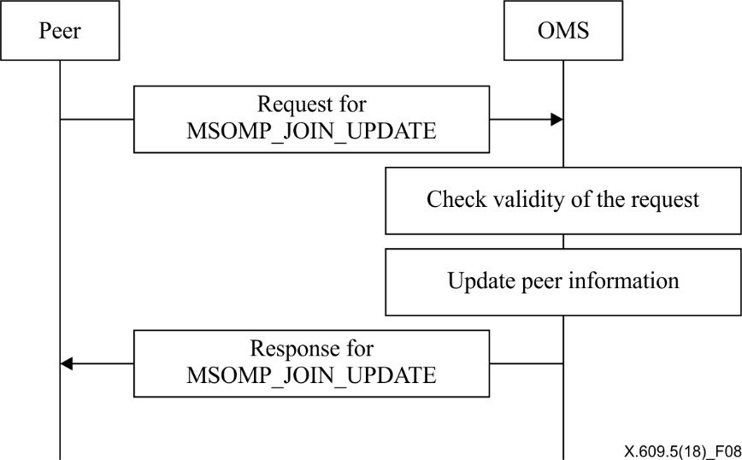

Figure 8 – Operations for peer information update

### 7.2.3 Overlay network leave

A peer can leave the joined overlay network anytime without the need to notify OMS. However When the peer leaves an overlay network, it may notify OMS of its leave. The graceful leave helps OMS manage overlay networks precisely. OMS may consider that a specific peer leaves if it does not receive any peer information update request from the peer within a predefined period of time. This process is depicted in Figure 9.

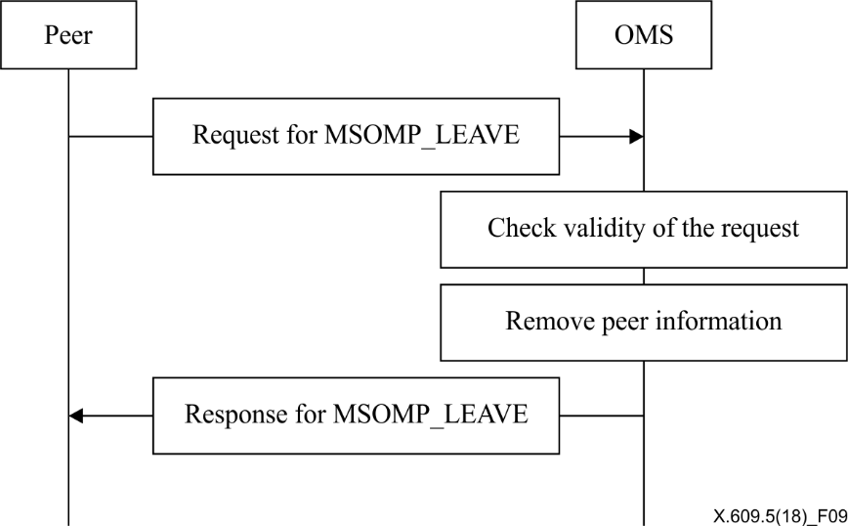

Figure 9 – Operations for overlay network leave

### 7.2.4 Peer list query

A peer can request OMS to send peer list of a specific overlay network. The request may include conditions of querying so that OMS can find the corresponding peers and respond with them. The condition includes list of fragments or range of fragments. OMS responds with the information about the corresponding peers which possesses the fragments specified in the request. This is depicted in Figure 10.

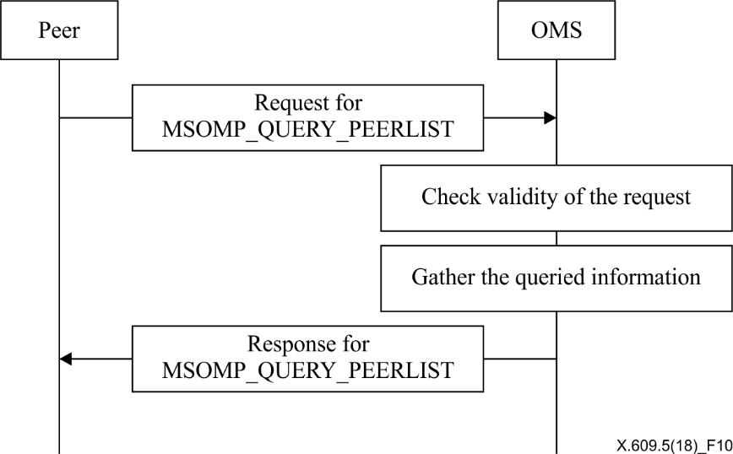

Figure 10 – Operations for peer list query

# 8 Messages

This clause describes the message formats for the multimedia streaming overlay management protocol (MSOMP). For extensibility, MSOMP is representational state transfer (REST)-ful architecture [b‑REST] and messages are encoded in Javascript object notation (JSON) [IETF RFC 7159].

## 8.1 Resource element type

This clause provides the format of resource element types used in this Recommendation. The grammar used in representing objects defined in this Recommendation is as follows:

– "STRING", "BOOLEAN", and "NUMBER" types are types are used to indicate string, boolean and number, respectively;

– An array of collective values are enclosed in brackets "[ ]" with value separated by commas ",";

– Selective options are separated by a vertical bar " | ".

### 8.1.1 Peer information element

The peer information element provides the information about peer. The peer information element is defined as follows:

Object {

STRING peer\_id;

network net\_info;

} peer\_info

The description of the attributes is as follows:

– *peer\_id* is an identifier of a peer;

– *net\_info* is an object of network element.

### 8.1.2 Network element

The network element provides the information regarding network address. The network element is defined as follows:

Object {

STRING ip-address;

INTEGER port;

BOOLEAN public;

} network

The description of the attributes is as follows:

– *ip-address* is an IP address of a peer;

– *port* is a port number of a peer;

– *public* indicates whether ip-address is public. The value is set to TRUE, if ip-address is a public address.

### 8.1.3 Peer list element

The peer list element provides the information about peers and fragments. The peer list element is defined as follows:

Object {

peer\_info [peer\_info];

} peer\_list

The description of the attributes is as follows:

– *peer\_info* is an array of peer\_info objects.

### 8.1.4 Overlay network information element

The overlay network information element provides identification information of an overlay network.

The overlaynetworkinformation element is defined as follows:

Object {

STRING version;

STRING overlay-network-id;

STRING index-url;

STRING owner-id;

INTEGER expires;

pam\_conf\_info pam\_conf;

auth\_info auth;

overlay\_status status;

peer\_list peer\_list

} overlay\_network\_information;

The description of the attributes is as follows:

– *version* indicates the version of the overlay network identified by *overlay-network-id*;

– *overlay-network-id* is an identifier of overlay network;

– *index-url* is an URL address of index server;

– *owner-id* is an identifier of peer which created the overlay network;

– *expires* indicates expiration time. Peers belonging to the overlay network should refresh their information within the expiration time;

– *pam\_conf* is an object of pam\_conf\_info element;

– *auth* is an object of auth\_info element;

– *status* is an object of overlay\_status element;

– *peer\_list* is an object of peer\_list element.

### 8.1.5 Overlay network list element

The overlay network list element provides the information about overlay networks. The overlay network list element is defined as follows:

Object {

STRING [overlay\_network\_id];

} overlay\_network\_list

The description of the attributes is as follows:

– *overlay\_network\_id* is an identifier of an overlay network. The array contains ordered list of overlay network identifiers.

### 8.1.6 Fragment list element

The fragment list element provides the information about fragments. The fragment list element is defined as follows:

Object {

NUMBER num\_of\_fragment;

NUMBER fragment\_size;

NUMBER [fragment];

} fragment\_list

The description of the attributes is as follows:

– *num\_of\_fragment* indicates the total number of fragments organizing the content shared in an overlay network;

– *fragment\_size* indicates the size of fragment in kilobytes;

– *fragment* is an identifier of a fragment. fragment\_list element can include list of fragment IDs.

### 8.1.7 Fragment range element

The fragment range element provides the information about range of fragments. The fragment range element is defined as follows:

Object {

NUMBER start\_fragment\_id;

NUMBER end\_fragment\_id;

} fragment\_range

The description of the attributes is as follows:

– *start\_fragment\_id* is an identifier of the first fragment in the range of fragments;

– *end\_fragment\_id* is an identifier of the last fragment in the range of fragments.

### 8.1.8 Peer activity management configuration information element

The peer activity management (PAM) configuration information element provides the configuration information about PAM. The PAM configuration information element is defined as follows:

Object {

BOOLEAN pam\_enabled*;*

STRING pams\_url*;*

INTERGER report\_interval*;*

} pam\_conf\_info

The description of the attributes is as follows:

– *pam\_enabled* indicates whether PAM function is enabled. If the value is set to *true*, PAM function is enabled;

– *pams\_url* is a URL of PAMS. pam\_url is used to indicate the location of PAMS;

– *report\_interval* is periodic interval in second for reporting dynamic status by peer.

### 8.1.9 Authentication information element

The authentication information element provides the information related to authentication required for an overlay network. The authentication information element is defined as follows:

Object {

STRING closed*;*

STRING auth-key*;*

STRING [user\_id];

} auth\_info

The description of the attributes is as follows:

– *closed* indicates whether an overlay network is closed group. The value is set to YES, if the overlay network is a closed group. In addition, user-id array should be specified in order to list members of the group. The value is set to NO, if the overlay network is not a closed group. The value can be set to AUTH if the overlay network is a closed group requiring a specific authentication key for joining the group;

– *auth-key* is an authentication key. This attribute is set only if attribute *closed* is set to AUTH;

– *user-id* is an identifier of a peer. The array contains list of peer identifiers so that the listed peers can join the overlay network.

### 8.1.10 Overlay status element

The overlay status element provides the status of an overlay network. The overlay status element is defined as follows:

Object {

INTEGER num-of-seed*;*

INTEGER num-of-leech*;*

STRING time-of-start;

STRING time-of-last-activity;

} overlay\_status

The description of the attributes is as follows:

– *num-of-seed* is the number of seed in an overlay network;

– *num-of-leech* is the number of leech in an overlay network;

– *time-of-start* indicates the time when an overlay network is created;

– *time-of-last-activity* indicates the time when the latest report from a peer is received.

## 8.2 Message format

This clause provides the format of messages for the operations explained in clause 7. All operations have request and response messages.

### 8.2.1 MSOMP\_CREATE

MSOMP\_CREATE is initiated by a peer to create a new overlay network into OMS. Upon receiving a request for MSOMP\_CREATE, OMS can create an overlay network.

#### 8.2.1.1 Request

The request message format for MSOMP\_CREATE is shown in Table 1.

Table 1 – Request message format for MSOMP\_CREATE

|  |  |
| --- | --- |
| Method | POST |
| URI | http://{OMS\_ADDRESS}a)/overlay\_networks/ |
| Body | overlay\_network\_information(refer to clause 8.1.4) |
| a) {OMS\_ADDRESS} refers to the FQDN address of OMS | |

An example HTTP request message for MSOMP\_CREATE is as follows:

POST /overlay\_networks/ HTTP/1.1

Host: www.exampleoms.com

Content-Length: 122

Content-Type: application/json

Accept: application/json

{

“overlay\_network\_information” : {

“version” : 1,

“owner-id” : “8djdhd”,

“expires” : 5,

“pam\_conf” : {

“pam\_enabled” : “TRUE”

},

“auth” : {

“closed” : “YES”,

“auth-key” : “9i8u7y”,

“user-id” : [7y6t5r, 9i8u7y52]

}

}

}

#### 8.2.1.2 Response

The response for MSOMP\_CREATE uses a response code to indicate the result. Table 2 lists the response codes and semantics for MSOMP\_CREATE. This Recommendation follows [IETF RFC 7231] for other response codes.

Table 2 – Response codes for MSOMP\_CREATE

|  |  |  |
| --- | --- | --- |
| Response code and semantics | | Body |
| 200 | OK  The request is accepted and creation is done. | overlay\_network\_information(refer to clause 8.1.4) |
| 401 | Unauthorized  The request requires user authentication. A peer may repeat the request with a suitable Authorization in HTTP header. | N/A |

An example HTTP response message for MSOMP\_CREATE is as follows:

HTTP/1.1 200 OK

Content-Length: 118

Content-Type: application/json

Connection: Closed

{

“overlay\_network\_information” : {

“version” : 1,

“overlay\_network\_id” : “12ekd4kd8”,

“index-url” : “http://www.exampleidx.com/ 12ekd4kd8”,

“owner-id” : “8djdhd”,

“expires” : 5,

“pam\_conf” : {

“pam\_enabled” : “TRUE”,

“pams\_url” : “http://www.examplepams.com/”,

“report\_interval” : 3

}

}

}

### 8.2.2 MSOMP\_UPDATE

MSOMP\_UPDATE is initiated by a peer to update the information of a specific overlay network. OMS allows the request only if the corresponding overlay network has been created by the requesting peer.

#### 8.2.2.1 Request

The request message format for MSOMP\_UPDATE is shown in Table 3.

Table 3 – Request message format for MSOMP\_UPDATE

|  |  |
| --- | --- |
| Method | PUT |
| URI | http://{OMS\_ADDRESS}a)/overlay\_networks/{NID}b) |
| Body | overlay\_network\_information(refer to clause 8.1.4) |
| a) {OMS\_ADDRESS} refers to the FQDN address of OMS.  b) {NID} refers to the ID of overlay network. | |

An example HTTP request message for MSOMP\_UPDATE is as follows:

PUT /overlay\_networks/12ekd4kd8/ HTTP/1.1

Host: www.exampleoms.com

Content-Length: 122

Content-Type: application/json

Accept: application/json

{

“overlay\_network\_information” : {

“version” : 2,

“index-url” : “http://www.exampleixs.com/12ekd4kd8”,

“owner-id” : “8djdhd”,

“expires” : 5,

“auth” : {

“closed” : “NO”

}

}

}

#### 8.2.2.2 Response

The response for MSOMP\_UPDATE uses a response code to indicate the result. Table 4 lists the response codes and semantics for MSOMP\_UPDATE. This Recommendation follows [IETF RFC 7231] for other response codes.

Table 4 – Response codes for MSOMP\_UPDATE

|  |  |  |
| --- | --- | --- |
| Response code and semantics | | Body |
| 200 | OK  The request is accepted and creation is done. | N/A |
| 401 | Unauthorized  The request requires user authentication. A peer may repeat the request with a suitable Authorization in HTTP header. | N/A |

### 8.2.3 MSOMP\_TERMINATION

MSOMP\_TERMINATION is initiated by a peer to terminate a specific overlay network. OMS allows termination, only if the requesting peer created the overlay network.

#### 8.2.3.1 Request

The request message format for MSOMP\_TERMINATION is shown in Table 5.

Table 5 – Request message format for MSOMP\_TERMINATION

|  |  |
| --- | --- |
| Method | DELETE |
| URL | http://{OMS\_ADDRESS}a)overlay\_networks/{NID}b)/ |
| Body | N/A |
| a) {OMS\_ADDRESS} refers to the FQDN address of OMS.  b) {NID} refers to the ID of overlay network to be deleted. | |

#### 8.2.3.2 Response

The response for MSOMP\_TERMINATION uses a response code to indicate the result. Table 6 lists response codes and semantics for MSOMP\_TERMINATION. This Recommendation follows [IETF RFC 7231] for other response codes.

| Table 6 – Response codes for MSOMP\_TERMINATION | | |
| --- | --- | --- |
| Response code and semantics | | Body |
| 200 | OK  The request is accepted and deregistration is done. | N/A |
| 401 | Unauthorized  The request requires user authentication. OMS may repeat the request with a suitable Authorization in HTTP header. | N/A |
| 404 | Not Found  The request is denied because there is no responding overlay network with the requested identifier. | N/A |

#### 8.2.4 MSOMP\_QUERY\_OVERLAY

MSOMP\_QUERY\_OVERLAY is initiated by a peer to query the status of a specific overlay network.

#### 8.2.4.1 Request

The request message format for MSOMP\_QUERY\_OVERLAY is shown in Table 7.

Table 7 – Request message format for MSOMP\_QUERY\_OVERLAY

|  |  |
| --- | --- |
| Method | GET |
| URI | http://{OMS\_ADDRESS}a)/overlay\_networks/{NID}b) |
| Body | N/A |
| a) {OMS\_ADDRESS} refers to the FQDN address of OMS.  b) {NID} refers to the ID of overlay network. | |

#### 8.2.4.2 Response

The response for MSOMP\_QUERY\_OVERLAY uses a response code to indicate the result. Table 8 lists response codes and semantics for MSOMP\_QUERY\_OVERLAY. This Recommendation follows [IETF RFC 7231] for other response codes.

Table 8 – Response codes for MSOMP\_QUERY\_OVERLAY

|  |  |  |
| --- | --- | --- |
| Response code and semantics | | Body |
| 200 | OK  The request is succeeded and this response contains peer list. | overlay\_network\_information(refer to clause 8.1.2) |
| 401 | Unauthorized  The request requires user authentication. Peer may repeat the request with a suitable Authorization in HTTP header | N/A |
| 404 | Not Found  The request is denied because there is no responding peer with the requested identifier. | N/A |

An example HTTP response message for MSOMP\_QUERY\_OVERLAY is as follows:

HTTP/1.1 200 OK

Content-Length: 255

Content-Type: application/json

{

“overlay\_network\_information” : {

“version” : 2,

“owner-id” : “8djdhd”,

“expires” : 5,

“auth” : {

“closed” : “NO”

}

“overlay\_status” : {

“num-of-seed” : 3,

“num-of-leech” : 10,

“time-of-start” : “1d10m55s”,

“time-of-last-activity” : “1s”

}

}

### 8.2.5 MSOMP\_JOIN

MSOMP\_JOIN is initiated by a peer to join a specific overlay network. OMS responds with peer-list containing the peers already participating in the overlay network.

#### 8.2.5.1 Request

The request message format for MSOMP\_JOIN is shown in Table 9.

Table 9 – Request message format for MSOMP\_JOIN

|  |  |
| --- | --- |
| Method | POST |
| URI | http://{OMS\_ADDRESS}a)/overlay\_networks/{NID}b)/peer/ |
| Body | peer\_information (refer to clause 8.1.1) |
| a) {OMS\_ADDRESS} refers to the FQDN address of OMS.  b) {NID} refers to the ID of overlay network. | |

An example HTTP request message for MSOMP\_JOIN is as follows:

POST /overlay\_networks/12ekd4kd8/peer/ HTTP/1.1

Host: www.exampleoms.com

Content-Length: 117

Content-Type: application/json

Accept: application/json

{

"peer\_information” : {

"peer\_id” : “8djdhd”,

"net\_info” : {

“ip-address” : “123.1.2.3”,

“port” : 5241,

“public” : “YES”

}

}

}

#### 8.2.5.2 Response

The response for MSOMP\_JOIN uses a response code to indicate the result. Table 10 lists response codes and semantics for MSOMP\_JOIN. This Recommendation follows [IETF RFC 7231] for other response codes.

Table 10 – Response codes for MSOMP\_JOIN

|  |  |  |
| --- | --- | --- |
| Response code and semantics | | Body |
| 200 | OK  The request is accepted and registration is done. | overlay\_network\_information(refer to clause 8.1.4) |
| 404 | Not Found  The request is denied because there is no responding overlay network with the requested identifier. | N/A |
| 409 | Conflict  The request is denied because peer with the same identifier is already joined. | N/A |

An example HTTP response message for MSOMP\_JOIN is as follows:

HTTP/1.1 200 OK

Content-Length: 118

Content-Type: application/json

{

“overlay\_network\_information” : {

“version” : 2,

“expires” : 5,

“pam\_conf” : {

“pam\_enabled” : “TRUE”,

“pams\_url” : “http://www.examplepams.com/”,

“report\_interval” : 3

},

“peer\_list” : {

"peers" : [“peerd”, “peerb”, “peerc”]

}

}

}

### 8.2.6 MSOMP\_JOIN\_UPDATE

MSOMP\_JOIN\_UPDATE is initiated by a peer to renew its subscription regarding specific overlay networks. A peer periodically requests OMS to renew its subscription by sending MSOMP\_JOIN\_UPDATE.

#### 8.2.6.1 Request

The request message format for MSOMP\_JOIN\_UPDATE is shown in Table 11.

Table 11 – Request message format for MSOMP\_JOIN\_UPDATE

|  |  |
| --- | --- |
| Method | PUT |
| URI | http://{OMS\_ADDRESS}a)/overlay\_networks/{NID}b)/peer/{PID}c) |
| Body | peer\_information (refer to clause 8.1.1), auth\_info (refer to clause 8.1.9) |
| a) {OMS\_ADDRESS} refers to the FQDN address of OMS.  b) {NID} refers to the ID of overlay network.  c) {PID} refers to the ID of peer to be updated. | |

An example HTTP request message for MSOMP\_JOIN\_UPDATE is as follows:

PUT /overlay\_networks/12ekd4kd8/peer/8djdhd HTTP/1.1

Host: www.exampleaoms.com

Content-Length: 117

Content-Type: application/json

Accept: application/json

{

"peer\_information” : {

"peer\_id” : “8djdhd”

},

“auth\_info” : {

“auth-key” : “78ue3ee2”

}

}

#### 8.2.6.2 Response

The response for MSOMP\_JOIN\_UPDATE uses a response code to indicate the result. Table 12 lists response codes and semantics for MSOMP\_JOIN\_UPDATE. This Recommendation follows [IETF RFC 7231] for other response codes.

Table 12 – Response codes for MSOMP\_JOIN\_UPDATE

|  |  |  |
| --- | --- | --- |
| Response code and semantics | | Body |
| 200 | OK  The request is accepted and registration is done. | overlay\_network\_information(refer to clause 8.1.4) |
| 404 | Not Found  The request is denied because there is no responding peer with the requested identifier. | N/A |

An example HTTP response message for MSOMP\_JOIN\_UPDATE is as follows:

HTTP/1.1 200 OK

Content-Length: 118

Content-Type: application/json

{

“overlay\_network\_information” : {

“expires” : 2

}

}

### 8.2.7 MSOMP\_LEAVE

MSOMP\_LEAVE is initiated by a peer to leave a specific overlay network.

#### 8.2.7.1 Request

The request message format for MSOMP\_LEAVE is shown in Table 13.

Table 13 – Request message format for MSOMP\_LEAVE

|  |  |
| --- | --- |
| Method | DELETE |
| URI | http://{OMS\_ADDRESS}a)/overlay\_networks/{NID}b)/peer/{PID}c) |
| Body | N/A |
| a) {OMS\_ADDRESS} refers to the FQDN address of OMS.  b) {NID} refers to the ID of overlay network.  c) {PID} refers to the ID of leaving peer. | |

#### 8.2.7.2 Response

The response for MSOMP\_LEAVE uses a response code to indicate the result. Table 14 lists response codes and semantics for MSOMP\_LEAVE. This Recommendation follows [IETF RFC 7231] for other response codes.

Table 14 – Response codes for MSOMP\_LEAVE

|  |  |  |
| --- | --- | --- |
| Response code and semantics | | Body |
| 200 | OK  The request is accepted and registration is done. | N/A |
| 401 | Unauthorized  The request requires user authentication. Peer may repeat the request with a suitable Authorization in HTTP header | N/A |
| 404 | Not Found  The request is denied because there is no responding peer with the requested identifier. | N/A |

### 8.2.8 MSOMP\_QUERY\_PEER

MSOMP\_QUERY\_PEER is initiated by a peer to query the status of a specific peer joining a specific overlay network.

#### 8.2.8.1 Request

The request message format for MSOMP\_QUERY\_PEER is shown in Table 15.

Table 15 – Request message format for MSOMP\_QUERY\_PEER

|  |  |
| --- | --- |
| Method | GET |
| URI | http://{OMS\_ADDRESS}a)/overlay\_networks/{NID}b)/peer/{PID}c) |
| Body | N/A |
| a) {OMS\_ADDRESS} refers to the FQDN address of OMS.  b) {NID} refers to the ID of overlay network.  c) {PID} refers to the ID of leaving peer. | |

#### 8.2.8.2 Response

The response for MSOMP\_QUERY\_PEER uses a response code to indicate the result. Table 16 lists response codes and semantics for MSOMP\_QUERY\_PEER. This Recommendation follows [IETF RFC 7231] for other response codes.

Table 16 – Response codes for MSOMP\_QUERY\_PEER

|  |  |  |
| --- | --- | --- |
| Response code and semantics | | Body |
| 200 | OK  The request is succeeded and this response contains peer list. | peer\_information (refers to clause 8.1.1) |
| 401 | Unauthorized  The request requires user authentication. Peer may repeat the request with a suitable Authorization in HTTP header | N/A |
| 404 | Not Found  The request is denied because there is no responding peer with the requested identifier. | N/A |

An example HTTP response message for MSOMP\_QUERY\_PEER is as follows:

HTTP/1.1 200 OK

Content-Length: 255

Content-Type: application/json

{

"peer\_information” : {

"peer\_id” : “8djdhd”,

“net\_ifo” : {

“ip-address” : “123.1.2.3”,

“port” : 5241,

“public” : “TRUE”

}

}

### 8.2.9 MSOMP\_QUERY\_PEERLIST

MSOMP\_QUERY\_PEERLIST is initiated by a peer to request OMS to send a list of peers joining a specific overlay network. The body of the request message may include a query condition so that peers possessing a certain range of fragment can be queried.

#### 8.2.9.1 Request

The request message format for MSOMP\_QUERY\_PEERLIST is shown in Table 17.

Table 17 – Request message format for MSOMP\_QUERY\_PEERLIST

|  |  |
| --- | --- |
| Method | GET |
| URI | http://{OMS\_ADDRESS}a)/overlay\_networks/{NID}b)/peer/ |
| Body | fragment\_list (refer to clause 8.1.6), fragment\_range (refer to clause 8.1.7) |
| a) {OMS\_ADDRESS} refers to the FQDN address of OMS.  b) {NID} refers to the ID of overlay network. | |

An example HTTP request message for MSOMP\_QUERY\_PEERLIST is as follows:

GET /overlay\_networks/12ekd4kd8/peer/8djdhd HTTP/1.1

Host: www.exampleaoms.com

Content-Length: 117

Content-Type: application/json

Accept: application/json

{

"fragment\_range":

{

"start\_fragment\_id":0,

"end\_fragment\_id":99

}

}

#### 8.2.9.2 Response

The response for MSOMP\_ QUERY\_PEERLIST uses a response code to indicate the result. Table 18 lists response codes and semantics for MSOMP\_QUERY\_PEERLIST. This Recommendation follows [IETF RFC 7231] for other response codes.

Table 18 – Response codes for MSOMP\_QUERY\_PEERLIST

|  |  |  |
| --- | --- | --- |
| Response code and semantics | | Body |
| 200 | OK  The request is succeeded and this response contains peer list. | peer\_list (refers to clause 8.1.3) |
| 401 | Unauthorized  The request requires user authentication. Peer may repeat the request with a suitable Authorization in HTTP header | N/A |
| 404 | Not Found  The request is denied because there is no responding peer with the requested identifier. | N/A |

An example HTTP response message for MSOMP\_QUERY\_PEERLIST is as follows:

HTTP/1.1 200 OK

Content-Length: 255

Content-Type: application/json

{

"peer\_list" : {

"peers" : [“peerd”, “peerb”, “peerc”]

}

"fragment\_list" : {

"fragment" : [100, 102]

},

"fragment\_range":

{

"start\_fragment\_id":0,

"end\_fragment\_id":99

}

}

Bibliography

[b-ITU-T X.1161] Recommendation ITU-T X.1161 (2008), *Framework for secure peer-to-peer communications*.

[b-ITU-T X.1162] Recommendation ITU-T X.1162 (2008), *Security architecture and operations for peer-to-peer networks.*

[b-ITU-T Y.2206] Recommendation ITU-T Y.2206 (2010), *Requirements for distributed service networking capabilities*.

[b-ISO/IEC TR 20002] ISO/IEC TR 20002 (2012), *Information technology - Telecommunications and information exchange between systems - Managed P2P: Framework*.

[b-REST] Fielding, R. (2000), *Architectural Styles and the Design of Network-based Software Architectures*, Doctoral Dissertation, University of California, Irvine, September.

|  |  |
| --- | --- |
| **SERIES OF ITU-T RECOMMENDATIONS** | |
| Series A | Organization of the work of ITU-T |
| Series D | Tariff and accounting principles and international telecommunication/ICT economic and policy issues |
| Series E | Overall network operation, telephone service, service operation and human factors |
| Series F | Non-telephone telecommunication services |
| Series G | Transmission systems and media, digital systems and networks |
| Series H | Audiovisual and multimedia systems |
| Series I | Integrated services digital network |
| Series J | Cable networks and transmission of television, sound programme and other multimedia signals |
| Series K | Protection against interference |
| Series L | Environment and ICTs, climate change, e-waste, energy efficiency; construction, installation and protection of cables and other elements of outside plant |
| Series M | Telecommunication management, including TMN and network maintenance |
| Series N | Maintenance: international sound programme and television transmission circuits |
| Series O | Specifications of measuring equipment |
| Series P | Telephone transmission quality, telephone installations, local line networks |
| Series Q | Switching and signalling, and associated measurements and tests |
| Series R | Telegraph transmission |
| Series S | Telegraph services terminal equipment |
| Series T | Terminals for telematic services |
| Series U | Telegraph switching |
| Series V | Data communication over the telephone network |
| **Series X** | **Data networks, open system communications and security** |
| Series Y | Global information infrastructure, Internet protocol aspects, next-generation networks, Internet of Things and smart cities |
| Series Z | Languages and general software aspects for telecommunication systems |
|  |  |

1. \* To access the Recommendation, type the URL http://handle.itu.int/ in the address field of your web browser, followed by the Recommendation's unique ID. For example, <http://handle.itu.int/11.1002/1000/11830-en>. [↑](#footnote-ref-1)