OEM REQUEST FORM

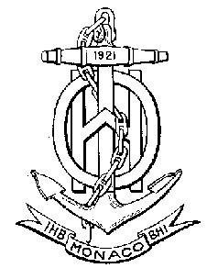 | IHO S-63 Data Protection Scheme  M_ID and M_KEY Request Form  Ed.1.0.1-2016
Form to be returned to:
International Hydrographic Organization
4b, Quai Antoine 1er, BP 445 - MC 98011 MONACO Cedex
Principality of Monaco

Tel: +(377) 93 10 81 00, Telefax: +(377) 93 10 81 40
Part I: To be completed by OEM organisation
Organisation:
Address:
Address:
Address:
Postal number/place: Country:
Tel: Fax: Web:
Administrative point of contact: Technical point of contact:
Name: Name:
Tel: Tel:
E-mail: E-mail:
Please verify the following information is included:
 All fields in Part 1 of this form are completed
 Signed IHO S-63 OEM Agreement, or  already available with IHO Secretariat
 Completed successful testing of application with the M_ID and M_KEY provided with the S-63 test dataset

Signed date: Name:
Part II: To be completed by IHO Secretariat
 Verify Part 1 is completed
 Signed OEM Agreement available, ref.
 Verify OEM does not have a previously issued M_ID and M_KEY
 Assigned M_ID: M_KEY:
 M_ID and M_KEY returned to OEM and all registered Data Servers

Signed date: Name:

