 | INTERNATIONAL TELECOMMUNICATION UNION

ITU-T | R.21
TELECOMMUNICATION  STANDARDIZATION SECTOR  OF ITU | (08/96)

SERIES R: TELEGRAPH TRANSMISSION
Voice-frequency telegraphy

9600 bit/s modem standardized for use in the telegraph TDM system

ITU-T Recommendation R.21
(Previously “CCITT Recommendation”)

ITU-T R-SERIES RECOMMENDATIONS
TELEGRAPH TRANSMISSION

For further details, please refer to ITU-T List of Recommendations.
Telegraph distortion | R.1-R.19
Voice-frequency telegraphy | R.20-R.39
Special cases of alternating current telegraphy | R.40-R.49
Transmission quality | R.50-R.59
Correction of signals | R.60-R.69
Telegraph maintenance | R.70-R.99
Time-division multiplexing | R.100-R.119
Transmission quality above 50 bauds | R.120-R.139
Definitions | R.140-R.149
Availability and reliability of international telegraph circuits | R.150-R.159

FOREWORD
The ITU-T (Telecommunication Standardization Sector) is a permanent organ of the International Telecommunication Union (ITU). The ITU-T is responsible for studying technical, operating and tariff questions and issuing Recommendations on them with a view to standardizing telecommunications on a worldwide basis.
The World Telecommunication Standardization Conference (WTSC), which meets every four years, establishes the topics for study by the ITU-T Study Groups which, in their turn, produce Recommendations on these topics.
The approval of Recommendations by the Members of the ITU-T is covered by the procedure laid down in WTSC Resolution No. 1 (Helsinki, March 1-12, 1993).
ITU-T Recommendation R.21 was prepared by ITU-T Study Group 14 (1993-1996) and was approved under the WTSC Resolution No. 1 procedure on the 16th of August 1996.

___________________

NOTES
1. In this Recommendation, the expression “Administration” is used for conciseness to indicate both a telecommunication administration and a recognized operating agency.
2. The status of annexes and appendices attached to the Series R Recommendations should be interpreted as follows:
– an annex to a Recommendation forms an integral part of the Recommendation;
– an appendix to a Recommendation does not form part of the Recommendation and only provides some complementary explanation or information specific to that Recommendation.

© ITU 1997
All rights reserved. No part of this publication may be reproduced or utilized in any form or by any means, electronic or mechanical, including photocopying and microfilm, without permission in writing from the ITU.

CONTENTS
Page
1 Scope 1
2 Normative references 1
3 Line signal structure 2
4 Requirements to received signals frequency tolerance 2
5 Transmitted power levels 2
6 Modulation method and signal space diagram 2
7 Data signalling and modulation rates 2
8 Received signal conditions 4
9 Interchange circuits 4
10 Synchronization 4
11 Special measures for raising modem immunity 5
12 Testing Facilities 5

Recommendation R.21
Recommendation R.21 (08/96)
9600 bit/s modem standardized for use in the
telegraph tdm system
(Geneva, 1996)
The ITU-T,
considering
(a) that V-Series modems are intended to be used for data transmission;
(b) that characteristics of these modems may preclude their use in telegraph TDM systems;
(c) that telegraph TDM systems serve a great number of subscribers (> 46) simultaneously and claim higher requirements for reliability and quality of the aggregate signal transmission over a bearer circuit;
(d) that a telegraph TDM system should have the possibility to transfer information in one direction when the other one is damaged;
(e) that it is important for TDM systems that resynchronization of modems should be carried out by means of the working signal without the use of special synchronization pattern and handshaking procedure;
(f) that in telegraph TDM systems special measures have already been taken to exclude the occurrence of long sequences “zeros” and “ones”,
recommends the following

1 Scope
This Recommendation defines a modem for use in telegraph TDM systems.
The principal characteristics of this Recommendation are for use on 4-wire leased telephone-type circuits. Other applications, such on the GSTN are for further study.

2 Normative references
The following Recommendations and other references contain provisions which, through reference in this text, constitute provisions of this Recommendation. At the time of publication, the editions indicated were valid. All Recommendations and other references are subject to revision: all users of this Recommendation are therefore encouraged to investigate the possibility of applying the most recent edition of the Recommendations and other references listed below. A list of the currently valid ITU-T Recommendations is regularly published.
– CCITT Recommendation H.22 (1984), Transmission requirements of international voice-frequency telegraph links (at 50, 100 and 200 bauds).
– ITU-T Recommendation M.1020 (1993), Characteristics of special quality international leased circuits with special bandwidth conditioning.
– ITU-T Recommendation M.1025 (1993), Characteristics of special quality international leased circuits with basic bandwidth conditioning.
– CCITT Recommendation V.2 (1980), Power levels for data transmission over telephone lines.
– ITU-T Recommendation V.10 (1993), Electrical characteristics for unbalanced double-current interchange circuits operating at data signalling rates nominally up to 100 kbit/s.
– ITU-T Recommendation V.24 (1993), List of definitions for interchange circuits between Data Terminal Equipment (DTE) and Data Circuit-terminating Equipment (DCE).
– ITU-T Recommendation V.28 (1993), Electrical characteristics for unbalanced double-current interchange circuits.
– CCITT Recommendation V.54 (1988), Loop test devices for modems.

3 Line signal structure

3.1 Carrier frequencies
The total number of carrier frequencies is to be 71.
3.1.1 Subchannel signals should be presented as sections of harmonic oscillation of multiple frequencies that are orthogonal within the:
T = 1/Δf interval
where Δf is the distance between carrier frequencies equal to 43.636 Hz.
3.1.2 By minimum dispersion of total additive and interference noises best 67 frequencies from 71 carrier frequencies fi = Δf (i + 6), i = 1, 2, ..., 71 from 305.455 Hz to 3360 Hz (i.e. operation bandwidth is 3054.545 Hz) are chosen to be working frequencies.
3.1.3 Two pilot frequencies 436.364 and 3229.094 are added to the working frequencies. These pilot frequencies are used as auxiliary frequencies for handling the signal at the receiver side.
3.1.4 Six other frequencies (after selection of better ones) are used to provide structural redundancy in order to raise signal interference immunity.

4 Requirements to received signals frequency tolerance
The carrier frequency tolerance allowance at the transmitter is ± 0.1 Hz. The receiver must be able to operate normally at a frequency shift of ± 7 Hz.

5 Transmitted power levels
The transmitted power level of the aggregate signal must conform to Recommendation V.2.

6 Modulation method and signal space diagram
6.1 The data stream to be transmitted is divided into groups of four consecutive data bits (quadbits). These groups are formed into modulo 1 of 252 bits and then distributed between 63 working subchannels on the quadbit basis. The first bit in time (Q1) of each quadbit is used to determine the signal element amplitude to be transmitted. The second (Q2), third (Q3) and fourth (Q4) bits are encoded as a phase change relative to the phase of the immediately preceding signal element (see Table 1).
6.2 The absolute amplitude of the transmitted signal element is determined by the first bit (Q1) of the quadbit irrespective of the value of the absolute phase of the signal element (see Table 2).
6.3 The initial establishing of the absolute phase is not required.
6.4 The absolute phase diagram of transmitted signal elements at 9600 bit/s must conform to Figure 1.

7 Data signalling and modulation rates
7.1 The data signalling rate shall be 9600 bit/s ± 0.01%. The modulation rate is 39.34 bauds in each subchannel. The length of the working bit is 25.417 ms, the guard interval is 2.5 ms.
7.2 The line signalling in the mode is 9914.753 bit/s. Due to the difference between the line signalling and the data signalling rate (9600 bit/s), the single error correction should be applied.
7.3 The Hamming code with the following parameter is used: the total length of the coded word = 252 bits; the information part of the pattern = 244 bits; the number of redundancy bits = 8.
TABLE 1/R.21

Q2 | Q3 | Q4 | Phase change (Note)
1 | 1 | 1 | 0°
1 | 1 | 0 | 45°
1 | 0 | 0 | 90°
1 | 0 | 1 | 135°
0 | 0 | 1 | 180°
0 | 0 | 0 | 225°
0 | 1 | 0 | 270°
0 | 1 | 1 | 315°
NOTE – The phase change is the actual phase shift in the transition region from one signalling element to the following signalling element.

TABLE 2/R.21

Phase change | Absolute amplitude | Q1
0°, 45°, 90°, 135°,  180°, 225°, 270°, 315° | 0.567 or 1 | 0 or 1

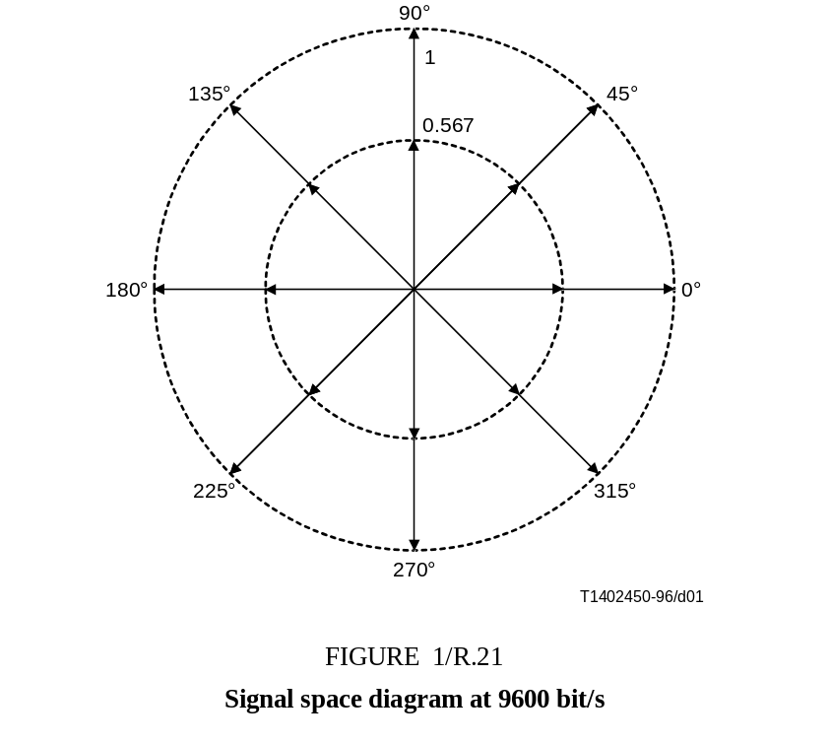

8 Received signal conditions
8.1 The modem must operate on special quality leased circuits conforming to Recommendations M.1020 and M.1025 and over circuits of lower quality at the discretion of the Administration concerned.
8.2 In most cases the telephone type bearer circuits conforming to Recommendation H.22 could be used.
8.3 When the modem is operating on a composite channel where the number of retransmit sections is more than two, the automatic “rough” non-adaptive correction of the amplitude/frequency (AFC) and signal transfer delay/frequency (STD) characteristics of the bearer circuits should be used. The tolerances on STD and AFC within the working frequency range of the modem should be ± 0.5 ms and ± 1 dB respectively.
8.4 The selection of necessary testing signals for automatic line distortion correction in the bearer circuit is the subject for further study.

9 Interchange circuits

9.1 List of interchange circuits (Table 3)
Table 3 lists the V.24 circuits which apply.
TABLE 3/R.21
Interchange circuits

No. | Description
102 | Signal ground or common return
103 | Transmitted data
104 | Received data
109 | Data channel received line signal detector
113 | Transmitter signal element timing
115 | Receiver signal element timing (DTE source)
141 | Local loopback (optional)
142 | Test indicator (optional)

9.2 Threshold of circuit 109
– greater than –26 dBm: circuit 109 ON;
– less than –31 dBm: circuit 109 OFF.
9.3 The electrical characteristics of the interchange circuits comply with Recommendation V.28 (Recommendation V.10).

10 Synchronization
10.1 The use of the special synchronizing signals in the modem is not provided. Only working signals should be used for this purpose.
10.2 The detection accuracy of the significant modulation transition shall be 1-2% of the unit element length.
10.3 The retiming period shall not exceed 0.6-1.0 s with the probability of 0.9.
10.4 The synchronization period should be not less than 10 s in the presence of 0.1-0.3 ms impulse noise and short interruptions in the bearer circuit. These values are subject to further study.

11 Special measures for raising modem immunity
The following information is provided to assist equipment manufacturers.

11.1 Improvement of frequency selectivity in the receiver subchannels
To improve immunity in the presence of interference and frequency shift distortions in the bearer circuits, it is necessary to multiply the receiving signal by the auxiliary reference signal of special form. The characteristics of this reference signal are for further study.

11.2 Power level redistribution between subchannels
To improve the modem immunity in the presence of AFC irregularity, it is necessary to redistribute the power levels between subchannels. In this way the proper predistortion coefficients should be introduced for all subchannels on the sending side.

11.3 The use of signal structure redundancy
To improve the modem immunity, the structure redundancy of subchannels should be predetermined. These subchannels could be used as an alternative for replacing the “low” quality subchannels. The criteria of subchannel selection is for further study.

12 Testing Facilities
Optionally, test loop 3, as specified in Recommendation V.54, could be provided.
ITU-T Recommendations series
Series A Organization of the work of the ITU-T
Series B Means of expression
Series C General telecommunication statistics
Series D General tariff principles
Series E Telephone network and ISDN
Series F Non-telephone telecommunication services
Series G Transmission systems and media
Series H Transmission of non-telephone signals
Series I Integrated services digital network
Series J Transmission of sound-programme and television signals
Series K Protection against interference
Series L Construction, installation and protection of cables and other elements of outside plant
Series M Maintenance: international transmission systems, telephone circuits, telegraphy, facsimile and leased circuits
Series N Maintenance: international sound-programme and television transmission circuits
Series O Specifications of measuring equipment
Series P Telephone transmission quality
Series Q Switching and signalling
Series R Telegraph transmission
Series S Telegraph services terminal equipment
Series T Terminal equipments and protocols for telematic services
Series U Telegraph switching
Series V Data communication over the telephone network
Series X Data networks and open system communication
Series Z Programming languages

