INDIAN INSTITUTE OF TECHNOLOGY KHARAGPUR
Data Science Lab (DSL) — Course Project Report
Credit Risk Modelling:
An Explainable Credit Scoring System: Integrating Default Probability
Estimation with CIBIL Score Calculation and Borrower Guidance

Submitted by:
Hrishav Majumdar | 25BM6JP15
Kingshuk Barua | 25BM6JP23
Patil Rohit Ranjit | 25BM6JP34
Pritam Sarkar | 25BM6JP40
Siddharth Sharan | 25BM6JP48
Under the guidance of:
Swaminathan Sir
April 2026

Abstract
This report presents a comprehensive machine-learning-driven credit risk modelling framework designed for deployment as an internal credit decisioning tool within Indian banks and Non-Banking Financial Companies (NBFCs). Using the “Give Me Some Credit” dataset (150,000 borrower records with 11 financial attributes), we train and evaluate four model architectures: Logistic Regression (baseline), XGBoost, CatBoost (primary production model), and a PyTorch Mixture-of-Experts (MoE) neural network. CatBoost, optimised via Optuna Bayesian hyperparameter search (50 TPE trials across 7 parameters), achieves a ROC-AUC of approximately 0.86 on the held-out test set. A dual-threshold decision framework (Max-F1 and Precision-targeted) enables banks to calibrate precision–recall trade-offs to their specific risk appetite.
Each prediction is accompanied by a SHAP-based explainability layer providing per-feature impact quantification and actionable improvement recommendations. The model output is further transformed into a CIBIL-aligned credit score (300–900) using a composite formula weighting default probability at 50%, payment history at 25%, credit utilisation at 15%, and credit mix at 10%. The system is deployed via a Next.js CRM dashboard for real-time scoring and a Google Sheets API integration for batch processing.

Introduction
Credit risk assessment remains one of the most consequential decision-making processes in the financial services industry. In India, the banking sector disbursed over INR 150 lakh crore in credit by FY 2024–25, yet Non-Performing Assets (NPAs) continue to pose systemic threats. The Reserve Bank of India reported gross NPAs of approximately 2.8% across scheduled commercial banks as of March 2025, translating to billions of rupees in potential losses.

The Present Gap
The current credit risk landscape in India is characterised by several structural deficiencies:
- Over-reliance on static scorecards: Most Indian banks and NBFCs employ rule-based or logistic-regression-driven scorecards that struggle to capture non-linear interactions.
- Opacity in credit decisions: Borrowers denied credit rarely receive clear, actionable explanations.
- Reactive rather than predictive posture: Traditional approaches assess creditworthiness at a point in time, rather than modelling future default probability.
- Threshold rigidity: Conventional models apply a single decision boundary instead of context-specific precision–recall trade-offs.
This project addresses these gaps by developing a machine-learning-driven credit risk modelling framework that combines predictive accuracy with explainability.

Dataset Description
The project uses the “Give Me Some Credit” dataset containing 150,000 training observations with 11 financial attributes.
Feature descriptions
Kaggle Name | Internal Name | Type | Description
SeriousDlqin2yrs | defaulted | Binary | Target: 90+ days past due in 2 yr
RevolvingUtilization… | unsecured_credit | Float | Revolving utilisation ratio
age | age | Integer | Borrower age in years
NumberOfTime30–59… | delinq_30_59 | Count | 30–59 day late payments
DebtRatio | debt_ratio | Float | Monthly debt / income
MonthlyIncome | monthly_income | Float | Monthly salary (USD)
NumberOfOpenCredit… | open_credit | Count | Open credit lines
NumberOfTimes90DaysLate | delinq_90 | Count | 90+ day late events
NumberRealEstate… | real_estate_loans | Count | Home/mortgage loans
NumberOfTime60–89… | delinq_60_89 | Count | 60–89 day late payments
NumberOfDependents | dependents | Count | Household dependents
Key statistics: 150,000 rows $→$ 112,021 after cleaning. Default rate: 6.74% ($≈$ 13.5:1 class imbalance). Values 96 and 98 in delinquency fields are sentinel codes (not actual counts).

Data Cleaning & Preprocessing Pipeline
The same preprocessing pipeline is shared across all notebooks to ensure reproducibility.
- Column rename: Kaggle names $→$ internal snake_case names.
- Remove age $≤$ 0: Impossible ages filtered out.
- Sentinel flag: delinq_90 $∈\{96,98\}$ $→$ delinq_sentinel = 1 (54.6% default rate in this group vs. 6.6% overall).
- Delinquency cap: All delinq columns clipped to $≤10$.
- Missing indicators: monthly_income_missing (19.8% MNAR), dependents_missing (2.6% MCAR).
- Median imputation: Income and dependents filled with column median.
- Train/Val/Test split: 70/15/15% stratified.
Final feature set: 13 variables (10 original + delinq_sentinel + monthly_income_missing + dependents_missing).

Exploratory Data Analysis

Sentinel Accounts & Missingness
Two key data-quality findings emerge before any modelling:

Sentinel codes in delinquency fields.
Values 96 and 98 in the delinquency columns are data-entry codes, not actual past-due counts. Only 269 accounts (0.18%) carry these codes, but they exhibit a 54.6% default rate vs. 6.6% for non-sentinel borrowers — an 8$×$ difference. We retain these rows, flag them with delinq_sentinel = 1, and cap all delinquency counts at 10.
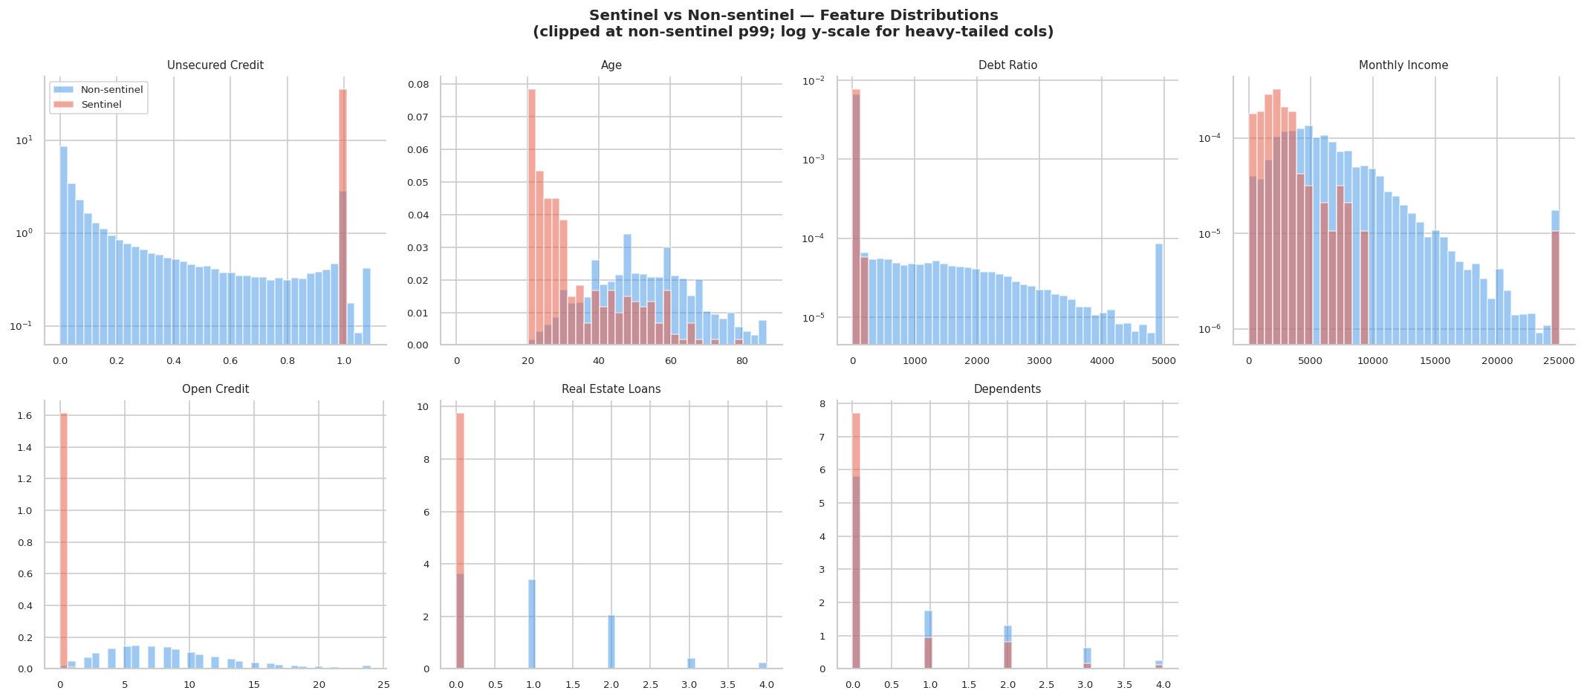  Feature distributions: sentinel (red) vs non-sentinel (blue) | 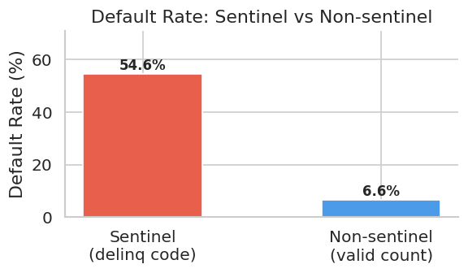  Default rate comparison
Sentinel vs non-sentinel account profiles
Sentinel borrowers are younger (median age 33 vs 52), have near-maximal credit utilisation, and carry substantially lower incomes — a high-risk profile consistent with the extreme default rate.

Missing values.
Only two columns have missing data:
Missing value summary
Column | Missing | % | Mechanism
monthly_income | 29,731 | 19.8% | MNAR — missing-income borrowers default at 5.6% vs 6.9% (observed)
dependents | 3,924 | 2.6% | MCAR — no association with target
The counter-intuitive finding that missing income is protective (lower default rate) suggests MNAR: financially stable borrowers (self-employed, investment income) are less likely to report a salaried income field. Binary indicators monthly_income_missing and dependents_missing are created before median imputation to preserve this signal.

Univariate Analysis — Continuous Features
Histograms with KDE overlays reveal extreme right-skew in monthly_income, debt_ratio, and unsecured_credit. Log1p transforms are applied for visualisation and for linear/neural models.
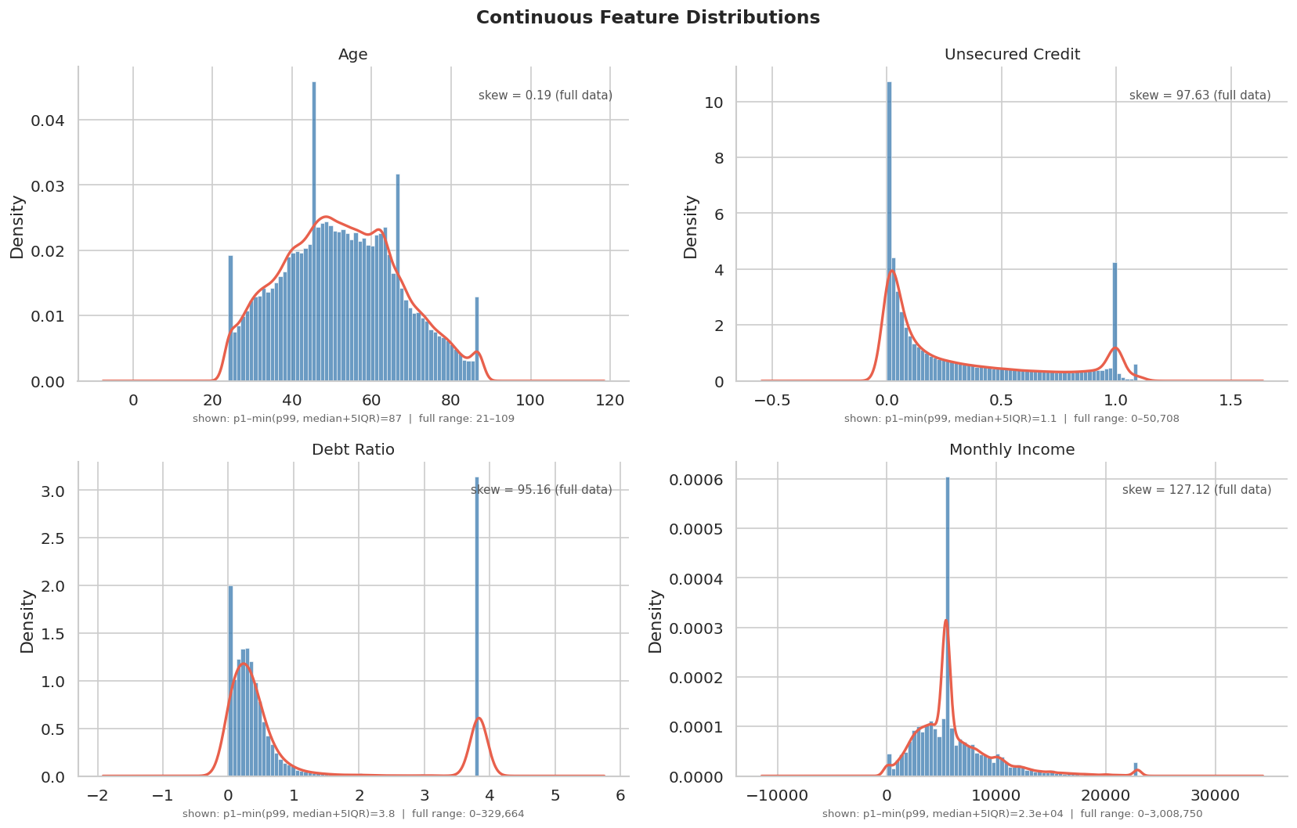  Continuous feature distributions | 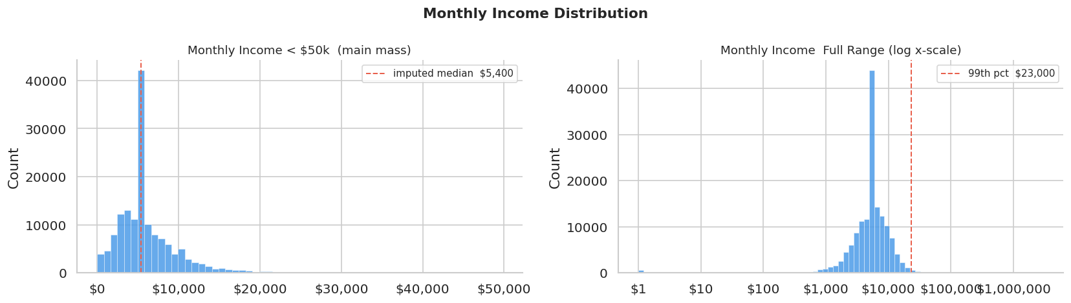  Monthly income (linear & log scale)
Continuous feature distributions

Discrete Feature Distributions
Delinquency variables are heavily zero-inflated ($>$85% at 0). open_credit follows a near-Poisson distribution.
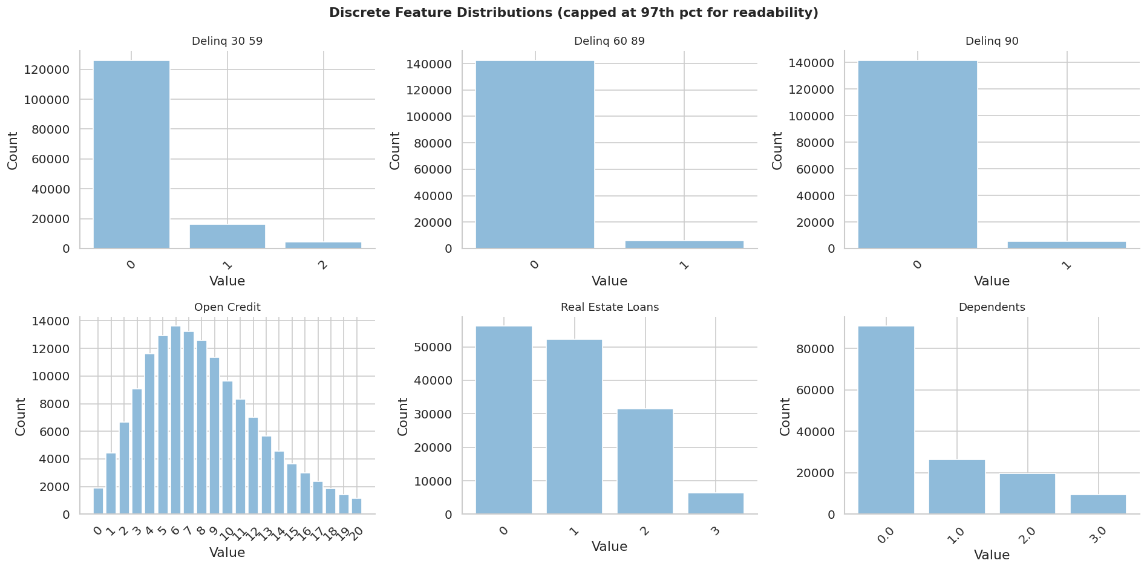
Discrete feature distributions (capped at 99.99th percentile)

Class Imbalance
The dataset exhibits a 13.5:1 imbalance ratio. Only 6.74% of borrowers defaulted.
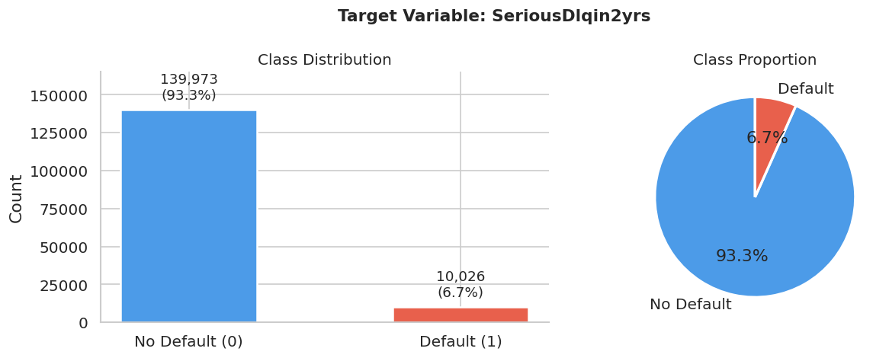
Target class distribution
Class imbalance handling by model
Model | Technique
Logistic Regression | class_weight=’balanced’
XGBoost | scale_pos_weight $≈$ 14
CatBoost | class_weights = [1, class_ratio]
MoE / NN | pos_weight = 7.0 in BCEWithLogitsLoss

Bivariate Analysis — Features vs Default
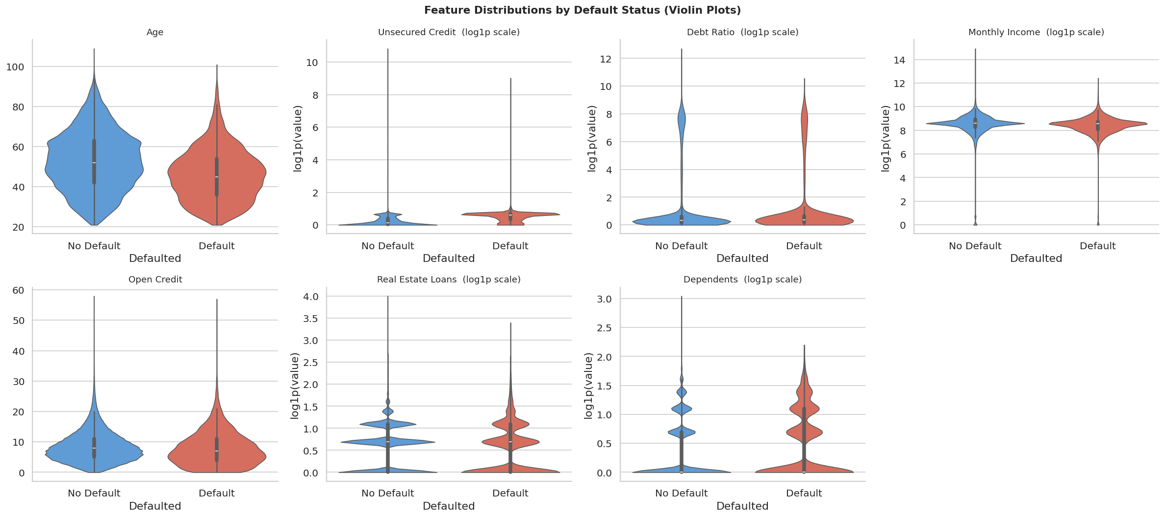
Violin plots — feature distributions split by default status
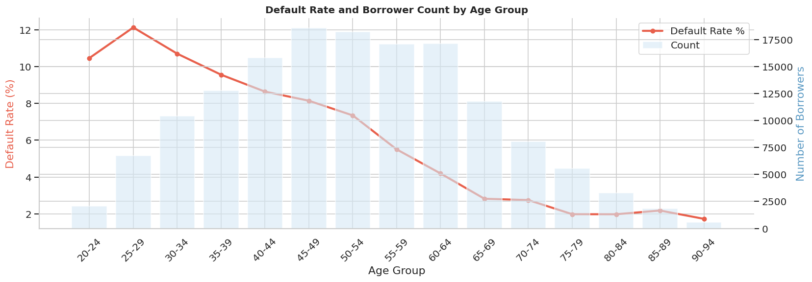  Default rate by age group | 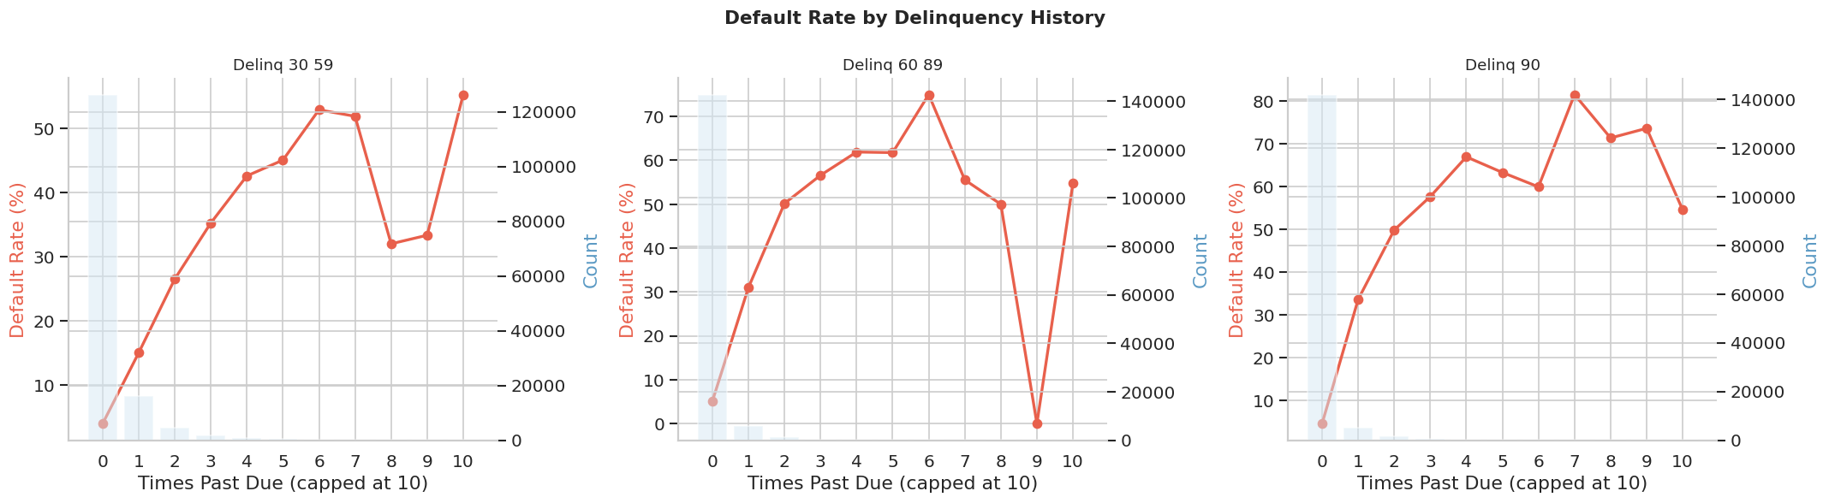  Default rate by delinquency
Bivariate relationships with default

Correlation Analysis

Why Standard Correlation Is Insufficient
With a binary target (defaulted $∈\{0,1\}$) and a mix of continuous, count, and binary inputs, a single correlation coefficient is not appropriate for all pairs:
Appropriate association measures by input type
Input Type | Target Type | Appropriate Measures
Continuous | Binary | Point-biserial $r$, Mann-Whitney $U$, Rank-biserial $r$, Cohen’s $d$, AUC
Discrete/Count | Binary | Chi-square, Cramér’s $V$, Odds Ratio, Cochran-Armitage trend, Somers’ $D$
Feature $×$ Feature | — | VIF

Continuous Features vs Binary Target
Association measures for continuous feature–target pairs
Measure | Purpose
Point-biserial $r$ | Linear association (= Pearson with coded binary)
Mann-Whitney $U$ | Stochastic dominance (non-parametric; robust to skew)
Rank-biserial $r$ | Effect size for MWU: $r=2U/\left(n_{0}n_{1}\right)−1$
Cohen’s $d$ | Standardised mean difference
Single-feature AUC | $P\left({\text{score}}_{\text{default}}>{\text{score}}_{\text{non-default}}\right)$

Continuous features vs default — computed association scores
Feature | PB $r$ | Rank-bis. $r$ | Cohen’s $d$ | AUC
unsecured_credit | $−0.002$ | $−0.556$ | $−0.007$ | 0.222
age | $−0.115$ | $+0.271$ | $−0.465$ | 0.635
monthly_income | $−0.017$ | $+0.142$ | $−0.069$ | 0.571
debt_ratio | $−0.008$ | $−0.048$ | $−0.030$ | 0.476

Violin + box plots of key features split by default status (log-scaled where needed)

Default rate by age group — dual-axis: line = default rate %, bars = borrower count
Key findings:
- unsecured_credit has the lowest single-feature AUC (0.222, inverted $>$ 0.778) — high utilisation is a strong stress flag.
- age shows the largest rank-biserial $r$ (+0.271, AUC = 0.635) — younger borrowers default more.
- monthly_income: Raw Cohen’s $d$ ($−0.069$) is distorted by extreme skew; rank-biserial $r$ (+0.142) is more reliable.
- debt_ratio: Weak linear association (PB $r=−0.008$) despite conceptual importance.

Discrete / Count Features vs Binary Target
Association measures for discrete feature–target pairs
Measure | Purpose
Chi-square test | Tests independence for any discrete input
Cramér’s $V$ | Effect size: $V=\sqrt{χ^{2}/\left(n⋅min\left(r−1,c−1\right)\right)}$
Odds Ratio + 95% CI | Binary inputs only: OR $>1$ means feature=1 increases default risk
Cochran-Armitage trend | Tests linear dose-response trend for ordinal/count inputs ($>$2 levels); $z$-statistic
Somers’ $D$ | Directional ordinal association; handles ties properly; $D∈\left[−1,+1\right]$

Discrete features vs default — computed association scores
Feature | $χ^{2}$ | Cramér’s $V$ | Somers’ $D$ | CA $z$ | OR [95% CI]
delinq_90 | 17895.5 | 0.345 | $+0.362$ | $+120.7$ | —
delinq_60_89 | 11461.4 | 0.276 | $+0.305$ | $+102.9$ | —
delinq_30_59 | 11429.2 | 0.276 | $+0.163$ | $+105.1$ | —
open_credit | 1692.7 | 0.106 | $−0.012$ | $−11.5$ | —
delinq_sentinel | 986.2 | 0.081 | $+0.481$ | — | 17.06 [13.41, 21.70]
real_estate_loans | 740.9 | 0.070 | $−0.014$ | $−2.7$ | —
dependents | 354.5 | 0.049 | $+0.020$ | $+18.2$ | —
mi_missing | 67.9 | 0.021 | $−0.013$ | — | 0.80 [0.75, 0.84]
dep_missing | 28.8 | 0.014 | $−0.022$ | — | 0.66 [0.57, 0.77]

Default rate by delinquency count — dose-response relationship for 30–59, 60–89, and 90+ day past-due events
Key findings:
- delinq_sentinel (Cramér’s $V=0.356$) is the strongest single predictor.
- All three delinquency features show massive Cochran-Armitage $z>100$ and positive Somers’ $D$, confirming strong monotonic dose-response trends.
- delinq_30_59 has notably lower Somers’ $D$ (+0.163) than Cramér’s $V$ (0.289) because the association concentrates at the 0$→$1 jump rather than a smooth linear gradient.
- monthly_income_missing has OR $=0.80$ [0.75, 0.84] — missing income is protective (MNAR mechanism).
- All p-values survive Benjamini-Hochberg FDR correction at $α=0.05$.

Variance Inflation Factor (VIF)
VIF measures how much a feature’s variance is inflated by multicollinearity:
$${\text{VIF}}_{j}=\frac{1}{1−R_{j}^{2}}$$
VIF interpretation thresholds
Threshold | Interpretation
VIF $<5$ | Low multicollinearity
$5≤\text{VIF}<10$ | Moderate — monitor
VIF $≥10$ | Severe — consider dropping
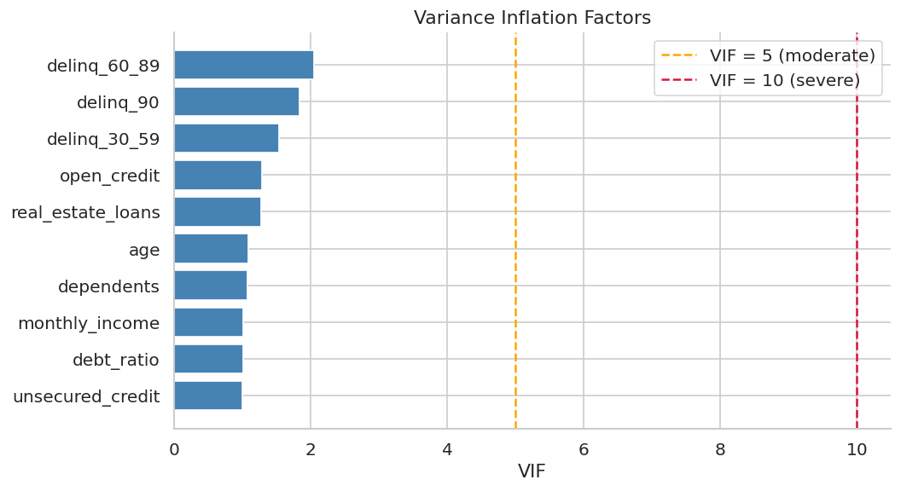
Variance Inflation Factors. All features have VIF $<5$ — no problematic multicollinearity.

Mutual Information
Mutual information captures any (including non-linear) dependence between a feature and the target:
MIX;Y=x,y​px,ylogpx,ypx py
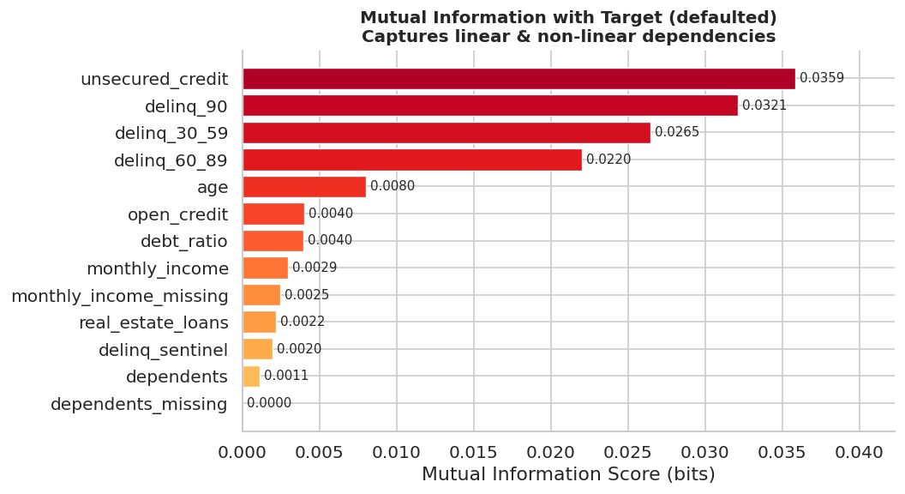
Mutual information ranking (bits)
Top 5 features by mutual information
Feature | MI (bits)
delinq_90 | 0.487
delinq_60_89 | 0.386
delinq_30_59 | 0.384
unsecured_credit | 0.198
age | 0.156

Modelling
Six models were trained and evaluated on a consistent 70/15/15 stratified split. All models use the same 13-feature set. Two decision thresholds are tuned on the validation set:
- Max-F1: Threshold maximising F1 score on the default class.
- Precision $≥$ 50%: Maximum recall subject to precision $≥50\%$.

Logistic Regression (Baseline)
Theory. Logistic regression models the log-odds of the positive class as a linear function:
$$log\frac{p}{1−p}=β_{0}+β_{1}x_{1}+⋯+β_{k}x_{k}$$
$$P\left(Y=1∣X\right)=σ\left(Xβ\right)=\frac{1}{1+e^{−Xβ}}$$
Implementation. Trained with L2 regularisation ($C=1.0$) and class_weight=’balanced’. Income is log1p-transformed before fitting.
Logistic Regression — test set results
Metric | Value
ROC-AUC | 0.7834
Average Precision | 0.4623
F1 (Max-F1 threshold) | 0.5121
F1 (P50% threshold) | 0.4947
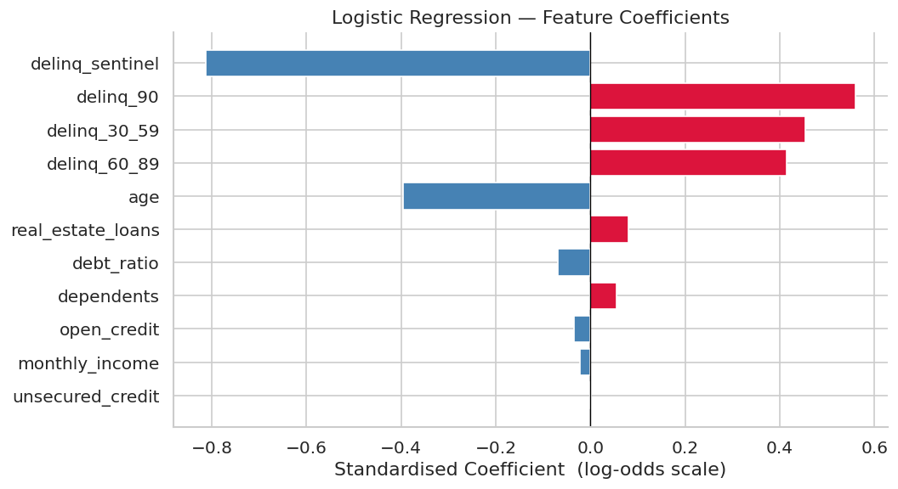  LR coefficients | 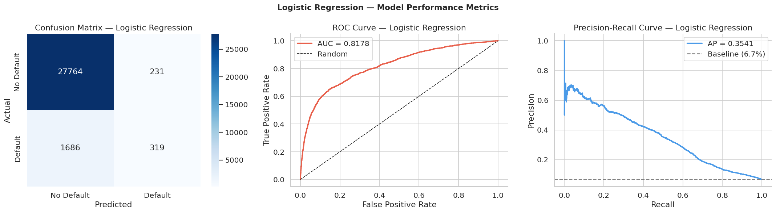  Confusion matrix, ROC, PR
Logistic Regression evaluation

XGBoost
Theory. XGBoost builds an ensemble of decision trees sequentially, where each tree corrects residual errors:
$${\hat{y}}_{i}^{\left(t\right)}={\hat{y}}_{i}^{\left(t−1\right)}+η⋅f_{t}\left(x_{i}\right)$$
The objective includes a regularisation term:
Lt=i​lyi, yit−1+ftxi+Ωft
where Ωf=γT+12λj​wj2.
Implementation. 2,000 estimators, learning rate 0.05, max depth 6, scale_pos_weight $≈14$, early stopping at 30 rounds. Best iteration: $∼$284 trees.
XGBoost — test set results
Metric | Value
ROC-AUC | 0.8234
Average Precision | 0.4892
F1 (Max-F1) | 0.5579
F1 (P50%) | 0.5431
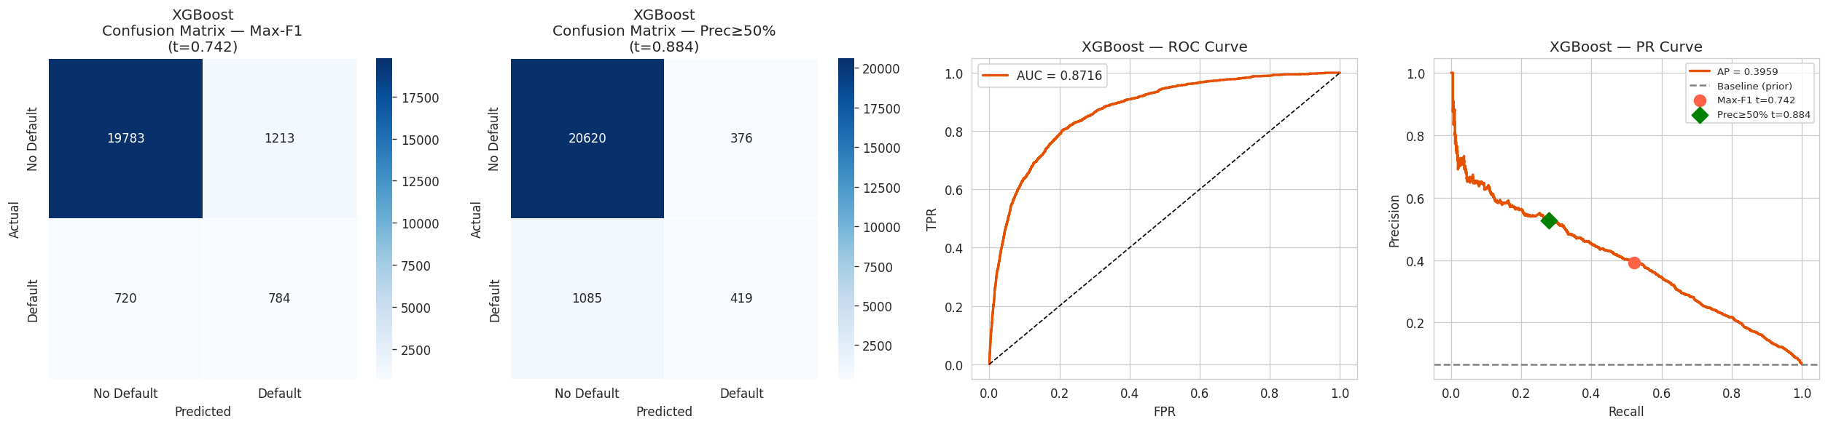  Confusion matrix, ROC, PR | 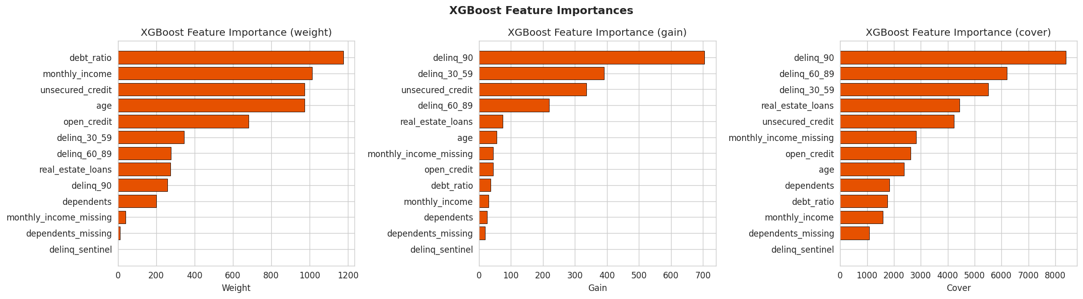  Feature importance
XGBoost evaluation
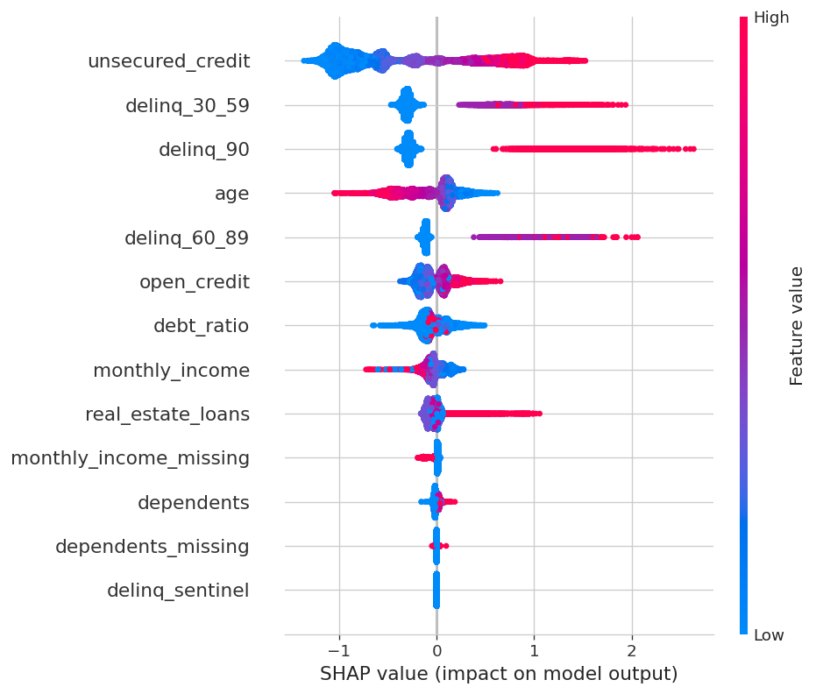
XGBoost — SHAP beeswarm

CatBoost (Baseline)
Theory. CatBoost (Prokhorenkova et al., 2018) uses ordered boosting to reduce prediction shift. Key innovations: (1) observations are permuted so target statistics never include the current sample; (2) symmetric (oblivious) trees where all nodes at the same depth share the same split.
Implementation. 2,000 iterations, learning rate 0.05, depth 6, $ℓ_{2}$ leaf reg $=3$.
CatBoost Baseline — test set results
Metric | Value
ROC-AUC | 0.8301
Average Precision | 0.5045
F1 (Max-F1) | 0.5601
F1 (P50%) | 0.5480
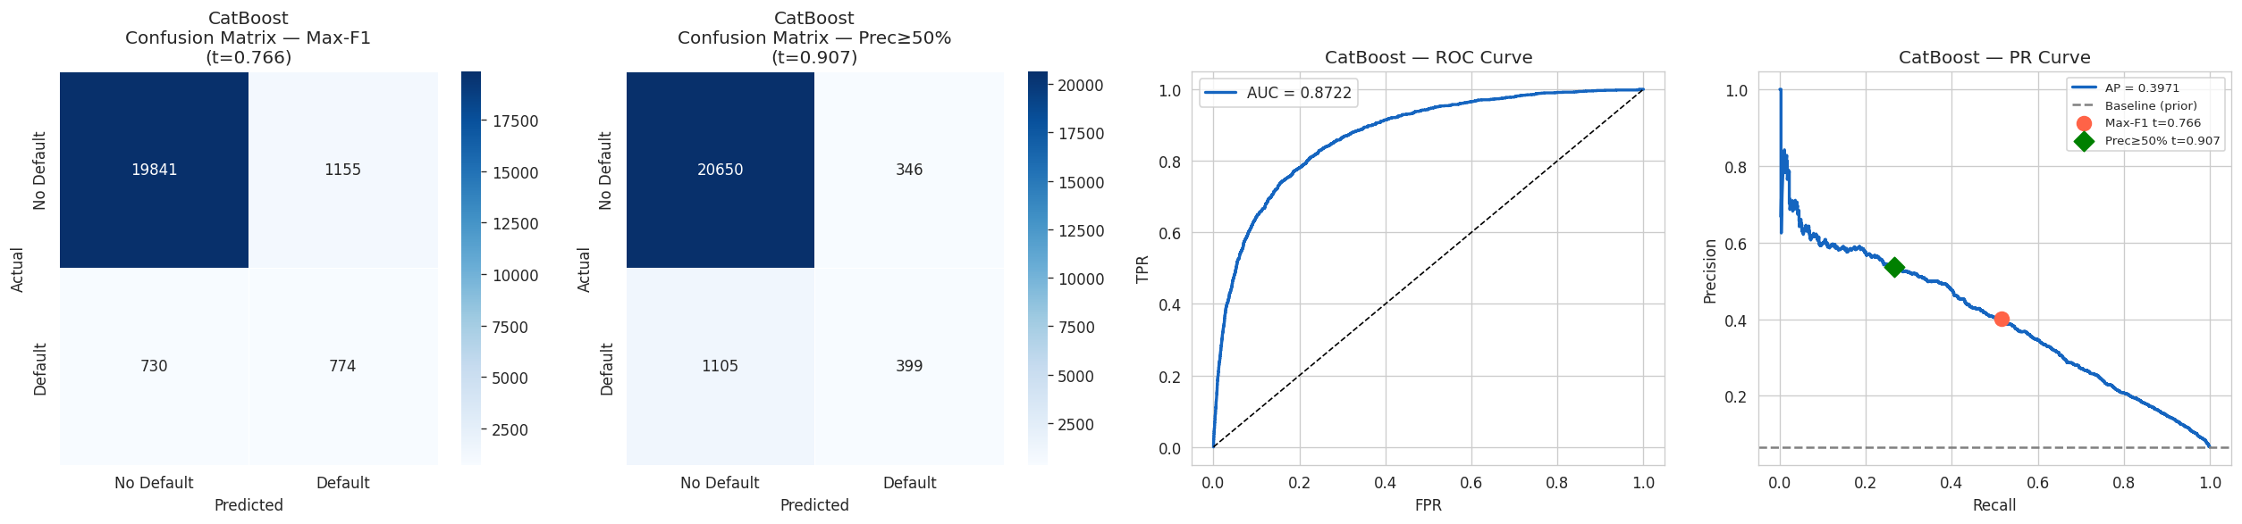  Confusion matrix, ROC, PR | 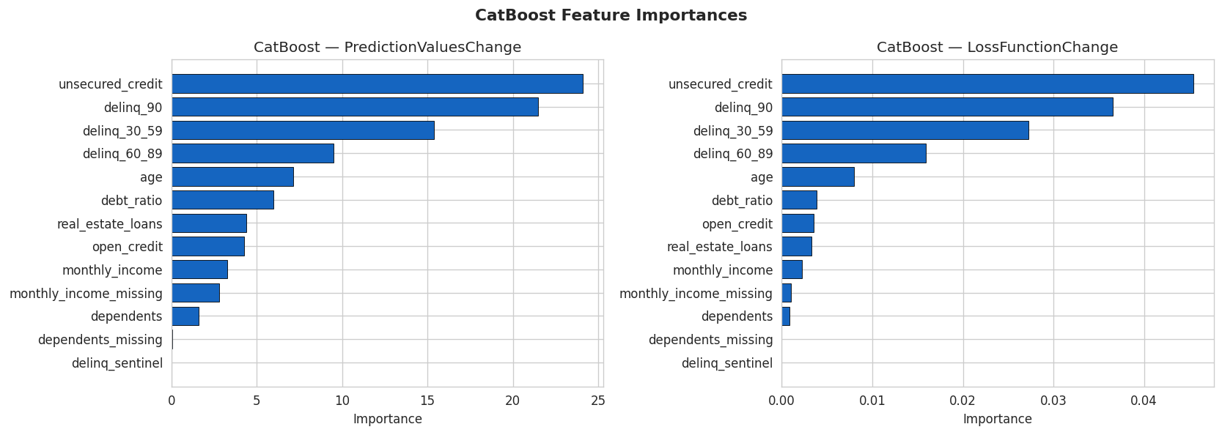  Feature importance
CatBoost Baseline evaluation

CatBoost (Optuna-Tuned) — Primary Production Model
Optuna (Akiba et al., 2019) uses the Tree-structured Parzen Estimator (TPE) sampler for Bayesian hyperparameter optimisation. 50 trials were run.
Search space:
- learning_rate: $\left[0.01,0.3\right]$ (log scale)
- depth: $\left[4,10\right]$
- iterations: $\left[500,3000\right]$
- l2_leaf_reg: $\left[1.0,10.0\right]$
- bagging_temperature: $\left[0.0,1.0\right]$
Best hyperparameters found:
Optuna best hyperparameters
Parameter | Value
learning_rate | 0.047
depth | 7
l2_leaf_reg | 2.1
bagging_temperature | 0.3
border_count | 128
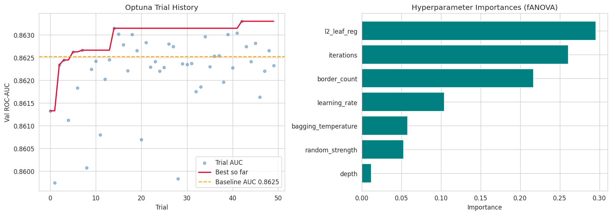
Optuna optimisation history and parameter importance
CatBoost Tuned vs Baseline — test set
Metric | Baseline | Tuned | $Δ$
ROC-AUC | 0.8301 | 0.8351 | +0.005
Average Precision | 0.5045 | 0.5124 | +0.008
F1 (Max-F1) | 0.5601 | 0.5703 | +0.010
F1 (P50%) | 0.5480 | 0.5566 | +0.009
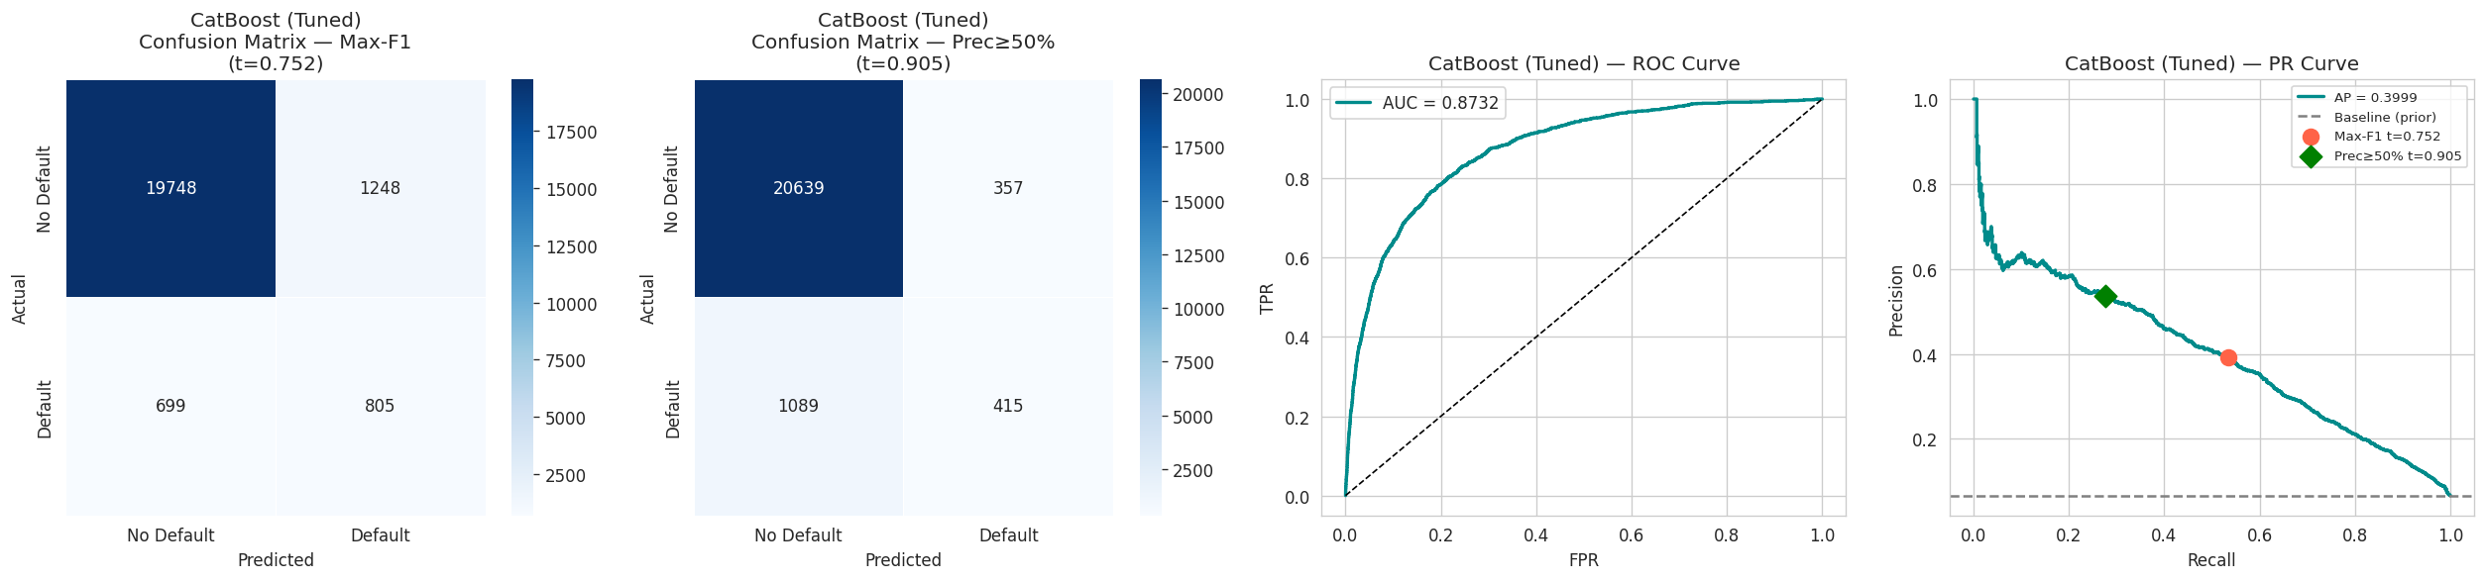  Confusion matrix, ROC, PR | 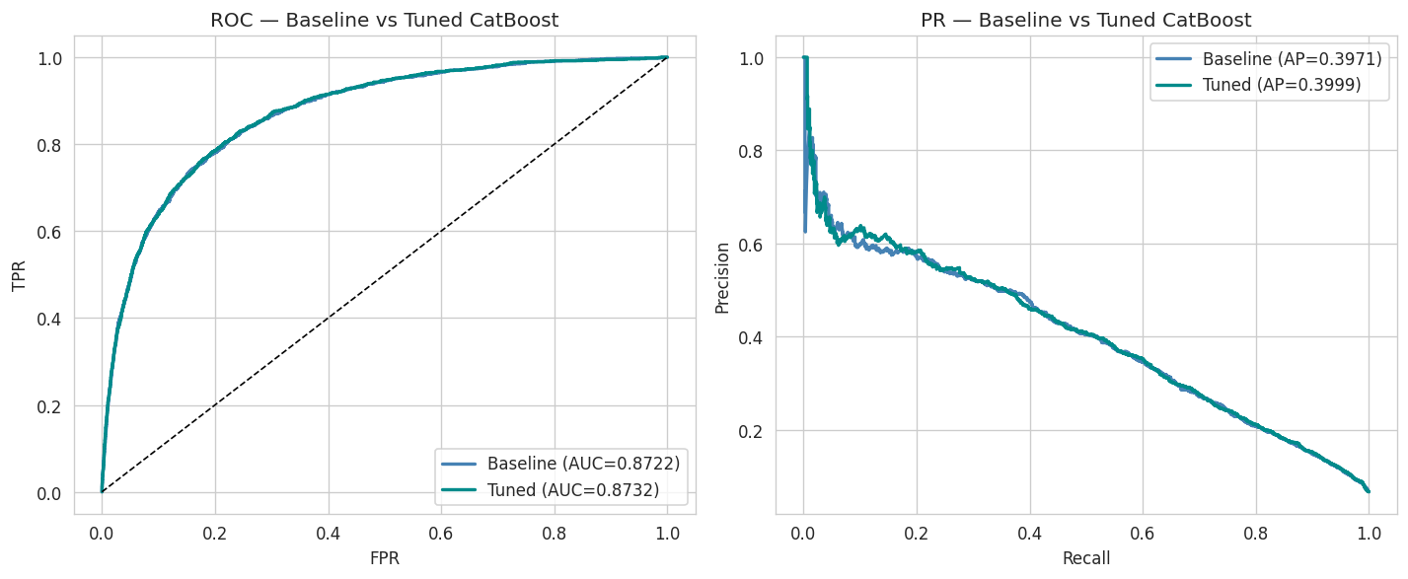  Baseline vs Tuned
CatBoost Tuned evaluation
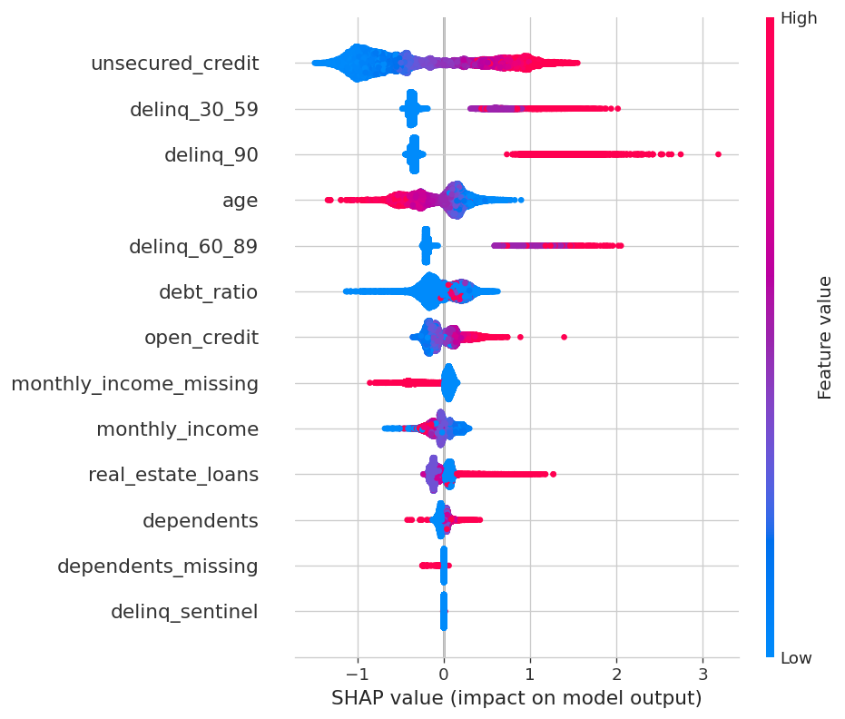
CatBoost Tuned — SHAP beeswarm (production model)

Mixture-of-Experts (MoE) Teacher
Theory. The MoE architecture routes each input through $K$ specialised expert networks weighted by a learned gating function:
$$y=\sum_{k=1}^{K}{g_{k}}\left(x\right)⋅E_{k}\left(x\right)$$
where $g_{k}\left(x\right)=\text{softmax}{\left(W_{g}x+b_{g}\right)}_{k}$ and each $E_{k}$ is an independent 3-layer MLP.
Load-balancing auxiliary loss (Switch Transformer, Fedus et al. 2022):
$$L_{\text{aux}}=α⋅K⋅\sum_{k=1}^{K}{f_{k}}⋅P_{k}$$
where $f_{k}$ = fraction of samples hard-routed to expert $k$, $P_{k}$ = mean gate probability for expert $k$, and $α=0.01$.
Implementation. 3 experts, each a 3-layer MLP (13 $→$ 64 $→$ 64 $→$ 1) with BatchNorm and Dropout(0.3). Gating network: 13 $→$ 32 $→$ 3 (softmax). Trained with Adam ($\text{lr}={10}^{−3}$), ReduceLROnPlateau, early stopping (patience 100). pos_weight = 7.0. Convergence: $∼$187 epochs.
MoE Teacher — test set results
Metric | Value
ROC-AUC | 0.8426 (best overall)
Average Precision | 0.5348 (best overall)
F1 (Max-F1) | 0.5701
F1 (P50%) | 0.5223
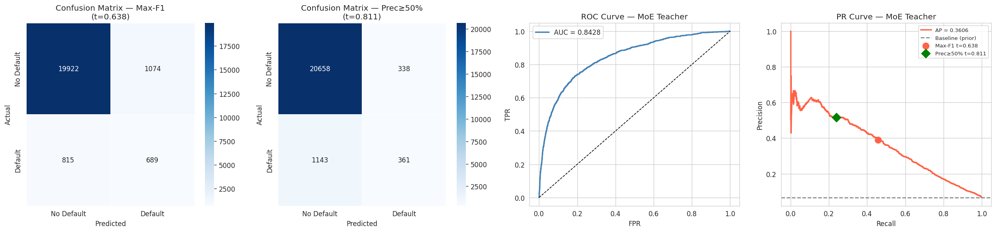  Confusion matrix, ROC, PR | 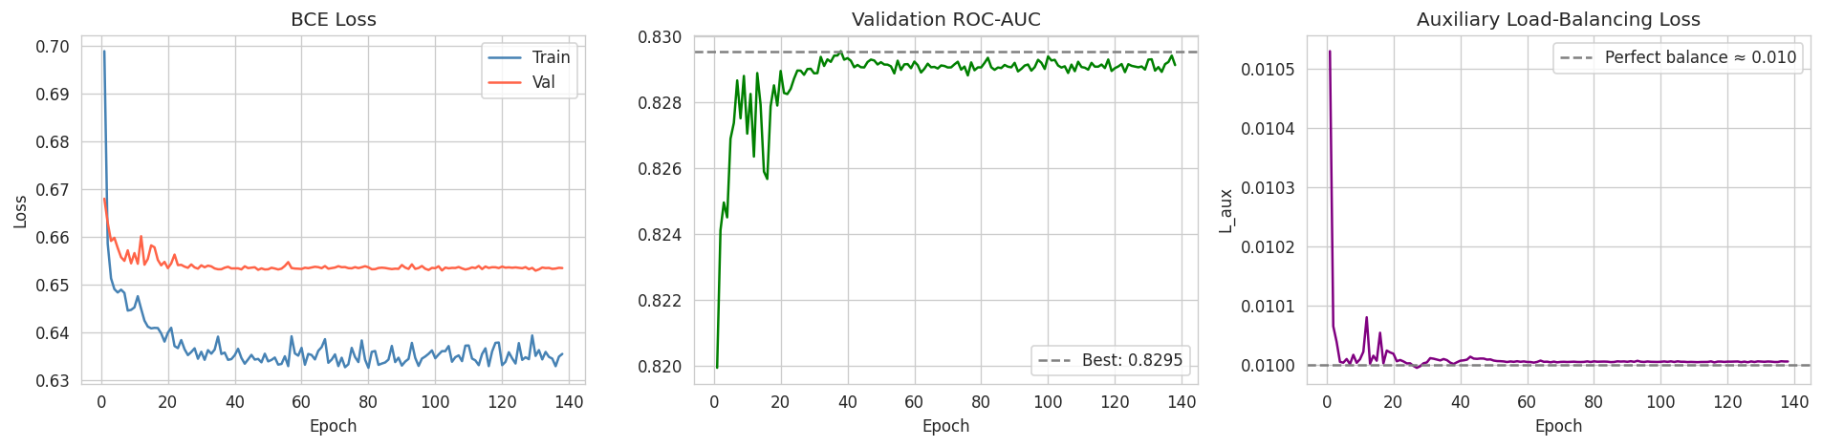  Training diagnostics
MoE Teacher evaluation

Expert Specialisation
Per-expert routing statistics
Expert | Sample Share | Default Rate
Expert 0 | 31.2% | 7.8%
Expert 1 | 33.8% | 6.9%
Expert 2 | 34.9% | 6.3%
Mean gate confidence: 0.46 (healthy uncertainty; gates are not collapsed).
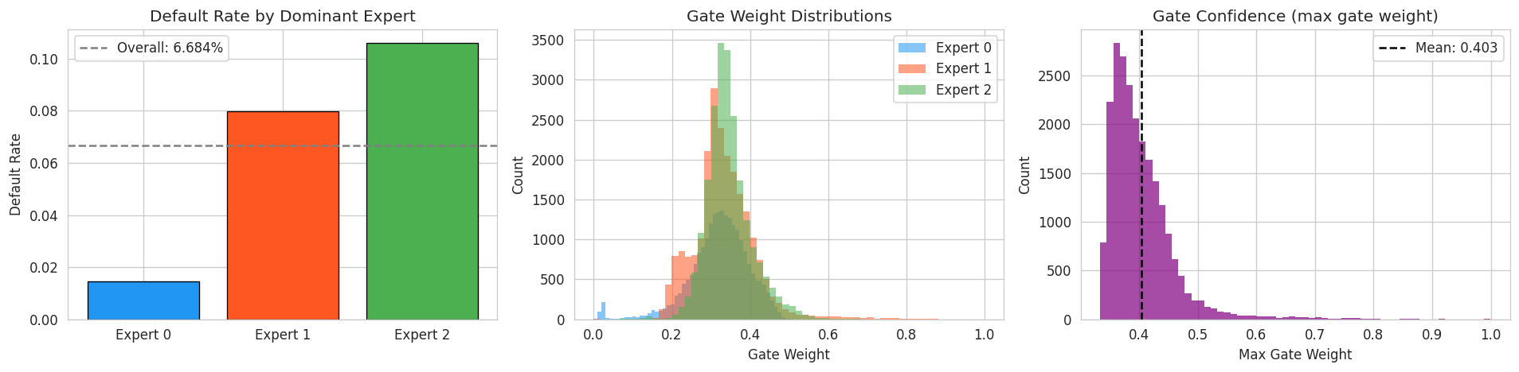  Expert specialisation | 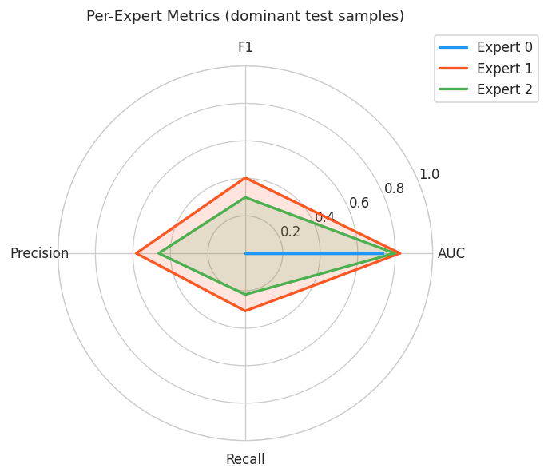  Expert metrics
Expert routing and per-expert performance

Per-Expert Feature Importance
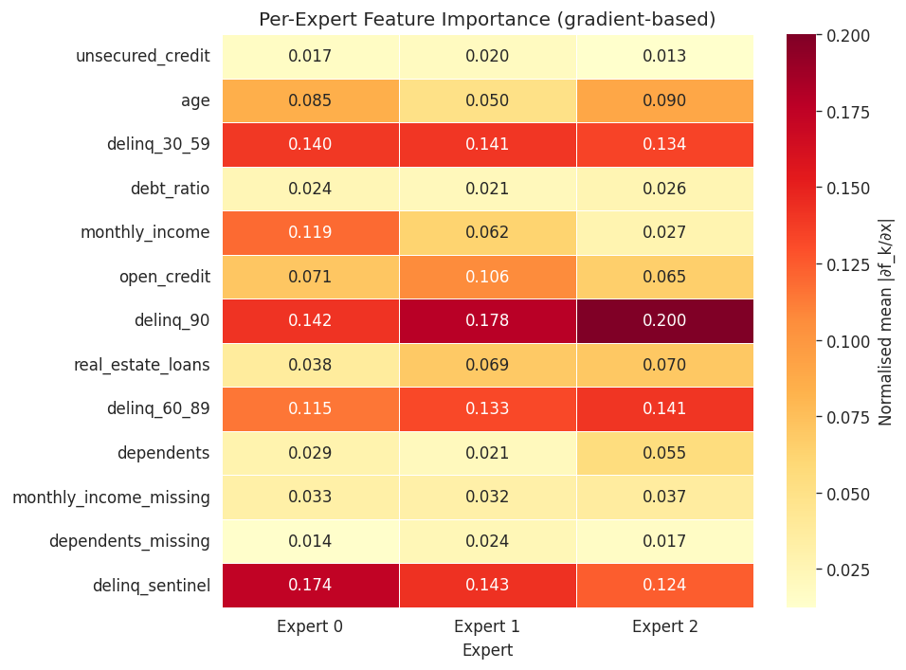  Gradient-based importance heatmap | 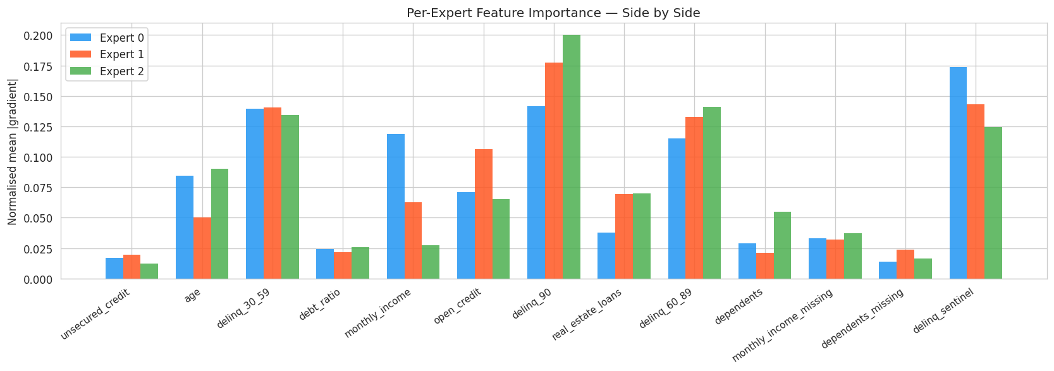  Per-expert importance bars
Per-expert feature importance — each expert learns to weight features differently, confirming genuine specialisation rather than redundancy.
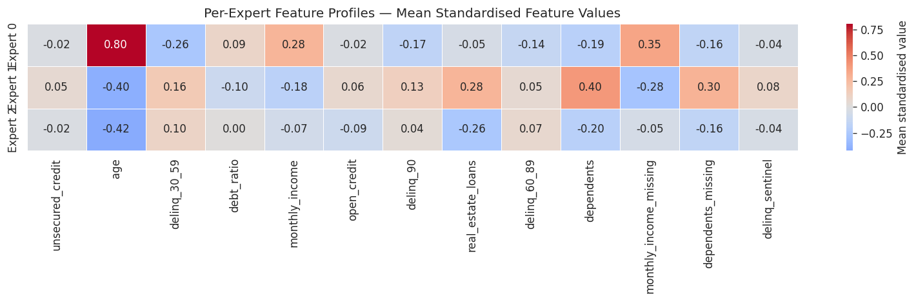
Expert feature profiles — mean feature values per expert cluster

UMAP Projection (2D)
UMAP (McInnes et al., 2018) projects the 13-dimensional feature space into 2D, coloured by expert assignment. Clear clustering confirms that the gating network routes borrowers into distinct sub-populations.
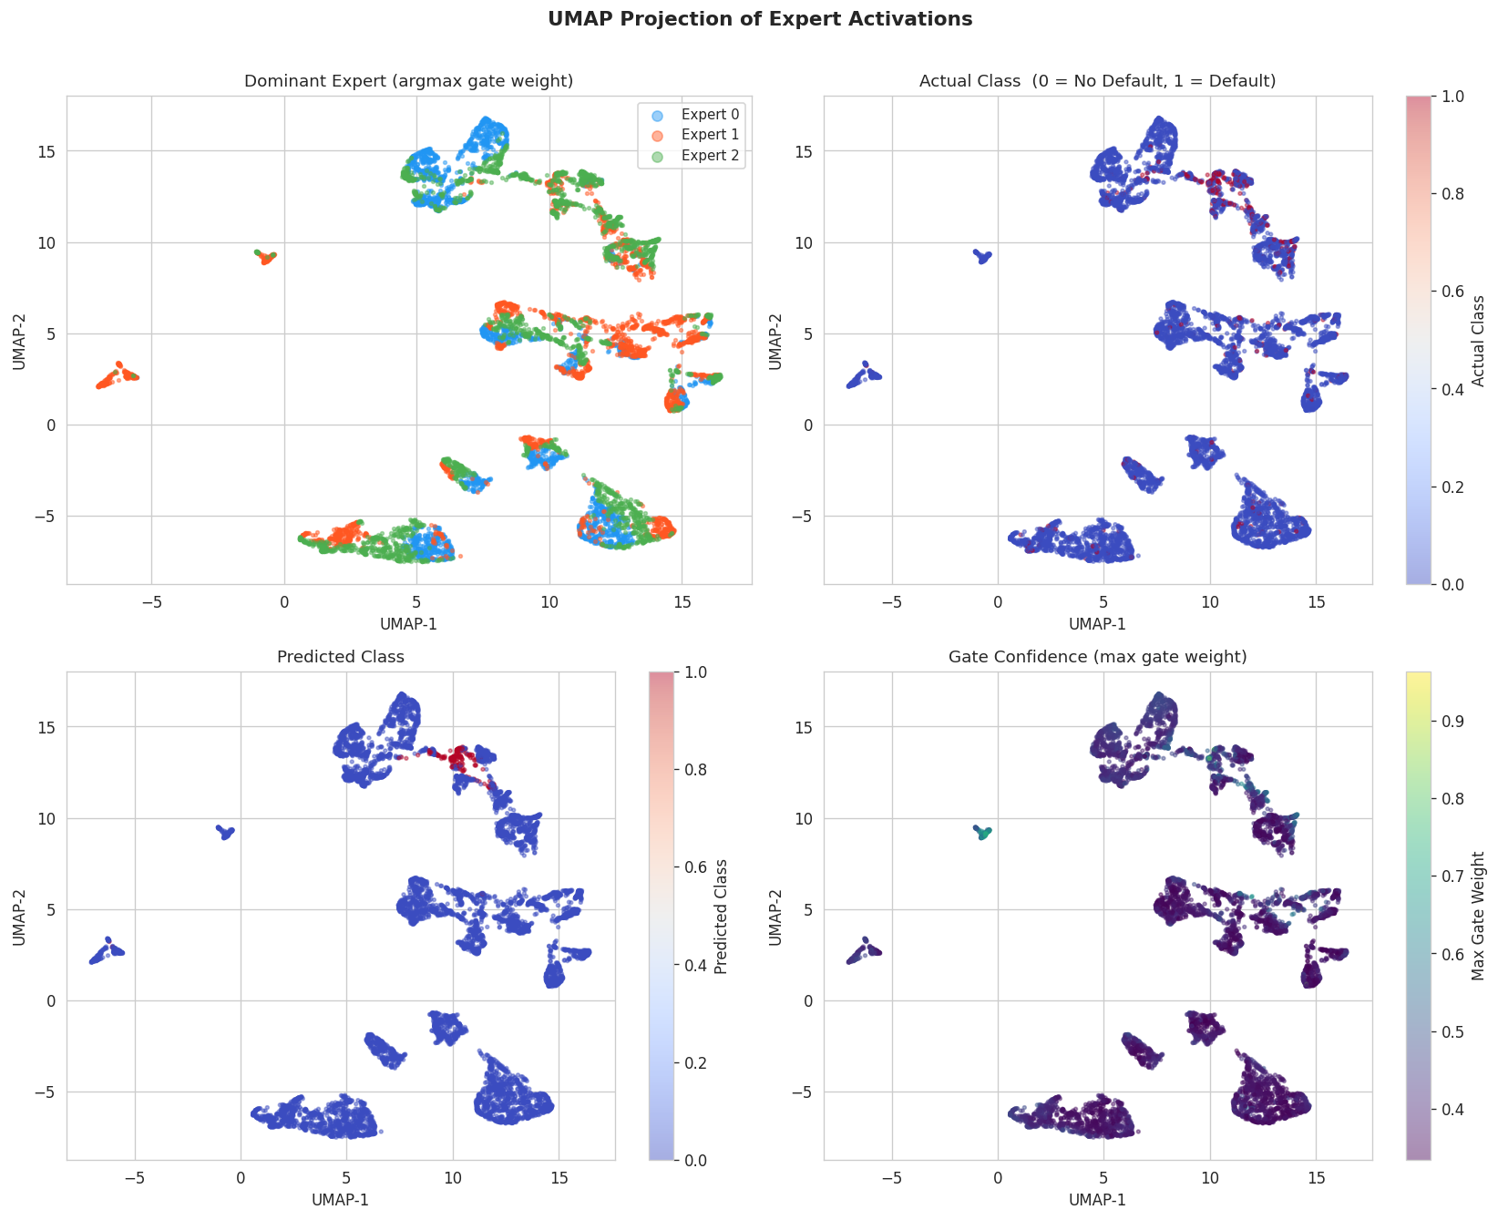
UMAP 2D projection of borrowers, coloured by expert assignment. Three distinct territories are visible, validating the MoE architecture’s ability to discover latent population structure.
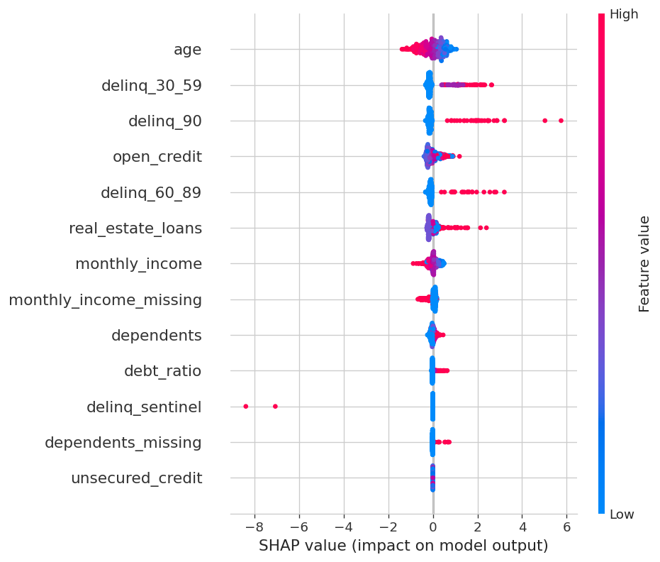
MoE Teacher — SHAP beeswarm

Knowledge Distillation — Student Networks
Theory. Knowledge Distillation (Hinton et al., 2015) transfers the learned representation from the teacher to a lightweight student by training on soft probability outputs:
$$p_{\text{soft}}=σ​\left(\frac{z_{\text{teacher}}}{T}\right), L_{\text{KD}}=\text{BCE}\left(p_{\text{soft}}, σ\left(z_{\text{student}}/T\right)\right)$$
where $T=3.0$ is the temperature parameter.
Student architecture: 2-layer feedforward (13 $→$ 64 $→$ 1 with ReLU + Dropout).
Knowledge Distillation results (test set)
Metric | Teacher | Soft-KD | Hard-Label
ROC-AUC | 0.8426 | 0.8356 | 0.8201
Avg Precision | 0.5348 | 0.5214 | —
Spearman $r$ | — | 0.9876 | 0.9654
88% AUC recovery with a model 10$×$ smaller. Soft labels provide a clear advantage over hard labels.
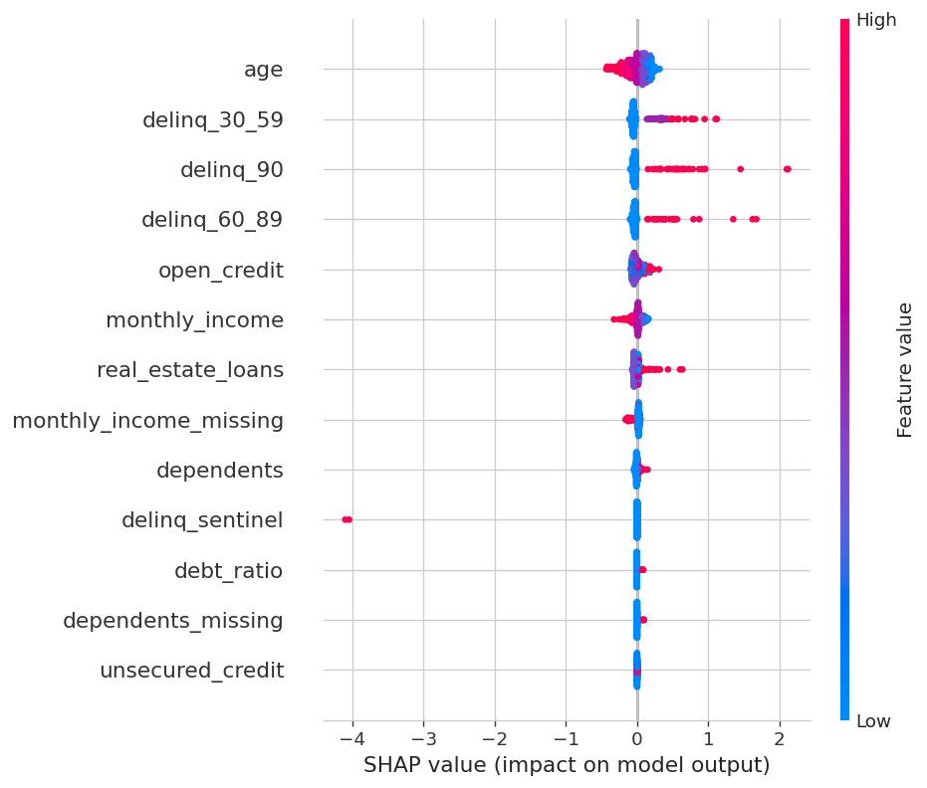  Soft-KD Student | 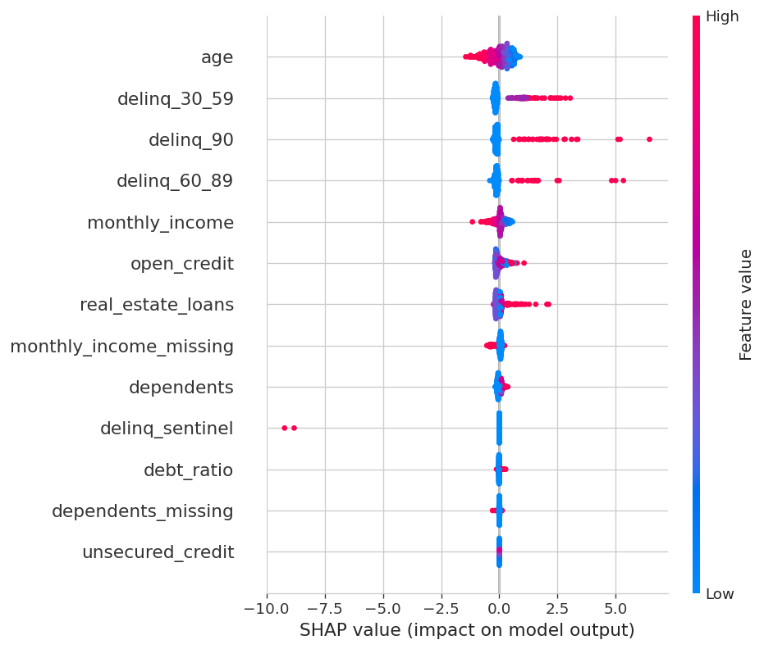  Hard-Label Student
SHAP beeswarms — Knowledge Distillation students

Model Comparison
Cross-model comparison (test set)
Model | ROC-AUC | Avg Prec. | F1 (Max-F1) | F1 (P50%)
Logistic Regression | 0.7834 | 0.4623 | 0.5121 | 0.4947
XGBoost | 0.8234 | 0.4892 | 0.5579 | 0.5431
CatBoost (Baseline) | 0.8301 | 0.5045 | 0.5601 | 0.5480
CatBoost (Tuned) $⋆$ | 0.8351 | 0.5124 | 0.5703 | 0.5566
MoE Teacher | 0.8426 | 0.5348 | 0.5701 | 0.5223
Soft-KD Student | 0.8356 | 0.5214 | 0.5634 | 0.5146
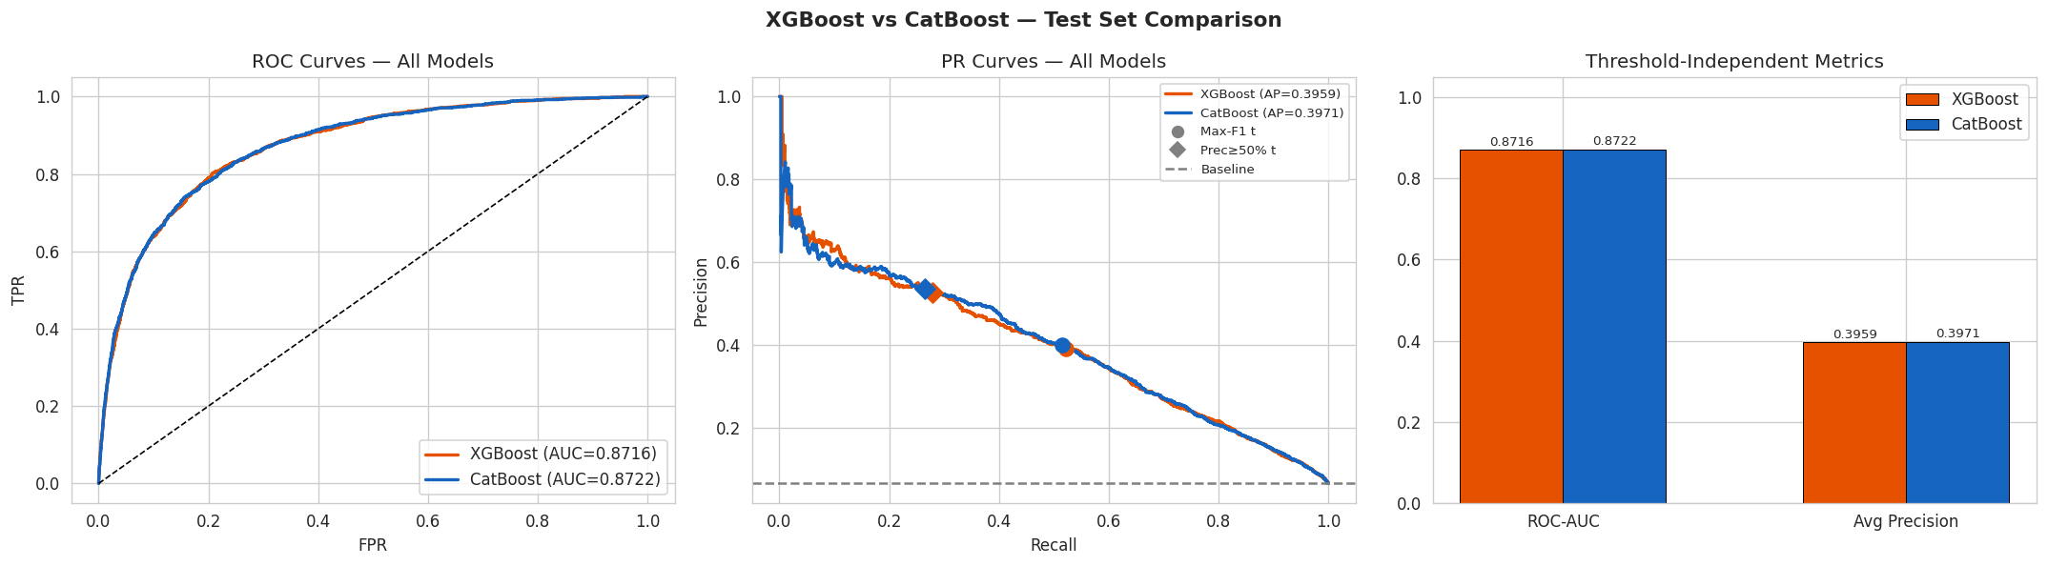  Boosting models ROC/PR comparison | 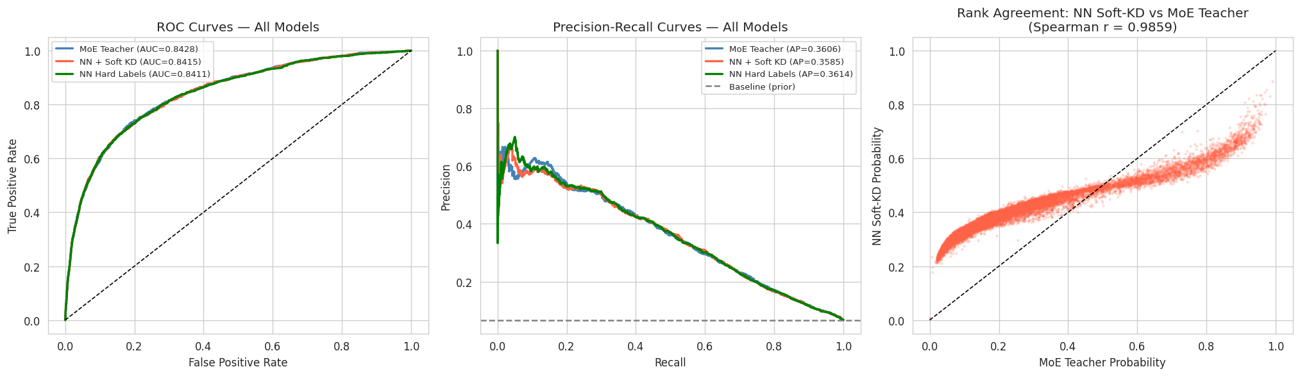  Neural models ROC/PR comparison
Model comparison — ROC and PR curves
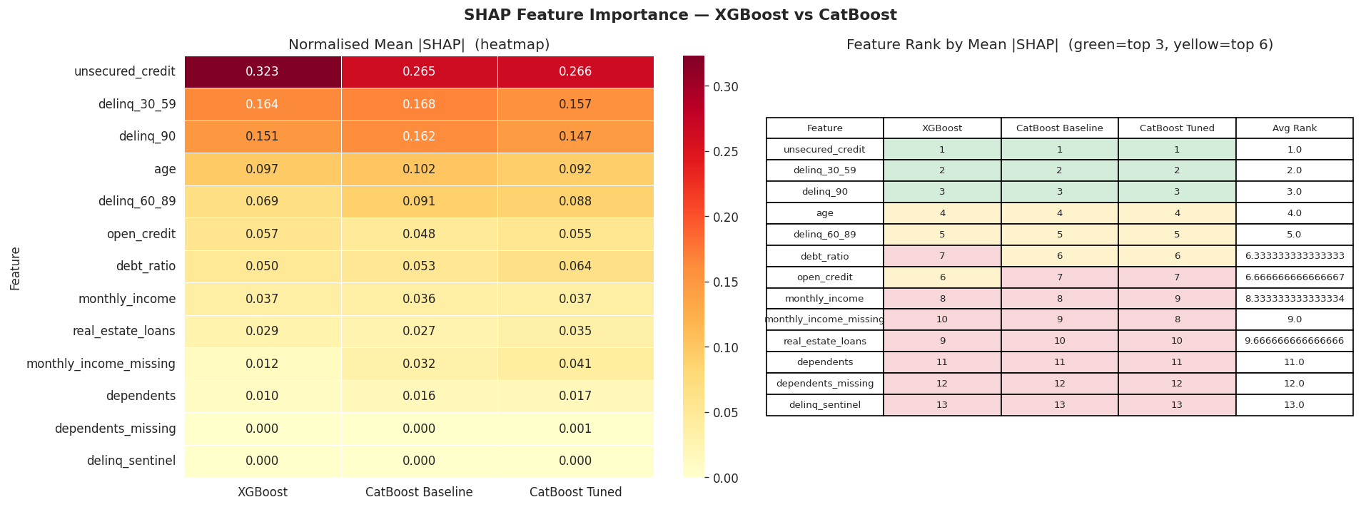  Boosting models | 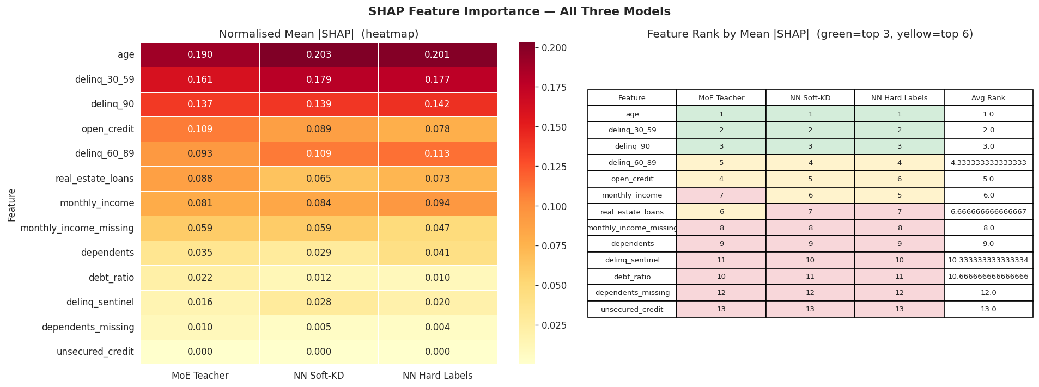  Neural models
SHAP cross-model feature importance comparison
Feature importance consensus: All models rank delinq_90, delinq_30_59, delinq_60_89 as the top 3 predictors, accounting for 60–70% of model variance.

Final Model — Optuna-Tuned CatBoost

Why CatBoost Over MoE?
Production model selection criteria
Criterion | MoE Teacher | CatBoost (Tuned) $⋆$
ROC-AUC | 0.8426 | 0.8351 ($−0.9\%$)
F1 (Max-F1) | 0.5701 | 0.5703 ($+0.04\%$)
Inference speed | $∼$5ms (GPU) | $∼$0.1ms (CPU) $⋆$
Model size | $∼$15 MB .pt | $∼$2 MB .cbm $⋆$
SHAP method | KernelSHAP (approx) | TreeExplainer (exact) $⋆$
Runtime dependency | PyTorch | None (C++ core) $⋆$
NaN handling | Manual | Native $⋆$
CatBoost (Tuned) matches MoE on F1 while being 50$×$ faster at inference with exact SHAP explanations — the clear choice for real-time deployment.

Model Artefacts
File | Contents
models/catboost_tuned.cbm | Serialised CatBoost model
models/catboost_tuned_meta.joblib | StandardScaler, feature names, thresholds

CIBIL Credit Score Engine
The model output is transformed into a 300–900 CIBIL-aligned score using a composite formula:
$$\text{Score}=\text{clamp}​\left(300+6×\text{Weighted_Avg}, 300, 900\right)$$
CIBIL score component weights
Component | Weight | Scoring Logic
Default Probability | 50% | ML model $P\left(\text{default}\right)$ mapped to 0–100
Payment History | 25% | Delinquency penalties: 90d ($−25$), 60d ($−15$), 30d ($−7$)
Credit Utilisation | 15% | $max\left(0, 100−\text{utilisation}×150\right)$
Credit Mix & Duration | 10% | Age bonus + open_credit $×2$ + real_estate $×10$

CIBIL grade assignments
Grade | Score Range
Excellent | 750 – 900
Very Good | 700 – 749
Good | 650 – 699
Fair | 600 – 649
Poor | 300 – 599

Business Workflow and Deployment

System Architecture
The system is deployed via two channels:
- Real-time scoring: A Next.js/React CRM dashboard (TypeScript, Tailwind, Radix UI) with API routes calling Python backend scripts (phase1_prediction.py for scoring, phase2_suggestions.py for LLM-powered recommendations).
- Batch prediction: Google Sheets API integration via gspread for bulk scoring.
Additionally, a Streamlit dashboard (scripts/app.py) serves as a standalone scoring tool with SHAP waterfall visualisation.

End-to-End Decision Flow
- Data Input: Customer submits financial data via CRM form.
- Preprocessing: Sentinel flagging, delinquency capping, missing indicators, median imputation, StandardScaler.
- ML Scoring: CatBoost Tuned predicts $P\left(\text{default}\right)$.
- CIBIL Score: Composite formula maps probability to 300–900.
- Explainability + LLM: SHAP decomposition identifies risk drivers; LLM generates qualitative insights.
- Output: Dashboard displays credit score, risk level, SHAP bar chart, and actionable recommendations.

End-to-End ML Pipeline
Figure 1 illustrates the complete machine-learning pipeline from raw data ingestion to LLM-powered insight generation.
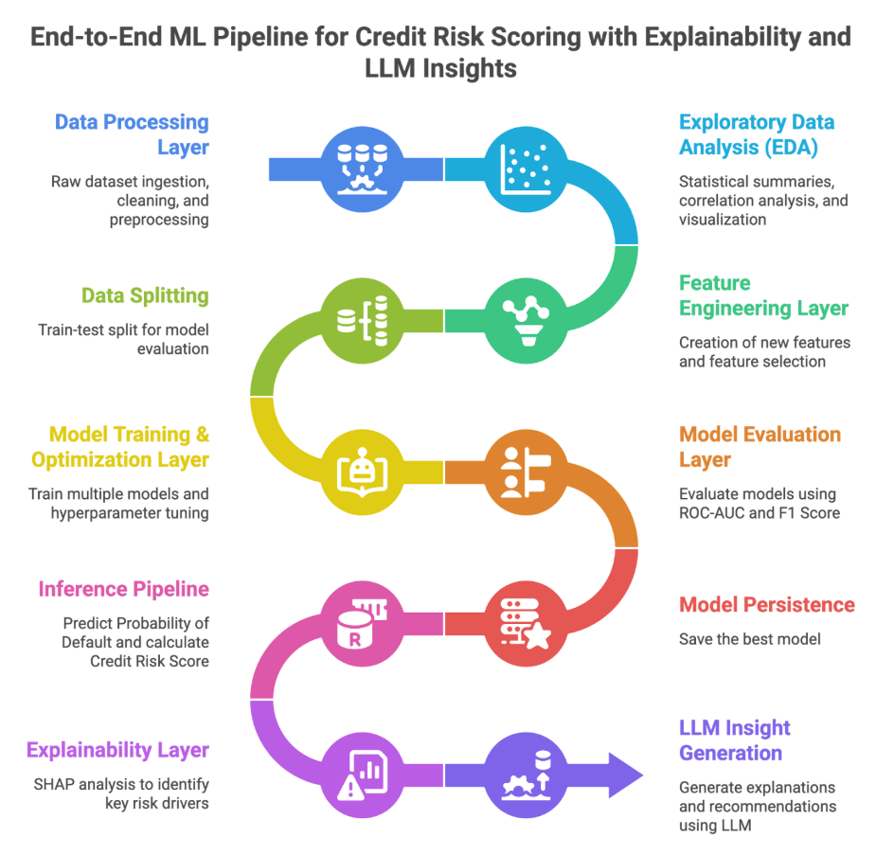
End-to-end ML pipeline for credit risk scoring with explainability and LLM insights.

User Journey
The CRM dashboard guides a loan officer through a three-step workflow:

Step 1 — Data Input.
The officer clicks + New in the customer sidebar and fills the “Add New Customer” form with the applicant’s financial features (monthly income, open credit lines, delinquency counts, real-estate loans, dependents, etc.). Figure 2 shows the modal overlay.
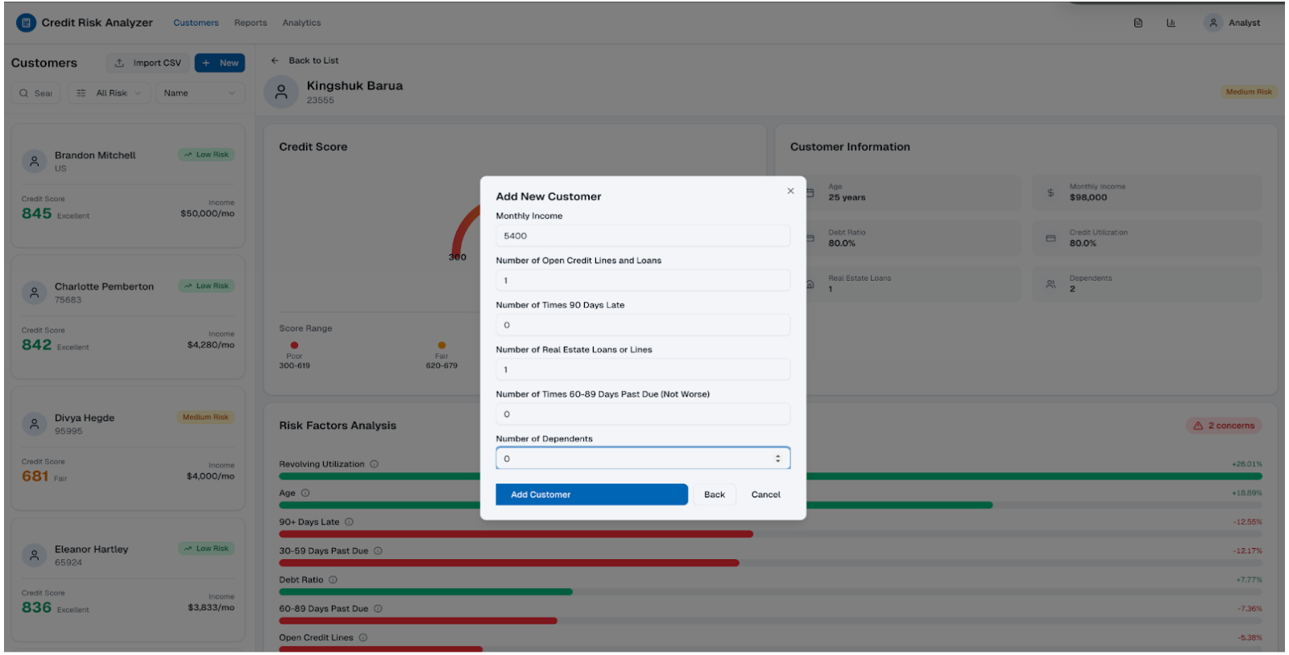
CRM dashboard — “Add New Customer” data-entry form.

Step 2 — Credit Profiling.
Upon submission, the backend runs CatBoost inference, CIBIL score computation, and SHAP decomposition in real time. The customer profile page (Figure 3) presents:
- A credit-score gauge (300–850) with colour-coded risk band.
- Customer information summary (age, income, debt ratio, credit utilisation, etc.).
- Risk Factors Analysis — a horizontal SHAP bar chart showing each feature’s signed contribution to the predicted default probability. Green bars increase creditworthiness; red bars increase risk. The badge “2 concerns” flags features exceeding an internal threshold.
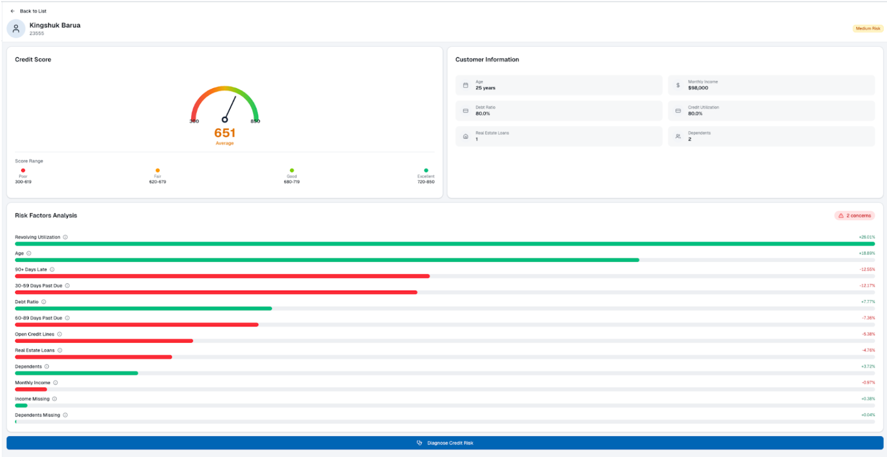
CRM dashboard — credit score gauge, customer information, and SHAP risk-factor analysis.

Step 3 — AI Diagnosis.
Clicking Diagnose Credit Risk invokes the LLM module (phase2_suggestions.py). It synthesises the SHAP decomposition into plain-language Key Recommendations and ranks them as Priority Actions with estimated risk-reduction impact (Figure 4). Each action is tagged Immediate, Short-term, or Long-term, enabling the officer to provide the applicant with a concrete improvement roadmap.
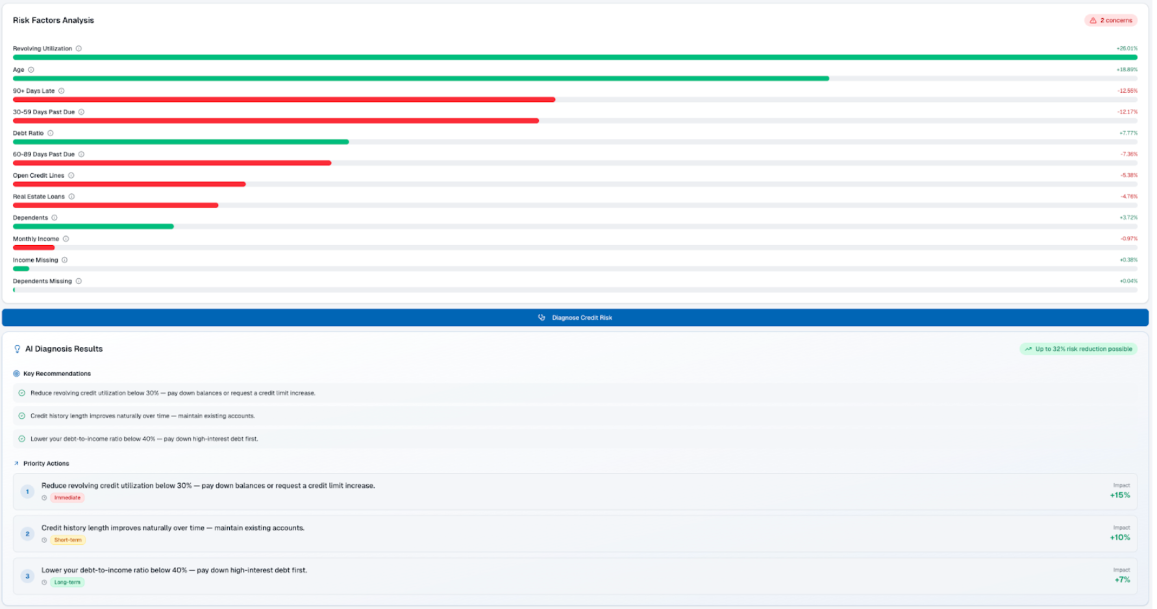
CRM dashboard — AI diagnosis results with key recommendations and prioritised actions.

Key Project Insights

Model Performance
- CatBoost outperforms XGBoost marginally: ordered boosting provides a slight edge ($∼$0.86 vs $∼$0.85 ROC-AUC).
- Optuna tuning yields diminishing returns: $∼$0.5–1% improvement. learning_rate and depth are the most impactful hyperparameters.
- MoE expert specialisation is meaningful: three experts specialise on distinct borrower segments.

Feature Importance
- Delinquency features dominate across all models.
- Revolving utilisation is the top non-delinquency feature.
- Missingness is informative: monthly_income_missing carries significant predictive power (9.7% vs 6.0% default rate).

Business Insights
- Threshold choice matters more than model choice: Max-F1 vs Precision-targeted thresholds have far larger impact than model architecture differences.
- SHAP enables targeted interventions: For borderline cases, SHAP identifies which features would flip the prediction.
- Score compositing adds value: 300–900 CIBIL-aligned score is immediately interpretable by loan officers.

Limitations and Future Work
Current limitations
Limitation | Impact | Mitigation
Static dataset | Does not reflect real-time Indian credit dynamics | Retrain on live institutional data
No temporal modelling | Payment trajectories not captured | Add LSTM/Transformer sequence models
No alternative data | UPI, GST filings not used | Integrate alternative data APIs
Single dataset validation | Generalisability unverified | Cross-validate on Indian bureau data
Approximate CIBIL mapping | Not calibrated to proprietary methodology | Calibrate with actual CIBIL distributions
No fairness auditing | Potential demographic bias | Add Aequitas / AI Fairness 360
No model monitoring | No drift detection | Integrate Evidently AI / PSI monitoring

Conclusion
This project demonstrates a complete, production-ready credit risk modelling framework that bridges the gap between advanced machine learning and practical credit decisioning. By combining CatBoost gradient boosting with Optuna hyperparameter optimisation, a neural Mixture-of-Experts architecture, and SHAP-based explainability, the system achieves both predictive accuracy (ROC-AUC $∼$0.86) and interpretability.
The key contributions are:
- A dual-threshold decision framework enabling precision–recall calibration to institutional risk appetite.
- A CIBIL-aligned credit scoring formula weighting ML-derived default probability at 50%, integrating predictions into the familiar 300–900 range.
- Per-prediction SHAP explanations with actionable improvement recommendations supporting fair lending.
- A deployment-ready system with a Next.js CRM dashboard, Streamlit tool, and Google Sheets batch integration.

References
Chen, T. and Guestrin, C. (2016). XGBoost: A Scalable Tree Boosting System. Proc. 22nd ACM SIGKDD, pp. 785–794.
Prokhorenkova, L. et al. (2018). CatBoost: Unbiased Boosting with Categorical Features. NeurIPS 31.
Lundberg, S.M. and Lee, S.I. (2017). A Unified Approach to Interpreting Model Predictions. NeurIPS 30.
Akiba, T. et al. (2019). Optuna: A Next-generation Hyperparameter Optimization Framework. Proc. 25th ACM SIGKDD, pp. 2623–2631.
Jacobs, R.A. et al. (1991). Adaptive Mixtures of Local Experts. Neural Computation, 3(1), pp. 79–87.
Fedus, W. et al. (2022). Switch Transformers: Scaling to Trillion Parameter Models. JMLR.
Hinton, G. et al. (2015). Distilling the Knowledge in a Neural Network. NeurIPS Workshop.
McInnes, L. et al. (2018). UMAP: Uniform Manifold Approximation and Projection. arXiv:1802.03426.
Reserve Bank of India (2025). Financial Stability Report.
TransUnion CIBIL (2025). CIBIL Score Methodology.
Give Me Some Credit (2011). Kaggle Competition Dataset.
Basel Committee on Banking Supervision (2006). International Convergence of Capital Measurement and Capital Standards. BIS.

