Form S-6: Sensitivity and Uncertainty Analysis for Modeled Losses

Rough Draft V1 (July 12, 2026)

Notes:
Red typeface implies material copied from previous ROA
Blue typeface indicates comments or currently incomplete material

- Purpose.
The purpose of form S-6 is to identify a required set of model sensitivity analyses that are to be carried out by the modeling organization, and to provide guidance, as well as templates, for the reporting of results. Successful completion of Form S-6 demonstrates that the effects of changes to key model parameter inputs to resulting estimated losses are defensible from scientific, engineering and actuarial perspectives. It further demonstrates that the modeling organization is capable of running an insurance portfolio at a latitude/longitude level directly and at a street address level indirectly with appropriate conversion to latitude/longitude.
- Overview and deliverables
To carry out a sensitivity analysis for a required output (as listed below), a metamodel (or emulator) of the organization’s catastrophe model must be developed. The sensitivity analysis is then performed on the metamodel. The data required to build the metamodel is obtained from a computer experiment on the organization’s catastrophe model. In the experiment, key input parameter values are systematically varied in a series of model runs and the outputs are recorded. Typically, the design for the computer experiment is a space-filling design, such as a Latin hypercube design. Let n denote the number of input combinations in the space-filling design, and let p denote the number of key parameters identified by the modeling organization. Then the space-filling design would identify n combinations of the p parameters that effectively “fill” (or span) the space of possible parameter values. The computer experiment is then comprised of n runs of the catastrophe model, where the input parameters for each run are specified by the design. Once the n input combinations have been run and required the catastrophe model outputs recorded, a metamodel can be developed for each output and sensitivity analyses can be conducted.

Deliverables include:
- An n-row spreadsheet entitled “FormS6inputsAndOutputs.xlsx” containing the input parameter combinations in columns one through column p, along with required outputs from each run (detailed below) in columns p+1 through p+n_{SA}. (“n_{SA}” will depend on how many SAs we will ultimately require. In this draft, n_{SA} = 18 but it needs to be reduced) This file will enable the Professional Team to carry out its own sensitivity analyses using the modeling organization’s data, and thereby verify results.
- n_{SA} sensitivity analyses are conducted---one for each of the n_{SA} output columns identified above. The sensitivity analysis results are comprised of Sobol indices for (at a minimum) each main effect and each two-factor interaction, as well as graphical depictions of the main effects and two-factor interactions. Details are provided below. In addition,empirical cumulative distributions of losses for categories 1, 3 and 5, and a contour plot of overall percentage losses at eachi grid coordinate are required. (Not yet described herein)
- Constructing the metamodels
  - Generating the data needed for metamodel construction.
    - Calculating loss costs
Hurricane loss costs are to be determined using a $100,000 insured structure with a zero deductible policy, not to include contents, time element, or appurtenant structure coverages, at each of the 682 land-based vertices in Figure 4. The 21x40, 840-element grid illustrated in Figure 4 for southern Florida uses an approximate 3 statute mile spacing. For purposes of hurricane decay, use existing terrain consistent with the grid in Figure 4 or Figure 3 (map version with grid identified as a rectangular region).

The input file “FormS6GridCoordinates.xlsx” lists the 840 grid coordinates with an indicator variable defined as follows:
- 0 = coordinate is over water
- 1 = coordinate is over land

The following house (i.e., $100,000 exposure) is assumed at each of the land-based grid points designated by the indicator variable:
- Single family
- Single story
- Masonry walls
- Truss anchors
- Gable end roof
- No shutters
- Shingles with one layer 15# felt
- 1/2" plywood roof deck with 8d nails at 6" edge and 12" field
- House constructed in 1995
- Age of roof unknown
The hurricane track to be deployed moves straight west passing through the landfall location (25.8611N,80.1196W). The point (0,0) is the location of the center of the hurricane at time 0 and is XX miles east of the hurricane landfall location.

Let i denote the ith input parameter combination for i = 1,…,n, and let x and y denote, respectively an E-W and N-S grid coordinate location. The loss cost from input i at grid combination (x,y) for hurricane category c is denoted
LC_{c}(i,x,y) = Loss cost from input combination i at the (x,y) grid location
Define the percent loss cost at (x,y) for the ith input for category c as
%LC_{c}(i,x,y) = LCc(i,x,y)/$100,000
where $100,000 is the exposure at grid coordinate (x,y).
Define the total loss cost from input i over all grid coordinate locations for hurricane category c as
TLC_{c}(i) = Σ_{x} Σ_{y} LC_{c}(i,x,y),
and finally define the percentage total loss cost due to input parameter combination i for category c as
%TLC_{c}(i) = TLC_{c}(i)/68,200,000,
where we have divided TLC(i) by the total exposure to get percentage of total loss cost from input i.
    - Selection of key input parameters
Each modeling organization is responsible for identifying p ≥ 6 key input parameters for its model.
    - Selection of space-filling design
The literature on space-filling designs has grown rapidly in the last two decades, and a variety of SFD approaches have been developed. Among the more popular choices are
- Latin hypercube designs
- Maximin and minimax distance designs
- MaxPro designs
- Maximin Latin hypercube designs
- Maximum entropy designs
- Fast flexible filling designs (useful when irregular constraints on the parameter space are present)
The choice of design is left to the modeling organization. The rationale for the choice must be based on the latest scientific and technical literature. The sample size, n, is also left to the modeling organization subject to n ≥ 100. Francom and Nachtsheim (2025) recommend sample sizes between 10p and 100p when the metamodel is created using Gaussian Process Regression. The uncertainty analysis described in Section 3.2.3 can aid in determining if a sample size is sufficiently large to guarantee adequate metamodel precision.

    - Required output from the space filling design.

As noted above, the first p columns of the n-row spreadsheet FormS6InputsAndOutputs.xlsx consist of the n input parameter combinations for the space-filling design. We now detail the n_{SA} required output columns (and thus the response variables for the n_{SA} required sensitivity analyses).

Location-specific sensitivity analyses are to be conducted for output variable %LC_{c}(i,x,y) for each of the following grid point combinations for each of the hurricane categories c = 1, c = 3, and c = 5:
- Location 1: x₁ = XXXXX, y₁ = YYYYY
- Location 2: x₂ = XXXXX, y₂ = YYYYY
- Location 3: x₃ = XXXXX, y₁ = YYYYY
- Location 4: x₄ = XXXXX, y₄ = YYYYY
- Location 5: x₅ = XXXXX, y₅ = YYYYY
For each hurricane category, one additional, overall (non-location specific) sensitivity analysis will be conducted for output variable %TLC_{c}(i). Thus the number of required sensitivity analyses is n_{SA} = 3*6 = 18. (OK, so here is where we need to get realistic. This can be reduced by selecting just one of the three hurricane categories (Cat 5?) and/or reducing the number of locations---for discussion).
The 18 output columns in Forms6InputsAndOutputs.xlsx can be listed now as shown in the table below.
Cat | Loc 1 | Loc 2 | Loc 3 | Loc 4 | Loc 5 | Overall
1 | %LC₁(i,x₁,y₁) | %LC₁(i,x₂,y₂) | %LC₁(i,x₃,y₃) | %LC₁(i,x₄,y₄) | %LC₁(i,x₅,y₅) | %TLC₁(i)
3 | %LC₂(i,x₁,y₁) | %LC₂(i,x₂,y₂) | %LC₂(i,x₃,y₃) | %LC₂(i,x₄,y₄) | %LC₂(i,x₅,y₅) | %TLC₂(i)
5 | %LC₃(i,x₁,y₁) | %LC₃(i,x₂,y₂) | %LC₃(i,x₃,y₃) | %LC₃(i,x₄,y₄) | %LC₃(i,x₅,y₅) | %TLC₃(i)

In addition to the spreadsheet “FormS6InputsAndOutputs.xlsx” described above, output for each sensitivity analysis will include
- Sobol indices for (at a minimum) main effects and two-factor interactions
- Conditional main effects (profile) plots for each main effect
- An interaction matrix depicting all _{p}C₂ conditional interaction plots
Details concerning the calculation of Sobol indices, conditional main effects plots and conditional interaction matrices are provided in (Proteam model paper and Francom and Nachtsheim (2025)). An example sensitivity analysis is provided in Section 4.

  - Metamodel development
    - Choice of methodology
Given the results of the computer experiment for an output, methodologies for creating a metamodel include (to name just a few):
- Gaussian process regression (GPR)
- Neural networks
- Regression tree methodologies including random forests and boosted regression trees
- The fitting of second-order (or higher-order) regression models.
The choice of methodology is left to the modeling organization, as long as the choice can be justified by current scientific and technical literature.
    - Model validation, testing and uncertainty analysis
A standard paradigm for the use machine-learning model development considers three phases:
- Training of model
- Validation of model
- Testing (and evaluation of final model in terms of uncertainty and precision)
Each of these three phases should be documented, although there are variations as to how these phases can be implemented. For example a simple approach is to divide the data into three segments corresponding to training, validation, and testing. Training and validation phases, however, are not generally independent. Feedback from the validation phase may lead to changes in the structure and/or complexity of the model. This feedback loop is automated when using k-fold validation. However, once a final model has been selected, it should be tested on hold-out data that has not been employed either in the training or validation phases.

We recommend the use of k-fold validation and that a separate, 30-run space-filling design be constructed for the testing phase. For each of the 30 combinations of input parameters in the test design, the catastrophe model is run to obtain a new set of outputs, which can then be compared to the predicted outputs from the metamodel. More precisely, let %LC_{c}(i, x, y) denote the lost cost produced by the catastrophe model for the ith input combination at grid coordinate (x, y), and let Pred%LC_{c}(i, x, y) denote the predicted loss cost produced by the metamodel for the same input combination (i) and location (x,y). A simple measure of the precision of the metamodel predictions is given by predicted R². Let
where denotes the sample average of the 30 new responses. Then the predicted R² value
provides a useful measure between zero and one of the precision of the metamodel, with values near one indicate high precision. A useful measure of uncertainty is the standard deviation of prediction

Given $s_{\text{pred}}$, an approximate $(1 - α)100\%$ confidence interval for prediction (i.e., prediction interval) is given by
for any input parameter combination i in the space of all potential input parameter combinations.

- An example sensitivity analysis
  - Overview
In this section, we will use the Professional Team Hurricane Model to conduct a sensitivity analysis of the output %LC(i,x₁,y₁). In the Professional Team model there are $p = 6$ parameters, namely
- CP = central pressure (in millibars)
- Rmax = radius of maximum wind (in statute miles)
- VT = translational velocity (translation speed in miles per hour)
- WSP = hurricane model windfield shape parameter
- CF = conversion factor for converting the modeled gradient winds to surface winds
- FFP = far-field pressure (in millibars)
A 100-run Latin hypercube design was employed. The model inputs and outputs are provided in the file “S6ExampleSensitivityAnalysisInputsAndOutputs.xlsx.” A metamodel was constructed from these inputs using Gaussian process regression. We turn now to the sensitivity analysis of the resulting metamodel.

  - Numerical summaries of sensitivities using Sobol indices
Sobol indices are widely used to quantify the sensitivity of a model to the main effects of input variables, two-factor interactions among input variables, and higher-way interactions among variables. Francom and Nachtsheim (2025) provide an readable overview of the method and computational details can be found in the original paper by Sobol (2001). Various packages exist for obtaining Sobol indices. Generally, the larger is a Sobol index for a main effect or an interaction effect, the more sensitive is the metamodel to that effect.

The Sobol indices for our GPR meta model are shown in the table below.

Table here: Paul – can the model create this table (or does it already do that?)

From the table, it is clear that the metamodel is most sensitive to …..

  - Graphical summaries of sensitivities
In this section we display the conditional main effects plots and the conditional interaction matrix for our meta model. The graphics show exactly how the model is affected by the main effects and interactions with relatively large Sobol indices.
    - Depiction of main effect sensitivities
The conditional main effects plots for all six input variables are shown below in Figure 1, and a bar chart of the S0b0l indices is shown in Figure 2.

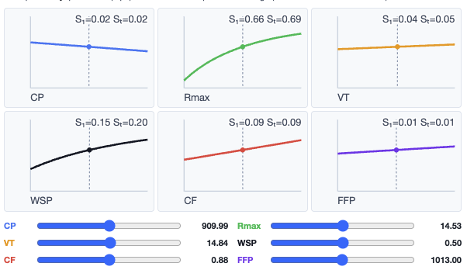
Figure 1. Conditional main-effects plots

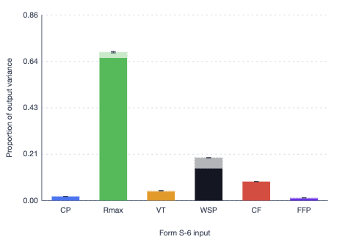
Figure 1. Sobol main effects indices
Clearly, from Figure 2, the model is most sensitive to Rmax (Sobol index = 0.66), followed by WSP (Sobol index = 0.20) and CF (Sobol index = 0.09). The model is relatively less sensitive to the CP, VT, and FFP input parameters.
    - Depiction of two-factor interaction sensitivities
The conditional interaction matrix is shown in Figure 3, where the Sobol index for each interaction is shown in the upper right corner of each plot. From the Sobol indices, there is really only one interaction to which the model is sensitive, namely, the WSP-by-Rmax interaction (which has been highlighted in red).

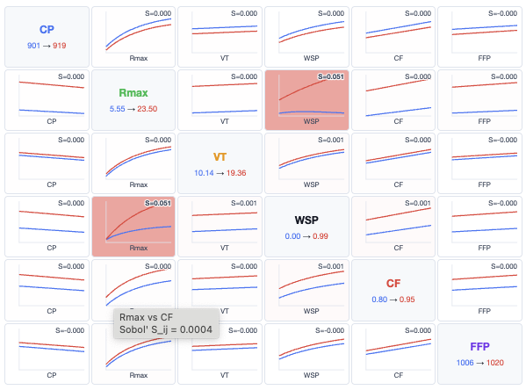
Figure 3. Conditional interaction matrix

- Justification of key results
Here the modeling organization would provide logical explanations for the larger sensitivities, justifying the nature of the key main effects and interactions. Additional (brief) justification for the lack of sensitivities to various main effects and interactions would also be expected.

References
Ilya M Sobol. Global sensitivity indices for nonlinear mathematical models and their Monte Carlo
estimates. Mathematics and computers in simulation, 55(1-3):271–280, 2001.

D. Francom and A. Nachtsheim. A Review and Comparison of Different Sensitivity Analysis Techniques in Practice. arXiv:2506.11471v1 [stat.ME], June 13 2025.
P. Fishwick. Pro Team Multimodel: Interactive Grid and Wind Fields — Sensitivity, Uncertainty, and Loss over Southern Florida. July 12, 2026

