Isosurface
Mathematics Inspired Meshes

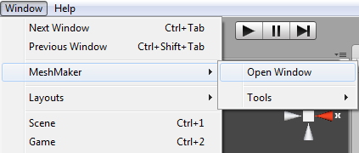
After importing the Isosurface package you will notice a new folder called Isosurface has been added to the project window.

To open the Isosurface window click on the Window menu item in Unity, hover the mouse over the Isosurface item and then click on Open Window.

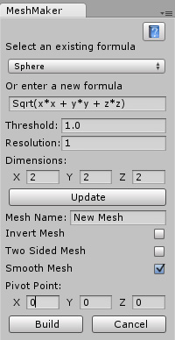
The Isosurface window is tabbed so you can dock the window by clicking on its tab and dragging it next to your other windows. The Isosurface window has a vertical style that works in conjunction with your Hierarchy window and we suggest you dock the window to the left of your Hierarchy view. If you need to get back to this tutorial while in Unity you can click on the help button at the top right of the window and this page will open up in your browser.

An isosurface is a three dimensional surface which is calculated from a mathematical formula. The surface is then rendered using the marching cubes algorithm. When entering a new formula care must be taken that the formula is a valid mathematical equation otherwise the program will throw an error. Often this error will appear as a frozen window, if this happens try selecting an existing formula to recover. If the error is serious then Unity may need to be restarted or the program will crash.

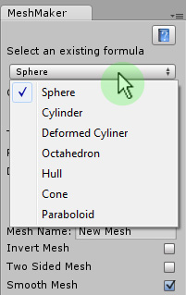
To select an existing formula click on the drop down list at the top of the window. The list is populated from a text file located in the resources folder within the MeshMaker folder. You can add your own formulas to this text file and the list will include them the next time you open MeshMaker. The format of this file is simply the name of the formula followed by a colon and then the formula itself.

Below is an example of the default formulas included with the program.
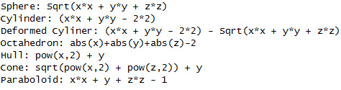

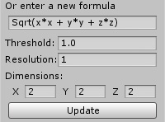
After selecting a formula or after entering a new formula you need to click on the Update button to change the mesh framework in the editor window. You will notice that the mesh framework is bounded by the edges of a green cube. This cube defines the dimensions of the sample space and you can adjust the dimensions of this cube using the input values above the Update button.

If you cannot see the mesh framework within the cube after clicking on the Update button you may need to either enlarge the dimensions of the cube or reduce the Threshold value for the formula. Generally a smaller threshold makes for a smaller mesh and increasing the threshold increases the size of the mesh.

You can also change the resolution of the final mesh by changing the resolution value. Think of the resolution as the size of each division of the cube, if the dimension is 2 and the resolution is 1 then there will be two divisions, if the resolution is 0.5 then there will be four divisions. A small resolution results in a very smooth mesh having a lot of polygons while a large resolution results in a crude mesh with very few polygons. If the resolution is very small while your cube is large it can take a very long time for the update to complete and it may look like the Update button is stuck, please wait and the button will return to normal when finished.
I would recommend starting with a high resolution when designing a new mesh and then choosing a smaller resolution when I was happy with the new design. This way it won't take too long to calculate and will run faster in the Unity editor window.

Below is an example of the same formula shown at a resolution of first 1 and then with a resolution of 0.2 for a cube with dimensions of 2.

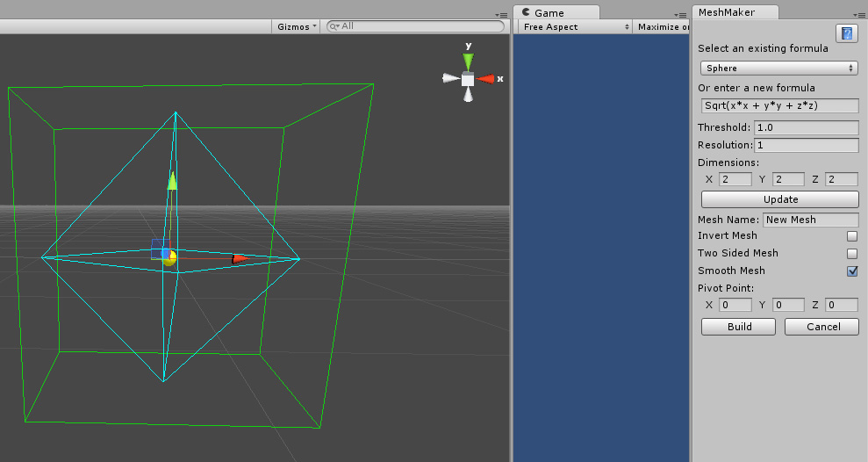

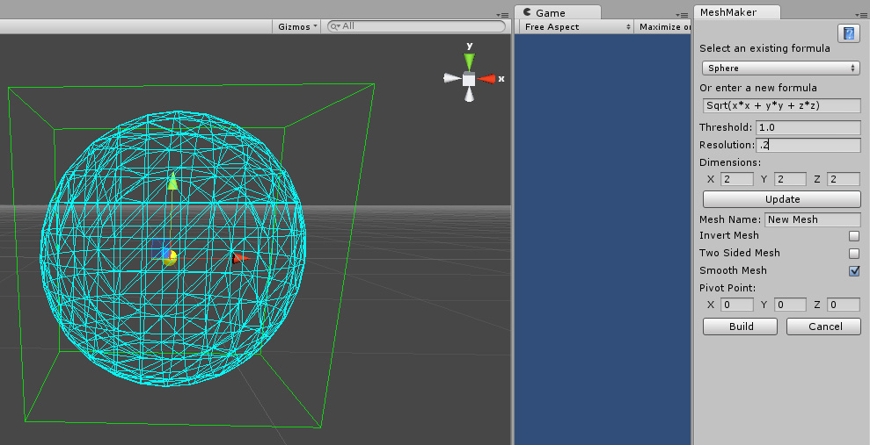

You can reduce the dimensions of the cube to get some interesting results. The following ring was produced by using the formula for a sphere and then reducing the length of the cubes Z axis to 1.

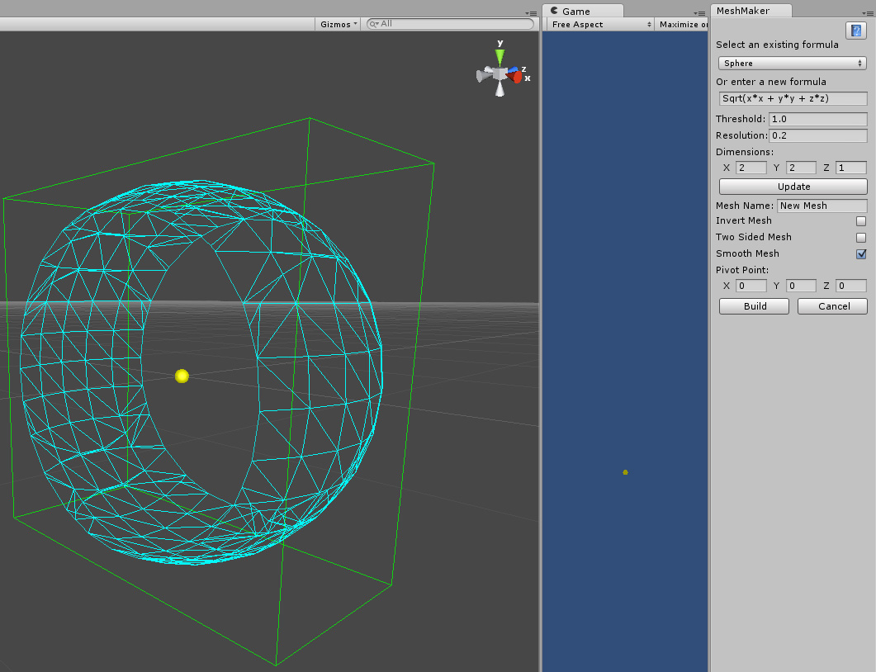

For the best results try to make the resolution a factor of the cubes dimensions. In this case the dimension of the cube in the Z axis is 1 and the resolution is 0.2 which gives us exactly 5 divisions. Once you are happy with the look of the mesh framework you can give the mesh a unique name in the box below the Update button and then clicking on the Build button to create the final mesh.

The check boxes located below the mesh name allow you to select whether to invert the final mesh, make a two sided mesh or whether to smooth the final mesh.

In the editor window you will notice that there is a yellow sphere that is centered in the middle of the cube. This sphere highlights where the pivot point of the final mesh will be located. To change where the pivot point is located you can adjust the values for its position in the boxes above the Build button. The following picture shows the pivot point for this mesh is located at the top right of the object.

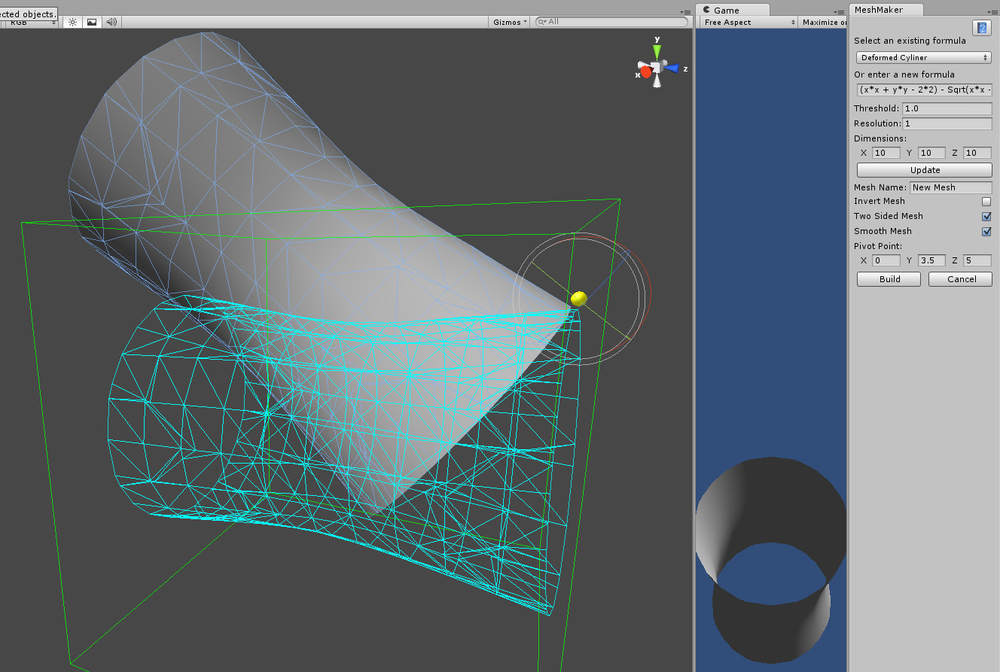

To export your new creations to the OBJ format you begin by first selecting the game object/s you would like to export and then clicking on the Window menu item in Unity, hovering over the Isosurface item and then the tools item before selecting the type of export you want to perform. The exported object will be saved in the Isosurface folder in a subfolder called Exported Objects.
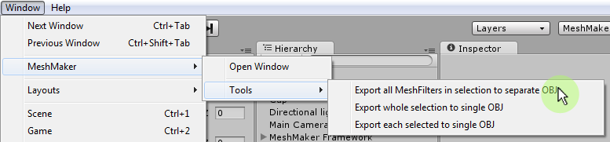

To learn more about Isosurface and to view the tutorial videos you can visit
MeshMaker.com

