Mesh Editor
Advanced Mesh Editing for Unity

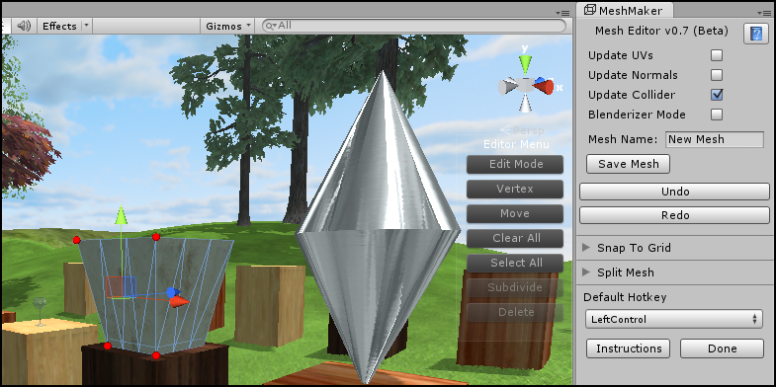

The following features are currently implemented
Move/rotate/scale of vertices/edges/triangles/faces  Extrude triangles/faces  Subdivide triangles  Delete triangles and faces  Split meshes into submesh or new mesh  Options to auto-update uvs/normals/colliders  Toggle Blenderizer option  Save meshes to project folder at any time | Full undo/redo system for all features  Built in snap to grid feature for position/rotation/scale  Preferred hotkey selection  Alt key highlights the wireframe  Marquee to select or deselect multiple vertices  Export to OBJ model format  Works with all colliders  No scripts or helper objects needed

More features will be added as the development cycle gets closer to version 1.0.

Starting Mesh Editor

To start using Mesh Editor click on the Window menu item, scroll down to the Mesh Editor item and then click on Open Window.

Editing Mode

Once the Mesh Editor window opens you will notice that a new menu has popped up over the top of the Scene view window. You can move this menu around the screen by middle mouse clicking on the menu title or background and dragging it to a new spot.

Next select a game object. It needs to have a mesh filter component attached but it can have any type of collider as the program works with all mesh colliders. By default the program starts in Normal Mode and you need to click on the top button of the menu to enter edit mode.

You can now begin right clicking on the active object to select the vertices of the mesh. A small red sphere will appear at the nearest vertex to where you clicked on the object. A move handle will also appear allowing you to move the selected vertex around. You can continue to right click on the model to select more vertices or you can hold down the hotkey (right-ctrl key by default) to deselect a previously selected point.

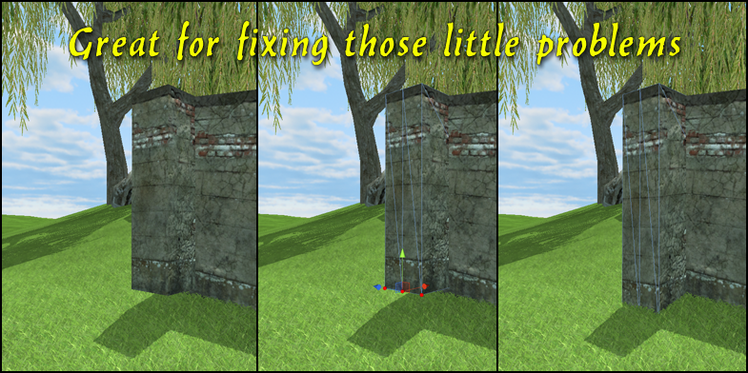

Selecting and Deselecting Multiple Vertices

To select whole groups of vertices at once, hold down the hotkey while right clicking and dragging the mouse and a selection marquee will appear. To deselect simply do the same but while holding the Left-Shift key down instead.
Edge, Triangle and Face Editing

The second button down changes the current editing mode from either Vertex, Edge, Triangle and Face selection. Edge mode allows you to select the two vertices of the nearest edge to where you clicked on the object. At the moment this is just a time saver but as the program develops this will become more important as features like edge loops are added to make splitting meshes easier.

Triangle mode works like vertex mode, you can select triangles by right clicking on them. To select more than one triangle or to deselect a triangle hold down the hotkey while clicking on it.

Face editing mode allows you to select whole faces of coplanar triangles with a single click.

Extruding Triangles and Faces

When you are in either Triangle or Face editing mode you can also extrude the mesh. To extrude simply hold down the shift key while dragging the move handle.

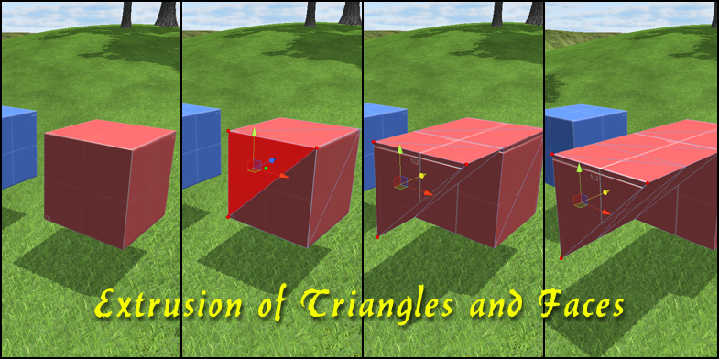

When you release the left mouse button to stop dragging the handle the extruded part of the mesh will be set and you can then start extruding another section.

A great feature of this editor is that you can extrude many triangles or faces at once regardless of whether they are touching each other or not. This allows for very fast and symmetrical extrusion of meshes.

Subdividing Triangles

The subdivision of triangles works but is still under development at the moment. More advanced splitting of triangles, faces and even the whole mesh will be implemented at a later date.
To begin splitting a triangle make sure you are in Triangle mode and click on the spot where you would like a new vertex to appear. A small green sphere will appear on the surface of the triangle where you clicked. Then simply click on the Subdivide button on the menu to perform the splitting. One point to remember is that after you have finished all the splitting you want to do you need to exit and enter Edit Mode again to update the program.

Deleting Triangles and Faces

Once you have selected a group of triangles while in Triangle or Face mode you can delete them from the mesh by clicking on the Delete button at the bottom of the menu.

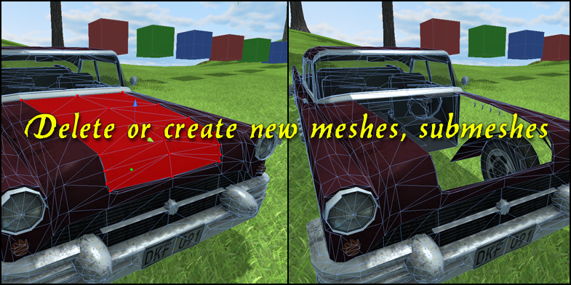

Creating New Meshes and Submeshes
You can also choose to split the existing mesh into either a new mesh or a submesh from the Mesh Editor window. Simply select the triangles or faces you want to use for the new mesh, open the Split Mesh foldout section in the window and click on the Split button. Ticking the box above this button will create a submesh instead and you can assign a new material to it from within the inspector window.

Auto Update UVs/Normals/Colliders
At the top of the Mesh Editor window you can select whether or not to auto update the UVs of the mesh, auto update the normals and recalculate the collider shape while reshaping or extruding the mesh.

Blenderizer Mode
The fourth checkbox down on the Mesh Editor window toggles what I call Blenderizer Mode. In this mode the editor window will behave in a more Blender like way where you can middle mouse click to rotate the camera around the object while editing as well as centering on the object while zooming in or out using the mouse wheel.

The other features like full numeric keypad controls are active all the time regardless of whether this mode is active or not.

Saving Meshes
At any time during the editing process you can save the current mesh as a new mesh. You have the option to give the mesh a new name before clicking on the Save Mesh button.

The new mesh will be added to the Meshes folder within the main program folder. You can do this repeatedly while editing to create a series of meshes for animations etc.

Full Undo/Redo System
The Mesh Editor program comes with a named undo and redo system that saves the last 100 steps while editing. This works for all editing operations as well as for deleting, subdividing and splitting operations.

Move, Rotate and Scale Modes

The third button down on the menu toggles the current editing mode. The three modes available are Move, Rotate and Scale. The handle will change to reflect which mode you are in and behave exactly like they do within Unity for other objects.
Snap to Grid
From the Mesh Editor window you can open the Snap to Grid menu foldout to access the snap to options. You can choose whether to snap to a certain step size while modifying the mesh as well as snapping to a certain rotation angle or scale increment while editing the mesh. I recommend only snapping to one axis at a time as this makes it easier to predict the final position of the move, rotate or scale operation.
Hotkey Selection

You can change the default hotkey used by the program by selecting a new key to use from the drop down menu at the bottom of the window.

Exporting

To export your new creations to the OBJ format you begin by first selecting the game object/s you would like to export and then clicking on the Window menu item in Unity, hovering over the Geom item and then the tools item before selecting the type of export you want to perform. The exported object will be saved in the Geom folder in a subfolder called Exported Objects.
Highlight Mesh

You can press the Left-Alt key while working in the Scene View window to highlight the currently active object. If you suspect that there is a problem with the current action then showing this mesh is a good way to test this. If the highlight mesh doesn't match the Unity mesh then it is recommended that you exit and re-enter editing mode for the active object.
FAQ

There is a known issue of inverted triangles sometimes being produced while extruding. It results from two triangles sharing a vertex at a single point. This will be fixed in the next update.

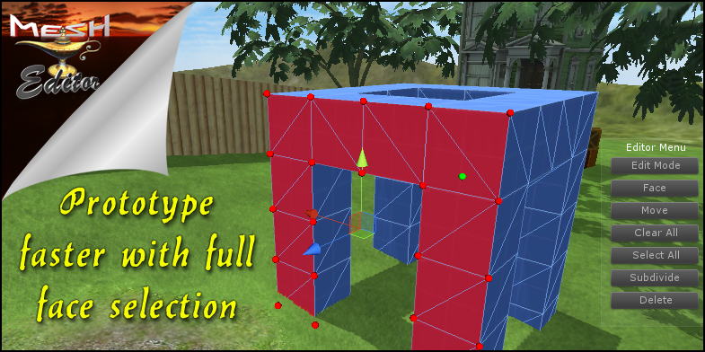

To learn more about Mesh Editor and to view the tutorial videos you can visit MeshMaker.com

