Geom
Quick and Easy Geometric Modeling

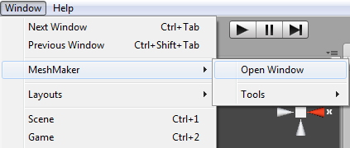
After importing the package you will notice a new folder called Geom has been added to the project window.

To open the Geom window click on the Window menu item in Unity, hover the mouse over the Geom item and then click on Open Window.

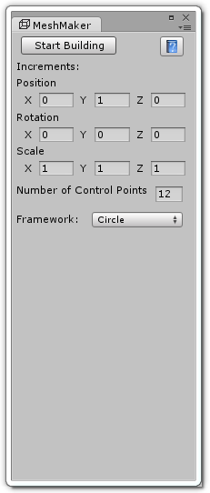
The Geom window is tabbed so you can dock the window by clicking on its tab and dragging it next to your other windows. The Geom window has a vertical style that works in conjunction with your Hierarchy window and we suggest you dock the window to the left of your Hierarchy view. If you need to get back to this tutorial while in Unity you can click on the help button at the top right of the Geom window and this page will open up in your browser.

Before clicking on the Start Building button at the top of the Geom window you can change a few starting parameters such as the initial increments to use as well as the number of control points and the type of framework to use. The more control points makes for a more detailed mesh with better shading and lighting.

By default the starting number of control points is 12 and the framework type is circle. You can select from five different framework types by clicking on the drop down list and choosing either Circle, Ellipse, Square, Triangle or Planes.

For the purposes of this tutorial we will just use the defaults, so to begin building go ahead and click on the Start Building button. The following image shows the Geom window docked next to the Hierarchy and running in Build mode.

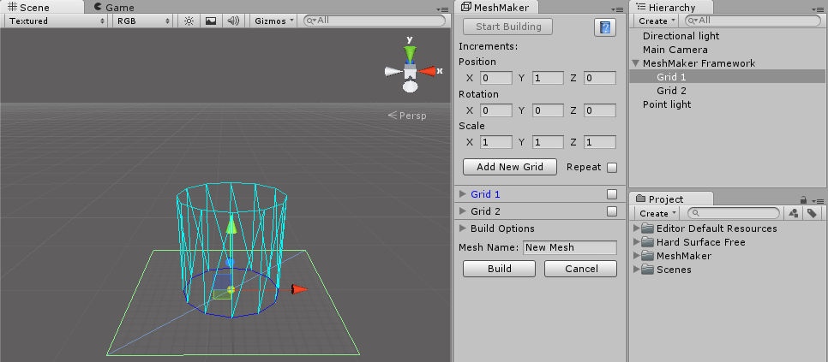

In the image above you can see the Geom framework in the Scene View window. The framework is made up of square grids that can be translated, rotated and scaled like other game objects.

If you want to transform the entire framework you can do this by selecting the Geom Framework in the Hierarchy and then transforming the framework as normal.

When you select a grid, either from the Geom window or the Hierarchy, and then mouse over that grid you will see a small yellow sphere following the mouse movements. This is the control point selector and if you left click once on this sphere the control point will move to follow the mouse position on the grid. To release the selector left click again and the control point will have been moved to that position.

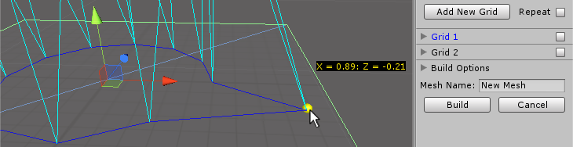

Sometimes you might need to move control points outside of the visible grid size which is set to 2x2 by default. To extent the area that you can move control points on simply left click on the small arrow next to the grid name in the Geom window.

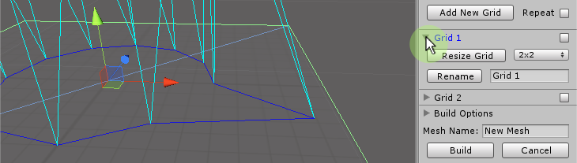

This will open out to allow you to select a new grid size from the drop down list, once selected click on the Resize Grid button to apply the change. Within this area you can also enter a new name for this grid by entering the new name in the text field and then clicking on the Rename button. The new name will then appear in the Geom window and in the Hierarchy. The opposite is not true, if you change the name of the grid in the Hierarchy it will not appear changed within Geom.
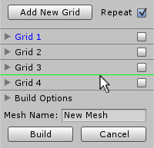
Sometimes you might have a grid in the list that you need to move in the order of grids, let's say you wanted to move the first grid to the last grid position. To do this simply left click on the grid in the Geom window and hold the mouse button down as you drag the mouse up and down. While dragging you will notice a green line appear between the other grids in the list which shows you where the grid will be inserted when you release the mouse button.

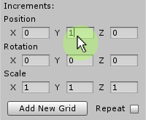

To add a new grid you can click on the Add New Grid button and the new grid will appear one unit above the last grid, or if you want to change where the next grid will appear then you can change the position, rotation and scale increments in the Geom window. This will allow you to set a series of transforms on the new grids as they are added to the framework.

If you have moved the control points of the last grid and would like to repeat that pattern in the new grid then you can click on the Repeat toggle switch next to the Add New Grid button. The new grid will retain the same control point layout as the previous grid but also pick up the increments you have entered so that you may combine the two operations.
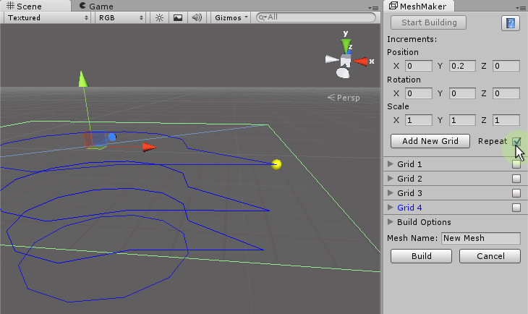
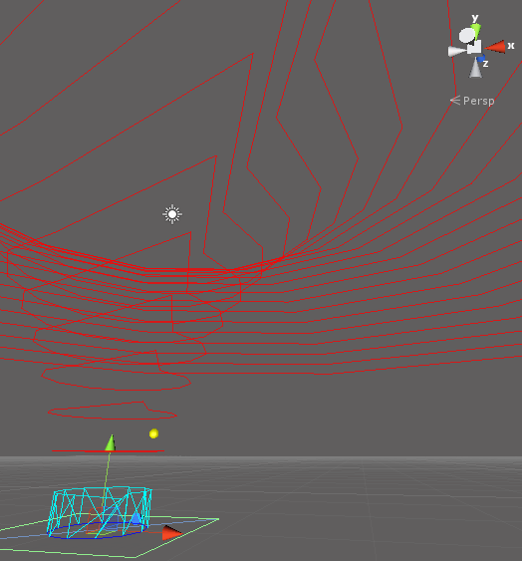
By right clicking on the Geom window you can bring up the context menu. From this menu you can select Toggle Framework Mesh which will disable the rendering of the mesh polygons in the Scene view as shown in the previous image.

From this menu you can also click on Toggle Preview Grids to see what effect the current increments will have on the next grids to be created. If the Repeat toggle switch is ticked then you will be able to see the results of this in the preview grids. You will get some strange artifacts showing up in this view if your increments such as scale are too high.

Once you have set up your framework and moved all of the control points you can save the framework by right clicking on the Geom window and selecting Save Framework from the context menu. You can then come back at a later time and resume working on the framework by loading it from the same context menu. You can also share the framework file that you have created with anybody else that is running Geom so that they can open your framework and continue working on it. You will find the newly saved framework file in the Geom folder under a subfolder called Frameworks.

At any time you can build your new mesh by entering a new name in the Mesh Name field and then clicking on the Build button to actually create your new mesh. You will find the new mesh has been placed in the Geom folder in a subfolder called Meshes. From here you can drag it to your own project folder, add materials or shaders and create a new prefab to use in your scenes.
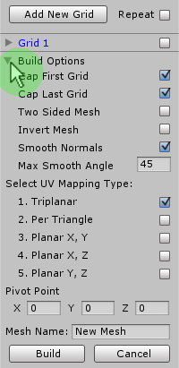
By default the new mesh will be a single sided, smoothed mesh with a cap on the top and the bottom. To change these default options left click on the Build Options item just below the list of grids in the Geom window and it will fold out to show a list of toggle switches that you can enable or disable.

The first two toggles allow you to turn on or off the capping of the first and last grid in your framework. If you were making a cup mesh for example, you would want to cap the first (bottom) grid and not cap the last (top) grid.

You can also select whether your new mesh is to be one sided or two sided by using the Two Sided Mesh toggle switch. If you were making a mesh like a glass that should be thin and visible from both outside and inside the mesh then you would toggle this on. Even though the object is very thin the final game object can still have a Rigidbody component added to it without causing any problems with the physics simulation.

Below this you can toggle whether to invert the final mesh. You can also toggle Smooth Normals on or off. When you want a mesh that will appear nicely rounded in the final build then leave this ticked, but if you are working on more angular meshes like parts of a space ship with lots of flat sides then you can toggle this off here. The Max Smooth Angle is the largest angle between polygons that will be smoothed.
Within the Build Options list you can also select the type of UV mapping you would like. This affects how a textured mesh will look and you can select from triplanar, per triangle or planar UV mapping from three different directions. The possible directions are from front to back (X, Y), from top to bottom (X, Z) and from left to right (Y, Z).

Unfortunately, without using advanced techniques like UVW unwrapping it is very difficult to texture a complicated mesh with a single texture. Most of the time you will want to break up the construction of a complicated mesh into several smaller parts and give each part a separate material/texture.

When building you will notice that the small yellow sphere used to move the control points on the grids jumps to the center of the first grid when you are not hovering the mouse cursor over a grid. The position that this sphere jumps to is the pivot point of the mesh and affects how the final game object will rotate if used as part of a door for example.

In the build options you can enter an offset to this pivot point which will be applied as part of the final build process. You can change these offsets at any time to visually see where the final pivot point will be located as part of your mesh.

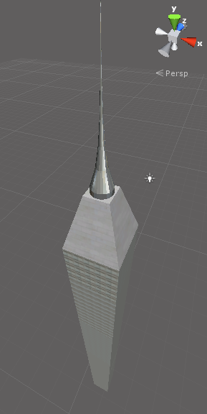
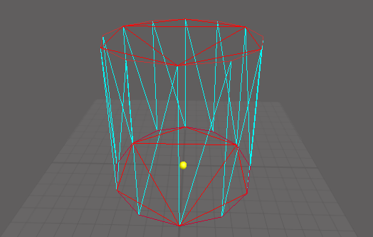

This image also shows the tessellated caps, you can select Toggle Tessellated View from the context menu to see how the caps will be tessellated in the final mesh.

The currently selected grid in the Geom window is highlighted in blue. If you right click on this grid in the list and select Copy it will make a copy of the grid ready to paste elsewhere in the framework. To paste the copy, right click on any grid in the list and select Paste from the menu to add the copy to the list after the item you clicked on. The same is true for multiple copies, if you want to copy more than one grid simply tick the boxes for each grid you want to copy before selecting copy from the menu.

The grids that are pasted into the framework will still have their original positions and rotations and will need to be selected as a group in the hierarchy before dragging them to the new position in the framework depending on where you pasted them.

When adding or deleting grids in the framework you can undo/redo the operations by right clicking on the Geom window and selecting Undo or Redo from the context menu.

Also from the context menu, you can quickly reset the increments back to the defaults by selecting Reset Increments or you can reset the orientation of the current grid by selecting Reset Grid. And if you have made a lot of changes to the control points on a grid and would like to reset them back to the default shape of the framework type you can select Reset Control Points from the menu.

To export your new creations to the OBJ format you begin by first selecting the game object/s you would like to export and then clicking on the Window menu item in Unity, hovering over the Geom item and then the tools item before selecting the type of export you want to perform. The exported object will be saved in the Geom folder in a subfolder called Exported Objects.
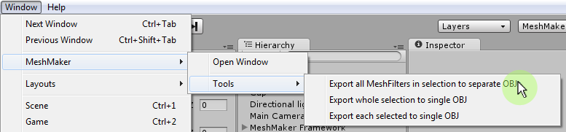

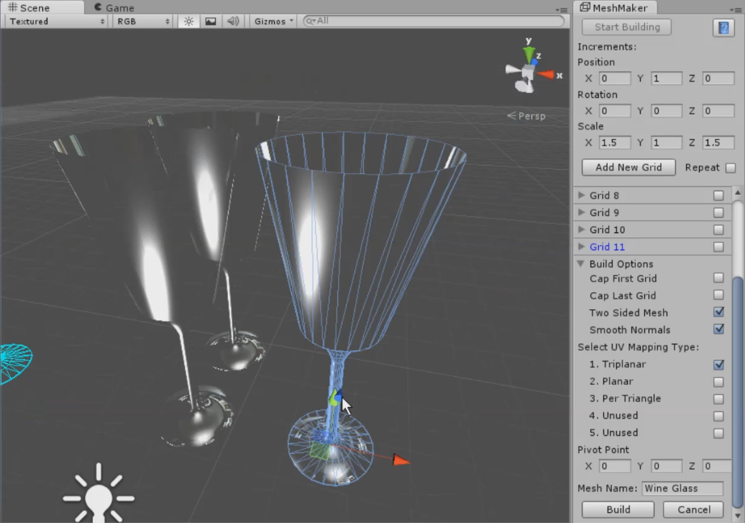

To learn more about Geom and to view the tutorial videos you can visit
MeshMaker.com

Update

As of July 2014 MeshMaker is now called Geom. MeshMaker still exists as the main title for the collection of mesh creation and editing programs.
Introduced in version 1.7 you can now set the positions of the control points directly via the Geom window. To set a points position simply click on it in the Scene View to make it the current point and open the grid foldout for that grid. You will then be able to enter the values for the points X and Y axes to set its position.

