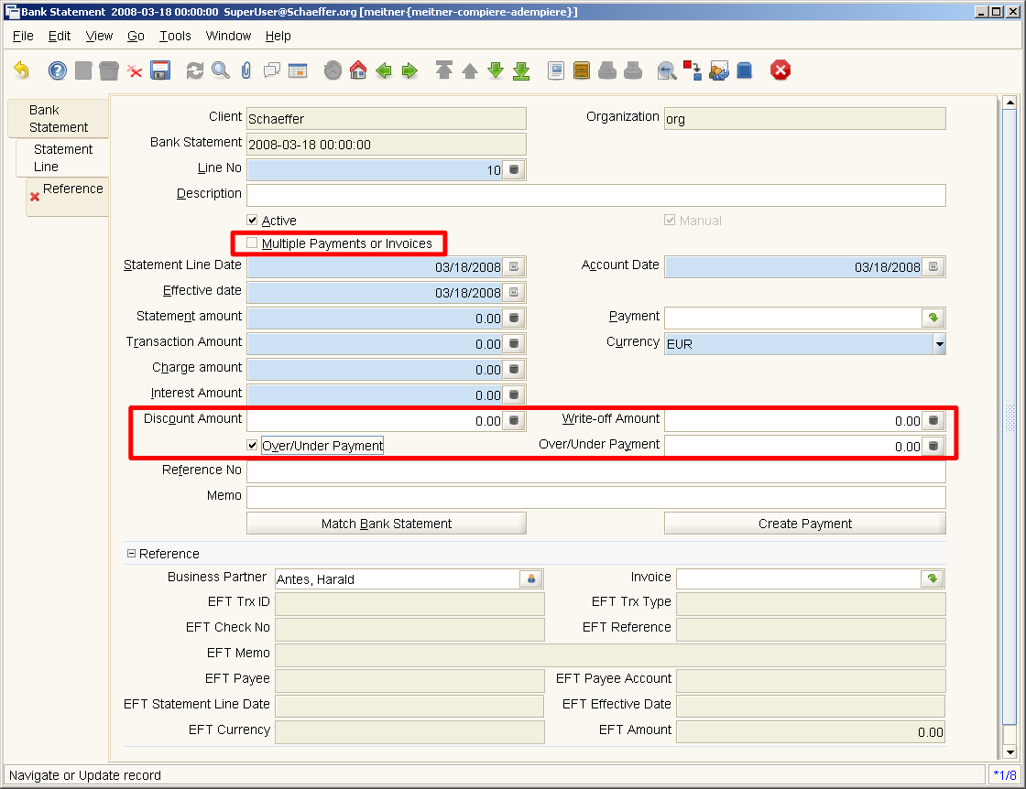
New fields in BankStatementLine:
Discount Amount, Write-Off Amount, OverUnder Payment (boolean) and OverUnder Payment (amount) are similar to the fields in the payment window with the same functionality (callouts). When an invoice is selected the discount amount is calculated (depending on the payment term).

If the checkbox 'Multiple Payments or Invoices' is checked the tab 'Reference' is available and more than one invoice / payments for the BankStatementLine can be entered.

This is useful for the following cases:
- One payment pays several invoices
- One bank statement line sums up several payments and charges (credit card payments from your bank)

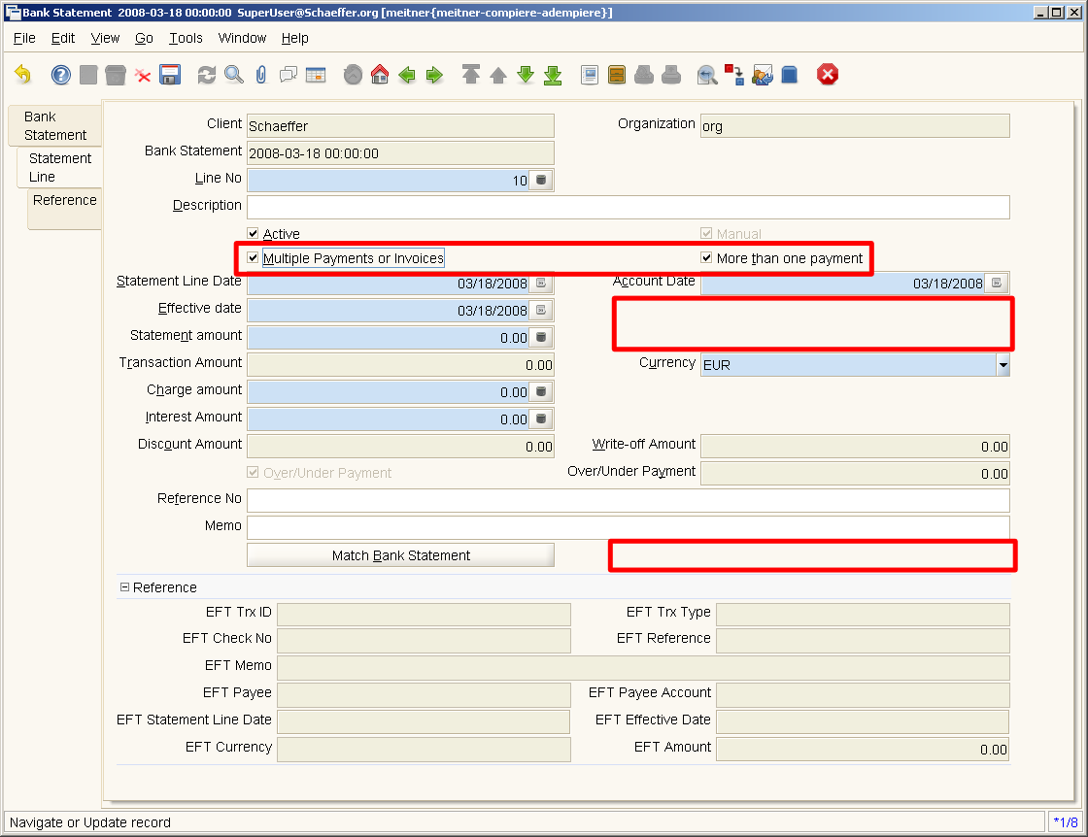
If 'Multiple Payments or Invoices' is checked the field 'More than one payment' is shown to distinguish between both cases. If 'More than one payment' is set, the fields' Payment' und 'Create Payment' are hidden because the payments are entered at the 'Reference' tab. The fields Transaction Amount, Discount Amount, Write-Off Amount and Over-Under Payment are readonly and calculated from the 'Reference' entries.

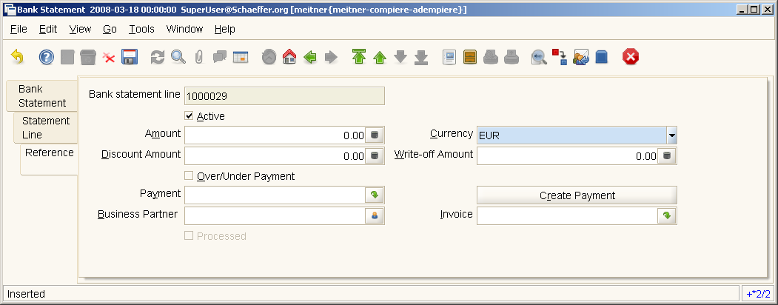
The Reference tab works similar to the statement line. If an invoice is selected the Amount and Business Parter fields are set. The Create Payment button creates a payment (and allocation) from these data. It is possible to select a payment directly or to create a payment without selecting an invoice also.

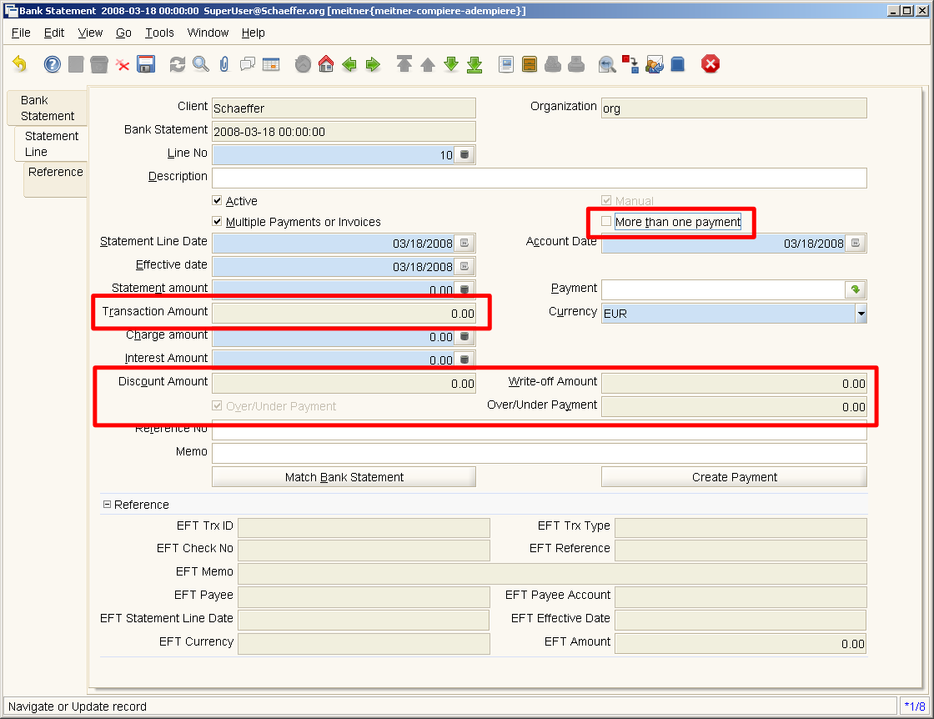
If the 'More than one payment' checkbox is not selected (one payment, several invoices) the marked fields are readonly. The values are calculated from the reference entries. Enter the invoice data at the Reference tab and create the payment with the 'Create Payment' button on the Statement Line tab. An allocation will be created for all invoices. A validation rule makes shure that all entered invoices have the same business partner.

Create Packout.xml

If you want to create a packout.xml from the in a current Adempiere instance that have the migration scripts applied, these are the elements that need to be in the package.

Table: C_BankStatementLine
Table: C_BankStatmentLine_Ref
Window: Bank Statement
Dynamic Validation Rule:
C_BPartner first of C_BankStatementLine_Ref
C_Payment not in BankStatement
C_Invoice not in BankStatement

For some reason however, I can't get the packin to work. It refuses to read the tab „Reference“ in the Bank Statement window.

