

A Network of Excellence forging the
Multilingual Europe Technology Alliance

META-SHARE V 2 User Manual

Authors: Bernardo Magnini, Manuela Speranza, Dimitris Mavroeidis.
Date: March 7th, 2012

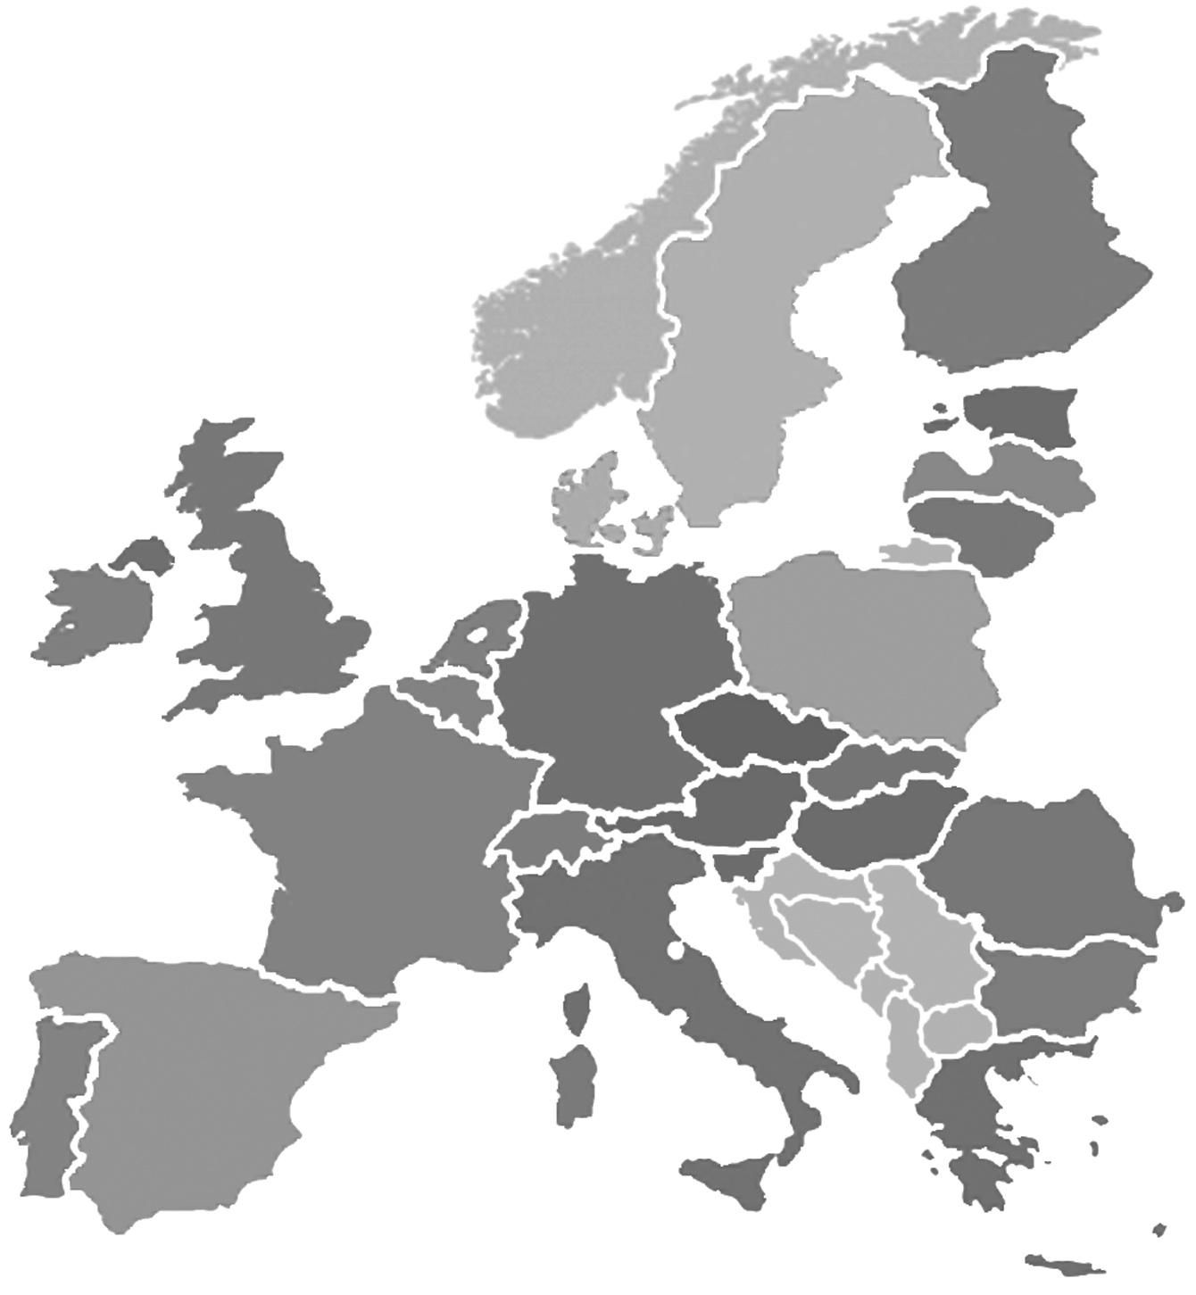

Table of Contents

1 Executive Summary 3
2 Introduction 3
3 User-oriented documentation 3
3.1 Search and browse the catalogue 3
3.1.1 Search the catalogue 3
3.1.1.1 Simple search 4
3.1.1.2 Faceted search 5
3.1.2 Browse the catalogue 6
3.2 View details about a LR 7
3.3 Download a LR 8
3.4 View general statistics 8
3.5 Access as a registered user 10
3.5.1 Register as a new user 10
3.5.2 Log in 11
3.5.3 Create/Edit User Profile 11

Executive Summary
This document is a guide for the users of META-SHARE. As such, it describes the functionalities implemented in V2 of META-SHARE and provides the users with step-by-step explanations of how to exploit them.

Introduction
META-SHARE (http://www.meta-share.eu/ and http://www.meta-share.org/) is a network of repositories of language resource (LRs), including both language data and language tools, described through a set of metadata (see T4ME Deliverable 7.2.4 for a detailed description of the schema of the metadata), aggregated in central inventories allowing for uniform search and access to resources. LRs can be both open and with restricted access rights, either for free or for-a-fee.
More specifically, META-SHARE V2 offers to the user the possibility to:
- search and browse the catalogue;
- view details about a LR;
- download a LR;
- view general statistics;
- have access as a registered user;

User-oriented documentation

Search and browse the catalogue
When looking for a LR, the user can perform both keyword-based search and browsing of the catalogue.

Search the catalogue
Both a simple search and a faceted search mechanism are available to search through META-SHARE.

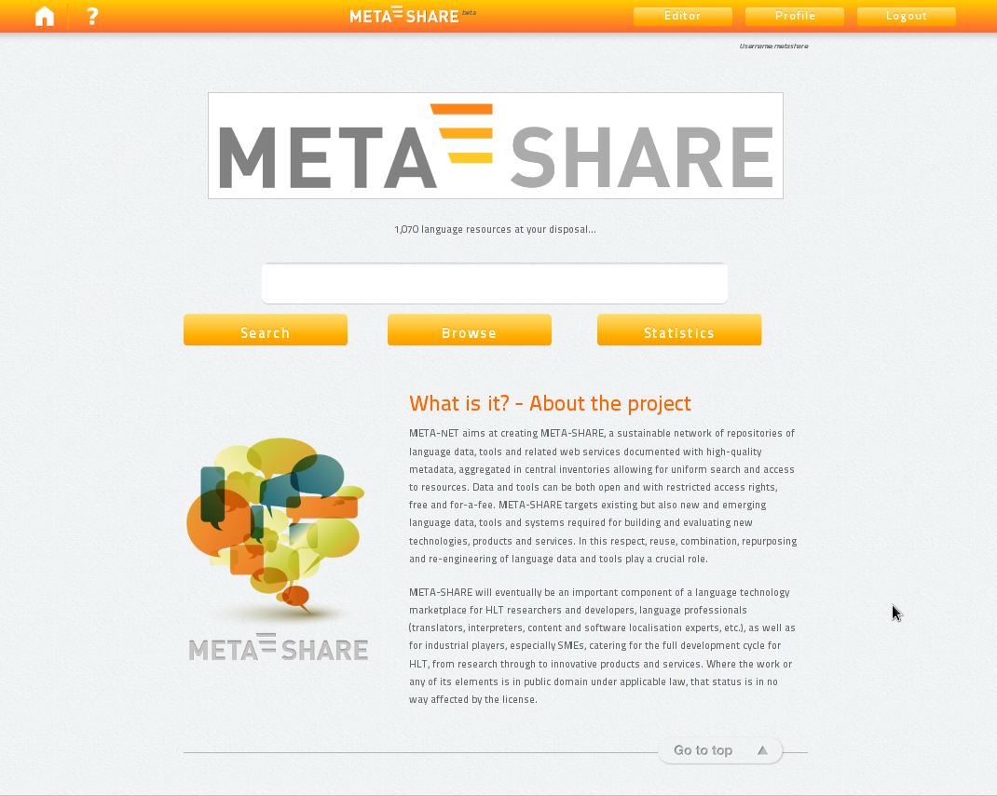
Figure 1: META-SHARE homepage

Simple search
The user can have access to the entire META-SHARE catalogue through a simple keyword-based search:
- Enter any word(s) into the text box at the top of the home page (see Figure 1).
- Click on the “Search” button below the text box or press “Enter” on the keyboard to begin the search. The search is performed over a subset of the metadata used to describe LRs; this subset is composed of: resource name, resource short name, description, resource type, media type, language name, language variety name, annotation type, licence, tool service type, tool service subtype, lexical conceptual resource type, language description type and use NLP specific.
- Results contain the search term in any of the searched metadata, in the following ways:
- a whole word;
- combination of words: combined search will return resources containing all of the search terms entered (AND operator);
- phrases: the user can enter words included in double quotes (“). This kind of search will provide the user with an exact match of the quoted text.

The results page (see Figure 2) lists all the LRs matching the query (if the user doesn’t type any word, the result consists of the entire catalogue). For each LR, the following metadata information is provided: resource name, resource short name (if available), resource type, media type (if available) and language (if available).

Faceted search
On the left pane of the results page, there is a list of facets (or filters). The user can filter the search results by any of the following fields:
- resource type
- media type
- language
- availability
- license
- restrictions of use
- validated
- foreseen Use
- foreseen Use/use NLP specific
- resource Creator
- linguality type
- multilinguality type
- modality type
- mimetype
- best practices / conformance to standards
- domain
- geographic coverage
- time coverage
- subject/topic
Filters can be combined with search terms entered in the search box. The number of resources available, if a specific filter is selected, are reported alongside each group of resources. When the user selects a filter, it's typeface changes to bold. Multiple filters can be applied. For instance, if a user requires a parallel corpus of English and French, he/she can select both “French” and “English” in the “language” part of the filtering part as well as “corpus” in the “resourceType” part. Filters can be removed by selecting the “x” button next to each selected field.

Browse the catalogue
The user can browse the catalogue as follows:
- Click on the "Browse" button below the text box in the home page;
- The user can now browse the whole META-SHARE catalogue in two ways:
  - page through all LRs using the “Next” link which is provided both at the top and at the bottom of the LR list for that page.
  - browse the catalogue by using the filters on the left pane of the results page (see Section 3.1.1.2 “Faceted Search”).

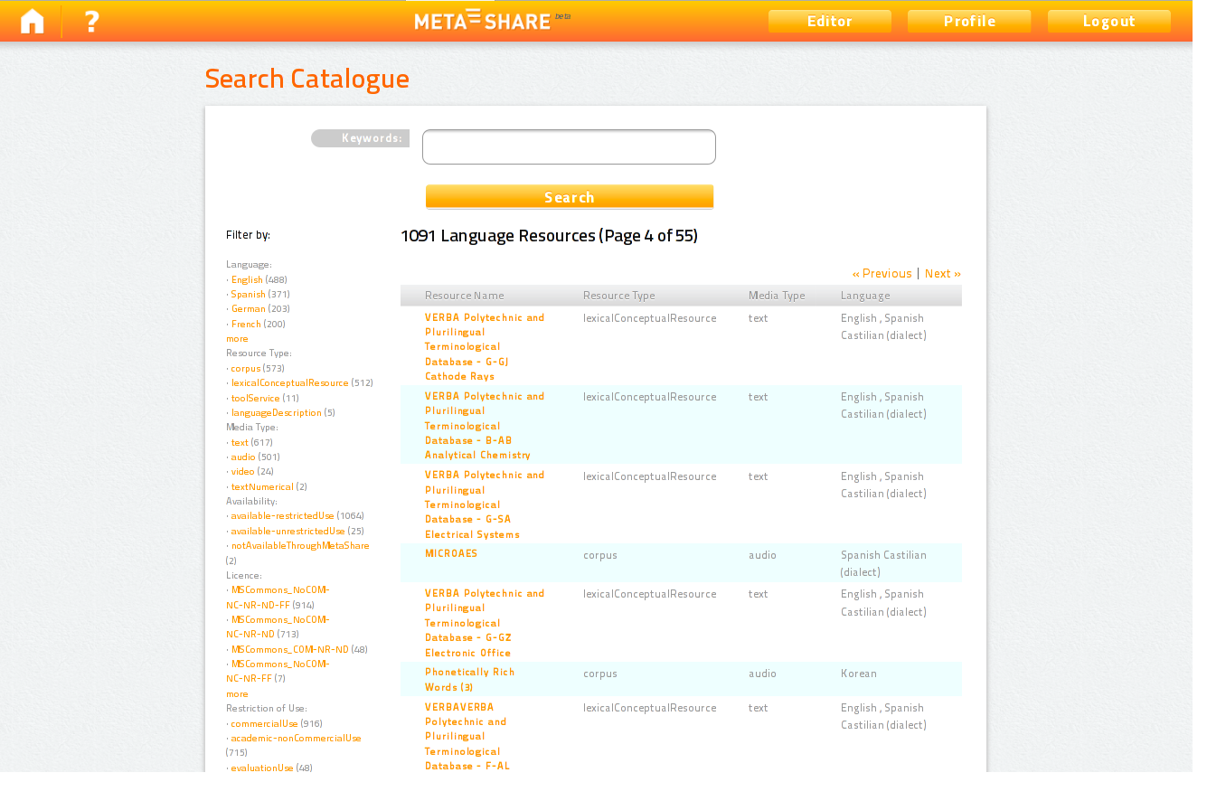

Figure 2: Results page

View details about a LR
The user can click on the name of a LR from the results page obtained by any type of search (see previous Section) to open the page with the details for that LR (see Figure 3). Information about a LR includes all the metadata information available for that resource (e.g. a textual description, the licensing conditions under which it is distributed, etc.).

Some statistics about a single LR are also provided:
- the icon representing an eye indicates how many times users have viewed the detailed information for that LR;
- the icon representing a down arrow indicates how many times it has been downloaded;
- the check mark indicates how many times the resource has been updated and the date of the last update (which appears by positioning the cursor on the check mark).
Each icon is shown at the top right of the page if the count associated with it is at least 1.

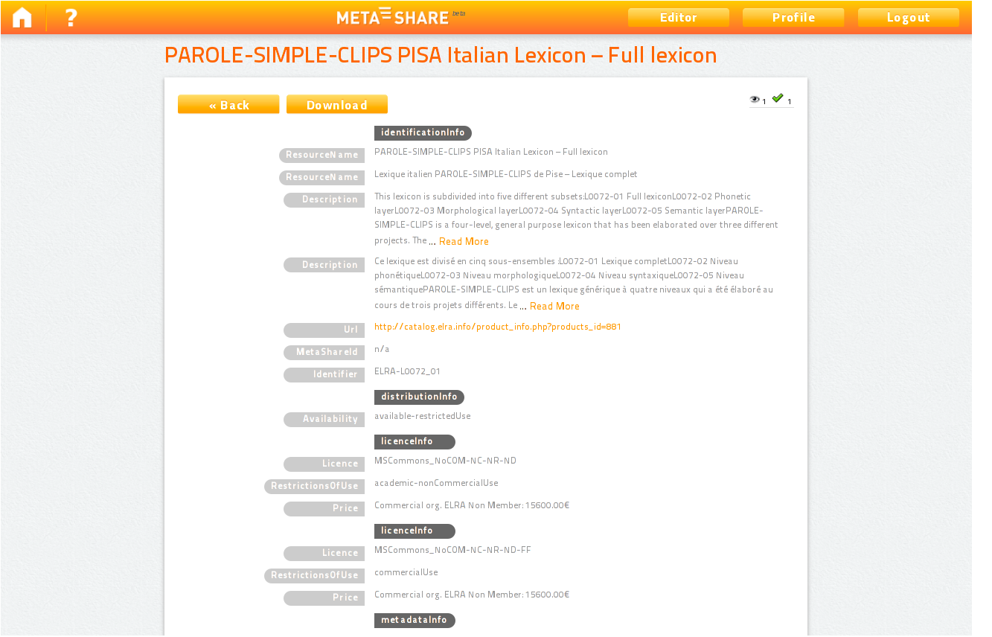

Figure 3: Page with detailed information for a single LR

Download a LR
If a LR is directly provided through META-SHARE, the user can download it from the page with the details for that LR (Figure 3). Steps to follow are:
- Click on the “Download” button at the top left or bottom left of the page.
- Accept the license terms under which the LR is distributed by ticking the corresponding box.
- Click on the “Download Resource” button at the bottom of the page.

View general statistics
Various types of general statistical information about the use of META-SHARE are available to the user:
- Click the “Statistics” button below the text box in the home page to see the statistics.
Four different lists are available:
- the 10 most viewed LRs;
- the 10 most downloaded LRs;
- the 10 most recently updated/added LRs;
- the 10 most recent queries.
By default, the system shows the 10 most viewed LRs; the user can select the other lists from the select box on top of the statistics page (see Figure 4).
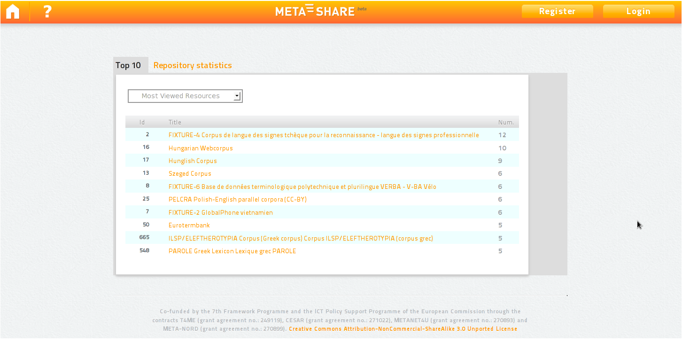
Figure 4: Statistics about the use of META-SHARE

The user can also see statistics about the contents of META-SHARE by clicking on the “Repository statistics” link next to “Top 10” (see Figure 5).

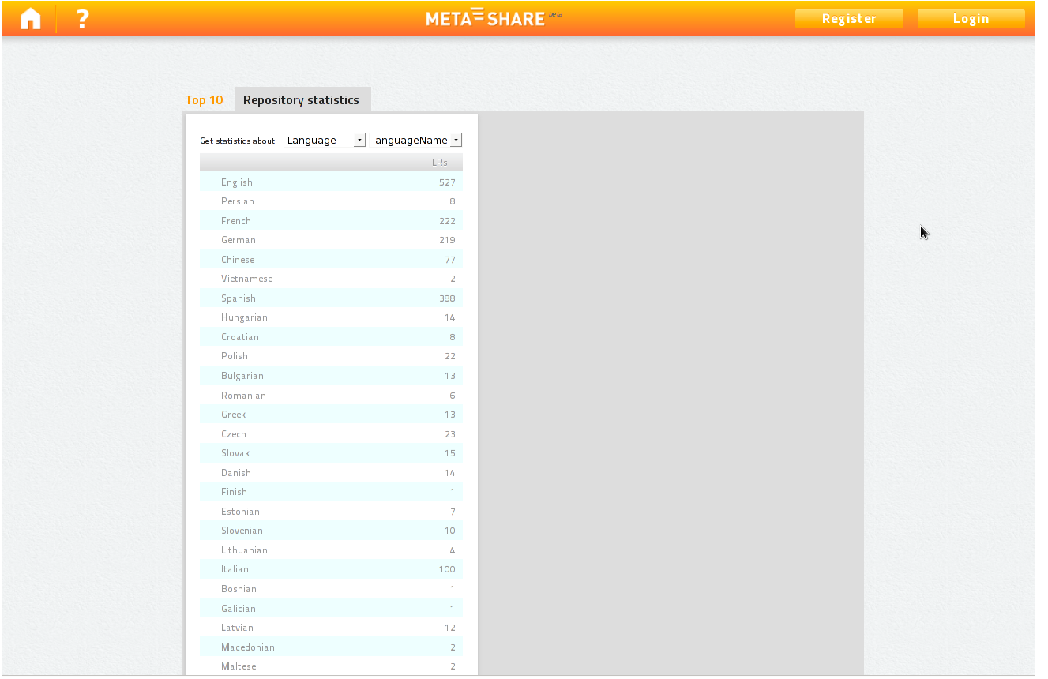
Figure 5: Statistics about the contents of META-SHARE

Access as a registered user
Users can register to META-SHARE and log in to META-SHARE in order to have access to further functionalities of the portal, such as uploading a LR.

Register as a new user
In order to register to META-SHARE and get an account:
- Click the “Register” button at the top right of the META-SHARE home page.
- Fill in the “Create Account” form with a Username of your choice, your First Name, Last Name and Email address.
- Click the “Create Account” button.
- The following message appears in the META-SHARE home page: “We have received your registration data and sent you an email with further activation instructions.”
- The system generates a message asking for a confirmation of the registration and sends it to the address provided when registering.
- Click on the link provided in the message to confirm the registration (this has also the effect of logging in the user for the first time).
- A confirmation message appears in the META-SHARE home page as follows: “We have activated your user account and sent you an email with your personal password which allows you to log in to the website.”

Log in
Registered users can use their credentials to log in to META-SHARE:
- Click the “Login” button at the top right of the home page (see Figure 1).
- Fill in the “User Authentication” form with Username and Password.
- Click the “Login” button.
At the end of the working session, the user can log out by clicking on the “Logout” button at the top right of the home page.

If the user forgets its password, the system offers the possibility to retrieve it:
- Click the “Login” button at the top right of the home page.
- Click on “Forgotten your password? Click here to reset your account”.
- Fill in the “Reset Account” form with the Username and Email address used for the registration.
- Click the “Reset Account” button.
- The system generates a message asking for a confirmation of the reset request and sends it to the user.
- Click on the link provided in the message to confirm the request.
- A confirmation message appears in the META-SHARE home page as follows: “We have re-activated your user account and sent you an email with your personal password which allows you to log in to the website.”

Create/Edit User Profile
The user can create his/her profile by providing some information:
- Log in to META-SHARE (see Section 3.5.2).
- Click the “Profile” button at the top right of the home page (this button is present only when the user is logged in).
- Fill in the “Profile” form with the following information: Date of Birth, Affiliation(s), Position, and Homepage.
- Click the “Edit Profile” button.

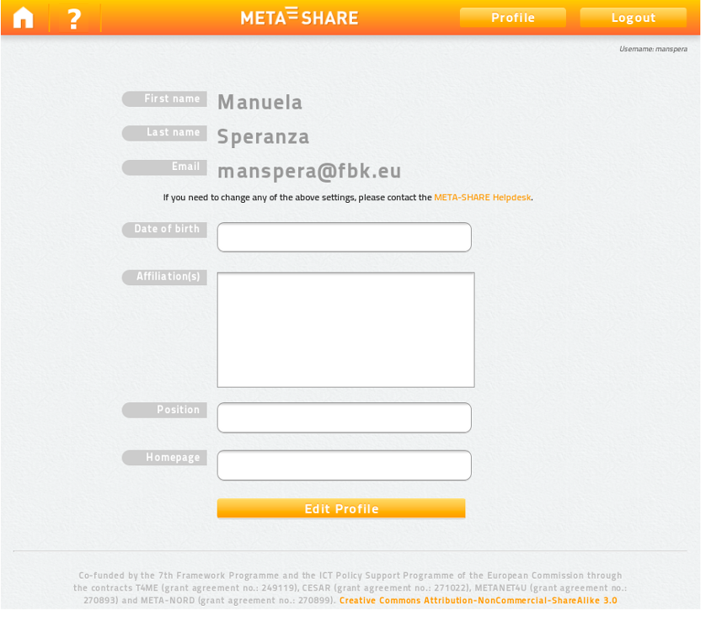
Figure 5: Profile form

The user can also edit his/her Profile:
- Log in to META-SHARE (see Section 3.5.2).
- Click the “Profile” button at the top right of the home page (this button is present only when the user is logged in).
- Fill in the “Profile” form with a new Date of Birth, Affiliation(s), Position, or Homepage.
- Click the “Edit Profile” button.

In order to change the First Name, Last Name, or Email, the user should contact the META-SHARE Helpdesk at helpdesk-technical@meta-share.eu

The match of a search word is performed is performed over the union of the selected metadata (metadata_1 OR metadata_2 OR … metadata_n).
In the case of two or more search words, the matching is performed as a boolean search: “*word1* AND *word2* AND…*word n*”.
Both fields are compulsory

