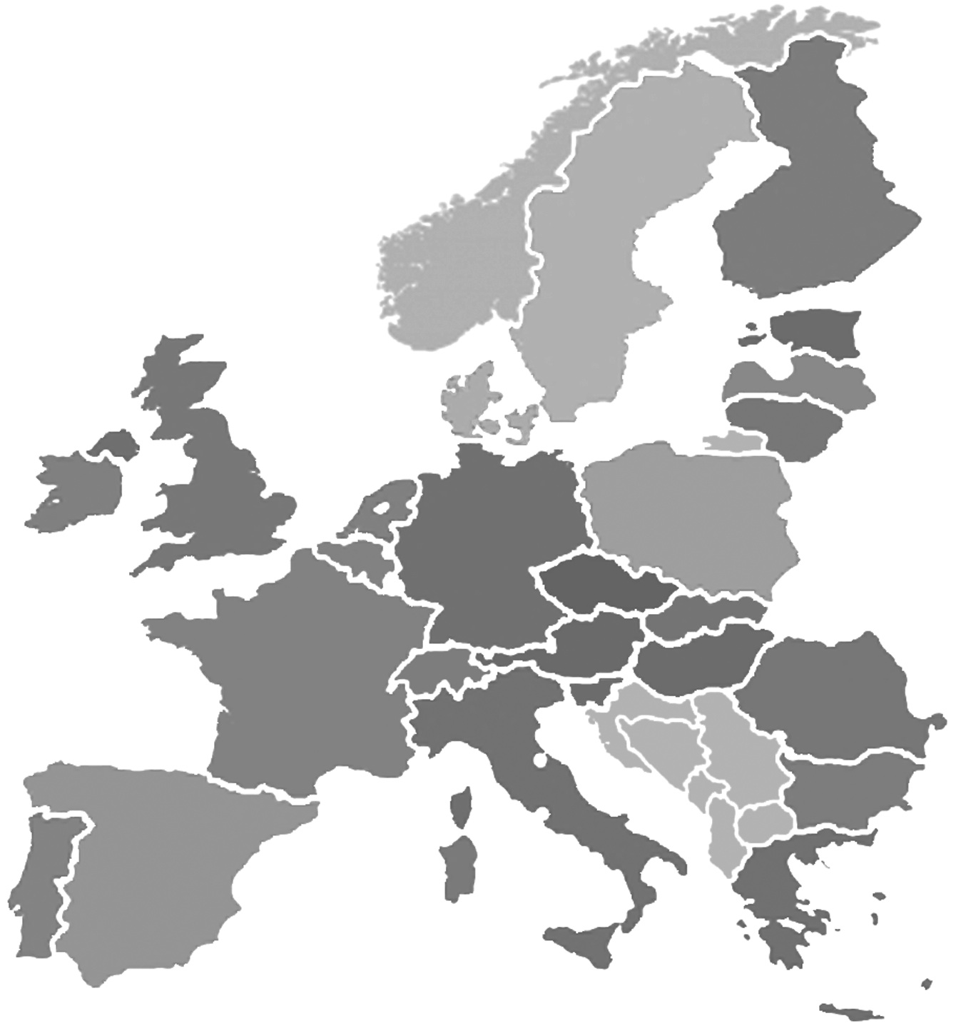


A Network of Excellence forging the
Multilingual Europe Technology Alliance

META-SHARE V2.9-beta Provider Manual

Authors: Victoria Arranz, Christian Federmann, Ioanna Giannopoulou, Olivier Hamon, Marc Schröder, Christian Spurk
Date: July 17, 2012

Table of Contents
1 Executive Summary 3
2 User and Access Rights Management 3
2.1 Basic User Roles and Permissions 3
2.2 Resource Ownership and Access 4
2.2.1 Resource Owners 4
2.2.2 Editor Groups for Resources 4
2.3 Managing User Accounts 5
2.3.1 Managing Editor Users 5
2.3.1.1 Creating and Managing Editor Groups 5
2.3.1.2 Applying for Editor Group Memberships 5
2.3.1.3 Directly Adding a User Account to an Existing Editor Group 5
2.3.1.4 Removing Users from Editor Groups 6
2.3.2 Managing Editor Group Managers 6
2.3.3 Adding and Managing Organizations 6
2.4 Granting Permissions 6
3 Provider-Oriented Documentation 7
3.1 Add a Language Resource 7
3.2 Edit Language Resources 12
3.3 Add Other Metadata Entities 13
3.4 Manage Language Resources 13
3.5 Export LR Descriptions to XML 13
3.6 Details of Adding and Editing Metadata Information 13
3.6.1 Input Types 15
3.7 Import Language Resources 17
3.7.1 Prepare the Import File 17
3.7.2 Upload Using the Import Script 17
3.7.3 Upload Using the Web Interface 18
3.7.4 Conversion of Existing LRs 18
3.7.5 Conversion from META-SHARE V2.0 to V2.1 or Later 20
3.8 Add Downloadable Content to Resources 20
3.8.1 Adding Downloadable content 20
3.8.1.1 Upload via the Web Interface 20
3.8.1.2 Upload Using the Command Line storage_admin.py Script 23
3.8.2 Known Limitations 23
4 Glossary 24

Executive Summary
This document is a guide for those who are interested in providing Language Resources (LRs) with META-SHARE. It also explains user and access rights management of the META-SHARE web editor.

User and Access Rights Management
Version 2.9-beta of the META-SHARE web application introduced a fine-grained user and access rights management system which determines who may do what on a META-SHARE node. For example, LR providers have more rights than a normal user who just wants to download LRs, some non-provider users may be members of an organization which grants special download rights, etc.
This section describes the META-SHARE user and access rights management system.

Basic User Roles and Permissions
META-SHARE knows the following user roles:
- anonymous user: used for non-logged in users; no user account; may browse published LR descriptions but cannot download any of the LRs themselves; can see node statistics
- registered user: personalized user account tied to an e-mail address; in addition to the rights of an anonymous user, a registered user may also download freely available LRs; can apply for editor group membership
- editor user: a registered user who is member of one or more editor groups; may create own LR descriptions and may upload smaller data files for them; may alter LR entries belonging to her editor group; may add owned resources to the editor groups she is member of
- editor group manager: a registered user who manages a certain editor group; may accept or turn down applications for the managed editor group; may ingest, publish, unpublish and delete LRs belonging to the managed editor group
- organization member: a registered user who is member of an internally known organization group
- organization manager: a registered user who manages an internally known organization; may add and remove registered users to/from the managed organization group
- superuser: a registered user who has all possible permissions of the META-SHARE web application; a superuser account is usually created during the installation of a node; superusers are especially needed for creating editor groups, for making registered users editor managers, for creating organization groups and for making registered users organization managers
- node administrator: the person who administers the META-SHARE node installation; not a META-SHARE web application role but the administrator should have a superuser account; apart from the node installation, a node administrator may be needed for uploading larger LR data sets
In addition, there are the following permissions which can be granted to a group or to individual user accounts:
- META-SHARE associate member: this permission currently has no effect in the META-SHARE web application, however, it is expected to have in the future
- META-SHARE full member: this permission grants the right to freely download LRs with a META-SHARE Commons license

Resource Ownership and Access
META-SHARE is all about LRs. Consequently, the META-SHARE user roles and permissions (Section 2.1 ) are centered around creating, modifying, accessing and otherwise managing these LRs.

Resource Owners
A LR has zero or more owners, i.e., users who own the resource. The user who creates a LR is usually the first owner of a LR. Owned LRs are listed on the “My Resources” page of the web editor. Additional owners can be added on that page, too. Only superusers can withdraw LR ownership.
Owners may always edit their LRs, no matter if they are in an editor group of that LR (Section 2.2.2 ) or not.

Editor Groups for Resources
A LR belongs to zero or more editor groups. As can be expected, editors of these editor groups may edit such LRs. The user who creates a LR determines what editor groups a LR gets by default. Additional editor groups can be added on the “My Resources” page of the web editor. Only superusers can remove editor groups from a LR again.

Managing User Accounts
The META-SHARE User Manual explains how web application users can register for a new user account. This section details how existing META-SHARE user accounts can be provided with the different roles that we introduced in Section 2.1 .

Managing Editor Users
An editor user is a user who is member of one or more editor groups.

Creating and Managing Editor Groups
In a new META-SHARE installation there are no editor groups in the system at all. A superuser first has to create them. Whenever a new editor group is needed, it has to be created by a superuser.
To create or manage editor groups, choose “Editor groups” from the “Manage” menu of the web editor. Creating new editor groups can be accomplished with the “Add editor group” button in the top right corner of the “Select editor group to change” page. You basically only need to specify a meaningful name (such as “XYZ Corpus editors”) and then save; usually you will not want to change any of the preselected permissions (unless you really know what you are doing).

Applying for Editor Group Memberships
Every registered user may apply for membership in one or more editor groups, i.e., for being an editor user. Such an application is possible from your user profile page (accessible from the front page using the “Profile” button in the top right corner, when logged in) and then clicking the “Apply for new membership of editor groups.” link. Editor group managers of the applied-for group and superusers will be notified of the application.
As an editor group manager (or superuser) you can accept or turn down an editor group membership application by first choosing “Editor group applications” from the “Manage” menu of the web editor. From the editor group application list choose the application that you would like to accept or to turn down. Choose the relevant action at the top of the list and click the “Go” button.

Directly Adding a User Account to an Existing Editor Group
Superusers can directly add existing user accounts to an editor group. To do this, go to the web editor and choose “Users” from the “Manage” menu. Click the user you would like to add to an existing editor group. At the bottom of the “Change user” page in the “Groups” section, select the editor group you would like the selected user to be a member of.
Before you save your changes, make sure that the user has “Staff status” in the “Permissions” section.

Removing Users from Editor Groups
Only superusers can remove users from editor groups. To do this, go to the web editor and choose “Users” from the “Manage” menu. Click the user you would like to remove from an editor group. At the bottom of the “Change user” page in the “Groups” section, deselect the editor group from which you would like to remove the selected user.

Managing Editor Group Managers
Only superusers can manage editor group managers. Technically, a manager for some editor group is a user who is member of a so-called “manager group” which manages that editor group. Thus, before you can make a user an editor group manager, you have to have a corresponding manager group.
To create a manager group, choose “Manager groups” from the “Manage” menu of the web editor and then click the “Add manager group” button in the top right corner of the page. You need to specify a meaningful name (such as “XYZ Corpus editor group managers”) and select the editor group that shall be managed by the new manager group. Then save; usually you will not want to change any of the preselected permissions (unless you really know what you are doing).
To add members to a manager group, you can either use the same method as described in Section 2.3.1.3 for editor groups. Or you can choose “Manager groups” from the “Manage” menu of the web editor, then select the manager groups to which you would like to add new members, then choose the “Add users to selected manager groups” action, then click the “Go” button and on the following page choose the users that you would like to have as members of the selected manager groups.
To remove members from a manager group again, you can either use the same method as described in Section 2.3.1.4 for editor groups. Or you can choose “Manager groups” from the “Manage” menu of the web editor, then select the manager groups from which you would like to remove members, then choose the “Remove users from selected manager groups” action, then click the “Go” button and on the following page choose the users that you would like to not be members of the selected manager groups anymore.

Adding and Managing Organizations
TODO

Granting Permissions
Permissions are very fine-grained flags which control what users and groups may or mustn’t do in the META-SHARE web application. Only superusers can manage permissions. However, when using the mechanisms described in Section 2.3 , you will usually not need to care about permissions at all – with one exception: META-SHARE memberships. Aside from META-SHARE memberships you should usually never change any of the built-in permissions – unless you really know what you are doing.
At some point you may want to make single users or organizations META-SHARE members. As noted in Section 2.1 , META-SHARE membership is controlled with two permissions. To grant one of these permissions to a single user, go to the web editor and choose “Users” from the “Manage” menu. Click the user whom you would like to give the permission. On the “Change user” page in the “Permissions” section, make sure that either the “accounts | user profile | Is a META-SHARE associate member.” permission or the “accounts | user profile | Is a META-SHARE full member.” permission is selected. Then save.
To grant one of the permissions to a group of users (usually to an organization), go to http://<YOUR_NODE>/editor/auth/group/ of the web editor and click the group to which you would like to give the permission. On the “Change group” page under “Permissions”, make sure that either the “accounts | user profile | Is a META-SHARE associate member.” permission or the “accounts | user profile | Is a META-SHARE full member.” permission is selected. Then save.

Provider-Oriented Documentation

Add a Language Resource
An editor user can add a new LR by inserting the metadata that describes this LR. The editor user must be registered and logged in so as to add new LRs, and then do as follows:
- Click on the “Editor” button on the top right of the main page of META-SHARE.
- In the result page (“META-SHARE backend for resource providers”), click on the “Share/Create” link at the top left (see Figure 1). From the drop-down menu that appears, click on “Resource”. The result page presents a drop-down menu, listing all the available resource types (see Figure 2).
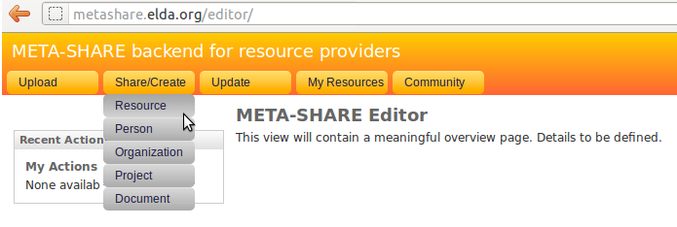
Figure 1: META-SHARE backend for resource providers

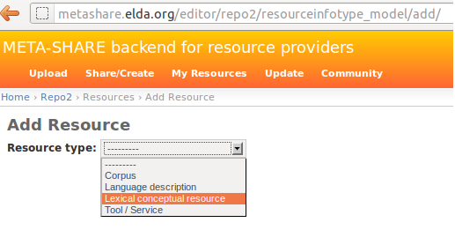
Figure 2: Choose one of the available resource types

- Choose a resource type for the LR. (A LR can only have one resource type).
If your choice is “tool / service”, go directly to step 4.
If your choice is of the other three resource types, select from the appearing check-box list, the media type(s) for the LR (see Figure 3).
Note: In the case of “lexical conceptual resource” and “language description” resource types, “text” is a required media type and, as such, it is selected by default and cannot be unselected.
- Click on the “proceed” button.
In the result page (see Figures 4 & 5), all the metadata information to be filled in, is summarized under a left hand side menu (see Section 3.6 for the description of the metadata fields). On the top of this menu, there is the administrative information categorized as required, recommended and optional, if any. A click on any of these options, will lead in expanding the appropriate metadata block on the right hand side.

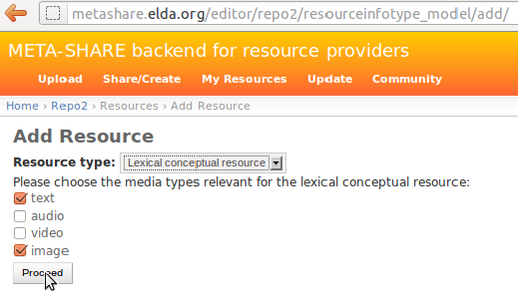
Figure 3: Choose media types for the selected resource type

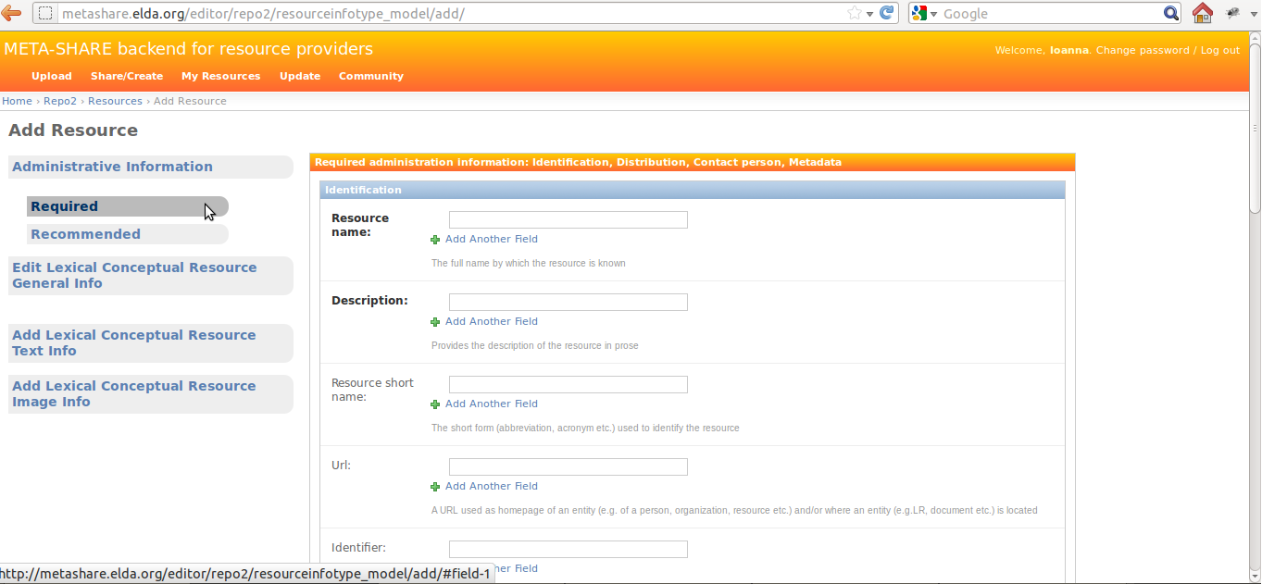
Figure 4: Administrative Information metadata block (Required)

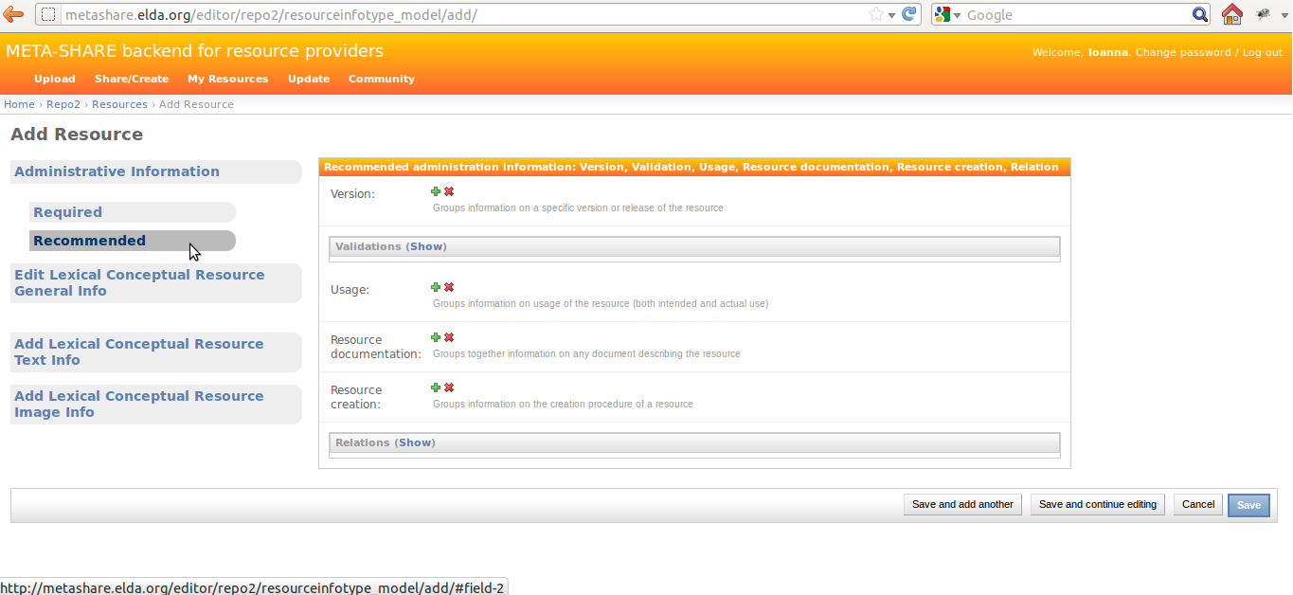
Figure 5: Administrative Information metadata block (Recommended)

- Fill in the administrative metadata fields (Only the required information -appearing as bold- is necessary for a LR to be successfully saved).
On the same level of the left hand side menu as the administrative information, there are the resource-type-specific information. Clicking on one of these, will lead in opening a pop-up window, containing the blocks of metadata to be filled in (see Figure 6 for an example). These pop-up windows follow a similar menu structure (required / recommended / optional) as the main page.
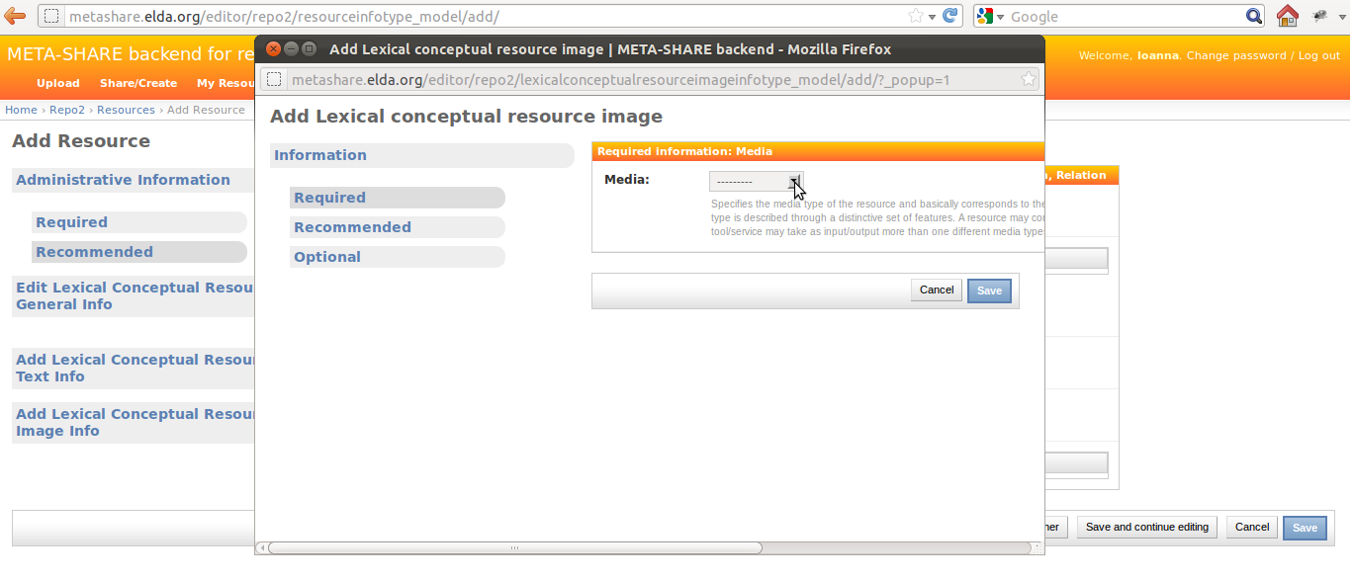
Figure 6: Resource-type-specific pop-up window (here for a Lexical-Conceptual Resource)
- For each one of the pop-up windows, fill in the metadata fields (again, only the required information is necessary for a LR to be successfully saved). Once done with filling in information within a pop-up window, click on the “Save” button at the bottom of the page. In case of errors, a message will be displayed on the top of the page, the errors will be reflected on the menu options and the problematic fields (i.e., fields which either contain an error or are empty) will be highlighted in red (see Figure 7 for an example). If there are no errors, the “Save” button will close the pop-up window, returning to the previous page.
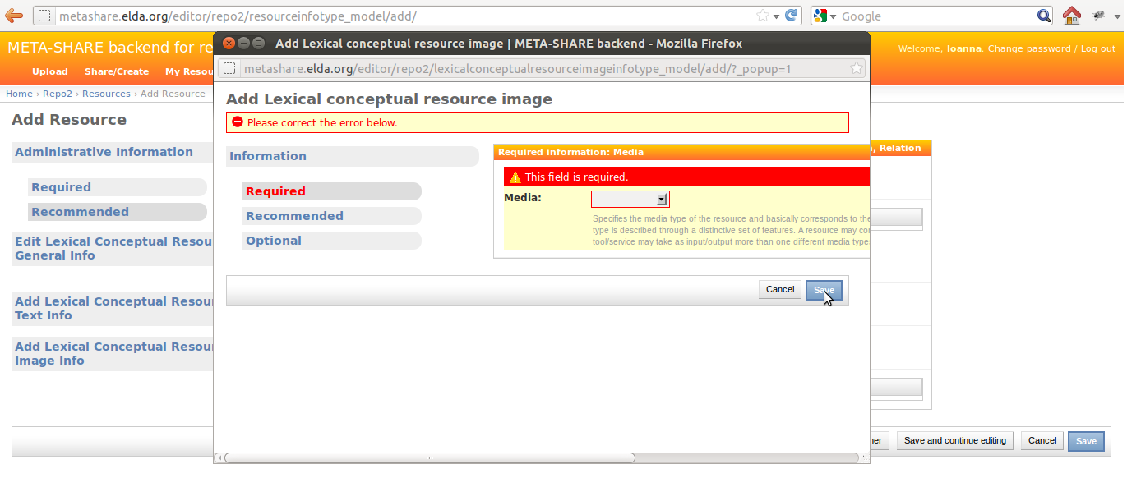
Figure 7: Errors in pop-up window: the media field has not been filled-in

- Once done with filling in information both in the main page and in all the pop-up windows, click on the “Save” button at the bottom of the main page. If there are errors, they will be indicated in a similar way as in the pop-up windows (see Figure 8 for an example). If there are no errors, clicking on “Save” will result in a new page, displaying the message “The Resource 'resource name' was added successfully”, and listing all the LRs added in META-SHARE, included the newly created one (see Figure 9).
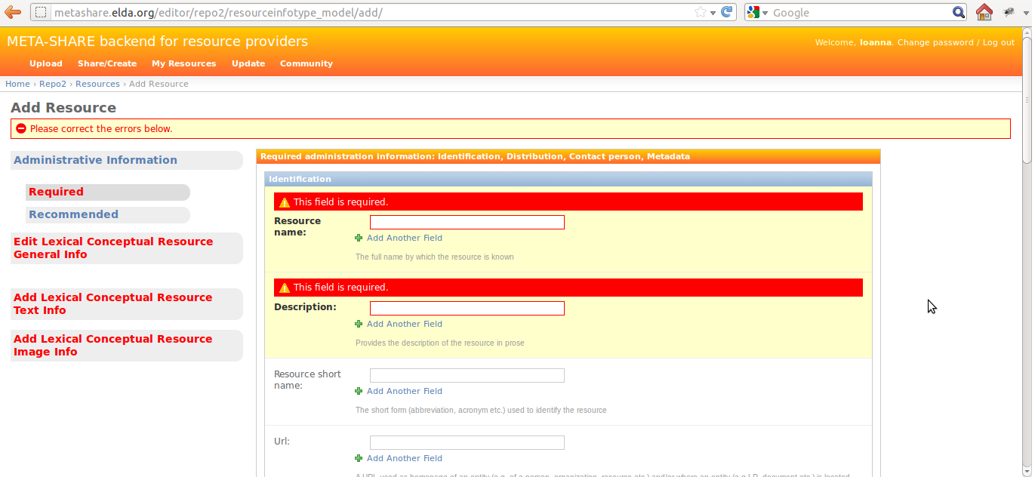
Figure 8: Errors in main page: the resource name and the description have not been filled-in, errors also in General Info and Text Info tabs
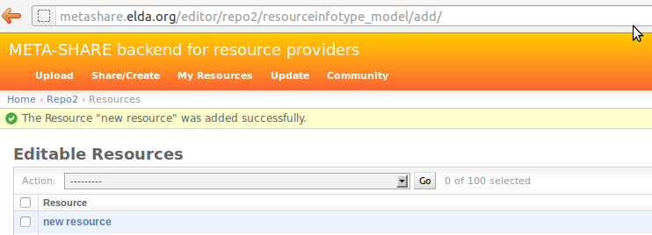
Figure 9: Successfully saved LR

Edit Language Resources
As described in Section 2.1 , an editor user can edit all LRs within the specific META-SHARE node which he owns or which belong to the editor group of which he is a member. On the top left of the “META-SHARE backend for resource providers” page, the editor can click on the “Update” link, where he can view a list of all the LRs / People / Organizations / Projects / Documents for the specific META-SHARE node. He can also click on the “My Resources” link, where he can only view a list of the LRs he has provided on META-SHARE himself (or more precisely: the LRs of which he is set as an owner).
If the provider wishes to edit a LR, he can click on its name. This will result in a page where he can edit all the metadata fields for this resource, which will appear in exactly the same view as described in Section 3.1 .

Add Other Metadata Entities
As shown in Figure 1, the editor user has a choice of creating other entities as well. The point of creating these types of metadata (namely Person, Organization, Project, Document) apart/independently from a resource, is that they can be reused in many LR descriptions. So, if for example a provider creates a project description first, then all he has to do when creating a LR description, is to select the project from the list of existing projects, instead of creating it from scratch.

Manage Language Resources
An editor group manager can delete, ingest, publish and unpublish all LRs that belong to his managed editor group. He can select the LRs to which he wishes to apply one of these actions and then select an action from the drop-down menu of actions (delete, publish, unpublish or ingest). Clicking on the “Go” button will execute the selected action.

Export LR Descriptions to XML
An editor user is able to export the description of a LR to META-SHARE XML format. One way of performing the exporting is through the “export” action on the Update page for one or more LRs – as described in the previous section. Another way of exporting is through the metadata editing page, by clicking on the relevant button on the top right of the page (see Figure 10).

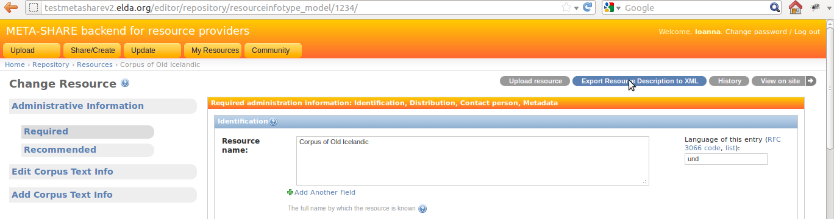
Figure 10: Exporting a LR description to XML

Details of Adding and Editing Metadata Information
Metadata information for LRs are organised in two levels, the first being Administrative / Type-specific, and the second being required / recommended / optional.
The tabbed menu described in Section 3.1 shows the two levels (see Figures 2, 3 & 4). A description of the metadata fields follows:
1. Administrative
- Required: contains information on identification, distribution, contact person, metadata of the resource, etc.
- Recommended: contains information on version/release, validation, usage, documentation, creation, relations of the resource, etc.
- Resource type: Corpus
2. Corpus Text Info*: Information on the text component of the resource, such as the language, the text format, the encoding, the annotation, etc.
3. Corpus Audio Info*: Information on the audio component of the resource, such as the language, the audio format, the size, the recording, the capture, etc.
4. Corpus Video Info*: Information on the video component of the resource, such as the size, the video format, the content, the language, etc.
5. Corpus Image Info*: Information on the image component of the resource, such as the size, the image format, the content, etc.
6. Corpus Text Numerical Info*: Information on the numerical text component of the resource, such as the size, the content, the creation, etc.
7. Corpus Text n-gram Info*: Information on the text n-gram component of the resource, such as the base item (word, syllable, letter, etc.), the language, the size, the text format, the encoding, etc.

- Resource type: Language Description
2. Language Description General Info*: Information on the specific type of the resource (grammar, etc.), the encoding, the performance, etc.
3. Language Description Text Info*: Information on the text component of the resource, such as the language, the linguality (monolingual, bilingual, etc.), the text format, the encoding, the size, etc.
4. Language Description Video Info*: Information on the video component of the resource, such as the creation, the size, the content, the video format, the language, etc.
5. Language Description Image Info*: Information on the image component of the resource, such as the creation, the size, the content, the image format, etc.

- Resource type: Lexical Conceptual Resource
2. Lexical Conceptual Resource General Info*: Information on the specific type of the resource (thesaurus, terminology, etc.), the encoding, as well as further details about the creation of the resource.
3. Lexical Conceptual Resource Text Info*: Information on the text component of the resource, such as the languages, the linguality (monolingual, bilingual, etc.), the text format, the encoding, the size, etc.
4. Lexical Conceptual Resource Audio Info*: Information on the audio component of the resource, such as the size, the audio format, the content, the language, etc.
5. Lexical Conceptual Resource Video Info*: Information on the video component of the resource, such as the video content, the size, the video format, the language, etc.
6. Lexical Conceptual Resource Image Info*: Information on the image component of the resource, such as the image format, the size, the content, etc.

- Resource type: Tool / Service
2. Tool / Service Info*: Information on the specific type of the resource (tool, service, platform, infrastructure, etc.), details about the input and output types, information on the operating systems and running environments, etc.

*All this information is divided in blocks: required / recommended / optional.

Input Types
In order to insert or modify metadata, the web application provides different kinds of input types:
- Text field: the editor user may add/modify free text that corresponds to the description of the metadata elements;
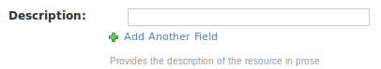

- Drop-down list box: the editor user may choose one item from the list provided;
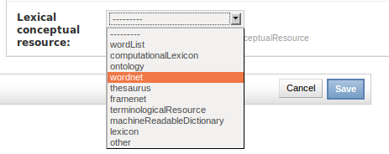

- Multiple-choice Drop-down list box: the provider may chose one or several items from the list provided;
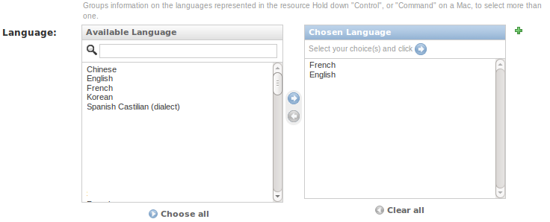

- Repeatable text field: the editor user may add or delete all the text field he wants to by clicking on the “+” or “x“ buttons, respectively.
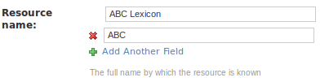

- Calendar text field: the editor user may write a full date on his own or select a date from a pop-up calendar.
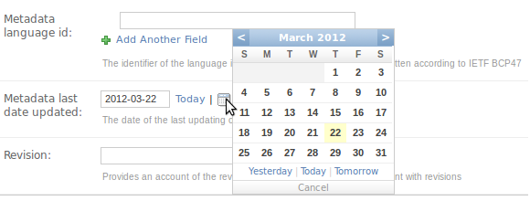
All fields are accompanied by a short description/explanation line, as shown below:
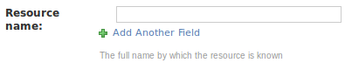

Import Language Resources

Prepare the Import File
To be able to import new LRs, the user must first create XML metadata files for each LR, that follow the META-SHARE metadata XML Schema. This compliance can be validated using the META-SHARE XML Schema (XSD); the current version can be found in the misc/schema/v2.1 folder.

Upload Using the Import Script
The META-SHARE node administrator (cf. Section 2.1 ) may import XML metadata from the command line using the import_xml.py script which can be found within the metashare installation folder. Basic usage information is given when called without any arguments:
$ python import_xml.py
usage: import_xml.py <file.xml|archive.zip> \
[<file.xml|archive.zip> ...]

The script reports errors and gives import statistics when finished.
A single XML file can be imported as follows:
$ python import_xml.py my_LR.xml
Done. Successfully imported 1 files into the database, \
errors occurred in 0 cases.

Multiple LRs can be imported using the “*” wildcard or by packaging the xml file into a zip file:
$ python import_xml.py metashare-v1-resources.zip
Done. Successfully imported 1,277 files into the database, \
errors occurred in 0 cases.

Importing a large zip file, or a large amount of XML files, takes some time; this is normal. The last line of the import_xml.py output should report no errors. After successful import of these files, the new resources should be available on the META-SHARE node.

Upload Using the Web Interface
An editor user can upload an XML metadata file by clicking on the “Upload” link at the top left of the “META-SHARE backend for resource providers” page. Uploading works as follows:
- Choose a file by clicking on the “Browse button”;
- Click on “Upload Terms” check-box to accept them;
- Click on the “Upload” button.

Conversion of Existing LRs
The conversion of the existing LRs from several different XML schemata to META-NET XML schema has been made with XSL transformations.
The process was the following:
- The first step was to map all the elements of the other XML schema to the elements of META-NET XML schema, one by one.
- Then, an XSL file was created, which contains the structure of META-NET XML schema, and XSLT lines harvesting the information from the files of the other XML schema format.
- The conversion process was executed for all given files.
Example:
Element resource_periodofcoverage from ELRA format has been mapped to timeCoverage element in META-SHARE schema format.
Line in ELRA XML file:
<resource_periodofcoverage>Between 1992 and 1999</resource_periodofcoverage>
XSL conversion file:
<xsl:variable name='time' select='preceding-sibling::resource_periodofcoverage'/>

<xsl:if test='$time!=""'>
<timeCoverageInfo>
<timeCoverage>
<xsl:value-of select='$time'/>
</timeCoverage>
</timeCoverageInfo>
</xsl:if>

Lines in final META-SHARE XML file:
<timeCoverageInfo>
<timeCoverage>Between 1992 and 1999</timeCoverage>
</timeCoverageInfo>

In the example above, the element “timeCoverage” is part of the meta-share XML structure. The content inside the element is added by the line <xsl:value-of select='$time'/>, where $time is a XSL variable, defined before, as the (xpath) “preceding-sibling” with the name ”resource_periodofcoverage”. If the variable is empty, the element does not appear in the final XSL file.
This is the way to construct, little by little, a META-SHARE compliant XML file.
For the conversion, there are many things that need to be taken into account, such as mandatory fields, unique fields, repeated fields, elements that have the enumeration constraint (i.e., that can only contain a value from a set of acceptable values), etc. Thus, the conversion files may contain far more complicated transformations than the one displayed before.
Due the complexity of the META-SHARE schema and the significant differentiation between this and the other formats, some tools and mechanisms were used to simplify the conversion process.
In the case of ILSP and PSP resources conversion, the tool Altova-MapForce was used for the mapping between schemata and the production of the XSL files. Yet, there were quite a few cases where the automatically produced files had to be manually edited in order to fully comply with META-SHARE schema.
In the case of ELRA resources conversion, there was a pre-conversion stage, where the ELRA format files were converted in simple XML flat list files, with the following format:
<resource id="1">
<resource_id>1</resource_id>
<resource_reference>ELRA-S0148</resource_reference>
…
…
</resource>
<resource id="2">
…
Files with this format were the input to the XSL file that were converted in META-SHARE format. The tool Altova-MapForce, facilitated here as well the mapping process.

Conversion from META-SHARE V2.0 to V2.1 or Later
All the previously mentioned LRs were converted to META-SHARE XML schema version 2.0. As there have been some minor changes in the schema from version 2.0 to version 2.1, the LRs had to be changed accordingly. The conversion from LRs in version 2.0 to version 2.1 has been performed by XSL transformations as well. The process of converting LRs from V2.0 to V2.1 is described in the META-SHARE installation manual, Section 6.4.2 “Upgrade the XML Files to the Latest Metadata Format ”.

Add Downloadable Content to Resources
Each META-SHARE resource can contain downloadable content. At the moment, it is possible to add exactly one archive file to a resource. Its name is fixed to archive.{'zip', 'tar.gz', 'gz', 'tgz', 'tar', 'bzip2'}.
After upload, the archive.ext, where .ext will be the file extension of the original file, will be placed inside the dedicated storage folder of the resource: each StorageObject has a local folder attached to it which is used to store associated downloadable data.

Adding Downloadable content
There are two ways of adding downloadable content to an existing META-SHARE resource:
- Upload via the web interface (for editor users), or
- Upload using the command line storage_admin.py script (for node administrators only)

Upload via the Web Interface
To upload data via the Web Interface, the provider has to go to the META-SHARE web editor page for an existing resource. It is not possible to upload files for new resources. On the top-right of the browser window, there is a button "Upload Data" next to "History".


Clicking the "Upload Data" button will load an upload page for the current resource.
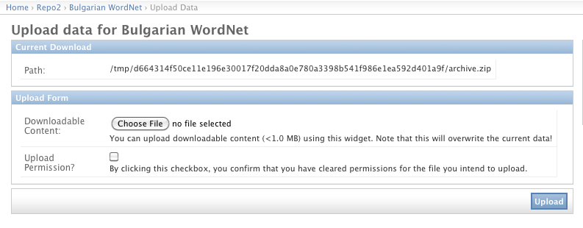
The “Path” information is displayed for convenience and allows to quickly retrieve the file system path of the StorageObject's downloadable content.
Note: It is required to click the “Upload Permission?” check-box to verify that the edito user accepts liability for the file he intends to upload. The editor user should only upload an archive to a META-SHARE resource if he is allowed to do so; if not, it is better to ask the original owner of the resource to do so.
Both fields are required. In case the provider attempts to upload without having filled them in, the fields are highlighted in red, with the message “This field is required”.
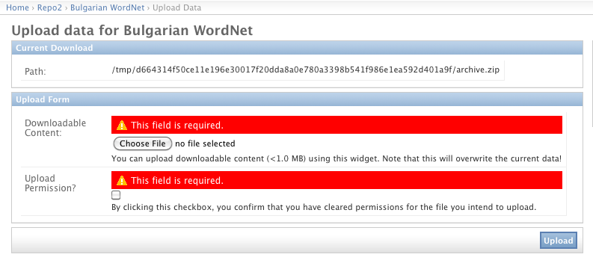
Once the upload is successful, the file is copied to the StorageObject's storage folder as archive.ext (see above). The user gets redirected to the editor page for the current resource, i.e., the page where he started the upload process.
Limitation: The web interface upload page only allows files smaller than MAXIMUM_UPLOAD_SIZE = 1 * 1024 * 1024 bytes to be uploaded. This is a robustness fix which ensures that the web editor page does not crash due to a very large file being uploaded. Section 3.8.1.2 offers a solution for uploading larger files.

Upload Using the Command Line storage_admin.py Script
When you need to add a large file as downloadable content to an existing resource, the node administrator can use the storage_admin.py script, which is available within the metashare/ folder.
If called without arguments, the script provides an overview on available options:
metashare $ python2.7 storage_admin.py
usage: storage_admin.py MODE ARGS...

MODE = [help, checksum, create, update, purge, folder, delete]
Use storage_admin.py help MODE for detailed usage instructions.

To add a large file as downloadable content, you simply have to copy it over to the storage folder belonging to the resource. The storage folder path can be retrieved like this:
metashare $ python2.7 storage_admin.py folder <storage-object-id>

To retrieve the <storage-object-id> argument, the provider can go to the web interface upload view (see Section 3.8.1.1 ) and copy the last bit of the storage folder information. This is a 64-char hexadecimal String, e.g., c0b9a36b50ce11e1a4570017f20dda8ac8066602350044549d62c1bdb750883c.
Once having copied a file named archive.ext to the storage folder path for <storage-object-id>, the provider has to update the file checksum to “activate” the new downloadable content. This is the use of storage_admin.py:
metashare $ python2.7 storage_admin.py checksum <storage-object-id>
...
Checksum: d41d8cd98f00b204e9800998ecf8427e

If no file archive.ext can be found within the storage folder for <storage-object-id> the script will return Checksum: None.

Known Limitations
It is mandatory to follow the naming scheme. The provider has to make sure that the downloadable data is contained within one archive file. This file needs to have one of the following, allowed extensions (as defined in storage/models.py):
ALLOWED_ARCHIVE_EXTENSIONS = ('zip', 'tar.gz', 'gz', 'tgz', 'tar', 'bzip2')

Glossary
- Ingest: Within the META-SHARE context, ingesting a LR into the database is a one-time, irreversible step. It is preceded by a phase of editing an “internal” LR, visible only to the LR owners and to the members of the editor group of the LR. Once the decision is taken that the metadata for a particular LR is “ready” to make the entry more widely visible, the provider “ingests” the LR into the database. An ingested LR is still visible only in the web editor. Ingested LRs are synchronized to other META-SHARE nodes.
- Media types: Within the META-SHARE context, the media types of a LR depend on its resource type. Thus, a Corpus LR can contain one or more of the following media types: text, audio, video, image, text-numerical and text-ngram. A Lexical-Conceptual Resource must contain a text media type and can also contain audio, video and image media types. A Language Description LR must contain a text media type and can also contain video and image media types. A Tool/Service does not contain any media types.
- Metadata: All the information that describes a given LR. Within the META-SHARE context, metadata can describe all different aspects of a LR, varying from details on the creation of the LR, to content or language or size information.
- Publish: Within the META-SHARE context, publishing a LR means making it visible to all META-SHARE users, registered and anonymous.
- Resource type: Within the META-SHARE context, the resource type of a LR has to be strictly one of the following:
- Corpus
- Lexical-Conceptual Resource
- Language Description
- Tool / Service
- Unpublish: Within the META-SHARE context, unpublishing a LR means making it visible only to META-SHARE editors.
- XML metadata file: A XML format file that contains metadata on a LR.
- XML Schema (XSD): An XML Schema is a description of a specific XML type of files. It contains the structure that these XML files should have, along with all the constraints that should be respected so that the XML files are valid, such as the uniqueness of elements, the specific values that elements should contain etc.

