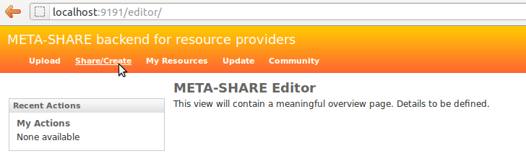
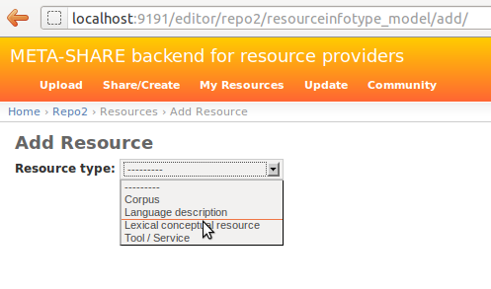
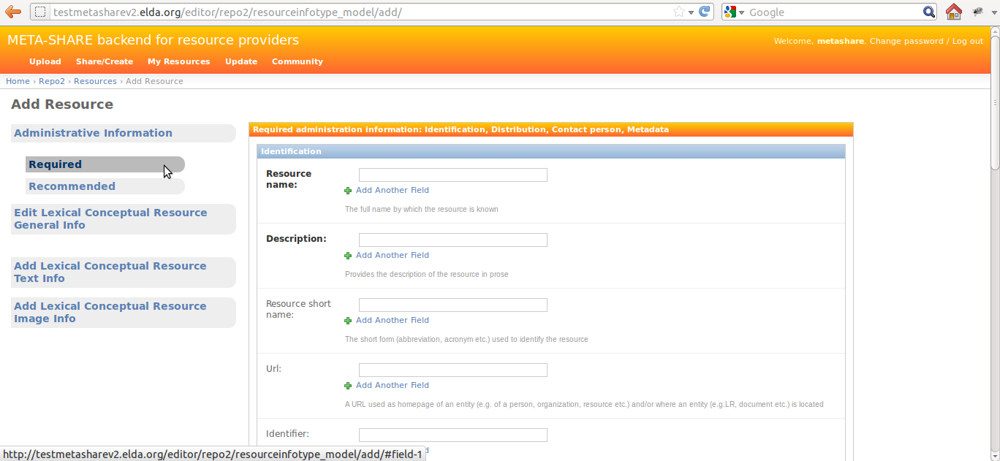
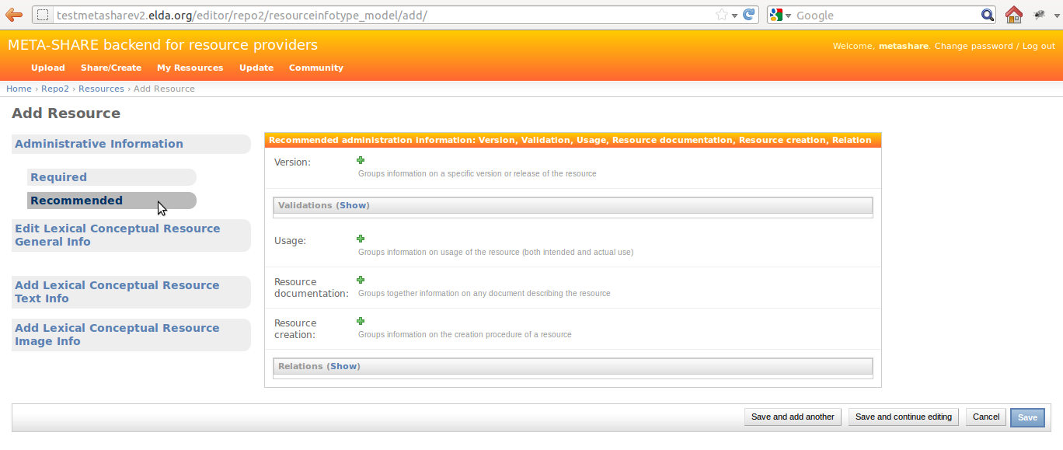
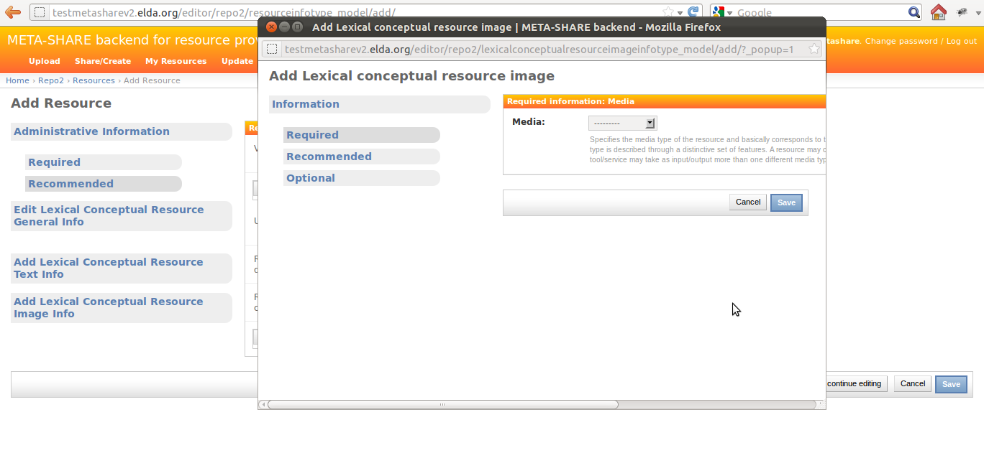
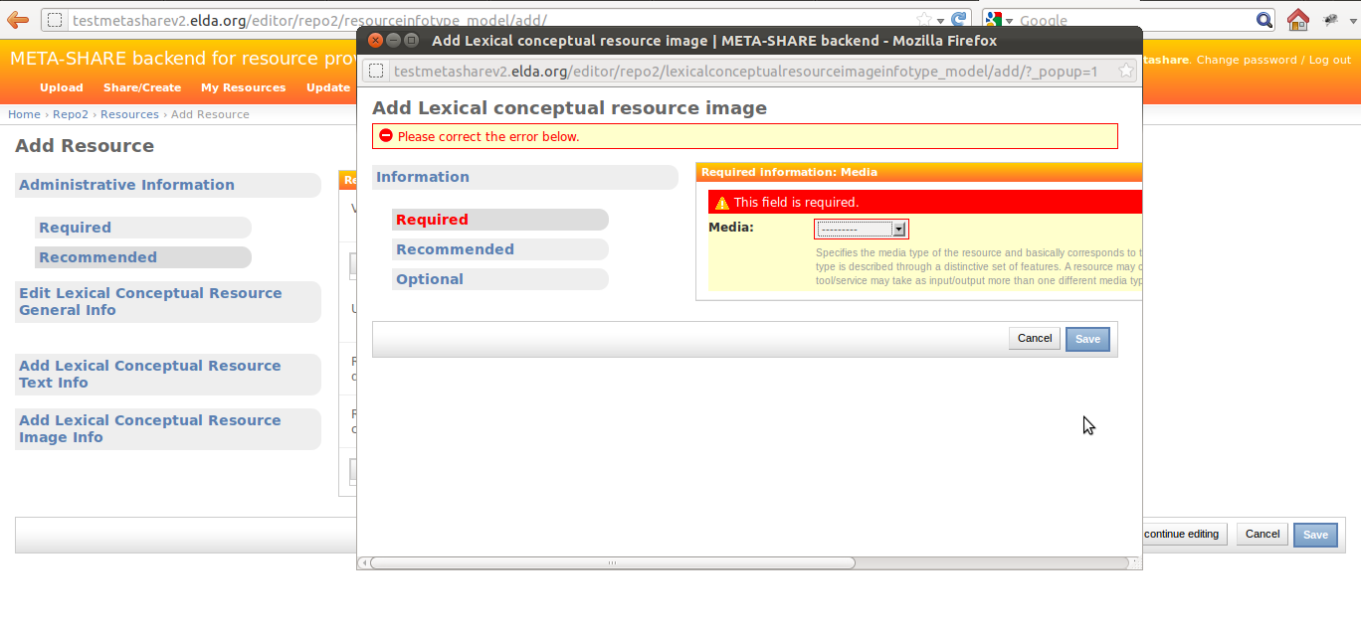
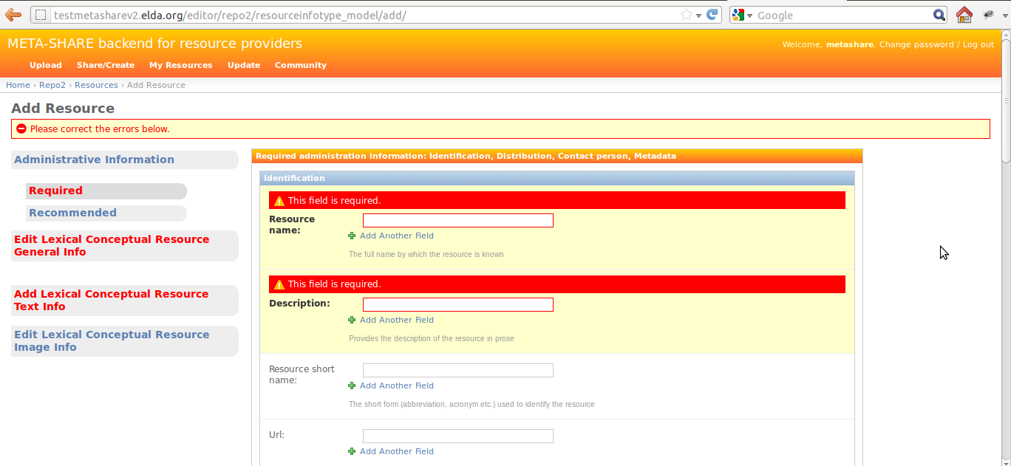
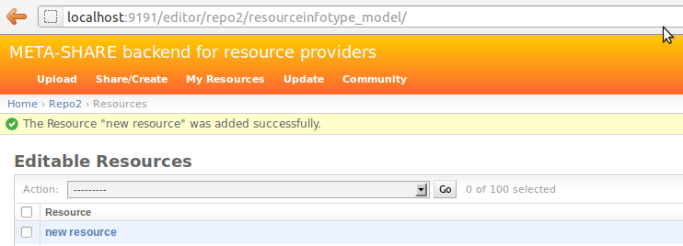
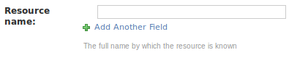
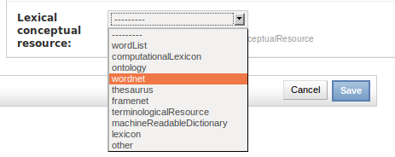
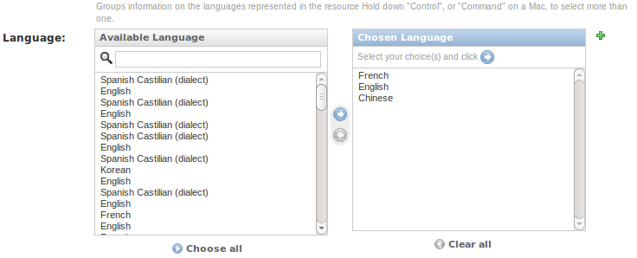
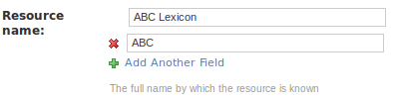
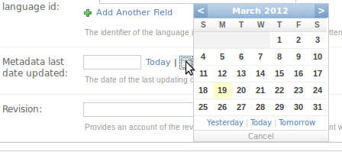

A Network of Excellence forging the
Multilingual Europe Technology Alliance

META-SHARE V2 Provider Manual

Author(s): Victoria Arranz, Christian Federmann, Ioanna Giannopoulou, Olivier Hamon, Marc Schröder
Date: March 07th, 2012

Table of Contents

1.Executive Summary 3
2.Provider-oriented documentation 3
2.1.Upgrading a user account to a provider account 3
2.2.Add a Language Resource 3
2.3.Manage Language Resources 8
2.4.Add and edit metadata information 8
2.5.Import Language Resources 12
2.5.1.Prepare the import file 12
2.5.2.Upload/Import in META-SHARE 13
2.5.2.1.Import script 13
2.5.3.Conversion of existing LRs 14
2.6.Add downloadable content to resources 15
2.6.1.Adding downloadable content 16
2.6.1.1.Upload via the Django admin backend 16
2.6.1.2.Upload using the command line storage_admin.py script 17
2.6.2.Known Limitations 18

Executive Summary
This document is a guide for the users of META-SHARE interested in providing Language Resources (LRs) through META-SHARE.

Provider-oriented documentation

Upgrading a user account to a provider account
As per V2 of META-SHARE, only user accounts marked as “staff” users have the permission to create or edit LRs. For any given META-SHARE node, each “staff” user has the right to edit all LRs on that node. This means that only trusted individuals should be granted staff status.
Future versions of META-SHARE will provide a more fine-grained system of access rights.
In order to endow a user account with provider access, the following steps are necessary.
- The user account should be created as documented in the general User Manual.
- An administrative user must upgrade this account to a “staff” account. As described in the Installation Manual, at least one Administrator account is created as part of the installation process. This administrator can log into the administrative interface at <metashare-url>/admin. Under “Users”, go to the “Details” page for the user in question, tick the permissions box “Staff status”, and confirm with “Save”.
- The staff user should now be able to log in to the META-SHARE portal as described in the User Manual and have the permissions required to add and edit LRs as described below.

Add a Language Resource
The provider can add a new LR by inserting the metadata that describes this LR. The provider must be registered and logged in so as to add new LRs, and then do as follows:
- Click on the “Editor” button on the top right of the main page of META-SHARE.
- In the result page (“META-SHARE backend for resource providers”), click on the “Share/Create” link at the top left (see Figure 1) . The result page presents a drop-down menu, listing all the available resource types (see Figure 2).
Figure 1: META-SHARE backend for resource providers

Figure 2: Choose one of the available resource types

- Choose a resource type for the LR. (A LR can only have one resource type).
If your choice is “tool / service”, go directly to step 4.
If your choice is of the other three resource types, select from the appearing check-box list, the media type(s) for the LR.
Note: In the case of “lexical conceptual resource” and “language description” resource types, “text” is a required media type and, as such, it is selected by default and cannot be unselected.
- Click on the “proceed” button.
In the result page (see Figures 3 & 4), all the metadata information to be filled in, is summarized under a left hand side menu (see section 2.4 for the description of the metadata fields). On the top of this menu, there is the administrative information categorized as required, recommended and optional, if any. A click on any of these options, will lead in expanding the appropriate metadata block on the right hand side.

Figure 3: Administrative Information metadata block (Required)
Figure 4: Administrative Information metadata block (Recommended)

- Fill in the administrative metadata fields (Only the required information -appearing as bold- is necessary for a LR to be successfully saved).
On the same level of the left hand side menu as the administrative information, there are the resource-type-specific information. Clicking on one of these, will lead in opening a pop-up window, containing the blocks of metadata to be filled in (see Figure 5 for an example). These pop-up windows follow a similar menu structure (required / recommended / optional) as the main page.
Figure 5: Resource-type-specific pop-up window (here for a Lexical-Conceptual Resource)
- For each one of the pop-up windows, fill in the metadata fields (again, only the required information is necessary for a LR to be successfully saved). Once done with filling in information within a pop-up window, click on the “Save” button at the bottom of the page. In case of errors, a message will be displayed on the top of the page, the errors will be reflected on the menu options and the problematic fields (i.e. fields which either contain an error or are empty) will be highlighted in red (see Figure 6 for an example). If there are no errors, the “Save” button will close the pop-up window, returning to the previous page.
Figure 6: Errors in pop-up window: the media field has not been filled-in

- Once done with filling in information both in the main page and in all the pop-up windows, click on the “Save” button at the bottom of the main page. If there are errors, they will be indicated in a similar way as in the pop-up windows (see Figure 7 for an example). If there are no errors, clicking on “Save” will result in a new page, displaying the message “The Resource 'resource name' was added successfully”, and listing all the LRs added in META-SHARE, included the newly created one (see Figure 8).

Figure 7: Errors in main page: the resource name and the description have not been filled-in, errors also in General Info and Text info tabs

Figure 8: Successfully saved LR

Manage Language Resources
The provider is a “staff” member, which means, as mentioned above, that he can edit all the LRs within the specific METASHARE node. On the top left of the “META-SHARE backend for resource providers” page, the provider can click on the “Update” link, where he can view a list of all the LRs for the specific META-SHARE node. He can also click on the “My Resources” link, where he can only view a list of the LRs he has provided on META-SHARE himself.
The provider can view, edit, delete or publish / unpublish / ingest all the listed LRs. He can select the LR(s) he wishes to apply an action to and then select an action from the drop-down menu of actions (delete / publish / unpublish / ingest). Clicking on “Go” button will execute the selected action.
If the provider wishes to edit a LR, he can click on its name. This will result in a page where he can edit all the metadata fields for this resource, which will appear in exactly the same view as described in section 2.2.

Add and edit metadata information
Metadata information are organised in two levels, the first being Administrative / Type-specific, and the second being required / recommended / optional.
The tabbed menu described in section 2.2 is making the two levels clear to the provider (see Figures 2,3 & 4). A description of the metadata fields follows:
1. Administrative
- Required: Contains information on identification, distribution, contact person, metadata of the resource, etc.
- Recommended: Contains information on version/release, validation, usage, documentation, creation, relations of the resource, etc.
- Resource type: Corpus
2. Corpus Text Info*: Information on the text component of the resource, such as the language, the text format, the encoding, the annotation, etc.
3. Corpus Audio Info*: Information on the audio component of the resource, such as the language, the audio format, the size, the recording, the capture, etc.
4. Corpus Video Info*: Information on the video component of the resource, such as the size, the video format, the content, the language, etc.
5. Corpus Image Info*: Information on the image component of the resource, such as the size, the image format, the content, etc.
6. Corpus Text Numerical Info*: Information on the numerical text component of the resource, such as the size, the content, the creation, etc.
7. Corpus Text n-gram Info*: Information on the text n-gram component of the resource, such as the base item(word, syllable, letter, etc.), the language, the size, the text format, the encoding, etc.

- Resource type: Language Description
2. Language Description General Info*: Information on the specific type of the resource (grammar, etc), the encoding, the performance, etc.
3. Language Description Text Info*: Information on the text component of the resource, such as the language, the linguality (monolingual, bilingual, etc), the text format, the encoding, the size, etc.
4. Language Description Video Info*: Information on the video component of the resource, such as the creation, the size, the content, the video format, the language, etc.
5. Language Description Image Info*: Information on the image component of the resource, such as the creation, the size, the content, the image format, etc.

- Resource type: Lexical Conceptual Resource
2. Lexical Conceptual Resource General Info*: Information on the specific type of the resource (thesaurus, terminology, etc), the encoding, as well as further details about the creation of the resource.
3. Lexical Conceptual Resource Text Info*: Information on the text component of the resource, such as the languages, the linguality (monolingual, bilingual, etc), the text format, the encoding, the size, etc.
4. Lexical Conceptual Resource Audio Info*: Information on the audio component of the resource, such as the size, the audio format, the content, the language, etc.
5. Lexical Conceptual Resource Video Info*: Information on the video component of the resource, such as the video content, the size, the video format, the language, etc.
6. Lexical Conceptual Resource Image Info*: Information on the image component of the resource, such as the image format, the size, the content, etc.

- Resource type: Tool / Service
2. Tool / Service Info*: Information on the specific type of the resource (tool, service, platform, infrastructure, etc), details about the input and output types, information on the operating systems and running environments, etc.

*All this information is divided in blocks: required / recommended / optional.

All fields are accompanied by a short description/explanation line, as shown below:

In order to insert or modify metadata, the provider has access to different kinds of fields:
- Text field: the provider may add/modify free text that corresponds to the description of the metadata elements;

- Drop-down list box: the provider may choose one item from the list provided;

- Multiple-choice Drop-down list box: the provider may chose one or several items from the list provided;

- Repeatable text field: the provider may add or delete all the text field he wants to by clicking on the “+” or “x“ buttons, respectively.

- Calendar text field: the provider may write a full date on his own or select a date from a pop-up calendar.

Import Language Resources

Prepare the import file
To be able to import new LRs, the provider must create XML metadata files for each LR, that follow the META-SHARE metadata. This compliance can be validated using the META-NET XML schema (XSD), the current version being under the misc/schema/v2.0 folder.

Upload/Import in META-SHARE
A provider can upload an XML metadata file by clicking on the “Upload” link at the top left of the “META-SHARE backend for resource providers” page. Uploading works as follows:
- Choose a file by clicking on the “Browse button”;
- Click on “Upload Terms” check-box to accept them;
- Click on the “Upload” button.

Importing XML metadata is also performed from the command line. It describes the import of existing LRs, but the process is the same for LRs converted from different representations as described below.

Import script
Importing of resources is possible using import_xml.py which can be found within the metashare installation folder.
Basic usage information is given when called without any arguments:
$ python import_xml.py
usage: import_xml.py <file.xml|archive.zip> \
[<file.xml|archive.zip> ...]

The script reports errors and gives import statistics when finished.
A single xml file can be imported as follows:
$ python import_xml.py my_LR.xml
Done. Successfully imported 1 files into the database, \
errors occurred in 0 cases.

Multiple LRs can be imported using the “*” wildcard or by packaging the xml file into a zip file:
$ python import_xml.py metashare-v1-resources.zip
Done. Successfully imported 1,277 files into the database, \
errors occurred in 0 cases.
Importing a large zip file, or a large amount of XML files, takes some time; this is normal.
After successful import of these files, the provider should have the new resources available on his META-SHARE node.
The last line of the import_xml.py output should report no errors.

Conversion of existing LRs
The conversion of the existing LRs from several different XML schemata to META-NET XML schema has been made with XSL transformations.

The process was the following:
- The first step was to map all the elements of the other XML schema to the elements of META-NET XML schema, one by one.
- Then, a XSL file was created, which contains the structure of META-NET XML schema, and XSLT lines harvesting the information from the files of the other XML schema format.
- The conversion process was executed for all given files.

Example:
Element resource_periodofcoverage from ELRA format has been mapped to timeCoverage element in META-SHARE schema format.
Line in ELRA XML file:
<resource_periodofcoverage>Between 1992 and 1999</resource_periodofcoverage>
XSL conversion file:
<xsl:variable name='time' select='preceding-sibling::resource_periodofcoverage'/>

<xsl:if test='$time!=""'>
<timeCoverageInfo>
<timeCoverage>
<xsl:value-of select='$time'/>
</timeCoverage>
</timeCoverageInfo>
</xsl:if>

Lines in final META-SHARE XML file:
<timeCoverageInfo>
<timeCoverage>Between 1992 and 1999</timeCoverage>
</timeCoverageInfo>

In the example above, the element “timeCoverage” is part of the meta-share XML structure. The content inside the element is added by the line <xsl:value-of select='$time'/>, where $time is a XSL variable, defined before, as the (xpath) “preceding-sibling” with the name ”resource_periodofcoverage”. If the variable is empty, the element does not appear in the final XSL file.
This is the way to construct, little by little, a META-SHARE compliant XML file.
For the conversion, there are many things that need to be taken into account, such as mandatory fields, unique fields, repeated fields, elements that have the enumeration constraint (i.e. that can only contain a value from a set of acceptable values), etc. Thus, the conversion files may contain far more complicated transformations than the one displayed before.
Due the complexity of the META-SHARE schema and the significant differentiation between this and the other formats, some tools and mechanisms were used to simplify the conversion process.
In the case of ILSP and PSP resources conversion, the tool Altova-MapForce was used for the mapping between schemata and the production of the XSL files. Yet, there were quite a few cases where the automatically produced files had to be manually edited in order to fully comply with META-SHARE schema.
In the case of ELRA resources conversion, there was a pre-conversion stage, where the ELRA format files were converted in simple XML flat list files, with the following format:
<resource id="1">
<resource_id>1</resource_id>
<resource_reference>ELRA-S0148</resource_reference>
…
…
</resource>
<resource id="2">
…
Files with this format were the input to the XSL file that were converted in META-SHARE format. The tool Altova-MapForce, facilitated here as well the mapping process.

Add downloadable content to resources
Each META-SHARE resource can contain downloadable content. At the moment, it is possible to add exactly one archive file to a resource. Its name is fixed to archive.{'zip', 'tar.gz', 'gz', 'tgz', 'tar', 'bzip2'}.

After upload, the archive.ext, where .ext will be the file extension of the original file, will be placed inside the dedicated storage layer of the resource: each StorageObject has a local folder attached to it which is used to store associated downloadable data.

Adding downloadable content
There are two ways of adding downloadable content to an existing META-SHARE resource:
- Upload via the Django admin backend, or
- Upload using the command line storage_admin.py script

Upload via the Django admin backend
To upload data via the Django admin backend, the provider has to go to the Django admin editor page for an existing resource. It is not possible to upload files for new resources. On the top-right of the browser window, there is a button "Upload Data" next to "History".
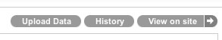

Clicking the "Upload Data" button will load an upload page for the current resource.
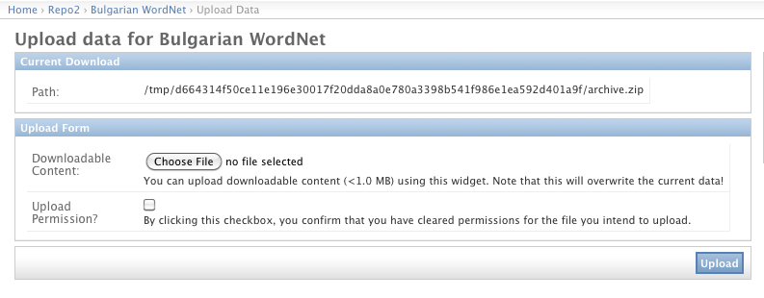
The "Path" information is displayed for convenience and allows to quickly retrieve the file system path of the StorageObject's downloadable content.
Note: It is required to click the "Upload Permission?" check-box to verify that the provider accepts liability for the file he intends to upload. The provider should only upload an archive to a META-SHARE resource if he are allowed to do so; if not, it is better to ask the original owner of the resource to do so.
Both fields are required. In case the provider attempts to upload without having them both filled in, the fields are highlighted in red.
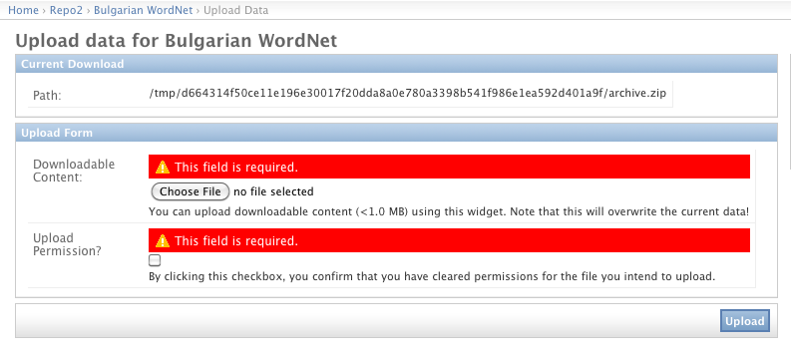
Once the upload is successful, the file is copied to the StorageObject's storage folder as archive.ext (see above). The provider gets redirected to the editor page for the current resource, the page where he started the upload process.
Limitation: The admin backend upload page only allows files smaller than MAXIMUM_UPLOAD_SIZE = 1 * 1024 * 1024 bytes to be uploaded. This is a robustness fix which ensures that admin page does not crash due to a very large file being uploaded.

Upload using the command line storage_admin.py script
When the provider wants to add a large file as downloadable content to an existing resource, he can use the storage_admin.py script, which is available within the metashare/ folder.
If called without arguments, the script provides an overview on available options:
metashare $ python2.7 storage_admin.py
usage: storage_admin.py MODE ARGS...

MODE = [help, checksum, create, update, purge, folder, delete]
Use storage_admin.py help MODE for detailed usage instructions.

To add a large file as downloadable content, the provider simply has to copy it over to the storage folder belonging to the resource. The storage folder path can be retrieved like this:
metashare $ python2.7 storage_admin.py folder <storage-object-id>

To retrieve the <storage-object-id> argument, the provider can go to the Django admin backend upload view (see above) and copy the last bit of the storage folder information. This is a 64-char hexadecimal String, e.g., c0b9a36b50ce11e1a4570017f20dda8ac8066602350044549d62c1bdb750883c.
Once having copied a file named archive.ext to the storage folder path for <storage-object-id>, the provider has to update the file checksum to "activate" the new downloadable content. This is the use of storage_admin.py:
metashare $ python2.7 storage_admin.py checksum <storage-object-id>
...
Checksum: d41d8cd98f00b204e9800998ecf8427e

If no file archive.ext can be found within the storage folder for <storage-object-id> the script will return Checksum: None.

Known Limitations
It is mandatory to follow the naming scheme. The provider has to make sure that the downloadable data is contained within one archive file. This file needs to have one of the following, allowed extensions (as defined in storage/models.py):
ALLOWED_ARCHIVE_EXTENSIONS = ('zip', 'tar.gz', 'gz', 'tgz', 'tar', 'bzip2')

Vocabulary of terms
- Metadata: All the information that describes a given LR. Within the META-SHARE context, metadata can describe all different aspects of a LR, varying from details on the creation of the LR, to content or language or size information.
- Resource type: Within the META-SHARE context, the resource type of a LR has to be strictly one of the following:
- Corpus
- Lexical-Conceptual Resource
- Language Description
- Tool / Service
- Media types: Within the META-SHARE context, the media types of a LR depend on its resource type. Thus, a Corpus LR can contain one or more of the following media types: text, audio, video, image, text-numerical and text-ngram. A Lexical-Conceptual Resource must contain a text media type and can also contain audio, video and image media types. A Language Description LR must contain a text media type and can also contain video and image media types. A Tool/Service does not contain any media types.
- Publish: Within the META-SHARE context, publishing a LR means making it visible to all META-SHARE users, registered and not registered.
- Unpublish: Within the META-SHARE context, unpublishing a LR means making it visible only to META-SHARE “staff” users.
- Ingest: Within the META-SHARE context, ingesting a LR into the database is a one-time, irreversible step. It is preceded by a phase of editing an "internal" LR, visible only to the provider. Once the decision is taken that the metadata for a particular LR is "ready" to make the entry more widely visible, the provider "ingests" the LR into the database. An ingested LR is only visible to to META-SHARE “staff” users.
- XML metadata file: A XML format file that contains metadata on a LR.
- XML schema (XSD): An XML schema is a description of a specific XML type of files. It contains the structure that these XML files should have, along with all the constraints that should be respected so that the XML files are valid, such as the uniqueness of elements, the specific values that elements should contain etc.

