Create Individual Song Files in Soundforge

Task Summary
- Given full album side recordings, create individual files for final upload to iTunes and other music platforms. Ripping vinyl LPs to source digital files will be covered in another How To.
This is a brief How-To and Cheat Sheet for KKCR Volunteers that would like to learn a set of keyboard shortcuts to create individual songs from full album side recordings.
There are multiple ways to achieve similar outcomes described in this brief guide. A free, highly recommended, and comprehensive library of Tutorials is available at SOUND FORGE | Tutorials | Professional Recording, Editing & Mastering (magix.com) <https://www.magix.com/us/music-editing/sound-forge/sound-forge-pro/tutorials/>.
Objectives
Because digital restoration project objectives, individual tastes, and preferences vary wildly, please check with your volunteer coordinator or team members to select the desired settings for your particular project. For example, some audio restoration projects prefer to leave in some level of noise, in order to preserve the imperfections of vinyl; others prefer to clean up as much noise as possible, in order to clarify the music itself.
So, this is just one suggested method for Using Keyboard Shortcuts to Create Individual Song Files in Soundforge from full album side files, as a way to help you get familiar with a few of the comprehensive audio engineering features provided by Soundforge.

Quick Cheat Sheet
Once familiar with the detailed steps below, you can use this as a quick cheat sheet for repeating key commands. If time allows, perhaps I'll create a single click macro to execute all of these commands at once, with exception of naming, which must be done manually, for now.
- Double click region
- CTL+C | CTL+N | Enter | CTL+V | ALT+T+U | Enter | ALT+P+N | Enter | ALT+I+S
- CTL+S | Name Track | CTL+W

Step 1: Locate file source and destination
- If it's your first time volunteering for this task, please ask for help about where to find the album side you'll be working on today.
- The individual mp3 song files that you create will be saved in the same folder where the source files are located.

Step 2: Verify marker locations in the source file

⚠ Please never skip this important step.
Either the software CD Architect or a person working before you may have placed a track marker in the wrong location, based upon moments of silence in the recording. Many ukulele classic songs are uniquely characterized by a slowly strummed chord, played a second or so after the apparent ending of a song. To confirm marker locations, please always play the beginning few seconds and closing few seconds of each demarcated audio Region, to be sure the spacing between songs is accurate and that each song is individually complete in itself.
 As needed, drag the marker tag to a new location. Markers will snap to other markers, regions, and command markers. Hold Shift while dragging to override snapping.

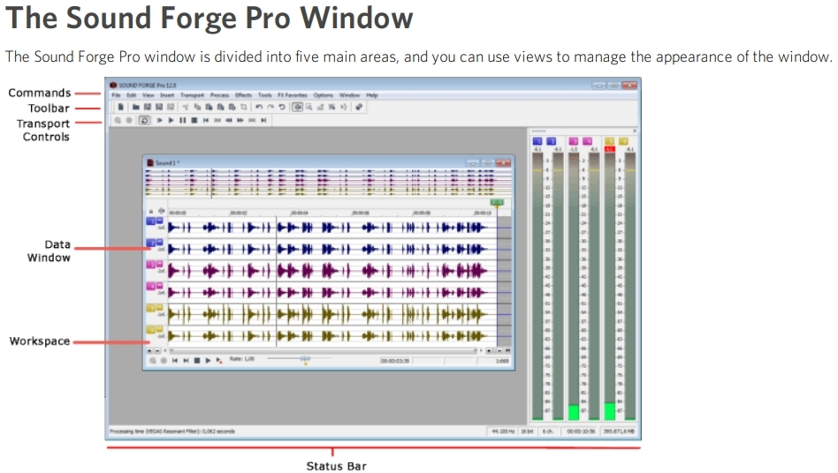

Step 3: Create New File, Copy, Paste the current track
Audio Regions (tracks) are segments of audio located between Markers.
- Double click a Region to select the track segment located between markers.
- CTL+C to copy.
- CTL+N to create a New File (this will become your individual song track).
- Press [Enter]
- CTL+V to paste the copied track into the new file.

Step 4: Restore Audio, Noise Reduction
📝 Note: As described in the Summary, above, Noise Reduction can be utilized to achieve a number of different desired outcomes, so discuss any specific objectives for this project with the volunteer coordinator or team members.
- Select Tools ➡ Noise Reduction setting (ALT+T+U).
- Configure Noise Reduction parameters according to the sound quality objective.
- Press [Enter] to execute the command.

Step 5: Normalize, Clear Markers
- Select Process ➡ Normalize to adjust the volume of a selection so that the highest sample level reaches a user-defined level (ALT+P+N).
  - ⚠ Please be mindful to select both channels in stereo recordings by clicking on the horizontal boundary of the two adjacent channels, in order to select the entire Region.
- Press [Enter] to execute the command.
Choose either of the following to Clear Markers.
- From the Edit menu, choose Regions List and choose Clear All from the submenu to remove all markers from the current file.
  - ⚠ Be careful to NOT do this in your source file, only in the individual track file.
- Right-click above the audio Region, choose Markers/Regions, Delete All, or select Delete All in the Selection submenu.

Step 6: Intro and Outro Spacing
Confirm approximately 2 to 3 seconds of silence at the beginning (Intro) of the new track.
- No less than 2 seconds, no more than 3 seconds.
Confirm approximately 1 to 2 seconds of silence at the end (Outro) of the new track.
- No less than 1 sec, no more than 2 seconds.
Keyboard Shortcuts:
- ALT+I+S
  - Select [Preset] 1 sec at start of file OR
  - Select [Preset] 1 sec at end of file

Step 7: Save, Name Files
- Select File ➡ Save to save the new file (CTL+S).
- Confirm [Template] 44,100Hz, 16-Bit, Stereo, PCM.
- Name the file you've created using the format:
  - Artist Name - Album Name - Side # - Track # - Song Name
- Close the current file (CTL+W).

About this Document
Description: Using Keyboard Shortcuts to Create Individual Song Files in Soundforge from full album side recordings.
Written By: Michael S.
Contact Information: ✉️ JustBePono@ProtonMail.com
Last Updated: September 1, 2021

