Meteb Almadi

200304

Github link: <https://github.com/metebalmadi/SE443Project_200304.git>

Screenshots:

Part 1 Code and output:

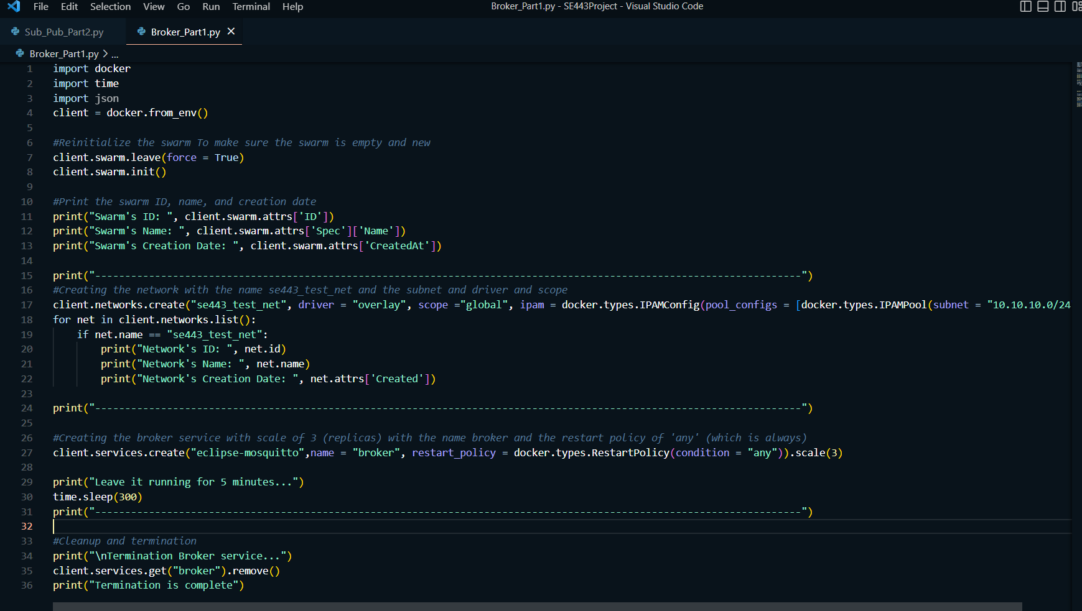

Output:

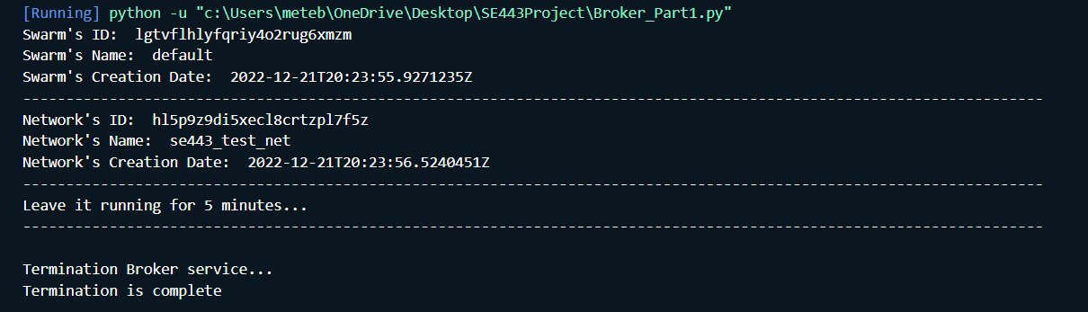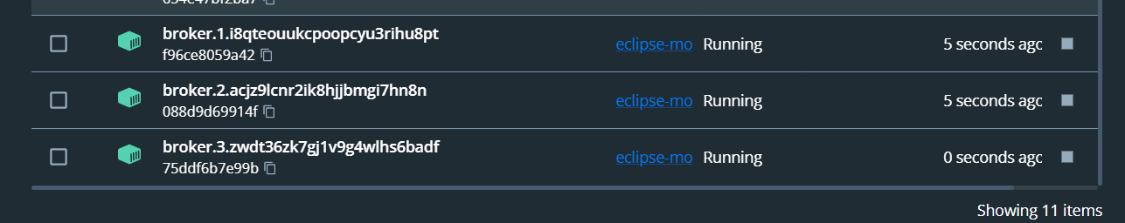

Part 2 Code:

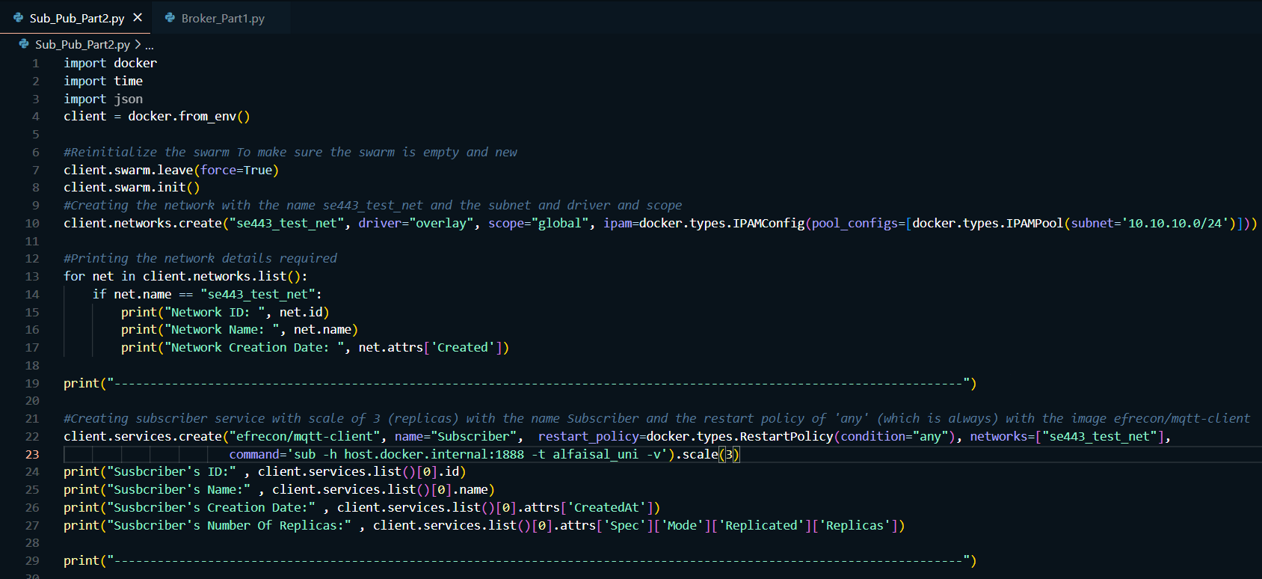

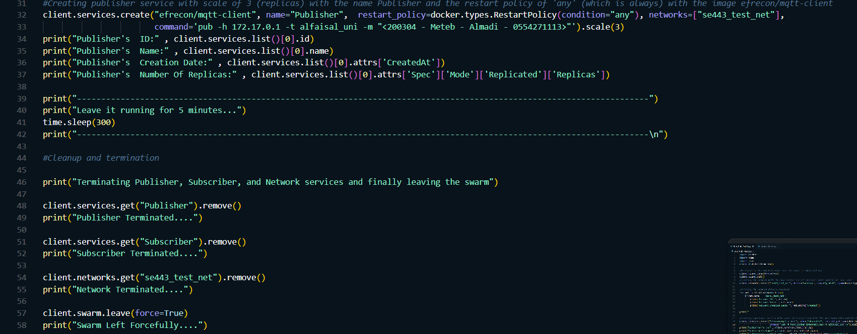

Output:

