İçindekiler
1. Project Overview 5
1.1. Requirements of Project 5
2. Researches and Informations 7
2.1. Metastability 7
2.2. Static Timing Analysis (STA) 7
2.3. Clock Domain Crossing (CDC) 7
2.3.1. Multi Flop Synchronizer 8
2.3.2. Open Loop 8
2.3.3. Close Loop Handshaking 8
2.3.4. Toggle Synchronizer 9
2.3.5. Mux-recirculation 9
2.3.6. Asynchronous FIFO 10
3. Module Design Techniques 11
3.1. Binary-Gray and Gray-Binary Converter Modules 11
3.2. Clock Divider Module 11
3.3. Synchronizer Module 12
3.4. Debouncer Module 12
3.5. Edge Detector Module 13
3.6. Write&Read Pointer Handler Modules 13
3.7. Read Controller Module 15
3.8. LUT ROM Module 15
3.9. FIFO Memory (Dual Port RAM) Module 16
3.10. FIFO Fsm Module 16
3.11. Top Module 17
4. TestBench Design and Simulation 18
4.1. Test Scenarios 18
4.2. Simulation and Waveforms 18
5. Synthesis and Implementation 20
5.1. Warnings and Errors 20
5.2. Solution Steps 20
6. Conclusion 21

Tablo 1: Given Module Port List 5
Tablo 2: ILA Integration Settings 5

Şekil 1: The Architecture 4
Şekil 2: Multi-Flop Synchronizer 7
Şekil 3: Open Loop 7
Şekil 4: Close Loop Handshaking 8
Şekil 5: Toggle Synchronizer 8
Şekil 6: Mux-recirculation 9
Şekil 7: Asynchronous FIFO 9
Şekil 8: Binary To Gray Converter 10
Şekil 9: Clock Divider Module 10
Şekil 10: Synchronizer Module 11
Şekil 11: Debouncer Module 11
Şekil 12: Edge Detector Module 12
Şekil 13: Read Pointer Handler Module 13
Şekil 14: Write Pointer Handler Module 13
Şekil 15: Read Controller Module 14
Şekil 16: LUT ROM Module 14
Şekil 17: FIFO Memory (Dual Port RAM) Module 15
Şekil 18: FSM Diagram 15
Şekil 19: FIFO FSM Module 16
Şekil 20: Full System Schematic 16
Şekil 21:Write Start Waveform 17
Şekil 22: Write Finish Waveform 18
Şekil 23: Read Start Waveform 18
Şekil 24: Reset Waveform 18

Project Overview
In this part, we will look the quick overview of this project requirements. The main focus of this project is to learn some of the most critical concepts of Digital IC Desing. These concepts are “Clock Domain Crossing (CDC)” and Asynchronous FIFO (First-in, First-out). Also one of the main problem of Digital IC Design world that when you transfering data one clock domain to another one, there can be a huge possibility to face with metastability. With this project and paper, you will learn how to handle with metastability and how you can design a FIFO via HDL.

Requirements of Project
The architecture, crossing domain, dual-port RAM connections and pointer synchronizations are given in the below.
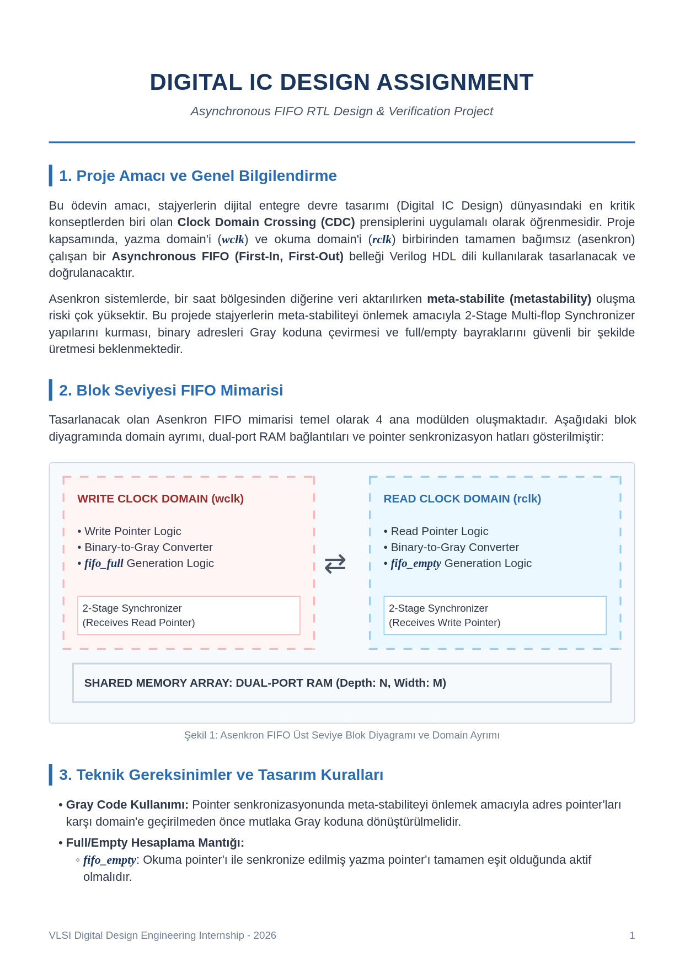
Şekil 1: The Architecture
All requirements and expectations are:
- Address pointers must be converted Gray code before the transfer to opposite domain.
- There has to be fifo_empty signal that when write pointer and read pointer equal has been activated.
- There has to be fifo_full signal that when write pointer and read pointer’s the most significent 2 bit’s not equal and the rest of equal has been activated.
- The design has to be as possible as parametric.
- There have to be meaningful submodules and these submodules would be connected in a top module.
- ILA IP has to be integrated to project to see waveforms in real time,
- Write domain clock has to be 5MHz and Read domain clock has to be 1MHz.
- DATAWIDTH=8bit and FIFO’s depth has to be 32 line (address width 5 bit)
- LUT ROM memory has to be 128x8 bit.

Module port list also given in the below.
Tablo 1: Given Module Port List
Port Name | Direction | Width (Bit) | Comment
wclk | Input | 1 | Write domain clock signal (Write Clock)
winc | Input | 1 | Write enable signal (Write Increment)
wdata | Input | [DATA_WIDTH-1:0] | Data line that will be written to FIFO
rclk | Input | 1 | Read domain clock signal (Read Clock)
rinc | Input | 1 | Read enable signal (Read Increment)
rdata | Output | [DATA_WIDTH-1:0] | Data line that will be read from FIFO
wfull | Output | 1 | FIFO full flag (synchron with wclk)
Almost_wfull | Output | 1 | FIFO almost full flag (synchron with wclk)
rempty | Output | 1 | FIFO empty flag (synchron with rclk)
Almost_rempty | Output | 1 | FIFO almost empty flag (synchron with rclk)
led | Output | [7: 0] | If SW[7: 0] == 8’h00 show rdata  Other show wfull, rempty, write_fsm_busy, wbtn_out, rbtn_out
SW | Input | [7: 0] | Changes led mode

ILA integration settigns are given in the below.
Tablo 2: ILA Integration Settings
ILA Name | Sampling Clock | Probes | Trigger Condition
ILA_Write | wclk (5MHz) | wbtn_out, winc, wfull, addr, wdata | winc == 1 && wfull == 1 (error analysis) or wfull positive edge
ILA_Read | rclk (1MHz) | rbtn_out, rinc, rempty, rdata | rinc == 1

Researches and Informations

Metastability
Metastability is the unpredictable behaviour that occurs at the output of a flip flop or a latch where its output assumes unspecific values between 0 and 1 for unspecific period of time.
How Do I Avoid Metastability?
In reality, one cannot avoid metastability and increased clock-to-Q delays in synchronizing asynchronous inputs, without the use of tricky self-timed circuits. So a more appropriate question might be "How do I tolerate metastability?" The most common way to tolerate metastability is to add one or more successive synchronizing flip-flops to the synchronizer. This approach allows for an entire clock period for metastable events in the first synchronizing flip-flop to resolve themselves.
In this way, we used synchronizers in our design at some critic parts. You can see that synchronizers are used at the entrance of gray to binary converters and debouncer modules.

Static Timing Analysis (STA)
It is a timing verification that ensures whether the various circuit timing are meeting the various timing requirements.
Timing Closure: In chip design and FPGA programming processes, Timing Closure refers to the situation where the designed digital circuit meets all predetermined speed and timing constraints with zero error.
STA is the method by which one can determine if timing closure is achieved or not by doing timing analysis on all paths within the digital circuit.

Clock Domain Crossing (CDC)
CDC is a critical design situation that occurs when there is a data sending operation between two circuit blocks that use different clock signals from each other.
Possible Issues Due to CDC:
- Metastability
- Data Loss: The data loss issue, as the name suggests causes some transitions, or data to be lost during the transfer from one clock domain to the other.
- Data Incoherence: Data incoherence is simple problem of data corruption as it traverses domains. If you have a multi-bit signal, like a counter or a state machine state or some other information, you don’t want its value to get modified just because you transferred it to a different clock domain.

Solutions of these problems:

Multi Flop Synchronizer
The Multi Flop synchronizer is a very simple and elegant solution that significantly maximizes the MTBF of the crossing. Each flop post the first synchronized output adds an extra full clock cycle to the time available for the metastability to settle.
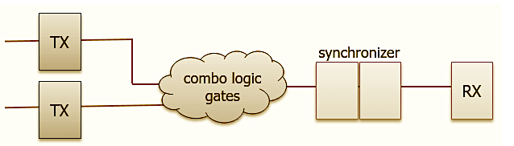
Şekil 2: Multi-Flop Synchronizer

Open Loop
Open loop simple means that there is no feedback to the source domain about whether the data it sent was safely captured on the other side. This might not necessarily be a bad thing if you are sure about the relationship between the clock frequencies and ensure that the source holds the information long enough for it to be safely taken through all the synchronizer stages.
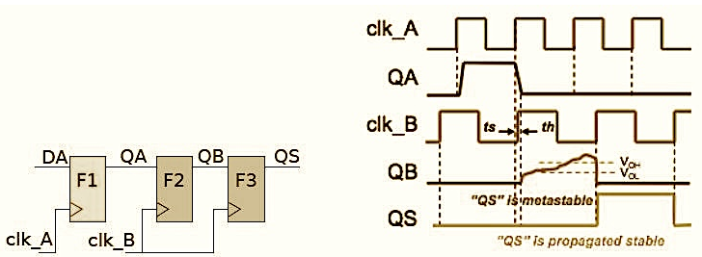
Şekil 3: Open Loop

Close Loop Handshaking
In a closed loop system, you set up a protocol that the source shall hold the data stable till it gets an acknowledgement (ack) back from the destination. This is much safer against unwarranted effects due to design changes.
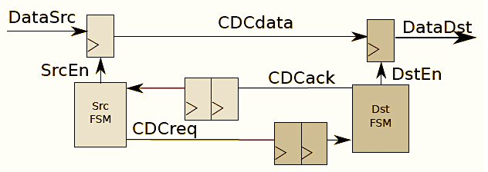
Şekil 4: Close Loop Handshaking

Toggle Synchronizer
For sparse pulses, you’re better off simply toggling a signal on the source side and then using it to manufacture a pulse in the destination. The minor advantage here is that you need not worry about the clock frequencies or the relationship between them chainging in the future and breaking this crossing.
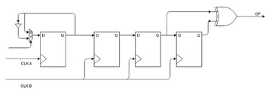
Şekil 5: Toggle Synchronizer

Mux-recirculation
This technique simplifies the CDC circuit for a multi-bit bus in specific cases where the data is not fast moving. This is also called the MCP or multi-cycle path strategy in some literature. A qualifier pulse is transferred to the destination domain using a double flop synchroniser or a toggle synchroniser and this pulse in the destination domain enables the sampling of the multi-bit bus.
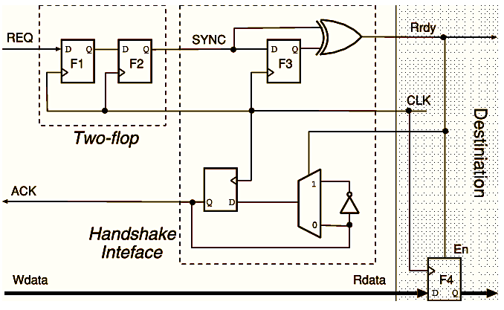
Şekil 6: Mux-recirculation

Asynchronous FIFO
The asynchronous FIFO is arguably the cleverest way to come up with a robust system that can ensure safety in all kinds of designs. It might look like the ultimate solution for any situation and most people, especially in FPGA tasks, where the rigour to make the most efficient design lower, use this block for almost any kind of CDC. Therefor we designed asynchronous FIFO because its great features.
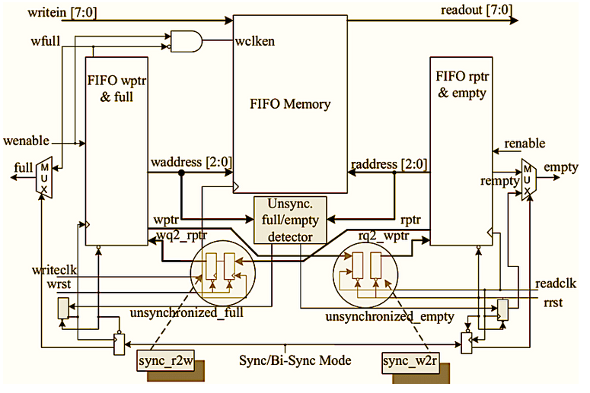
Şekil 7: Asynchronous FIFO

Module Design Techniques

Binary-Gray and Gray-Binary Converter Modules
In FIFO design, when data is transported from one clock domain to another clock domain it is a tricky way to use gray code. Because gray code has less transportation error probability thanks to its structure.
Binary to gray converter: To get a gray code version of a binary number, we put binary number and shifted version of this binary number in an XOR operation.
Gray to binary converter: To get binary version of a gray code, first the MSB is copied then the remaining numbers are converted with the formula of “ bin[i] = bin[i+1] ^ gray[i] ”.
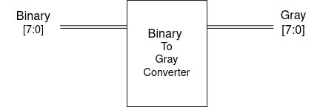
Şekil 8: Binary To Gray Converter

Clock Divider Module
Clock divider module is one of the most important modules in FIFO design. As you know the most important feature of FIFO is the capability of working with different clock domains. However, in an FPGA board there is just one system clock. In this way, we must design a clock divider module to get clock signals with different frequencies.
In this FIFO design, we used three different clock signals. These are 1MHz read clock, 5MHz write clock and 1Hz debounce clock.
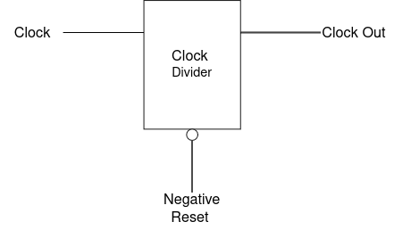
Şekil 9: Clock Divider Module

Synchronizer Module
Synchronizers are used to get rid of metastability in digital design. In FIFO, we used synchronizers in three parts. One of them is used when write and read pointer handlers communicate with each other. The other one is used in debouncer module to synchronize the button input. The last one is used to synchronize reset design to system clock.
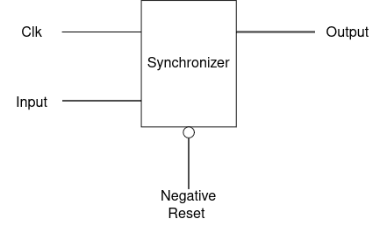
Şekil 10: Synchronizer Module

Debouncer Module
When we use buttons in our design, glitching is an inevitable issue for designers. To overcome this issue, debouncers are used. There are some different debouncer designs. We used a debouncer that counts the glitching button inputs coming from synchronizer. This module collects 20 samples then counts the ones in this sample chain. If there are 12 or more ones in this chain, the output becomes 1 if not the output is 0. In the FIFO design, we used the buttons in three parts. These are write button, read button and reset button.
Unlike other modules, we have two clocks in this. The reason for this structure with two clocks is that when we collact the samples and save them in a sample chain, 10k Hz clock is used and when we count the ones in this sample chain system clock is used. Because while we collact datas we should collact them with slow clock but there is no restriction in counting them, so ones are counted with fast clock. Also, synchronizers into the debouncers are using fast clock of course.
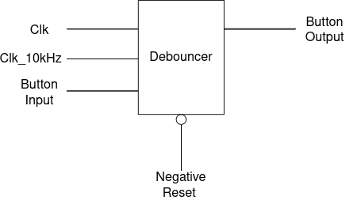
Şekil 11: Debouncer Module

Edge Detector Module
In FIFO design we used edge detector to get edges from debounced button input signals. This module takes input signal and its one clock cycle delayed version then puts them into an AND operation.
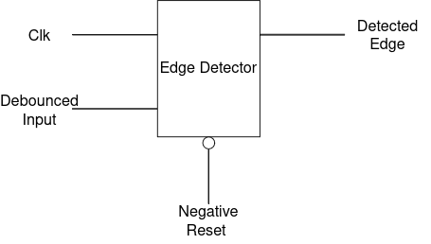
Şekil 12: Edge Detector Module

Write&Read Pointer Handler Modules
Write and read pointer handler modules are two critical modules in FIFO design. These modules always control and compare the outputs of each other. It is important because FIFO is a memory element that works with asynchron clock signals. To perform this without any loss in data, these two modules should share their addresses that they read or write the data. They share the pointers and data in gray code to obstruct data loss.
In read pointer handler:
The inputs of this module are clk, Rinc and rq2wpntr. Rinc is an indicator of the desire to read operations, and it runs this module. Rq2wpntr is the pointer of the write address that comes from the write pointer handler. The outputs of this module are Rpntr ( the pointer bit and address of read operation ), Raddr ( the address of read operation ), Rempty (this indicates that memory is empty) and Almost Rempty (this indicates that memory is nearly empty).
Rempty formula is that:
rempty = tempcntr[DATAWIDTH-1:0] == rq2wpntr[DATA_WIDTH-1:0]
Almost Rempty formula is that:
temp_cntr[DATA_WIDTH-1:0]+ 'd3 >= rq2_wpntr[DATA_WIDTH-1:0] || temp_cntr[DATA_WIDTH-1:0]>= rq2_wpntr[DATA_WIDTH-1:0]+ 'd25
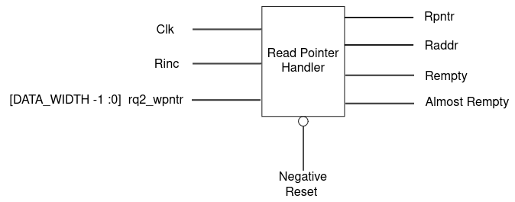
Şekil 13: Read Pointer Handler Module
In write pointer handler:
The inputs of this module are clk, Winc and wq2rpntr. Winc is an indicator of the desire to write operations, and it runs this module. Wq2_rpntr is the pointer of the read address that comes from the read pointer handler. The outputs of this module are Wpntr ( the pointer bit and address of write operation), Waddr (the address of write operation), Wfull (this indicates that memory is full) and Almost Wfull (this indicates that memory is nearly full).
Wfull formula is that:
wfull = (temp_cntr[DATA_WIDTH-1] != wq2_rpntr[DATA_WIDTH-1] && temp_cntr[DATA_WIDTH-2:0] == wq2_rpntr[DATA_WIDTH-2:0])
Almost Wfullformula is that:
almost_wfull = (wfill_level >= (1 << (DATA_WIDTH-1))-8)
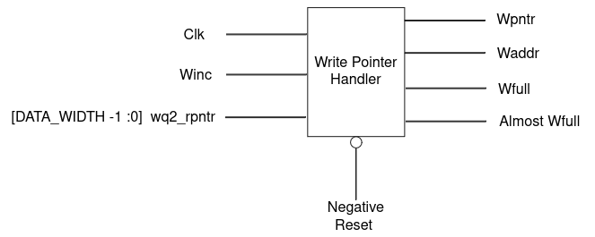
Şekil 14: Write Pointer Handler Module

Read Controller Module
This module has a function to decide if Rinc will be on or off. The inputs of this module are clk, R button out and Rempty. Rbtn_out and Rempty put in AND function and output is Rinc because Rinc should be ON when read button is pushed and the memory is not empty.
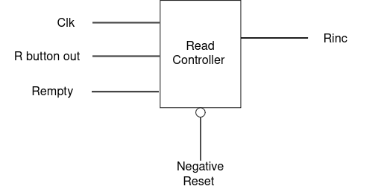
Şekil 15: Read Controller Module

LUT ROM Module

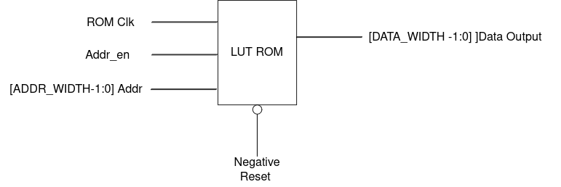
Şekil 16: LUT ROM Module

FIFO Memory (Dual Port RAM) Module

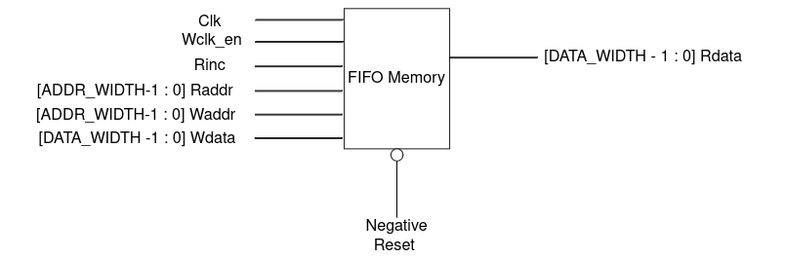
Şekil 17: FIFO Memory (Dual Port RAM) Module

FIFO Fsm Module
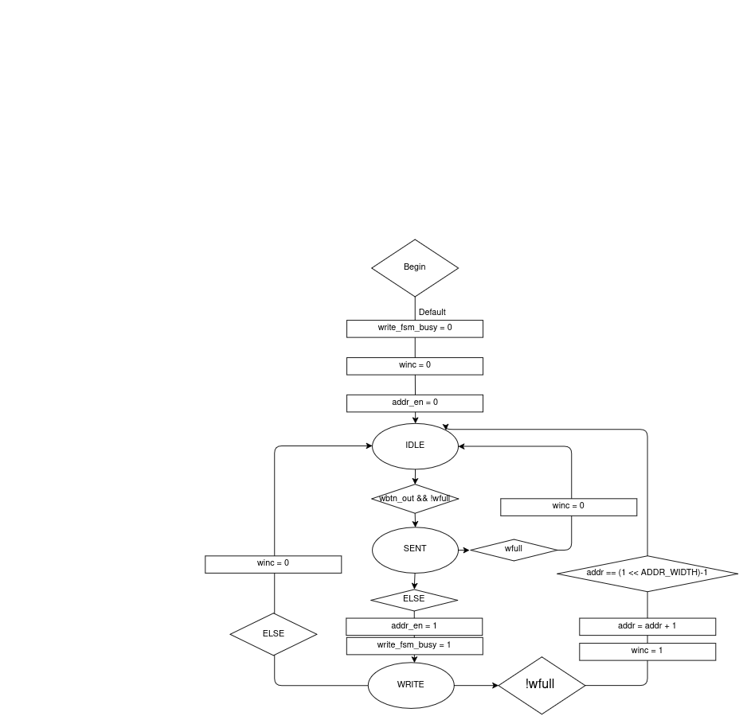
Şekil 18: FSM Diagram
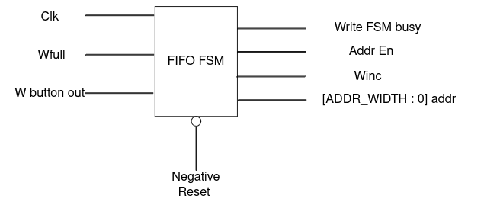
Şekil 19: FIFO FSM Module

Top Module

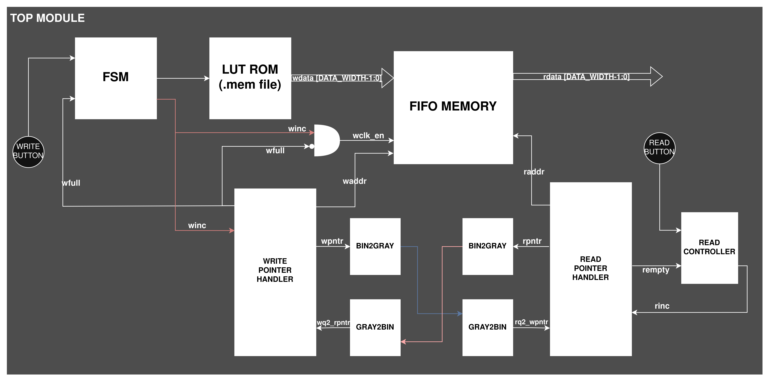
Şekil 20: Full System Schematic

TestBench Design and Simulation
The testbench is designed to rigorously verify the Asynchronous FIFO RTL design by simulating realistic operational environments, including asynchronous clocks and physical hardware imperfections.

Test Scenarios
The testbench implements specific tasks to validate the robustness of the debouncers, synchronizers, and domain crossing logic:
- Scenario 1: Evaluates the baseline functionality by simulating perfect, clean button presses consisting of 25 ms contact times followed by 20 ms release times.
- Scenario 2: Utilizes the press_wbtn_bouncy_1kHz and press_rbtn_bouncy_1kHz tasks to mimic mechanical switch bounce. It introduces rapid sequences of short contacts and breaks (e.g., 1.5 ms contact, 0.8 ms break, 3.0 ms contact) before a solid 25 ms hold, forcing the 12 ms debouncer threshold to properly filter the physical noise.
- Scenario 3: Uses the wbtn_glitch_1kHz task to inject an 8 ms noise spike onto the write line. This ensures that the debouncer correctly ignores signals that fail to meet the 12 ms threshold.
- Scenario 4: Toggles the switch (SW) inputs to verify that the monitoring LEDs correctly update to reflect different system states and data outputs.

Simulation and Waveforms
Write start: The waveform shows the debounced write button (wbtn_out) going high. Consequently, the write enable signal (wclk_en_wire) and write_fsm_busy are activated, initiating the sequential writing of data (wdata) into the memory addresses (addr).
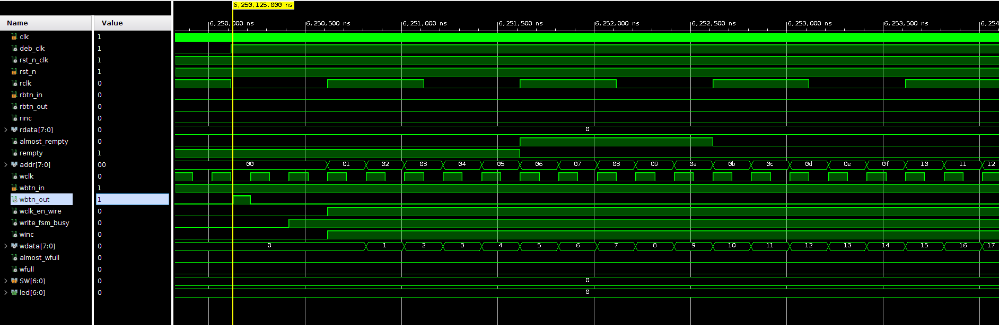
Şekil 21:Write Start Waveform

Write finish: As the memory depth is reached, the almost_wfull and wfull flags are successfully asserted high, dynamically blocking further write operations to prevent data overwriting.
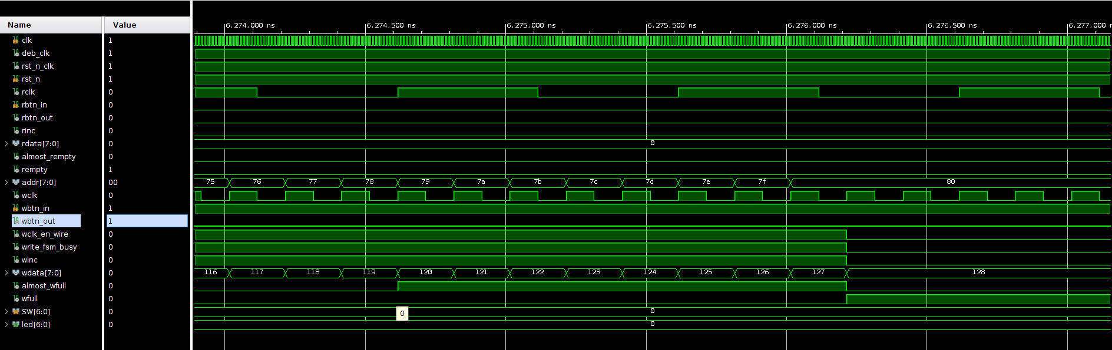
Şekil 22: Write Finish Waveform
Read Start: Triggered by the read button (rbtn_out), the read increment (rinc) signal activates. The FIFO then sequentially outputs the stored data to the rdata bus.
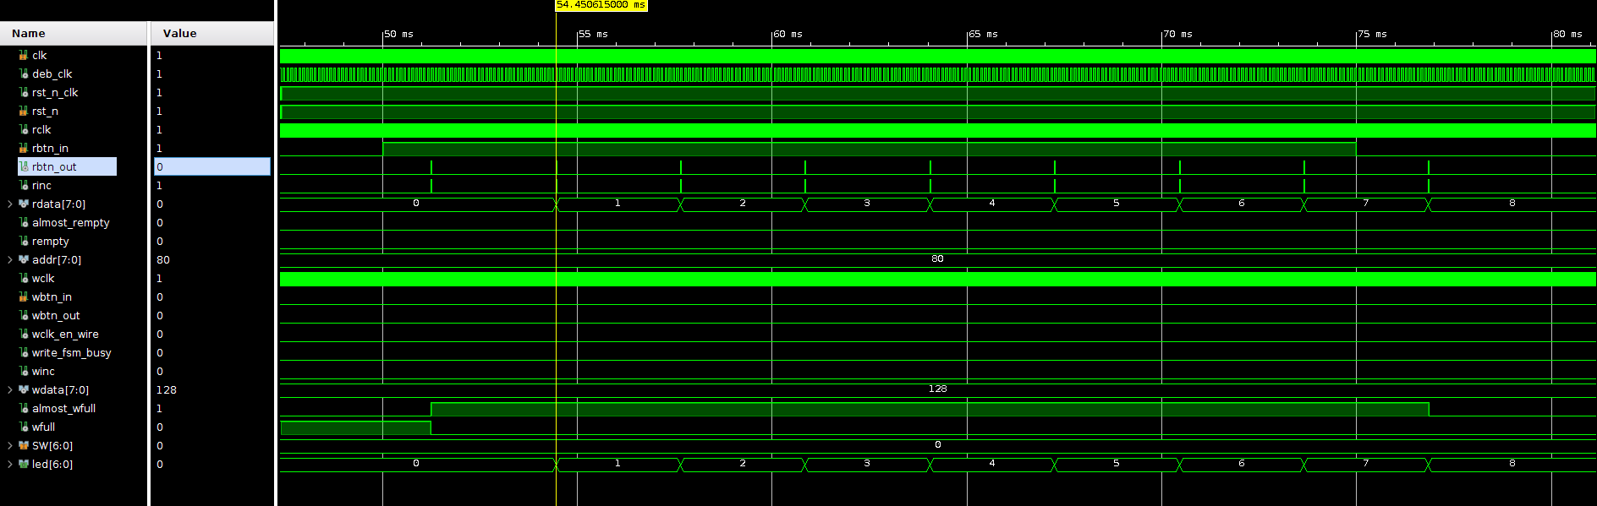
Şekil 23: Read Start Waveform
Reset: When the active-low reset signal (rst_n) is pulled to 0, the system successfully clears all flags (such as rempty, almost_rempty, wfull, almost_wfull), resets the data buses, and returns the pointers to their initial zero states.
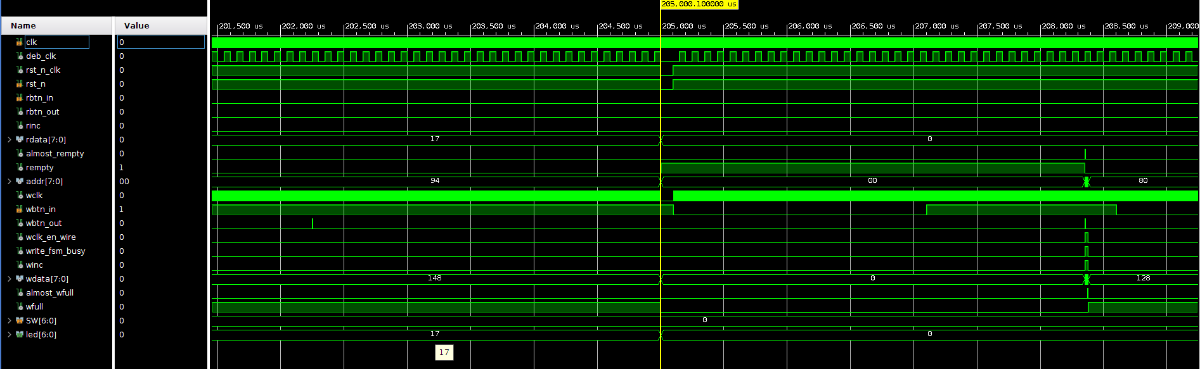
Şekil 24: Reset Waveform

Synthesis and Implementation
After verifying the functional correctness of the Asynchronous FIFO RTL design through testbench simulations, the project was advanced to the synthesis and implementation stages using the Vivado Design Suite. During these phases, the tool maps the RTL code to the physical FPGA primitives (such as LUTs, Flip-Flops, and BRAMs) and performs physical placement and routing. Multiple design rule checks (DRC), timing constraints, and methodology rules were evaluated, leading to several warnings and errors that required targeted optimizations.

Warnings and Errors
During the initial synthesis and implementation runs, the following critical warnings and errors were encountered:
- DRC REQP-1840 (RAMB18 Async Control Check): Multiple DRC violations were flagged on the Block RAM (RAMB18E1) module. The Vivado tool reported that the input control and address were being driven by multi-bit registers that possessed an active asynchronous reset. Because physical BRAMs in Xilinx FPGAs are strictly synchronous, asynchronous control signals can cause severe memory corruption during timing analysis.
- TIMING-17 (Non-clocked Sequential Cell): A static timing analysis (STA) critical warning was generated indicating that certain registers, such as samples_reg, were not being reached by a defined timing clock. The tool could not perform timing analysis because it did not recognize the clock source driving these flip-flops.
- TIMING-8 (No Common Period Between Clocks): Vivado flagged a bad practice timing warning regarding the relationship between the 100MHz system clock (clk_100mhz) and the severely divided debounce clock (deb_clk). The static timing analysis attempted to calculate setup and hold margins across these two clock domains but failed to find a reasonable common period (LCM) due to the massive frequency difference.
- Methodology PDRC (Suboptimally Placed Synchronized Register Chain): A placement methodology warning was reported for the multi-stage synchronizer flip-flops (e.g., stat_reg_reg[0] to [3]). Vivado successfully identified that these flip-flops were connected sequentially to mitigate metastability, but the placement engine (placer) failed to physically place them optimally close together within the FPGA fabric (SLICE), which increases routing delays and the risk of data incoherence.

Solution Steps
To achieve timing closure and pass all design rule checks, the following hardware design and constraint modifications were implemented:
- Converting to Synchronous Resets (Fixing DRC REQP-1840): The RTL code for the pointer handler modules (Write Pointer Handler and Read Pointer Handler) was refactored. The asynchronous reset condition was removed from the sensitivity lists of the always blocks driving the temp_cntr_reg address pointers. By relying exclusively on the clock edges (posedge wclk / posedge rclk), the resets were made fully synchronous. This aligned the pointer logic with the strict synchronous requirements of the Block RAM, clearing all multi-bit BRAM DRC warnings.
- Isolating Asynchronous Clock Domains (Fixing TIMING-8 and TIMING-17): To resolve the missing clock constraints and the common period mismatch between the fast and slow clocks, the Xilinx Design Constraints (XDC) file was updated. The system clock, debounce clock, read clock, and write clock were explicitly declared as entirely independent domains. Using the set_clock_groups -asynchronous command, Vivado was instructed to ignore timing path analysis between these disparate frequencies:
set_clock_groups -asynchronous -group [get_clocks clk_100mhz] -group [get_clocks deb_clk] -group [get_clocks wclk] -group [get_clocks rclk]
- Applying ASYNC_REG Attributes (Fixing Methodology PDRC): To ensure optimal physical placement of the 2-Stage Multi-flop Synchronizers, Vivado-specific synthesis attributes were added directly into the Verilog source code. The attribute (* ASYNC_REG = "TRUE" *) was placed immediately preceding the declaration of the synchronizer registers (e.g., stat_reg). This directive forces the Vivado placer to treat these flip-flops with maximum priority, packing them tightly into the same physical FPGA SLICE. This minimizes wire delay and effectively eliminates the physical metastability risk flagged by the methodology check.

Conclusion

