Clock Domain Crossing (CDC)
Any design can be work with more than one clock.

When we need more than one clock?
- Some operations like CPU processing… requires specific clocks to work
- Some functions like USB,HDMI… have properly defined frequency numbers and if you want to use these functions, you have to define another clocks for each one.
- Slow SPI,I2C.. interfaces cannot go beyond to MHz so you need to use another clock
You can’t use high clock for everything in the design. If you doing this, you are wasting the power.
If you use a lot more than two synchronizing FF even if you use approximately MTBF =$∞$ . Due to this extra FF’s your chip will be overheated and you have to use larger and more powerful fan.

To prevent this we need to choose architectures depending on the natüre of the data we’re transferring. It’s critical.

Possible Issues Due to CDC

Metastability

Data Loss (DL)
Data can be loss during the transfer between the clock domains. This happens when the source domain (clk) doesn’t hold the value of the pulse being synchronized for long enough.

If the active clock edges of C1 and C2 arrive close together, the first clock edge of C2, which comes after the transition on source data A, is not able to capture it. The data finally gets captured by the second edge of clock C2
However, if there is sufficient time between the transition on data A and the active edge of clock C2, the data is captured in the destination domain in the first cycle of C2

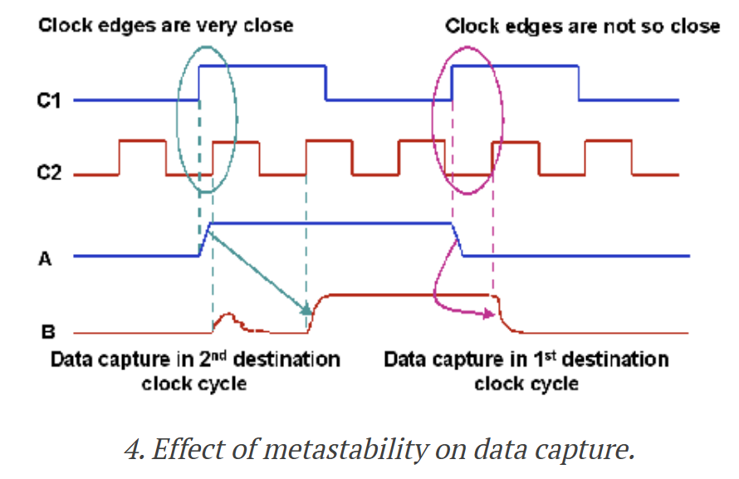
- When synchronizer’s first FF goes metastable, metastability can settle in either direction. If it settles a voltage level that not the same value being transferred by the source. We receive wrong data at the destination.
- When source domain has a smaller clock period than the destination and data to changes to fast before the posedge of the destination domain even.
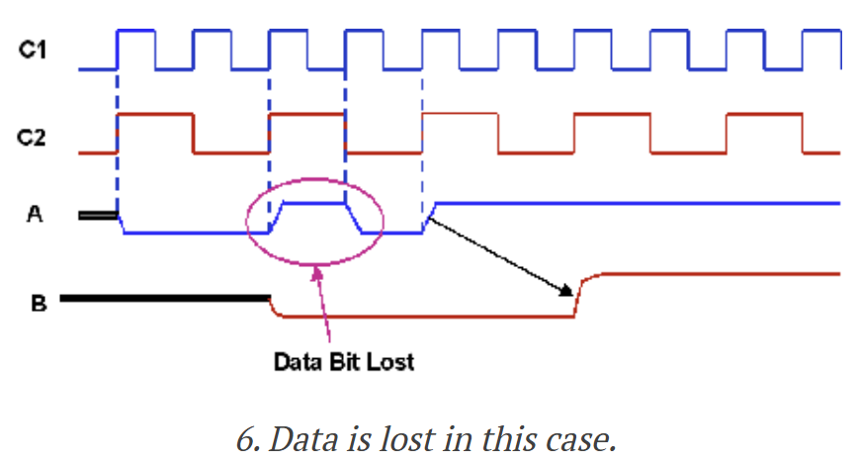
!!! SOLUTION: To prevent data loss, the source domain should hold the value for at least one complete posedge of the destination clock.
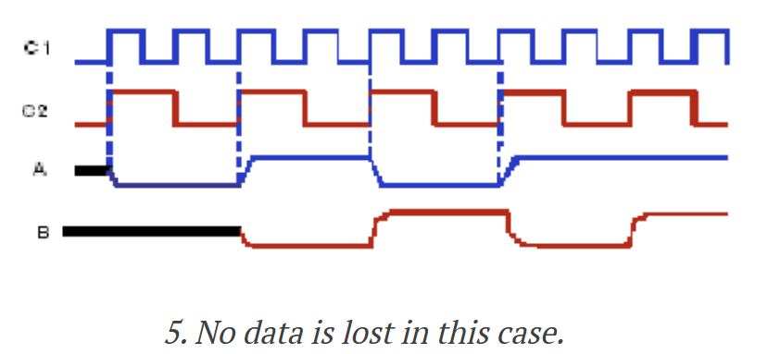

Data Incoherence (DI)
Consider a case where multiple signals are being transferred from one clock domain to another and each signal is synchronized separately using a multi-flop synchronizer. If all the signals are changing simultaneously and the source and destination clock edges arrive close together.
In this case, some of the signals may get captured in the destination domain in the first clock cycle while some others may be captured in the second clock cycle by virtue of metastability.
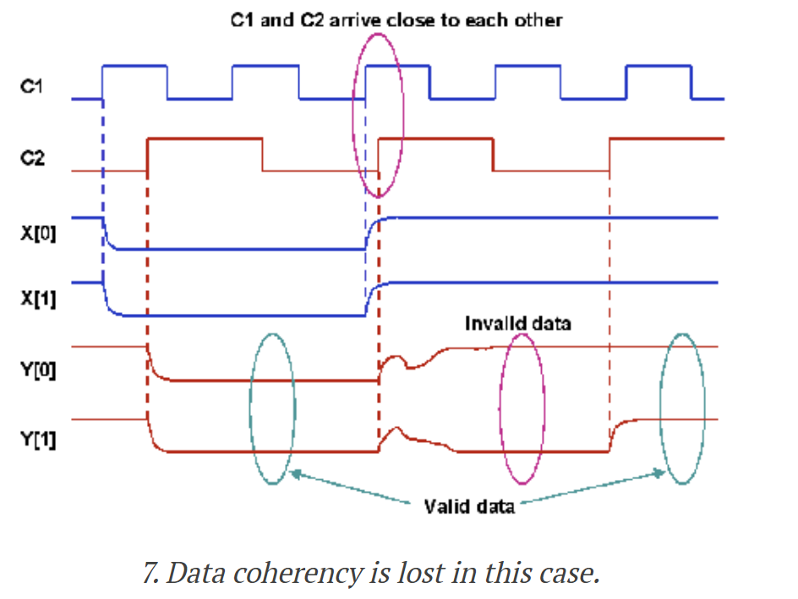
!!! SOLUTION: If all the bits either retain their original value or change to the new value in the same cycle, then the design either remains in the original state or goes to a correct new state. If the circuit is designed in such a way that while changing the design from one state to another, only one bit change is required, we can solve this problem with that if the bus is Gray-encoded.
!!! However, this is applicable only for control busses as it may not be possible to Gray-encode the data busses. In such cases, other techniques like handshake, FIFO and MUX recirculation can be used to generate a common control logic to transfer data correctly.
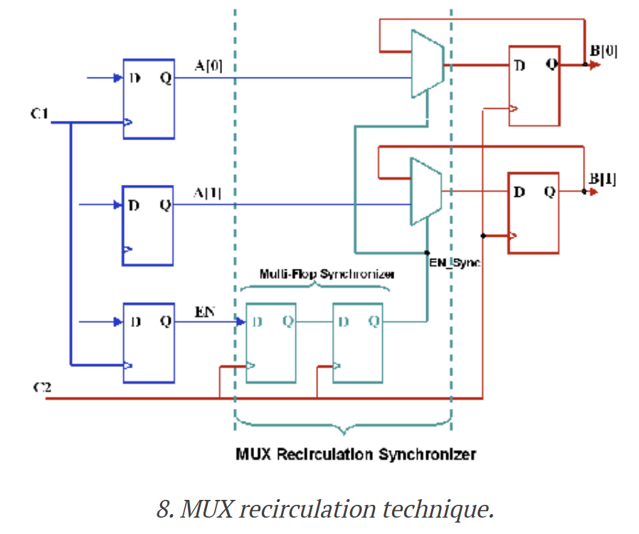

Re-convergence
(HIGHER LEVEL TOPIC than others)
More advanced version of Data Incoherence
This is visible when you analyse a system.
Even if you structually ensured metastability doesn’t break your chip, you also need to take care of to prevent the design from breaking functionally.

Possible Design Solutions of CDC

Multi-Flop Syncrhonizer
Very simple and elegant solution.
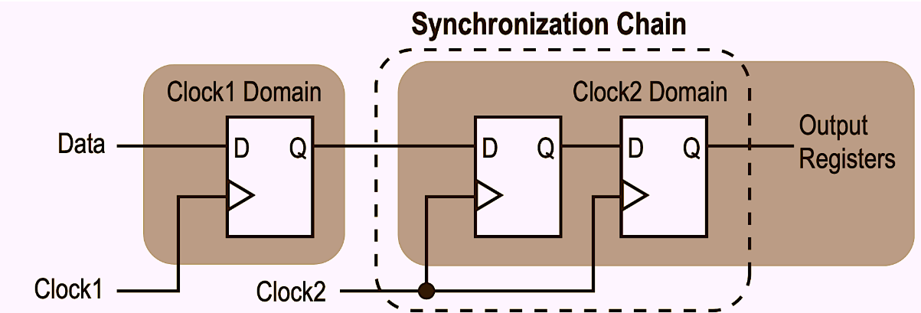
Each flop post the first synchronized output adds an extra full clock cycle to the time available for the metastability to settle. The other CDC techniques are originate from this.
Only useful for single bit data. There is a problem if you want to use it with multi-bit signal. The flip flops are slightly different from each other its electrical characteristics. You can’t ensure that all the multi-bit bus will settle on the same clock cycle. Hence, you run into the DATA INCOHERENCE (ID) problem.

OPEN LOOP

