Clock Domain Crossing (CDC)
→Any design can be work with more than one clock.

When we need more than one clock?
- Some operations like CPU processing… requires specific clocks to work
- Some functions like USB,HDMI… have properly defined frequency numbers and if you want to use these functions, you have to define another clocks for each one.
- Slow SPI,I2C.. interfaces cannot go beyond to MHz so you need to use another clock
→You can’t use high clock for everything in the design. If you doing this, you are wasting the power.
→If you use a lot more than two synchronizing FF even if you use approximately MTBF =$∞$ . Due to this extra FF’s your chip will be overheated and you have to use larger and more powerful fan.

To prevent this we need to choose architectures depending on the natüre of the data we’re transferring. It’s critical.

1-Possible Issues Due to CDC

1.1- Metastability

Data Loss (DL)
Data can be loss during the transfer between the clock domains. This happens when the source domain (clk) doesn’t hold the value of the pulse being synchronized for long enough.

→ If the active clock edges of C1 and C2 arrive close together, the first clock edge of C2, which comes after the transition on source data A, is not able to capture it. The data finally gets captured by the second edge of clock C2
→ However, if there is sufficient time between the transition on data A and the active edge of clock C2, the data is captured in the destination domain in the first cycle of C2

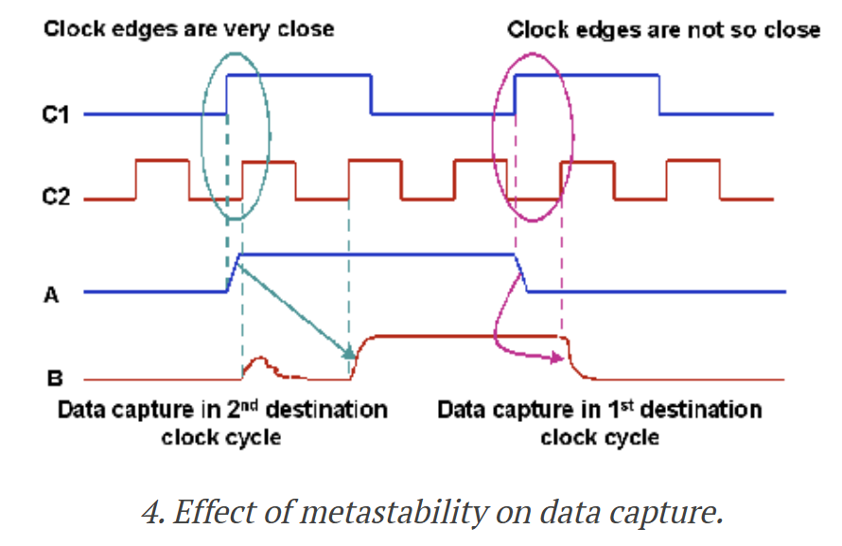
- When synchronizer’s first FF goes metastable, metastability can settle in either direction. If it settles a voltage level that not the same value being transferred by the source. We receive wrong data at the destination.
- When source domain has a smaller clock period than the destination and data to changes to fast before the posedge of the destination domain even.
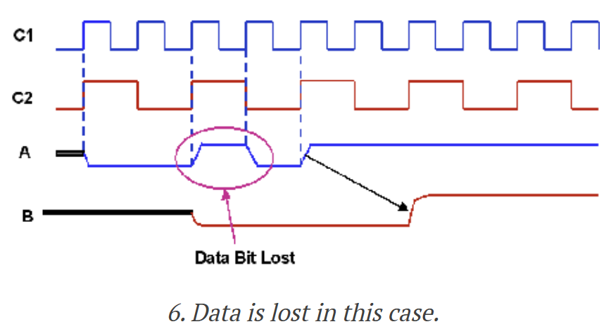
!!! SOLUTION: To prevent data loss, the source domain should hold the value for at least one complete posedge of the destination clock.
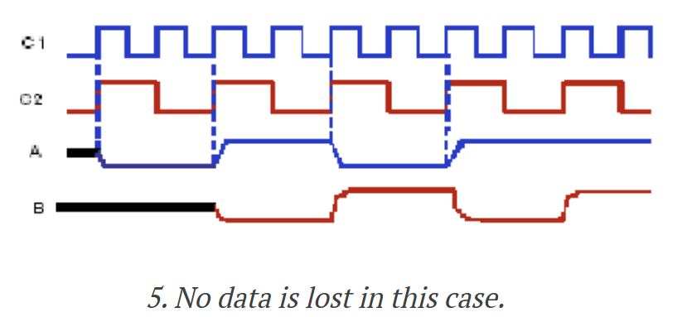

Data Incoherence (DI)
→Consider a case where multiple signals are being transferred from one clock domain to another and each signal is synchronized separately using a multi-flop synchronizer. If all the signals are changing simultaneously and the source and destination clock edges arrive close together.
→In this case, some of the signals may get captured in the destination domain in the first clock cycle while some others may be captured in the second clock cycle by virtue of metastability.
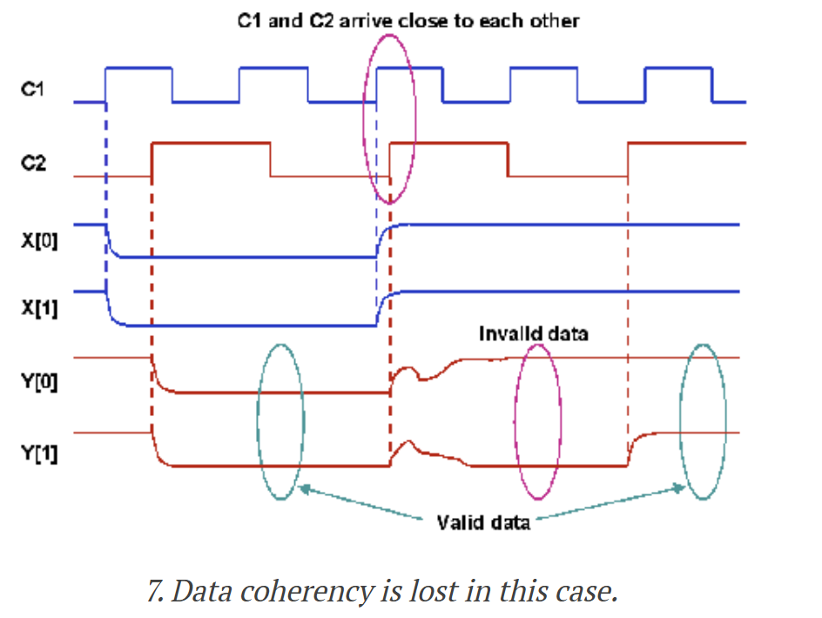
!!! SOLUTION: If all the bits either retain their original value or change to the new value in the same cycle, then the design either remains in the original state or goes to a correct new state. If the circuit is designed in such a way that while changing the design from one state to another, only one bit change is required, we can solve this problem with that if the bus is Gray-encoded.
!!! However, this is applicable only for control busses as it may not be possible to Gray-encode the data busses. In such cases, other techniques like handshake, FIFO and MUX recirculation can be used to generate a common control logic to transfer data correctly.
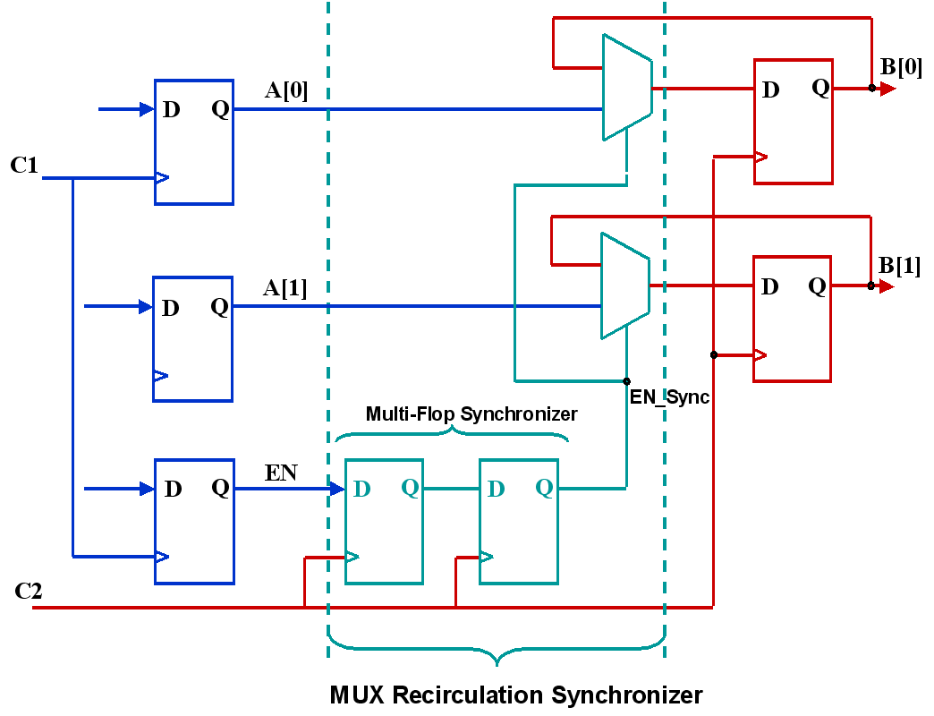
Here, a control signal EN, generated in the source domain is synchronized in destination domain using a multi-flop synchronizer. The output of multi-flop synchronizer is EN_Sync and this output drives the select pin of muxes, thereby you can control the data transfer for all bits of the bus A. So ther is NO DATA INCOHERENCY.

Re-convergence
(HIGHER LEVEL TOPIC than others)
→More advanced version of Data Incoherence
→This is visible when you analyse a system.
→Even if you structually ensured metastability doesn’t break your chip, you also need to take care of to prevent the design from breaking functionally.

Clock Domain Crossing Techniques & Synchronizers

Multi-Flop Syncrhonizer
→Very simple and elegant solution.
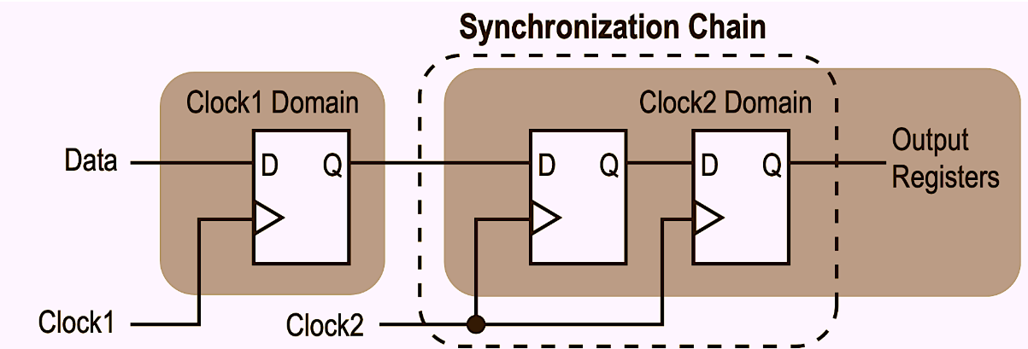
→Each flop post the first synchronized output adds an extra full clock cycle to the time available for the metastability to settle. The other CDC techniques are originate from this.
→ Only useful for single bit data. There is a problem if you want to use it with multi-bit signal. The flip flops are slightly different from each other its electrical characteristics. You can’t ensure that all the multi-bit bus will settle on the same clock cycle. Hence, you run into the DATA INCOHERENCE (ID) problem.

OPEN LOOP
Open loop simple means that there is no feedback to the source domain about whether the data it sent was safely captured on the other side. Actually there is no handshake. In real designs, open loop is a huge risk because frequencies keep changing.
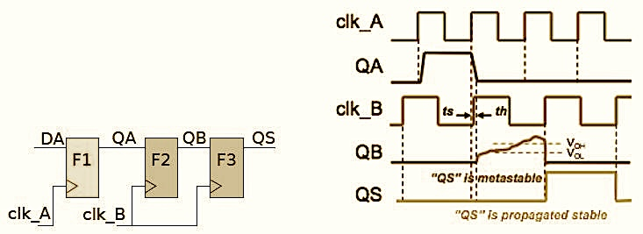
CLOSED LOOP (Handshaking)
In a closed loop system, you set up a protocol that the source shall hold the data stable till it gets an acknowledgement (ack) back from the destination. Data should be slow enough for the synchronizer to never miss a transaction.
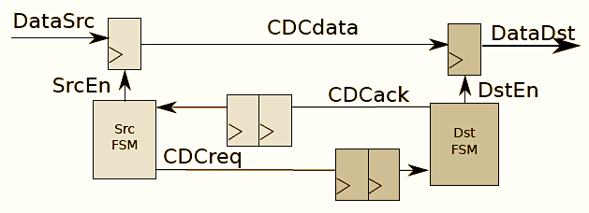
Two Stage vs Four Stage Handshaking
The handshaking method determines the throughput of the channel. So it is important question “How exactly the handshaking should be done?”.
You can learn more about that in the link → 2vs4_phase_Handshaking

2- Toggle Synchronizer
Toggle synchronizer is used to synchronize a pulse generating in source clock domain to destination clock domain. A pulse cannot be synchronized directly using 2 FF synchronizer.
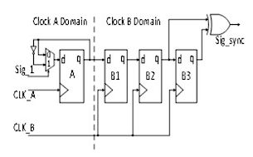
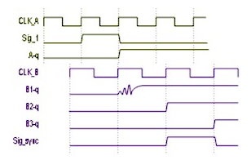
In the source clock domain, an input pulse triggers a toggle flip-flop. The toggled signal passes into the destination clock domain and goes through a standard multi-flip-flop synchronizer to resolve metastability. The destination domain detects the toggled state using an edge-detector circuit and reconstructs the original pulse.

3- Pulse Sycnhronizer
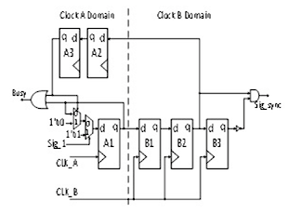
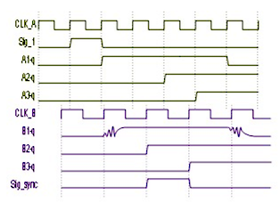
There is one restriction in pulse synchronizer that back to back pulses cannot be handled. To make sure the next generated pulse in source clock domain gets definitely transferred and synchronized in the destination clock domain, the handshake based pulse synchronizer generates a “Busy” signal by ORing A1 and A3 flip-flop outputs. Thus the logic generating the pulse shall not generate another pulse till the busy signal is asserted.

4- Gray Encoding for Multi-Bits Signal
When multi bit signals are synchronized with 2 flip flop synchronizer, each bit is synchronized using separate 2-FF synchronizer. That can causes metastability due to this output of every synchonizer mat not settle to correct value at same clock so there can be Data Incoherency. This problem can be achieved by gray encoding. Thereby only a single bit change will be guaranteed at a particular clock cycle.
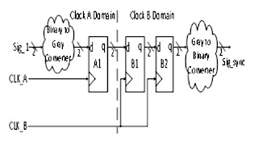
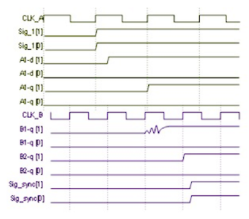
For example, in asynchronous FIFO design, when we synchronize read pointer value after converting to gray value in write clock domain using 2-FF synchronizer, there is possibility of metastability. As there is only one bit change in the gray encoding so even if there is metastability when clock crossing, the gray counter value will be previous value.

5- Recirculation Mux Synchronization
For isolated data and where multiple bits can transit at the same time.
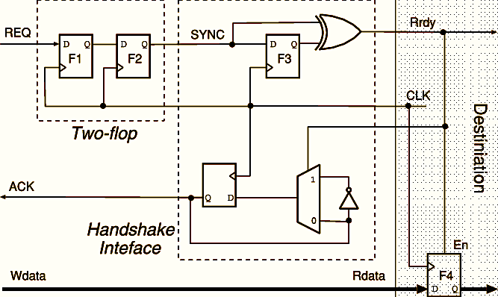
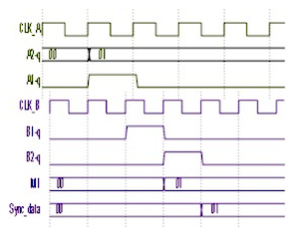
In order to synchronize data, a control pulse is generated in source clock domain when data is available at source flop. Control Pulse is then synchronized using 2 flip flop synchronizer or pulse synchronizer (Toggle or Handshake) depending on clock ratio between source and destination domain. Synchronized control pulse is used to sample the data on the bus in destination domain. Data should be stable until it is sampled in destination clock domain.

6- Handshake Synchronization
In this synchronization scheme request and acknowledge mechanism is used to guarantee the sampling of correct data into destination clock domain irrespective of clock ratio between source clock and destination clock. This technique is mainly used to synchronize vector signal which is not changing continuously or very frequently.
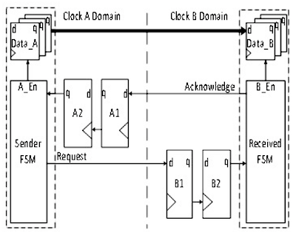
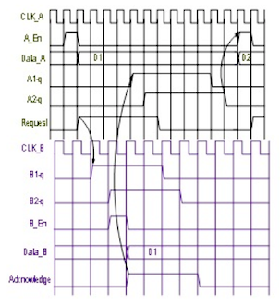

7- Asynchronous FIFO Synchronization
FIFO is best way to synchronize continuously changing vector data between two asynchronous clock domains. Offers solution for transferring vector signal across clock domain without risking metastability and coherency problems.
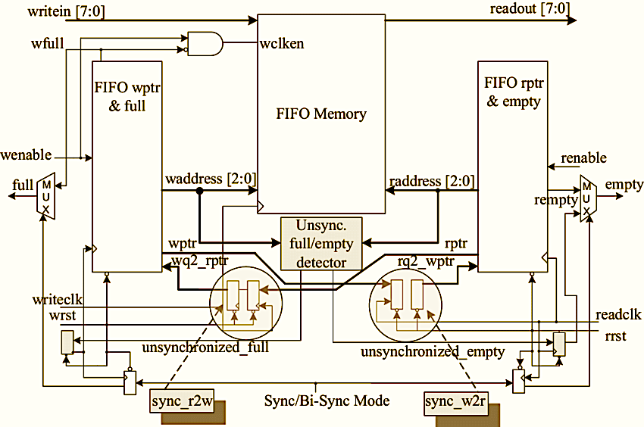
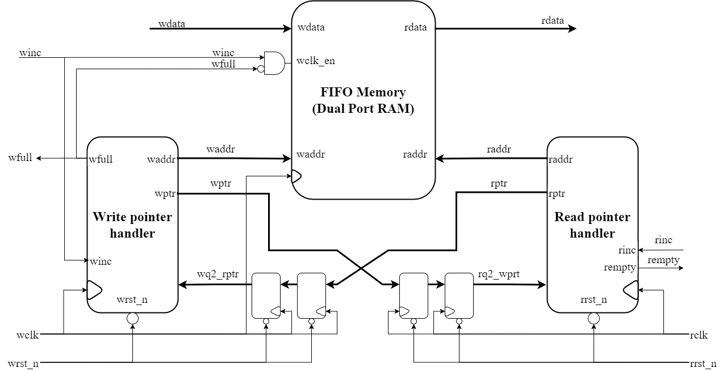

CDC Decision Tree

