



Defence Equipment & Support

Data Centre of Excellence

Current State Data Analysis Guide

written by: | Lawrence Grech, Dinyar Cooper | approved by:
unit: | Glue Reply, Data Management Practice | doc ID:
review: |  | issue date: |  | doc. model
Privacy notes

State of the document

Review | date | changes | (approved by)

Changes summary

Main changes list compared to the previous version:

Attachments:

Contents

1 Introduction 5
1.1 Background & Context 5
1.2 Document Purpose 6
1.3 Document Structure 6
1.4 Audience 6
1.5 References 6
2 Definition OF CURRENT STATE ANALYSIS 7
2.1 Description 7
2.2 Usage Scenarios 7
2.2.1 Scenario 1 7
2.2.2 Scenario 2 8
2.2.3 Scenario 3 8
3 Policy 9
3.1 Compliance with Core Data CoE Governance 9
3.2 Policies Specific to Current State Analysis 9
4 Process 11
4.1 The Data CoE Engagement Levels Applicable to Current State Analysis 11
4.2 Scope 11
4.3 Current State Analysis Tasks 12
4.4 Flow of Current State Analysis Tasks 13
4.5 Scheduling Current State Analysis Tasks 14
4.6 Estimation of effort 14
4.7 Stakeholders 16
4.8 Governance Schedule 18
4.8.1 Progress monitoring and reporting 18
4.8.2 Current State Analysis Products 18
4.8.3 Signoff 19
4.9 Approach to Data Repository Connection 19
4.9.1 Select Data Repository Instance 19
4.9.2 Requesting connection 21
5 Current State Analysis 22
5.1 Contextual Current State 22
5.1.1 Documentation Context 22
5.1.2 Functional Purpose 22
5.1.3 Financial Value 22
5.1.4 Mode of Operation 22
5.1.5 Organisational Context 23
5.1.6 Business Processes Context 23
5.1.7 Business Rules 23
5.1.8 Projects and Change Management 24
5.1.9 Applications 24
5.1.10 Data Imports 24
5.1.11 Data Exports 24
5.1.12 Enterprise Data Architecture Context 25
5.1.13 Standards, Methods and Tools Used 25
5.1.14 Technical Context 26
5.1.15 Performance and Service Levels 26
5.1.16 Operational Context 26
5.1.17 Backup and Archival Context 26
5.1.18 Special Security Considerations 27
5.1.19 Anecdotal Evidence 27
5.1.20 Data Challenges 27
5.2 Structural Current State 27
5.3 DATA CURRENT STATE 28
5.3.1 Data Profiling 28
5.3.2 Delta Profiling 30
6 Metadata CURRENT STAte 31
6.1 Approach to Mapping Current State Physical and Semantic Metadata 31
6.2 Associating Reference Data 32
6.3 Reference Data Lineage 33
7 CURRENT STATE ANALYSIS Completion 34
8 Best Practice 35
8.1 Engaging with stakeholders 35
8.2 Good meeting practice 35
8.3 Good email practice 36

Introduction

Background & Context

DE&S has recognised the need for a step change in the provision of Information Technology in support of the Joint Supply Chain as defined in JSP 886. To meet this need the UK MoD has sanctioned a programme to deliver Future Logistics Information Services (FLIS). FLIS capability change will result in the Logistics Network Enabled Capability (Log NEC) ‘one star’ organisation. To this end the FLIS programme is the vehicle by which the Logistics NEC end state [business as usual] will be reached. The FLIS programme is a business led change programme that will align a number of capabilities. To support its stated objectives, the Log NEC ‘one star’ organisation will develop, define and operate a Data Centre of Excellence (CoE) to support the Networked Enabled Logistics Information Services.

As one of the core services to be provided by the Data CoE, the Current State Data Analysis service shall gather and analyse information on the structure, characteristics, architecture, data and usage of data repositories, usually as a prerequisite to performing further services.

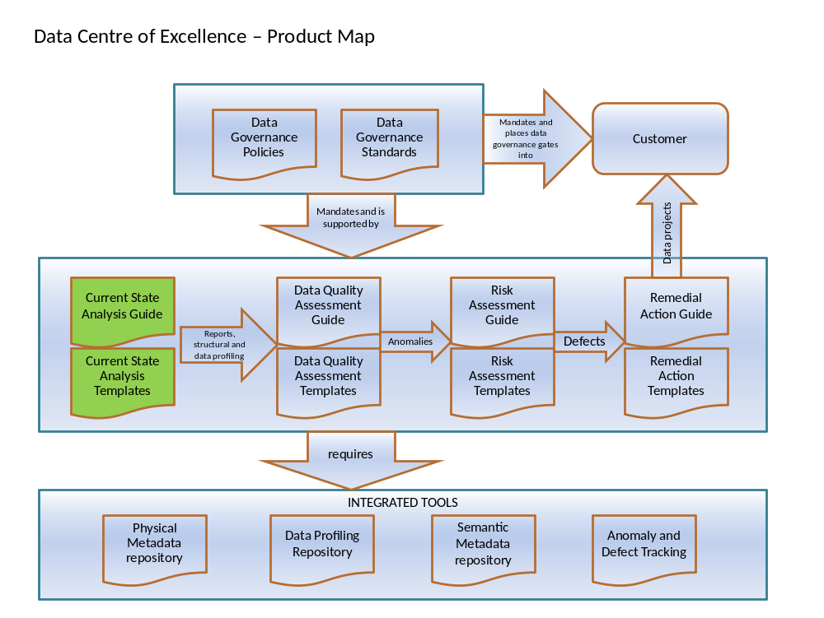

Document Purpose

The purpose of this document is to describe the steps required to carry out Current State Data Analysis ensuring a consistent approach and documentation of findings. The document is part of the Data Centre of Excellence Define phase Document Set.

It is not intended as a training guide and assumes that the Data Centre of Excellence team members who will undertake Current State Data Analysis will have the requisite technical skills.

Document Structure
This document defines the Current State capability and guides the Current State Analyst through the approaches recommended for acquiring and recording information about current state.

Document section | Description
Definition | The scope and examples of CSA
Policy | The rules governing CSA
Process | CSA methods and project management guide
Current state analysis | Guidance on the information to be acquired and recorded about a data repository
Current state analysis completion | Guidance on finishing up a CSA project
Best practice | Additional notes on CSA

Audience
The audience of this document is expected to be those involved in planning, scoping, executing and governing Current State Data Analysis including:

- Data Centre of Excellence team members (virtual or actual members)
- Delivery Partners. Where they are sub-contracted to deliver a Data CoE service
- Customers (usually Project Teams) who wish to undertake Current State Data Analysis
- Other stakeholders concerned with data within the enterprise

References

Definition OF CURRENT STATE ANALYSIS

Description

Current State Analysis (CSA) records a survey of the contextual, structural and data properties of a data repository. Contextual current state surveys the data repository’s position and use within the enterprise. Structural current state is about the construction of the data repository (also known as physical metadata). Data current state is a statistical profile of the data contained in the data repository. The analytical step within CSA is the association of the physical metadata to the logical metadata and through to business metadata. In performing this analysis, meaning is attributed to the components that make up the data repository.

This guide refers to the role of a Current State Analyst which is actually fulfilled by a Data Architect role. The term Current State Analyst clarifies the role responsible for carrying out CSA.

Usage Scenarios

Current State Analysis forms the base activity for many of the Data Centre of Excellence’s other capabilities as described in the following scenarios. It is the responsibility of the Current State Analyst to be as curious as possible in order to yield as much information as possible about the data repository under examination whilst remaining within the terms and scope of their brief

Scenario 1

A data migration is planned from two legacy systems to a new COTS system. The underlying legacy data repositories have no documentation and it is unclear whether a migration to the new system would be a good fit and successful. CSA is performed on the legacy data repositories.

Current State Analysis Step | Current State Report
Contextual analysis | - Legacy systems were used for transactional data and for generating management information reporting  - Identifies lack of data stewards to resolve conflicts in merging some fields with similar information in the two legacy data repositories
Structural profiling | - Results in information to carry out metadata mapping  - Provides an opportunity for performance tuning to keep the systems performing well for a little longer
Data profiling | - Results in an opportunity to perform Data Quality Analysis with a view to performing Data Cleansing
Metadata mapping | - Along with data profile, a physical to business metadata mapping reveals common fields between the data repositories.

Scenario 2

A large percentage of product codes in an inventory database are not being recognised picking robots in the physical warehouse. Urgent action is needed to rectify the situation since orders are being severely slowed down.

Current State Analysis Step | Current State Report
Contextual analysis | - Minimal mandatory contextual analysis gathered because of expediency
Structural profiling | - Provides in information to pin point design issues in the product related tables including validation constraints
Data profiling | - Data profiling is only performed on the suspected tables in columns in the first instance  - Provides the opportunity to focus on the product code problem
Metadata mapping | - Special dispensation is granted from the Data Centre of Excellence Escalation and Exception capability to skip this step in this instance on provision that it is revisited

Scenario 3

A biennial ‘health check’ of a data repository is to be carried out as required by a business’s data governance policies.

Current State Analysis Type | Current State Report
Contextual analysis | - Provides the opportunity to perform Capacity Planning exercise as the platform for the data repository is scheduled to be updated to new hardware
Structural profiling | - A structural profile provides the opportunity for a Data Quality Assessment to see whether the structure has been altered unexpectedly or without authorisation.  - Are the reasons for creating these indexes logged in the change control system?
Data profiling | - A sample based ‘quick’ data profile is performed
Metadata mapping | - Metadata mapping is checked and verified

Policy

Compliance with Core Data CoE Governance

The capability described in this document is supported by the following core Data CoE governance policies:

- The service levels of the customer and the customers data repositories must not be affected by Data CoE
- The Data CoE shall perform Current State Analysis as a service to its customers

- Projects Teams shall, through their own processes undertake to engage with the Data CoE in order to ensure that their data designs and systems are compliant with standards and best practice whilst improving the quality and performance of Project teams

- Projects in Log NEC shall undertake to make known the context, structure and data held in their data repositories, messages and files to the Data CoE.

- The Data CoE shall comply and uphold security requirements and protocols, respecting any additional security requirements of specific Project Teams.

- Data CoE shall create and maintain a sustainable, published record of the information acquired from their customers

Policies Specific to Current State Analysis

The capability described in this document defines the following technical policies:

- The work unit for a current state analysis should cover only one data repository at a time. There may be exceptions where the object of study is a group of closely connected data components. For example, a data repository containing multiple schemas.

- All results of Current State Analysis shall be recorded and published through the Data CoE toolset

- All research shall be carried out wherever possible using the Data CoE toolset. The Data CoE team carrying out the research may recommend extensions/enhancements to the toolset in order to improve capability

- In the course of carrying out Current State Analysis, connection to a live data repository should be a last resort. If it is necessary, caution and thorough due diligence is required in order to avoid disruption to business as usual activities

- Whenever the structure of the data repository is surveyed, a mapping of that structure to the logical data landscape metadata is mandatory as part of the Current State Analysis activity
- Access to data repositories shall always be carried out through the customer’s security protocols.
- Any extract or copy of a data repository will be maintained under customer’s security protocols.

- Current State Analysis shall be planned before commencement. Planning implies a schedule of tasks, estimate of effort and resources (staff and technical within the CoE and the customer) to be applied.

Process

The Data CoE Engagement Levels Applicable to Current State Analysis

The following engagement levels (See Log NEC Data CoE Charter) are permitted between the Data CoE and the customer for the purpose of performing CSA.

Engagement type | Description | Permitted for this capability
Governed | The customer utilises and manages its own resources with their activities governed by the Data CoE | Yes. Some involvement from Data CoE will be required in the operation of profiling tools and metadata mapping
Resourced | Data CoE provides the manpower which is subsequently managed by the project or programme but remains governed by the Data CoE | Yes
Managed | The Data CoE effectively provides a managed service whereby it delivers agreed services to a pre-defined time, cost and quality | Yes

Scope

Current State Analysis encompasses several facets of the data repository and not all of them are technical. Contextual analysis seeks to give an indication of how a data repository fits into an enterprise’s overall operation. Structure and data profiling is a technical activity focusing on describing the internal workings of the data repository. Metadata mapping seeks to assign meaning to individual components of the data repository at various levels of granularity. Delta profiling gives a view of behaviour over time.

CSA may be carried out in stages or all in one project. There are some parts of contextual analysis that are mandatory and must be done first. Structural profiling may be performed without performing data profiling but not vice versa. Delta profiling is only going to be applied to key data repositories that are undergoing significant structural or data change.

The CSA does not have to be complete in order to perform other Data CoE services and often the depth of the CSA will be defined based on the requirements of other services. Metadata mapping is mandatory in all CSA projects because the development of a semantic landscape is a primary objective of the Data CoE.

CSA may apply to any kind of new, current or legacy data repository. Technology may be based on relational tables, columns, rows or flat files, fields, records or XML document, complex type, simple type. Repositories based on legacy database management software (e.g. IDMS) may also be addressed although access to such repositories may require the involvement of database administrators and technology specialists.

It is not within scope of CSA to look for or analyse root cause or identify pain points.

Current State Analysis Tasks

The main steps of Current State Analysis are;

Step | Description
Plan, resource and initiate | Define scope, tasks, scheduling and resources
Identify and engage stakeholders | Enlist people to fulfil required roles
Identify and connect to data repository | Identify and connect to a representative instance of the data repository. Locate an instance of the data repository that causes the least disruption to the business whilst providing the best results to CSA. Acquire access permissions.
Profile contextual current state | Description of the data repository’s place within the enterprise and supporting infrastructure
Profile structural current state | Acquire the physical metadata of the data repository
Profile data current state | Acquire a statistical and pattern analysis of the data held in the data repository
Profile delta data current state | Acquire information on changes to the data over time
Metadata mapping | Connect physical metadata to business metadata
Report completion | Conclude the CSA project

Flow of Current State Analysis Tasks

The high level process flow shown below describes the sequence of tasks for carrying out a CSA. These tasks are described in more detail later in this document.
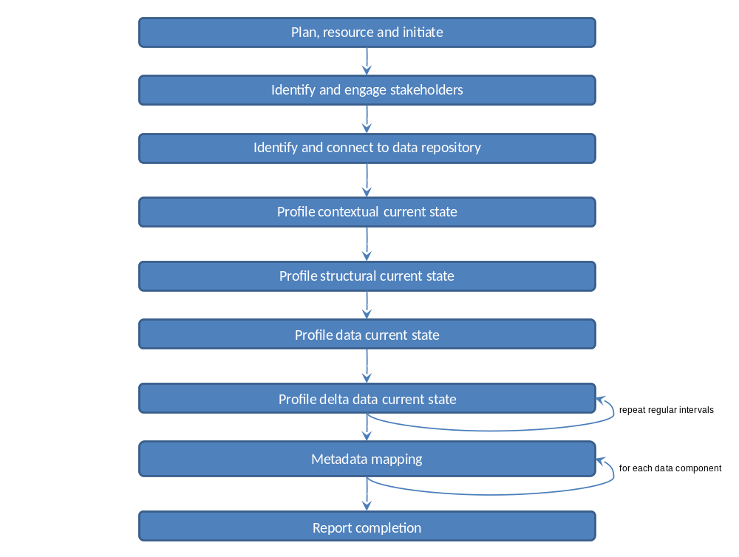

Scheduling Current State Analysis Tasks

The scheduling diagram shows which tasks have dependencies and which can be performed in parallel. The lengths of the bars indicate relative duration of the tasks. Arrows indicate dependencies. Overlapping bars indicate where there is an opportunity to perform tasks in parallel.

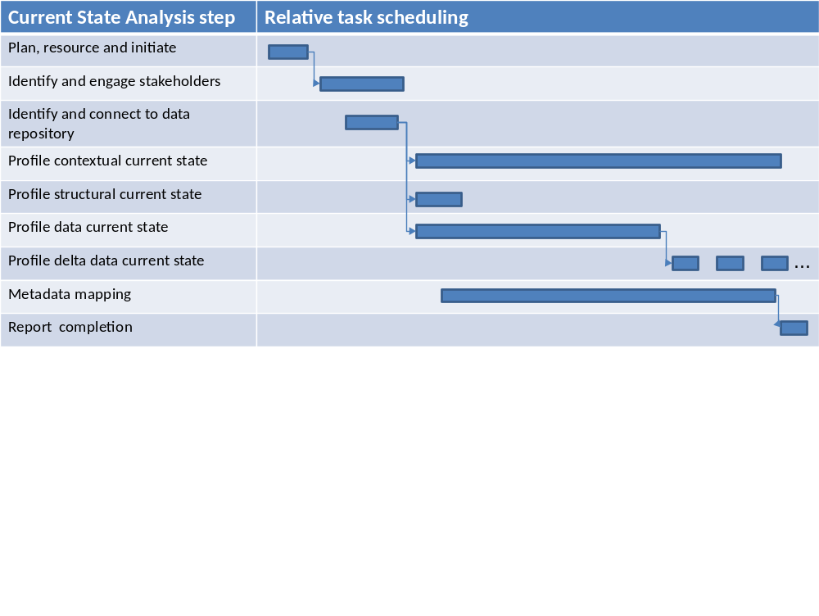

Estimation of effort

Current State Analysis is a somewhat subjective activity requiring technical and business analysis skills. For this reason the activity must be time bound. The table below shows approximate durations based on the complexity of the data repository. Complexity can be number of tables or columns, files or tags in the data repository so some enquires need to be made with the Data Steward or Database Administrator to find out how complex the data repository is. Use the approximate metrics below to estimate the duration of Current State Analysis tasks. Note that this table indicates amount of effort and not elapsed time for each task.
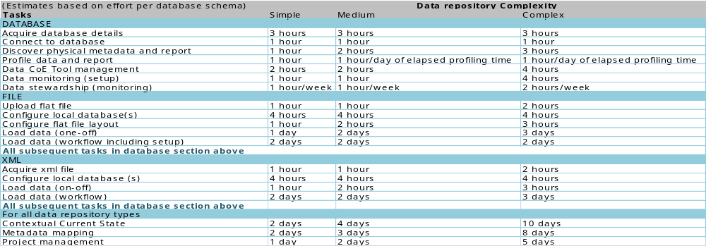

Stakeholders

Current State Analysis requires Data CoE team members and stakeholders to be engaged and aligned with the activity that is about to take place. The RASCI chart below shows how involvement is to be assigned based on the main tasks outlined in this guide and the roles defined in the Data CoE Charter.

The RASCI chart below shows the roles as defined in the Data CoE Charter in matrix with Current State Analysis tasks. In addition to the roles defined in the Charter there are additional roles defined;

- The Current State Analyst role is fulfilled by a Data Architect
- Data CoE Customer is the main customer contact within the customer’s department or team that is collaborating or procured the CSA

Ensure that the stakeholders are aware of their participation using the chart to convey the message. Ensure that the Stakeholders are aligned with the chart and make changes where necessary to suit the needs of the CSA project.

Note the following about RASCI charts;

- The Responsible party carries out the work. There may be more than one working together for each task.
- The Accountable party is the customer for the task. There can only be one per task.
- The Signoff party has oversight and quality control for the task prior to delivery to the Accountable party. There may be zero or more signoff parties per task.
- The Consulted party participates in the execution of the task by invitation from the Responsible party. There may be zero or more informed parties.
- The Informed party is kept up to date with the progress and events in a task. There may be zero or more informed parties.
- If appropriate RASCI can be reduced to RACI

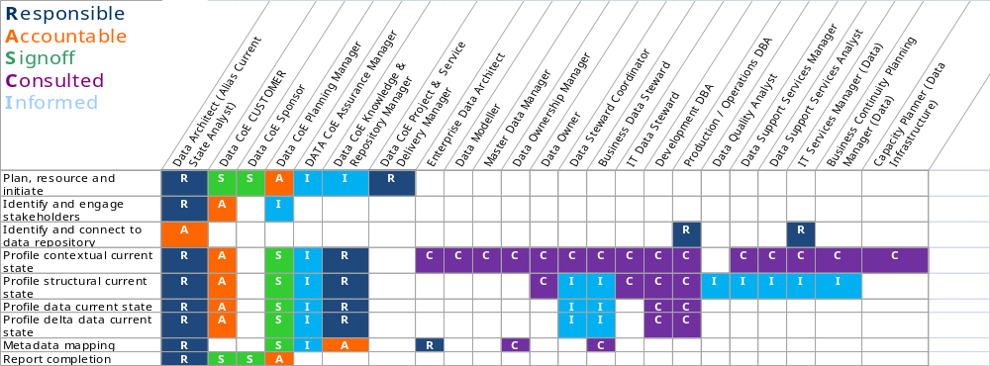

Governance Schedule

Progress monitoring and reporting

Reporting to the Data CoE planning manager must be carried out according to the Data CoE Project Management Guide.

Key meetings should be held by the Current State Analyst. The table below gives an indication of the kind of meetings to be held and the stakeholder types in RASCI chart above that should be involved. This is just a guide so it is up to the Current State Analyst and Data CoE Planning Manager to arrange meetings as per best practice 8.2 Good meeting practice.

Meeting type | Description | RASCI Audience Type
Planning meetings | Align all consulted and informed stakeholders with in the plan of action | R, A, S, C, I
Kickoff meeting | Ensure all resources are ready to participate | R, A
Deliverable meetings | Conclude each step with a delivery of the | R, S
Conflict resolution meetings |  | R, A, S

Current State Analysis Products
The following documents and reports will be produced from the CSA capability;

Product | Description
Project and resource plan | A detailed description of business justification, tasks, resources to undertake them and timeline
Estimation of effort | Breakdown of duration of each task given the size and complexity of the data repository
Data Repository Requests for Information | A request to the data repository access gatekeeper to provide information about the available instances
Data Repository connection request | A request from the Current State Analyst for permission and access credentials to the data repository
Current state contextual report | A report of all the finding about the contextual profile of the data repository
Current state structural report | A report of the detailed construction of the data repository. This may be enriched with descriptions.
Current state data profile report | Several reports will be available generated by the profiling tool
Delta reports | Reports on changes to structure and trends in data
Completion report | Summary of what was defined and the outcomes of the CSA. Lessons learned.

Signoff

The signoff points are shown in the stakeholders RASCI chart. Each main step has a signoff of deliverables and authority to commence to the next step.

Signoff criteria include:

- Is the deliverable comprehensible and coherent in terms of language?
- Have all business specific terms and acronyms been explained?
- Does the deliverable comply with this guide and the corresponding templates?
- Has there been any delay against the plan? If so account for the delay and document
- Could the guidelines be more specific so execution can be improved?
- Could the Data CoE software tools and processes be improved? Be specific.

Approach to Data Repository Connection

It is necessary to gain authorised access to a representative instance of a data repository in order to examine and profile its structure and data contents. The connection may be performed manually through a query tool or automatically through a profiling tool.

Select Data Repository Instance

Identify Access Gatekeepers

Identify the following stakeholders/owners for the data repository;

- Change manager if the data repository is undergoing change
- Operations manager if the data repository is part of business as usual operations
- Primary owner any subordinate data owners
- Data steward
- Data security owner
- Lead development or operational database administrator depending on whether data repository is under development or operational
- Data CoE Data Quality Assessor if one has been assigned

From these roles identify the gatekeepers for authorising access to the data repository. Make representations to the appropriate gatekeepers and keep all others informed.

Select Data Repository Instance

Most customers will have several instances of a data repository including those for;

- Development
- Various phases of testing
- Training
- Reporting
- Warehousing
- Backup
- Replicated
- Operational (live production)
- Local Data CoE copy

In negotiation with the access gatekeepers identify an instance that has the most representative structure and data. Development and test instances may be unstable in terms of structure and data will be unrepresentative of current operations. However this is an acceptable target if the CSA is part of software development lifecycle governance. If Data CoE has its own hardware infrastructure to support offline copies of data repositories then see if it possible to take a copy. Copies may be carried out through extract, restoration of logs, restoration of backup files or replication. Reporting copies of the operational instance are good targets.

If the only instance is the Operational instance, consider the following;

- Would change logs (redo logs) give a reasonable data profile? Note that connecting to the operational instance for structural profiling is acceptable.

- Can a copy be taken either through extract, replication or some other method?
- If a copy or extract is to be taken, so the resources and funding exist to do it?

- Are there non production time windows (usually overnight) which can be used to connect to the Operational instance? Check with systems operators to ensure there are no unusual overnight batch jobs due to be run such as month end or year end.

IMPORTANT

Extreme caution is required when accessing a customer’s data repository as connection and query may cause contention with other more important connections leading to degradation in data availability.

For this reason avoid connecting to a data repository without following agreed access protocols and clear notification to stakeholders.

Avoid connecting to live operational data repositories unless there are specific periods during the day/night which have been cleared specifically for CSA access. Ensure often that this connection window remains valid.

Ensure connection has only read-only permissions wherever possible.

Connection Adapters
Ensure that an industry standard connector exists from the Data CoE Profiling Tools to the target repository. ODBC and JDBC connectors may not be available for some kinds of legacy database. If this is the case, consider extraction of the data into database with an available connector. Keep in mind that connects are sensitive to data management software versions.

File and XML repositories
The profiling tool may require that data repositories in the form files and XML documents may need to be loaded into one or more relational tables prior to profiling. If this is the case, tools will be available to carry this out.

Requesting connection
In order to grant access to a data repository, most customers will require a request to be processed through a change request system. The Current State Analyst must make enquires and gain familiarity the appropriate change request processes.

Current State Analyst must request information from the access gatekeeper using the Connection Request for Information template [xref template].

Submit a Connection Request
The Data Architect submits a Change Request for the proposed connection and profiling activities to be done on the identified data repository.

Reviewers of the Change Request decide whether to grant permission to profile the data and identify appropriate timeslots and/or other conditions for scanning to minimize impacts to users of the data. All other stakeholders need to be kept informed. If the request reviews did not approve the scan request, the Current State Analyst needs to revise the request to address the DBA's concerns before asking again to scan.

Verify Database Connection
Update obtaining credentials to access the data repository, set up and verify the connection using the profiling tool. Ensure that no profiling is performed outside agreed time windows.

Current State Analysis

Contextual Current State

The objective of Contextual Current State is to record a variety of facets about the position of the data repository in the enterprise, the conceptual role that it plays and its physical configuration and management.

Documentation Context
Mandatory: Yes
Record the findings in the Current State Analysis Tool [xref to tools]
Template reference: [TBD]

Survey and list an inventory of any and all documentation associated with the data repository. This may be at any level from business and application through to infrastructure. Make a note of how current each item is.

Functional Purpose

Mandatory: Yes
Record the findings in the Current State Analysis Tool [xref to tools]
Template reference: [TBD]

Describe the broad purpose of the data repository.

What is the data repository for as perceived by its owners and the business units that use it? In some cases the data repository will not be perceived by the business since it may be completely hidden behind applications or service interfaces. Describe as much as possible in words and diagrams. Ensure to attribute sources of information.

Financial Value

Mandatory: No
Record the findings in the Current State Analysis Tool [xref to tools]
Template reference: [TBD]
What is the approximate value in financial terms of the data held in the data repository? If it is a transactional data repository then this may be measured in terms of the total value of transactions completed annually. If the data repository is a warehouse then this may be valued as a corporate asset at the rate of, for example, value per record/row or total stock value held. See the Data CoE Data Owner Management Guide for more on data repository valuation.

Mode of Operation

Mandatory: Yes
Record the findings in the Current State Analysis Tool [xref to tools]
Template reference: [TBD]

Define the data repository’s mode of operation.

Is the data repository mostly for transactional, data warehouse, management information, archival, messaging etc? Keep in mind that the data repository may be a file or an XML document so its purpose may be for message transmission and/or persistence. In the case of relational repositories it may several schemas, each having a different operational mode. Modes may be mixed. Is it of strategic or tactical importance?

Organisational Context

Mandatory: No
Record the findings in the Current State Analysis Tool [xref to tools]
Template reference: [TBD]

Describe the data repository in terms of its fit into the enterprise organisation.

Identify departments, teams or individuals that produce data into the data repository. Identify departments, teams or individuals that consume data into the data repository. View this from a strictly organisational perspective and not a process perspective which shall be mapped in a separate step. In some cases the answer will be more apparent from the users of applications that use the database. In cases where there is a service interface to the data repository, it may not be possible to identify the organisational units.

Business Processes Context

Mandatory: No
Record the findings in the Current State Analysis Tool [xref to tools]
Template reference: [TBD]

Where possible locate the repository containing the business process architecture.

This may be a design tool or a set of text documents. In an ideal situation, the business analysis will already give considerable information on how the business processes maps to the data and in this case only a reference to the material need be recorded. Where business processes are vaguely described, try to create one or more level 1 business process maps that indicate how the data repository is used. Application user guides or business operations manuals may help.

Business Rules

Mandatory: No
Record the findings in the Current State Analysis Tool [xref to tools]
Template reference: [TBD]

Describe any documentation of business rules that are encoded in the data repository.

Business rules tend to be implemented at all levels of the implementation stack. Sometimes the bias is towards encoding rules in the data repository layer, and sometimes the bias is towards implementation in the software layers above, be it a client application or SOA. Given that our focus is on the data repository, try to locate documentation on the business rules encoded into the data repository. This will be useful in evaluating the consistency and correctness between related data attributes.

Projects and Change Management

Mandatory: Yes
Record the findings in the Current State Analysis Tool [xref to tools]
Template reference: [TBD]

Describe any ongoing or near-term planned projects that could affect the structure or data of the data repository.

The business project managers and data stewards must be consulted to find out whether there are any changes planned with regard to the data repository under analysis. This information will indicate whether there could be any contention in obtaining access to an instance of the data repository for profiling. If will also indicate if the business and technical staff have the availability to help conduct the analysis since they will be busy with other duties at times of intense change. If further analysis is performed on the Current State Analysis this information will give an indication of whether the information has become ‘stale’.

Applications

Mandatory: Yes
Record the findings in the Current State Analysis Tool [xref to tools]
Template reference: [TBD]

Describe applications and software components that produce or consume data into the data repository.

Consult with system owners to describe the software components that read and write to the data repository. Look for one or more client applications, management information applications, commercial off the shelf software (COTS), service layer components and object-relational mapping layers.

Data Imports

Mandatory: Yes
Record the findings in the Current State Analysis Tool [xref to tools]
Template reference: [TBD]

Describe any regular or ad-hoc imports of data into the data repository.

Imports could be performed manually or by ETL software or from an application. Describe whether the source of the import is a file, XML document, FTP etc. Identify the originating system for the imported data.

Data Exports

Mandatory: Yes
Record the findings in the Current State Analysis Tool [xref to tools]
Template reference: [TBD]

Describe any regular or ad-hoc exports of data out the data repository.

Exports could be performed manually or by ETL software or from an application. Describe whether the result of the export is a file, XML document, proprietary replication etc. Identify the target system for the exported data. Identify the medium through which the export flows, for example, FTP, message queue, CD-ROM, ODBC, proprietary protocol.

Enterprise Data Architecture Context

Mandatory: Yes
Record the findings in the Current State Analysis Tool [xref to tools]
Template reference: [TBD]

Describe where the data repository is positioned in the enterprise data architecture

It is essential to have an awareness of how the data repository is related to other data repositories in the enterprise. Map the position of the data repository that is being assessed into the enterprise data architecture schematic. If a schematic does not exist then create one and maintain it incrementally as CSA’s are performed on various parts of the physical data landscape.

Standards, Methods and Tools Used

Mandatory: Yes
Record the findings in the Current State Analysis Tool [xref to tools]
Template reference: [TBD]

Describe any internal or external data standards used

Any use of following kinds of in house and external standards should be described

- Describe standards used in the construction of the repository such as e-GMS, ISO11179, ISO8000, XBRL etc.

- Describe any data standards used such as NATO Item Identification Number, postcode etc.

- Describe any modelling tools used such as Erwin, System Architect etc. including the specific notations in use.

Technical Context

Describe the infrastructure platform on which the data repository is located.

Consult the infrastructure owner and database administrators to identify the hardware, operating system(s) on which the data repository resides. Where the data repository is supported by database management software identify the technology and versions.

Performance and Service Levels

Describe any performance criteria and service levels formally defined for the data repository.

Consult the infrastructure owner and database administrators for any specific performance criteria or benchmarks defined. Service level agreements may involve performance criteria such as average retrieval time for a particular data query or availability levels for the data repository.

Operational Context

Mandatory: Yes
Record the findings in the Current State Analysis Tool [xref to tools]
Template reference: [TBD]

Describe the various instances and replicas of the data repository that exist within the enterprise

Locate all instances of the data repository. There may be more than one live copy replicated for various reasons. Perhaps there is a copy maintained for reporting that is a separate from the transaction master. Describe any replication taking place. Also locate all development, test and data staging versions of the data repository.

Backup and Archival Context

Mandatory: No
Record the findings in the Current State Analysis Tool [xref to tools]
Template reference: [TBD]

Describe how the data repository is defended from failure

Consult operations team and database administrators to identify backup, archival and disaster recovery regimes.

Archival may take place with the data repository at a record/row level. It may also take place through the saving of change log files or database snapshot. Try to document all the kinds of archival implemented.

Document references to disaster recovery procedure documents and point out if these don’t exist.

Backup may take place through replication, log files, proprietary technology, at a file level. List references to documents that define the backup regime. Identify any retention and offsite retention policies and practices that are in place.

Special Security Considerations

Mandatory: Yes
Record the findings in the Current State Analysis Tool [xref to tools]
Template reference: [TBD]

Describe any security or data sensitivity considerations

Some data in the repository may be of a sensitive nature, for example, credit card numbers, salary etc. Ascertain from the Data Steward which items cannot be read or require special permission. Note that profiling tools will take an extract of the data values and this may be prohibited for certain data attributes.

Anecdotal Evidence

Mandatory: Yes
Record the findings in the Current State Analysis Tool [xref to tools]
Template reference: [TBD]

Record any anecdotes about the data, the database and applications that operate on it

Anecdotal evidence can be very useful in building a picture of how a data repository is performing within an organisation. Record the anecdotes in as much detail as possible in words and diagrams. Ask permission before attributing source as some may prefer to remain anonymous. Make sure that all stakeholders are consulted, from business to technical staff.

Data Challenges
Mandatory: Yes
Record the findings in the Current State Analysis Tool [xref to tools]
Template reference: [TBD]

Describe points of conflict or difficulty

Document any specific known difficulties or challenges experienced by consumers and producers of the data. Do not include anecdotal accounts of conflict that seek to apportion blame.

Structural Current State

Mandatory: No
Record the findings in the Current State Analysis Tool [xref to tools]
Template reference: [TBD]

All data repositories possess structure of some sort. The objective of this CSA is to establish the structure no matter how simple or complex and document it in the Data CoE integrated tools. Structure may include all constructs that have been implemented by the underlying data management technology used. There are many database modelling software tools on the market that would refer to this task as reverse engineering the data repository.

Locate existing design documents and descriptions for the data repository

Ask the question of the Data Steward, Database Administrators, Business Analysts and Developers: Where is the data repository design documentation? Where it exists, record a reference to it and/or take copies and lodge them in the CoE tools. If there are descriptions of the components comprising the data repository, make a note of these as they will be required when building up the physical metadata. Where documentation does not exist, record this fact and begin the process of finding stakeholders who may be able to assist in identifying the meaning of data in the repository.

Where possible locate physical, logical and conceptual designs.
Connect to the data repository, scan and acquire the physical metadata

Where possible use automated features of the profiling tool to acquire the structure of the data repository. Where this is not possible or not warranted because the structure is so simple, record the structure into the profiling tool manually. Profiling should take into account the following physical metadata:

- Database, file, directory
- Language and character set
- Database management technology
- Table, file, schema level
- Row, record, document level
- Column, field, tag level
- Data type (simple and domains)
- Connections and references between all components
- Physical storage such as disk space occupied
- Indexing and lookup characteristics
- Volumetric such as row count
- Others, depending on the profiling tool used

Describe objects within the data repository based on known documentation

In the case of relational databases some description may be present in the structural metadata itself but this is very rarely implemented. Where possible work with data stewards, subject matter experts, developers and database administrators add known descriptions to the physical metadata.

DATA CURRENT STATE

Data Profiling

Mandatory: No
Record the findings in the Current State Analysis Tool [xref to tools]
Template reference: [TBD]

Data profiling takes data from the data repository and subjects it to various kinds of statistical and pattern analysis. The data may be processed in its entirety or randomly sampled. All columns/fields may be profiled or just selected ones.

Data profiling is usually a compute intensive, I/O intensive and time consuming task because it requires all values in the data repository to be retrieved and processed. Ensure that there are sufficient machine resources and enough time has been scheduled.

Is a data profile required and feasible?

Whilst it is desirable to perform data profiling, ensure there is enough time and resources to carry it out. If the data repository is supporting business operations then secure sufficient downtime. If the data repository is an offline copy, ensure the hosting machinery is available for a sufficient period of time and the instance of the data repository is not going to be repossessed prematurely to support another project.

Are the data volumes within the capabilities of the profiling tool?

Normally profiling tools have to scan data sets within the data repository. Some database management systems (such as Oracle) have specific commands to efficiently retrieve randomised rows through SQL. Taking into account the capabilities of the profiling tool and the data repository’s technology, assess whether the data sets can be profiled in a reasonable time. Data repositories with tens of millions of records and only the ability to sequentially scan may take too long to profile using the tool. In these cases it may be easier to inspect an extract of a few thousand records and make a rough assessment as to the profile of the data. Check the volumes in the structural profiling.

Has the best instance of the data repository been chosen?

There may be more than one instance of the data repository available. As per the approach defined earlier in this guide,

Is a profile of the entire data repository required?

If there are time or data repository access constraints then consider profiling selected parts of the data repository. Consider limiting the kinds of profiling performed. For example, outlier profiling may be more useful then pattern profiling in the first pass. Take stock of volumetrics before deciding whether to profile the data.

If the data repository instance is a Data CoE copy then perform a complete profile.

Configure profiling tool

Ensure the Data CoE profiling tool is correctly configured to connect to the data repository and ready to perform profiling. Ensure that other profiling tasks to not conflict for hardware resources

Commence profiling

Prior to commencement of profiling notify gatekeepers/owners/stakeholders of the data repository. Keep them informed of all starts, pauses and completions of profiling.

Complete profiling

On completion of profiling ensure that gatekeepers/owners/stakeholders are notified. Keep in mind that most profiling tools require the connection to the database to remain open so in browsing the profile information take care not to draw down information from the target data repository if that repository is a production instance.

Delta Profiling
The profiling tool will be capable of taking periodic incremental profiles of structure and data. This is useful in tracking whether the structure has incurred changes and analysing how the data is accumulating. Useful stewardship information can be derived from this.

All the guidelines defined for normal profiling need to be followed. The data profiling tool is configured to perform profiling and defined intervals over a period of time to build up enough information for trend analysis.

Structural profiling is usually brief enough to run perhaps monthly without any cut off date in order to monitor unauthorised changes to the structure.

Metadata CURRENT STAte

Mandatory: Yes, if structural profiling was performed
Record the findings in the Current State Analysis Tool [xref to tools]
Template reference: See Metadata Management Guide for style guidance

Information about the structural and data profile is known as physical metadata as it describes the tables, files, documents, data columns, fields and tags that describe the construction of the data repository. Business concepts are described in the semantic metadata. Semantic metadata resides in a Semantic Model, also known as a Enterprise Conceptual Model or Business Model.

Having ascertained a current state structural profile and optionally a data profile, it is now possible to associate the physical metadata to the semantic model. This step allows the reconciliation of the large and varied array of a customer’s data repositories into a single consistent conceptual view that contains business meaning. This semantic model is driven by whatever is discovered in the physical metadata so it is initial a blank sheet.

Refer to the Metadata Management Guide for how to perform mapping analysis.

Approach to Mapping Current State Physical and Semantic Metadata

The illustration below shows how a semantic model of a landscape can be associated with actual instances of landscapes. Components of the semantic model are described (land, tree, sky) and their relationships to each other within the semantic model are described (through relative positions in the picture). Components of the physical instances can then be associated with the semantic model even though they may be called different things in the physical world. By using the data profile (in this case shape, colour, texture) as well as the names we can ascertain that blue yonder and atmosphere can be associated to the concept of sky. In this way a conceptual picture of the business can be incrementally built up as new physical instances are discovered and associated.

The metadata mapping step uses the data repository structural profile (also known as physical metadata) and associates it with a constantly evolving semantic model. Tools are required to do this and maintain it effectively. If a new concept is discovered the semantic model can be amended which is a nontrivial exercise.

Some tools offer automated methods for detecting physical metadata that may have an association with existing semantic model components based on name and data profile matching.

The semantic model is the primary payoff to the Data CoE as it provides a means of considering

- consolidation or separation of data
- data migration paths
- A source of publishable knowledge about the business and data landscapes.
- Opportunities to enrich the semantic metadata further
- A stepping stone to master data management since it becomes possible to consider which source of any data item would be the most authoritative.

The precise method for carrying out the above is highly dependent on the tools in hand.

There is no correct level of detail in creating the semantic model but for a full description of the semantic landscape model, refer to Data CoE Metadata Management Guide.

Associating Reference Data
Mandatory: Yes, if structural profiling was performed
Record the findings in the Current State Analysis Tool [xref to tools]
Template reference: See Data CoE Metadata Management Guide and Managed Data Creation Guide

Reference data, also known as static data is of special interest in the metadata mapping step. Reference data values can

- enumerate a semantic concept (e.g. concept: address, enumeration: business, home, delivery)
- constrain values for a semantic concept (e.g. sex can only be male, female)
- classify a semantic concept (e.g. taxonomy for classifying trees)

The semantic model must be associated with any reference data that is discovered within the data repository.

Reference Data Lineage
Mandatory: No
Record the findings in the Current State Analysis Tool [xref to tools]
Template reference: Metadata Management Guide for reference data lineage analysis

Lineage must be derived for physical metadata wherever possible. It is useful to document the source of reference data, whether it resides within the data repository, in a separate associated data repository, a central reference data repository or even within applications consuming and producing data for the data repository.

CURRENT STATE ANALYSIS Completion

Mandatory: Yes
Record the findings into the Anomaly Tracking Tool [xref to Tools]
Template reference: [TBD]

Report completion of the Current State Analysis to the Data CoE Project Manager. Ensure that all agreed products are signed off as per the RASCI chart. Ensure that any issues, learnings are reported to the Data CoE project manager. Inform all stakeholders that the project has finished.

Best Practice

Engaging with stakeholders

- Do not apportion blame in describing issues in the CSA

- In most cases make progress through alignment rather than agreement. See diagram below.

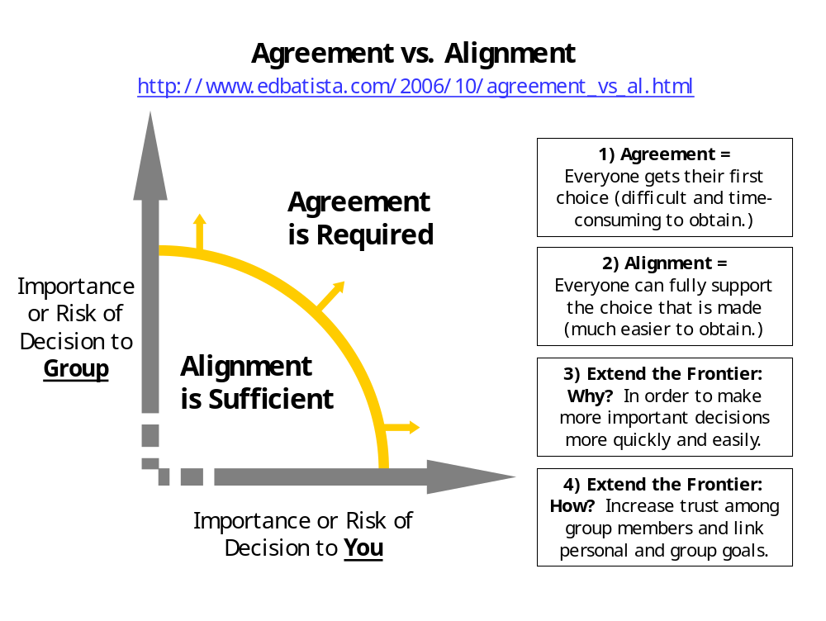

Good meeting practice

- Always arrange meetings with at least 24 hours notice to invitees

- There must always be an agenda attached with the invite

- Allow participants the opportunity to align on the agenda within reason

- Agendas must have at least three items for discussion

- Plan the meeting to take up 75% of the allotted time

Good email practice

- Subject line in email regarding should be prefixed with
  - [REQUEST]
  - [RESPONSE]
  - [UPDATE]
  - [INFO]
  - [FEEDBACK]

- Do not mix topics. An email must be about a single matter and not a series of issues. The subject line should reflect the matter clearly.

