**Database System Project 1 Step 5 Report**

Furkan KUSE - 150117041

Metehan ERTAN - 150117051

In this step we created a website for our database. This website is about a music store. In the website there is 6 main pages: Contact, Main Page, Sign in, Stores, Password update, User Page, Login Page. Also, user can navigate through these pages using header navigation tab.

Contact Page is about the information of the store chain.

Main Page is the main page of the site. Here user can login or sign in and the items that are in stock are listed in this page with info needed. All information is taken from the database.

With sign in page, user can add new online customers to the database. This page checks whether the given inputs are enough and according to the customer online requirements. This page takes the inputs from customer and inserts the inputs using SQL statements.

In stores page information of stores that are connected to our music store chain. These informations are taken from the database.

Passport update page is used for updating the password of the user that is already logged in user. Password must match the requirements. And the password is updated.

User page is the page that the user is directed after a login and when customer wants to go to their profile. User can see its information and their orders.

Login page is used for logging in for the website. Only after logging in user can change the password or go to their profile page. When not logged in user can register or login. When logging in website takes the information and compares them from the database and then log in.

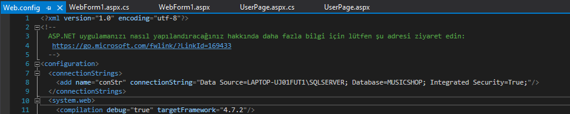

To create a connection between database and our web application, firstly we create a connection string. We make integrated security true because, there was security problems and we cannot connect the database otherwise.

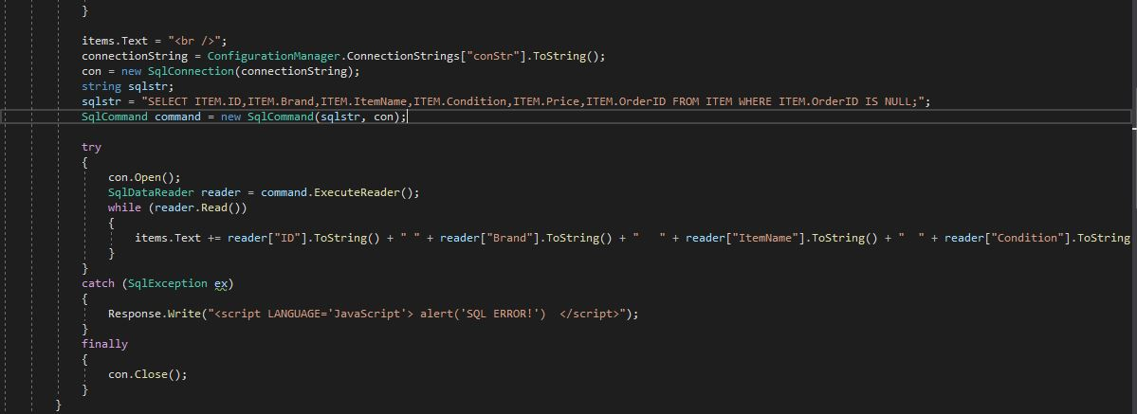

Our website shows purchasable items at the first page that opened. To be able to show that, we firstly create a new connection to database. Then we create new command with a SQL query statement. In the statement that stored in the “sqlstr” we select info about the items that belongs to ITEM table which does not belong to any order. In try part, firstly we try to open connection then we create a SQLReader object to reach information stored in the database, finally we print info about items to the page.

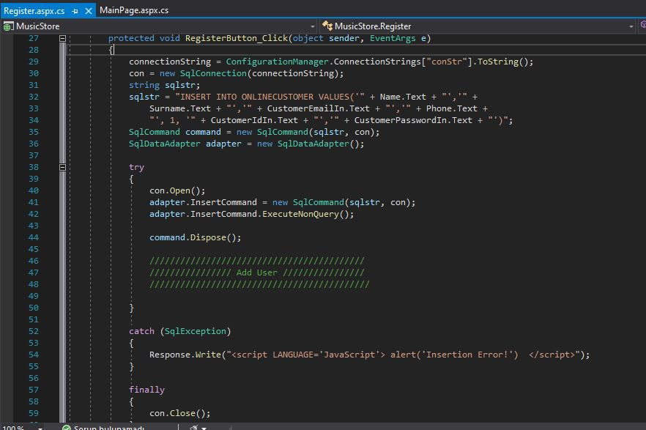

When the use clicks the register button after filling given textboxes, our program creates new connection with database. Then we create new SQL statement with given info to insert new member to ONLİNECUSTOMER table. Then we create new SqlAdapter object to run our statement in the database. In the try catch part we open a connection between our web application and database. Then we execute our SQL statement with help of SqlAdapter that we created recently. Finally, we close the connection.

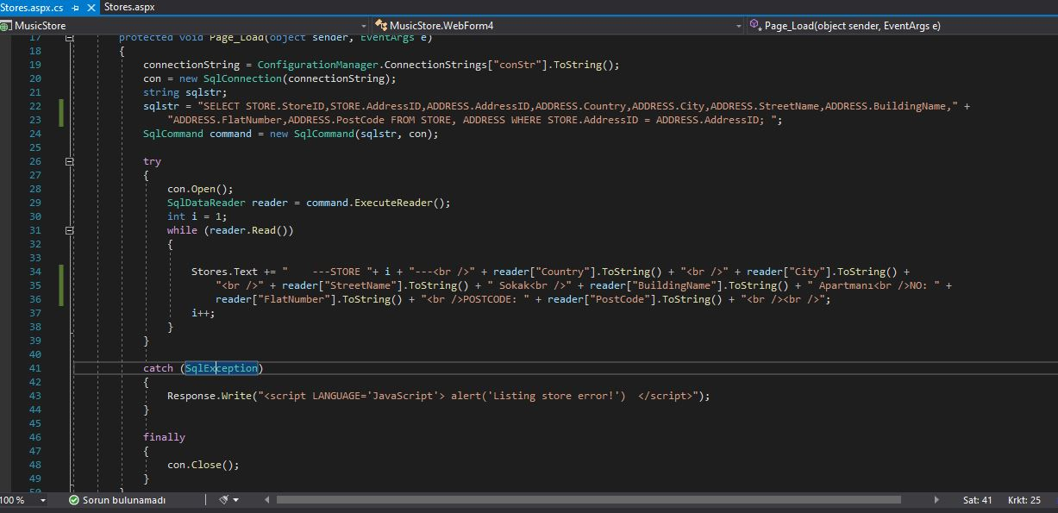

In Store page, to reaching addresses of the stores from database, we create a connection between our web application and database. Then we create new SQL statement which gets info about stores and their addresses. For reaching the addresses of the stores it checks if the address id of the store matches with the address id from the table ADDRESS. After that we open connection and print the info to the screen one by one.

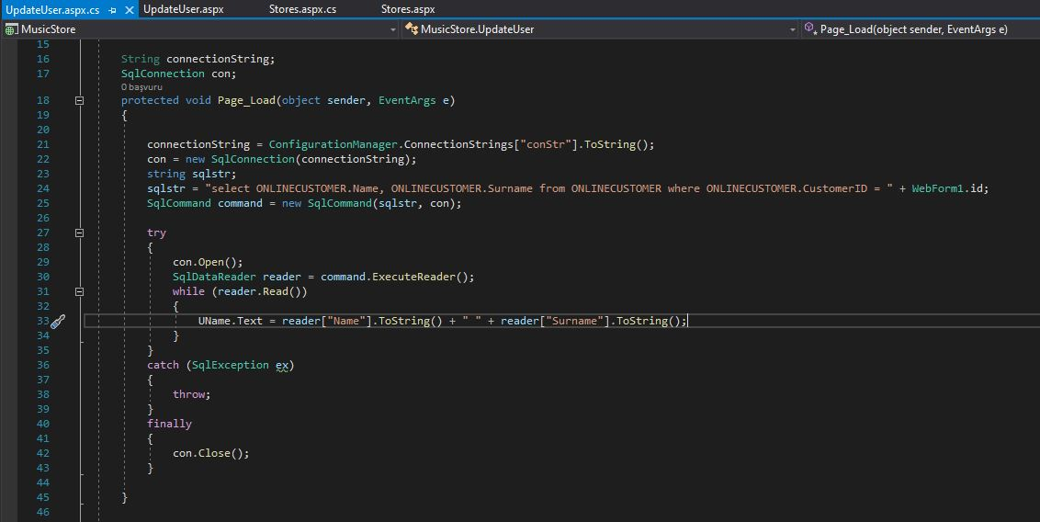

To initialize the change password page, our web application takes the name and surname of the customer from database. To do this we create connection between database and web application. Then we create our sql statement for searching customer with that id in id table.

After that we try to open the connection, then we create a sql reader object to be able to read info about customer from database. Finally, we print that info to the screen and close the connection.

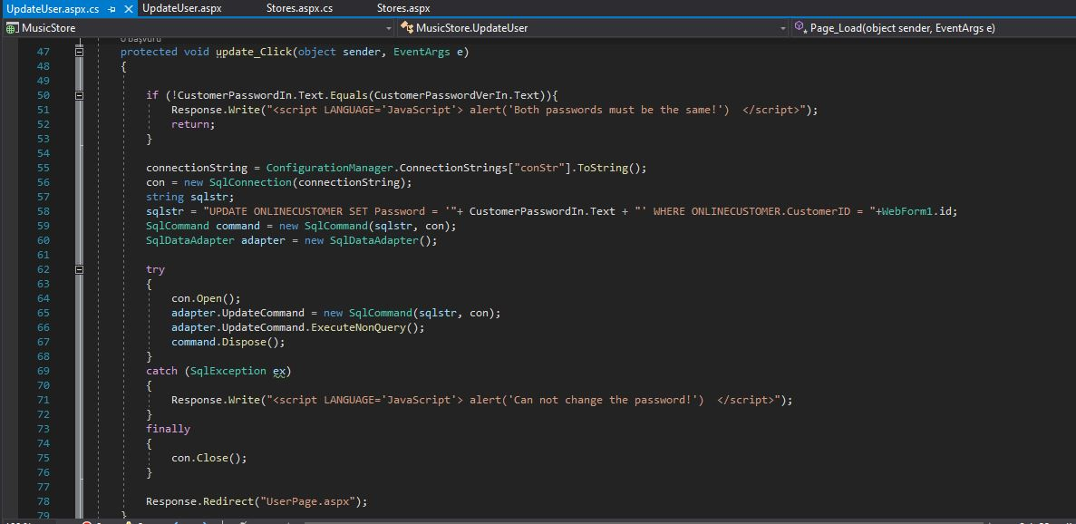

When user enters new password and press the button we firstly check if the passwords are equal. If they are then we create connection to database. The we create the SQL statement to do changes in database. We create new SqlAdapter object to run our statement in the database. In the try block we firstly open connection, then we run our code at database with help of adapter finally we close the connection. If any problem occur when we changing password we put a warning message to screen that says we cannot change the password.

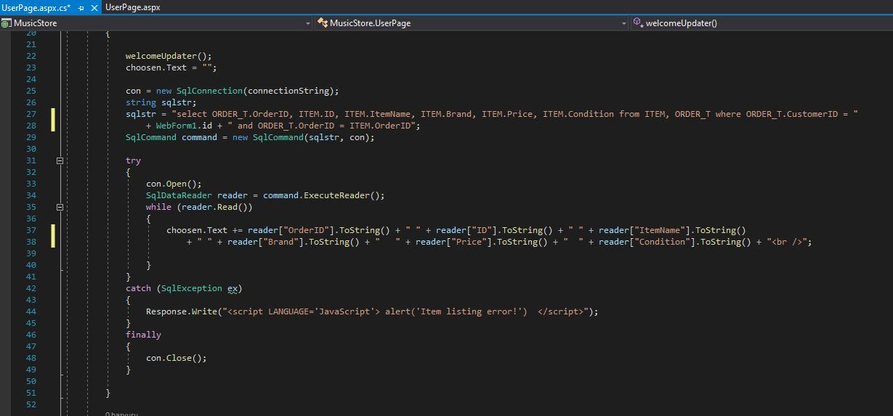

When the user entered the system successfully, he/she reaches his/her personal page which contains whole info about their previous orders. To show their orders we create connection between web application and database. To be able to see items that in an order which created by that user, we search for ids of the orders which created from specific customer when we find order id, we search in the ITEM table for items which belongs to that order. In the try block we open the connection after that with help of SqlDataReader we read info from database then we print that info about orders to the screen, finally we close the connection. If any error occurs at that time, we give an error message to user.

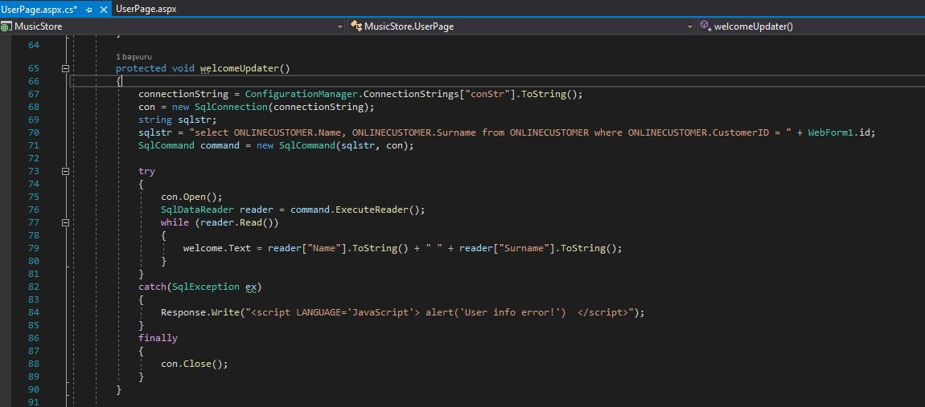

When the user entered the system successfully, he/she reaches his/her personal page. In upper side of this page name and surname of the user located. We get that info from the database.

To get this information we create a connection between our web application and the database. We create a SQL statement to run in the database which checks for name and the surname of the user with given id. In try block we open the connection, then with help of the SqlReader object we read info from database. Then we print that info to screen and close the connection in the end. If any error occurs in that process, we give error message to the user.

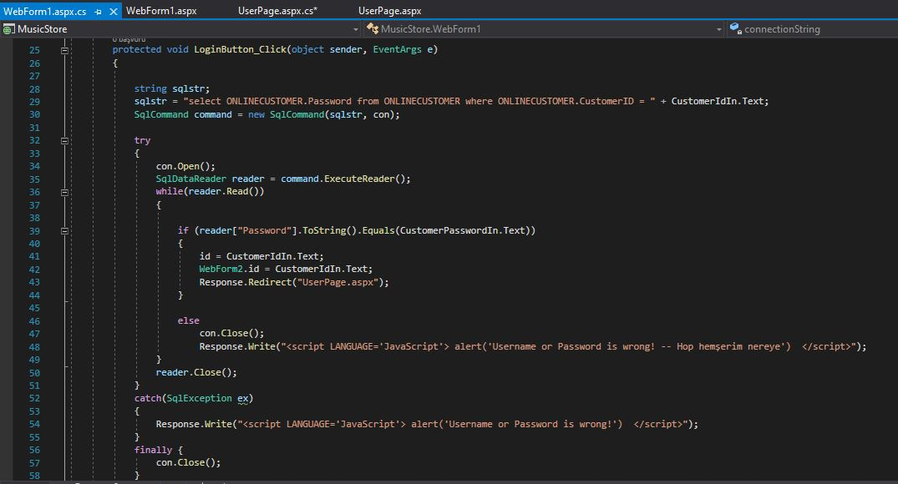

When user enters his user id and password and press the button to log in his/her page, we get his password from database. To be able to do this we create a connection between web application and database. We create SQL statement which searches for password of the given customer. In the try block we open the connection and with the help of the SqlReader object we read the password from database. If password and customer id matches, we redirect user to his/her personal page. Otherwise we give error message to the user. Finally, we close connection between database and b application.