**CSE 33 3 - OPERATING SYSTEMS Programming Assignment # 1**

Metehan ERTAN – 150117051

Furkan KUSE – 150117041

In this assignment we were expected to write some Shell scripts. One menu and some options that is going to be called from that menu Shell script. In this program we give user some options using Shell script. When user chosses an option main menu Shell script takes some inputs for that option and calls that option with given inputs. Main menu part:

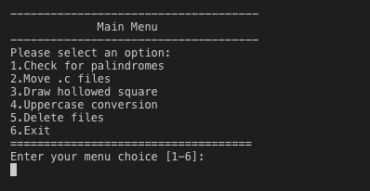

Checking for palindromes part takes a string input and calls its Shell script.

Move .c files part takes a path and calls its Shell script.

Drawing hollowed square part takes two input and calls its Shell script.

Uppercase Conversion part takes a wildcard and an optional pathname and calls its Shell script.

Delete files part takes an optional pathname and a -R option and calls its Shell script.

1. **Checking for palindromes**

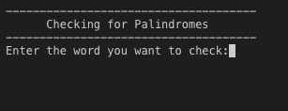

Here Shell uses the input given and reverses it character by character and store it in another variable. Then uppercases the input and reversed one then compares them. If those two are same then given input is a palindrome.

1. **Move .c files**

In the second question our shell script has two ways of work. In the first one we can run it without any parameters. When we run like that program creates a folder called “cprogs” and moves whole files that ends with .c to that folder. If there is no c file in that folder mv command gives an error by itself.

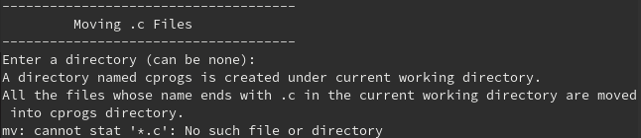

In our second way of running that program is with a parameter. When we run it like that program firstly checks if that directory exists. If directory exists than program creates folder called “cprogs” in that directory and moves whole files that ends with .c in that directory to that folder which created in that directory.

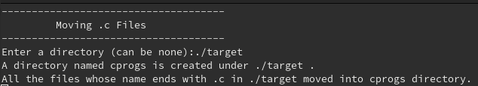

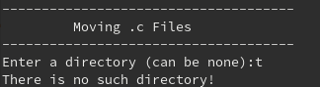

If we run that program more than one parameter program gives error and exits.

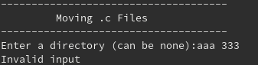

1. **Draw hollowed circle**

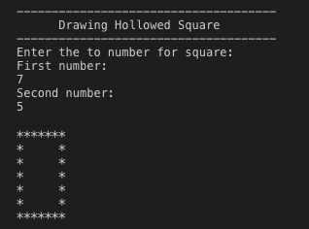

Here Shell script takes two inputs and check they are valid. To be valid number 1 needs to be greater than number 2 and the difference between two number must be a power of 2. Then prints a squre with * with size of the number but this square has another square within that square. Little square is build with spaces and its size is number 2.

Here is an error example:

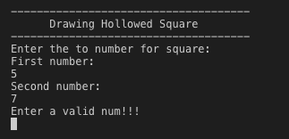

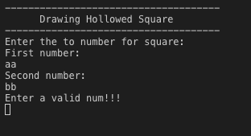

1. **Uppercase Conversion**

In the fourth question our shell script has 2 different way we can run. In the first one we can run it with just a wildcard word. When we run it like that our program search for each txt file in the current directory and search each words one-by-one if any word matches with our input, if it matches our program convert that word to upper-case and prints info about it.

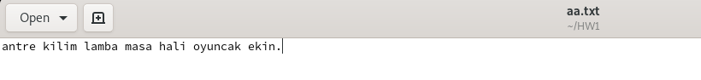

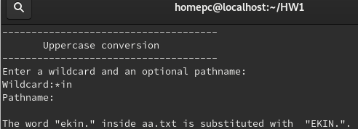



In the second way we can give a wildcard word and a directory. In this way of running our program does same thing that we did in the running with only one parameters To do this we check if there is two inputs and if there is we change directory to given one then do same job.

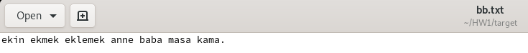

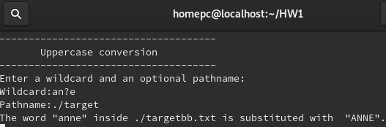



In the wild card we can also use “?”. If we run it with more than 2 parameters program gives an error and exits.

1. Delete File

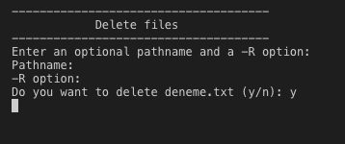

Here Shell script takes an optional pathname and an optional -R option. If pathname is given Shell continues in that directory. Program starts to find empty files in wanted directory and asks user if they want to delete it. If -R option is given program continues this procces with every sub-directory.

Error example:

