**ResampleAnArray**

In this project you are asked to implement mainly two functions:

* a method to create an array that contains all integers from –N to N for a user specified value of N
* a method that ()
  + resamples this array with a user specified rate (one sample out of each ‘rate’ samples are taken starting from the first sample).
  + **In other words,** if the ‘rate’ is specified to be k, new array (containing the resampled data) will only contain the elements of the original array at the following indexes: 0, k, 2k, 3k, 4k… etc.
  + **Or, to put it in different words**: your method will copy one sample in the new array and skip k-1 samples, copy the next sample in the new array and skip k-1 samples,… and perform this operation until the end of array is reached.

Here are some sample screen shots:

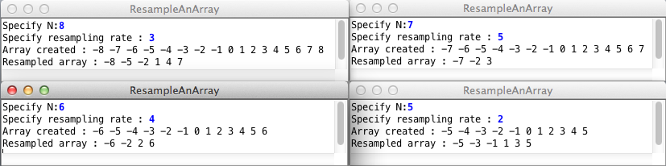

**Warning**: Check your result at least for the values in the four examples given. It is possible that your implementation contains a bug that shows up only for some combinations.