**Quiz 4-BouncingBallWithHoles**

You are given a Java project in which a bouncing ball is already implemented.

You are first asked to write a program such that there is a vertical wall placed in the middle of the window. Your program should ensure that every time the ball passes through the wall, the inside of the ball goes from empty to filled, or filled back to empty.

In addition, your code should add holes, in rectangular form, at the corners of the window (with the same size as the ball’s dimension, RADIUS). The holes should be painted Black. When the ball goes inside a hole, it should disappear and the “Game Over!” text message should be printed.

Your output should present views as below (arrows are put to indicate movement, they will not be printed on the window). An animation file is also included in your project folder. Double click that file to see the demo.

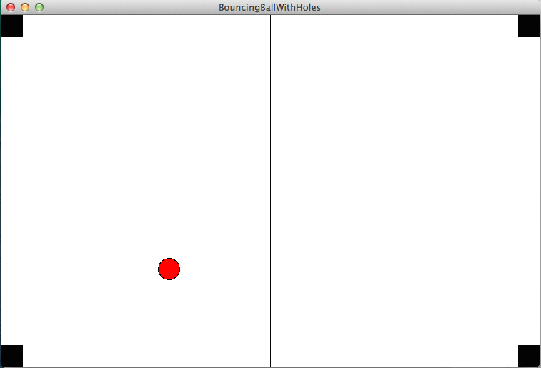 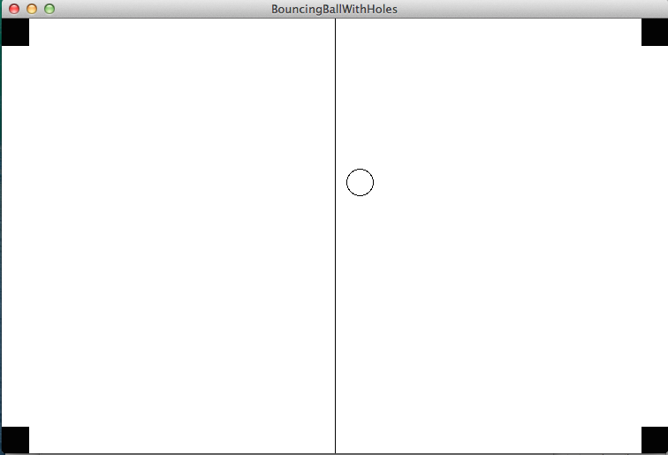

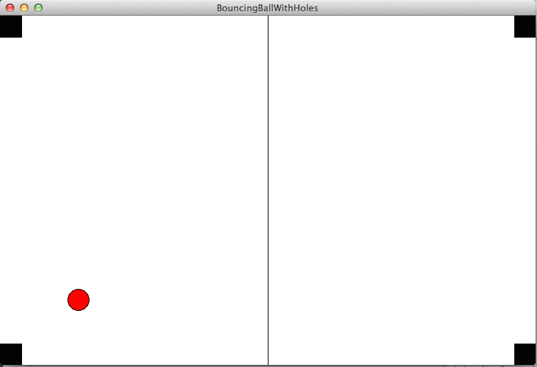 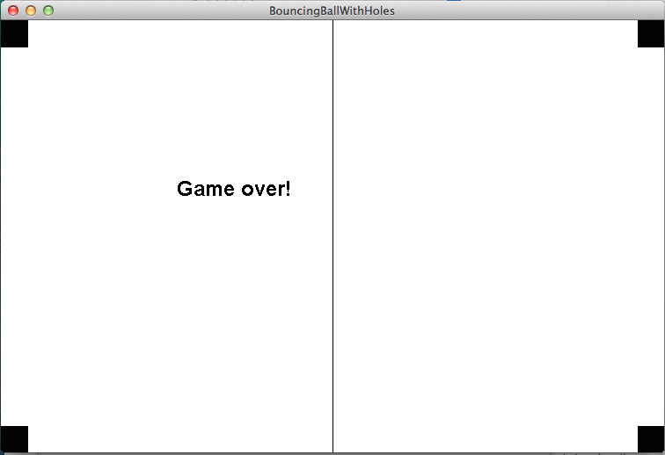

**Hints:**

1. You can access to current position of a rectangle, oval, etc.. by using the .getX() and .getY() methods.
2. Start by putting only one hole and implementing the ‘Game over’ functionality. This will bring you most of the credits. Then you can continue adding other holes and editing ‘Game over’ functionality to function when the ball falls into other holes.