**BabylonianAlgorithm**

Your task is to write a program that will find the root of a user specified value by using the Babylonian Algorithm.

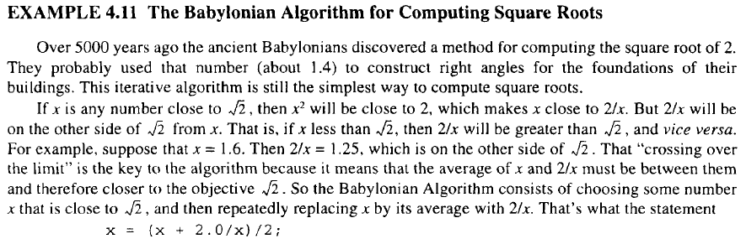

The above definition indicates the solution for finding the square root of 2. However, the approach can be generalized to find the square-root of any positive real value, ***c***, using the following iterative solution:

$$x=(x+\frac{c}{x})/2$$

**Here is a sample output for your program:**

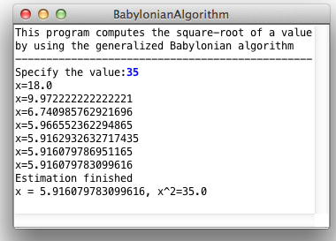

Resource:

<http://www.mhprofessional.com/product.php?isbn=0071420401>

**Schaum's Outline of Programming with Java, by John Hubbard, McGraw Hill**