

**Introduction to Programming**

**with Java**

**Class:** **YarnPattern.java**

**Score:** (Medium)

**Description:**

Implement a program that creates a yarn pattern. You should place start points (pegs) of the yarn at regular intervals around a rectangular border. Tie each peg with 2 other opposite pegs a certain distance ***DELTA*** ahead (Distance between opposite pegs is ***DELTA***).

An Opposite Peg

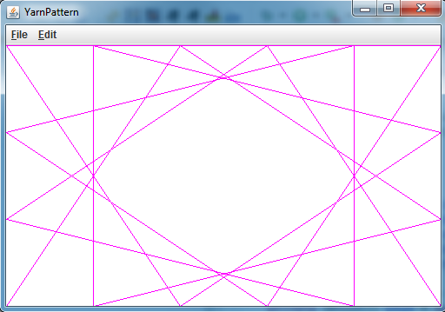

An Opposite Peg

A peg