**CarryAllToTheCorner**

Karel should pick all the beepers and move them to the end of the corner.

**Initial condition:**

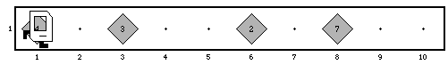

**Final condition:**

