**StudentGradeTable**

Your task is to write a program that will read the table of student grades given in a file named ‘notes’ and print the list of top most 3 grades for each student.

Some of the students did not take some of the exams; hence the number of grades is different for each of them.

Below, the text file containing the data and the example output is shown.

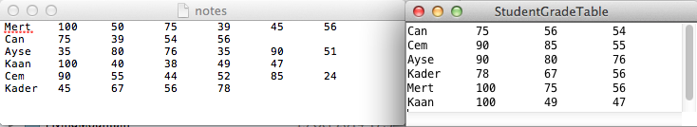

This project aims combining the use of following components:

StringTokenizer (to split a line read from the file)

ArrayList: To store each line and another to store varying number of grades for a student.

Iteration: Iterating over a set or list of values.

HashMap: To store student name mapped to an ArrayList of grades.