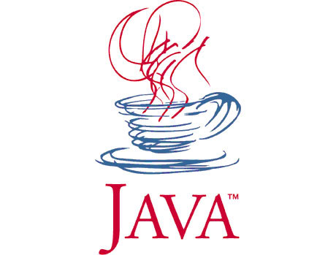
COMP 130 - Introduction to Programming
with Java

Class: SpellCheck.java
Write a program that does spell checking of English text entered by the user. The program should first read a file called “words” which contains valid English words one per line. The words should be read into a HashMap<String,Boolean> called “dictionary” where keys are the words and values are always true. This is done by the readDictionary() method. After reading the dictionary, the call dictionary.get(word) will return true if the word exists in the dictionary and null otherwise. Next, the program should ask the user to enter some text and call the spellCheck() method on this text. The spellCheck() method should split this text into words using the StringTokenizer class, check each one in the dictionary, and alert the user if any of the words have been misspelled. The user ends the program by entering a blank line.

Sample Run:

