2)

First I read univariate regression data set. Since dataset has header, we will skip it.



3)

I Divided the data set into two parts by assigning the first 150 data points to the training set and the remaining 122 data points to the test set.

4)

I set the bin width parameter to 0.37 and the origin parameter to 1.5. Since maximum value is not given. I put 5.25 by trying values which fits best for graphs.

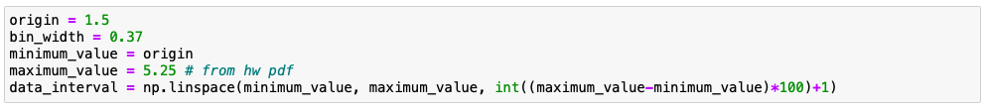

If we define an origin and a bin width and average the r values in the bin as in the histogram, we get a regressogram. So, to learn regressogram, I used following formulas which is given in the Section 8.8 of the textbook.

the output is:

5)

Calculate the root mean squared error (RMSE) of your regressogram for test data points. The formula for RMSE is:

$\sqrt{\sum_{i=1}^{N_{test}}{\frac{{\left(y_{i}-\hat{y_{i}}\right)}^{2}}{N_{test}}}}$

For regressogram we need to check borders to check whether test data is within bin_width. Otherwise numerator of condition is 0. Then we calculate rmse with given formula.

Output is:

6)

Having discontinuities at bin boundaries is disturbing as is the need to fix an origin. As in the naive estimator, in the running mean smoother, we define a bin symmetric around x and average in there (from book).

Using formula from the book is shows us how to Learn a running mean smoother.

implementation of given formula is follows. As in the formula we should check |u|<1/2.

the output is:

7)

rmse is calculated with given formula and I specified implementation in part 5 of this report.

$\sqrt{\sum_{i=1}^{N_{test}}{\frac{{\left(y_{i}-\hat{y_{i}}\right)}^{2}}{N_{test}}}}$

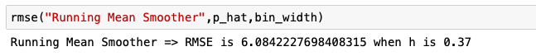

8)

As In the kernel estimator, we can use a kernel giving less weight to further points, and we get the kernel smoother. I implemented given formula from the book.

the output is:

9)

RMSE value of Kernel Smoother, is similar to the Running Mean Smoother. And implemented with given formula from the book.

