|  |  |  |
| --- | --- | --- |
| Course Code:**worksheet1** | | |
| Characteristics | interpreted languages | Compiled languages |
| 1. **produce** | result from a program, | program written in assembly language. assembler of architecture then turns the resulting program into binary code. Assembly language varies with different computers. So compiled programs can only run on computers that have the same architecture as the computer on which they were compiled. |
| 1. **Human readable** | Used by computer directly | Needs to changeto thearchitecture-specific machine language. |
| 1. **speed** | Slower. Because every time it needs to read whole code again | Faster, because computer changes program into machine code and saves it to the memory |
| 1. **debug and revise(flexibity)** | Easy. In every computer it works same. | Hard. It changes with respect to computer. (sometimes it doesn’t work on other kind of computers) |
| 1. **check** | No compile stages. Check at run time | Check at compile time |
|  |  |  |
|  |  |  |
|  |  |  |
|  |  |  |

|  |  |  |  |
| --- | --- | --- | --- |
| Course Code: | | | |
| Characteristics | Numeric(float-int ) | String | Boolean |
| 1. **limits** | **No limit** | **No limit** | **True or false** |
|  | **Have floating,integer,complex numbers** |  |  |
| 1. **Empty value** | **?** | **Can be empty** | **True or false**  **no empty** |
|  |  |  |  |
|  |  |  |  |
|  |  |  |  |
|  |  |  |  |
|  |  |  |  |
| **If statically typed cannot change type(variables have**  **types) ,otherwise data types can change its type**  **(values have types)** | | | |

|  |  |  |  |
| --- | --- | --- | --- |
| Course Code: | | |  |
|  | **int** | **Float** | **fraction** |
| **Similarities** | 5,7,10….. 10.5, 12.5, …. 1/5. 2/6….. | | |
| **Differences** | 1.without decimal parts  2.  3.  4.  5.  6.  7.  8.  9. | 1.with decimal parts  2.  3.  4.  5.  6.  7.  8.  9. | Has to imported.  125/50—>  numerator=5  denominator=2 |

|  |  |  |  |
| --- | --- | --- | --- |
| Course Code: | | |  |
|  | **definite** | **indefinite** | **indinite** |
| **Similarities** | 1.  2.  3.  4. | | |
| **Differences** | 1.with for loop  2.have end  3.iteration  4.  5.  6.  7.  8.  9. | 1.with while loop  2.have end  3.conditions  4.  5.  6.  7.  8.  9. | With for and while loop  Has not end |

|  |  |  |
| --- | --- | --- |
| Course Code: | | |
|  | **set** | **Frozen set** |
| **Similarities** | Has unordered datas. Can have intersection, itearion, union opearions. | |
| **Differences** | 1.mutable  2.  3.  4.  5.  6.  7.  8.  9. | 1.immutable  2.can be used for sets and dictionaries.  3.frozenset(object) gives datas of set and key set of the dictionary  4.  5.  6.  7.  8.  9. |

|  |  |  |
| --- | --- | --- |
| Course Code: | | |
| Characteristics | Compund | Collections |
| 1. **ordered** | **ordered** | **Not ordered** |
| 1. **indexable** | **yes** | **no** |
| 1. **contains different data types** | **yes** | **Yes?** |
| 1. **mutable** | **Tuples immutable** | **Mutable. Dictinaries can not change keys but can change values.** |
|  |  |  |
|  |  |  |
|  |  |  |
|  |  |  |
|  |  |  |

|  |  |  |  |
| --- | --- | --- | --- |
| Course Code: | | | |
|  | **/** | **//** | **%** |
| **Similarities** | First 2 are division methods. // divide the two number and adjust it to the left.  Dividing by zero is error for all three. | | |
| **Differences** | 1.dividing  2.  3.  4.  5.  6.  7.  8.  9. | 1.dividing  2.  3.  4.  5.  6.  7.  8.  9. | 1.extra part after dividing number  2.  3. |

|  |  |  |  |  |  |
| --- | --- | --- | --- | --- | --- |
| Course Code: | | | | | |
|  | **Lists** | **Tuples** | **Sets** | **String** | **Dictionaries** |
| Similarities: | Data types. Data can store inside of these types. | | | | |
| Differences: | Mutable. Ordered. Have index  Can have dublicate values | Faster than lists. Immutable. Ordered. Have index | Mutable. Unordered. Not dublicate values | Ordered. Immutable | Keys can not be changeable but values can change. Unordered. Have keys and values. Can have same values in different keys. Not dublicate keys.has hashing technique. Fast |

|  |  |  |  |
| --- | --- | --- | --- |
| Course Code: | | |  |
| Characteristics | Del() | Pop() | Remove() |
| 1. **deletes** | **yes** | **yes** | **yes** |
| 1. **first matches** |  |  | **yes** |
| 1. **with index** | **yes** | **yes** | **no** |
| 1. **specify element** | **no** | **no** | **yes** |
| 1. **return** | **no** | **yes** | **no** |
| 1. **error** | **indexError** | **IndexError** | **valueError** |
| 1. **can delete deletes more than 1 element with range** | **yes** | **no** | **no** |
|  |  |  |  |
|  |  |  |  |

|  |  |  |
| --- | --- | --- |
| Course Code: | | |
| Characteristics | Structured Data | Unstructured Data |
| 1. **Tabular** | **yes** | **no** |
| 1. **Form (Appearance)** | **Depend on creating data model** | **tends to be free-form** |
| 1. **organizing** | **Well organized** | **dispersed** |
| 1. **Availability** | **Can used by computer or person directly** | **requires deliberate** |
| 1. **files** | **Cvs, excel** | **Photos,pdf,ppt,emails,blogs, streaming instrument data..** |
| 1. **Association** | **organized** | **scattered** |
| 1. **appereance** | **Formally defined** | **Hard to access and query** |
| 1. **avaibility** | **Percentagewise lower** | **Percentagewise higher** |
| 1. **analysis** | **Efficient to analyse** | **Additional processing is needed** |

|  |  |
| --- | --- |
| Characteristics | Decision Tree |
| 1. **nonparametric** | This means that decision trees have no assumptions about the space distribution and the classifier structure. |
| 1. **supervised?** | **Supervised** |
| **interpretable** | can explain a decision tree as a set of questions/business rules.  **(easily understand)** |
| 1. **Speed** | **Fast-**set of comparison operations until you reach a leaf node |
| 1. **Optimization** | * Can be adapted to deal with **missing data** without imputing data, Less data cleaning required(this module does not support missing values ?) |
| 1. **Multi-output** | **Data type is not a constraint**  **(nonnumeric is hard to handle)**  **categorical-numerical data** |
| 1. **Terms** | 1. **Root Node:** It represents entire population or sample and this further gets divided into two or more homogeneous sets. 2. **Splitting:** It is a process of dividing a node into two or more sub-nodes. 3. **Decision Node:** When a sub-node splits into further sub-nodes, then it is called decision node. 4. **Leaf/ Terminal Node:** Nodes do not split is called Leaf or Terminal node. 5. **Pruning:** When we remove sub-nodes of a decision node, this process is called pruning. You can say opposite process of splitting. 6. **Branch / Sub-Tree:** A sub section of entire tree is called branch or sub-tree. 7. **Parent and Child Node:** A node, which is divided into sub-nodes is called parent node of sub-nodes whereas sub-nodes are the child of parent node. 8. **İmpurity of nodes:** being heteronomous 9. **Entropy**: amount of information disorder. if equally divided entropy is 1.. if completely homogenious entropy is 0 10. **Gini index**: name of cost func used to evaluate splits in the dataset.(0 gini=homogenious,0.5 gini=heterogenious) |
| 1. **overfitting** | * Decision-tree learners can create over-complex trees that do not generalise the data well. |
| 1. biased trees | * Decision tree learners create biased trees if some classes dominate. balance the dataset prior to fitting with the decision tree |
| 1. CART | * Uses Gini coefficient to decide partition feature. greedy approach to divide by recursive binary splitting… when it is done there will be cost function |

|  |  |  |
| --- | --- | --- |
| Course Code: | | |
|  | **Concept A** | **Concept B** |
| **Similarities** | 1.  2.  3.  4.  5.  6.  7.  8.  9. | 1.  2.  3.  4.  5.  6.  7.  8.  9. |
| **Differences** | 1.  2.  3.  4.  5.  6.  7.  8.  9. | 1.  2.  3.  4.  5.  6.  7.  8.  9. |

|  |  |  |
| --- | --- | --- |
| Course Code: | | |
| Characteristics | Concept A | Concept B |
|  |  |  |
|  |  |  |
|  |  |  |
|  |  |  |
|  |  |  |
|  |  |  |
|  |  |  |
|  |  |  |
|  |  |  |

metin, ekran görüntüsü içeren bir resim

Açıklama otomatik olarak oluşturuldu

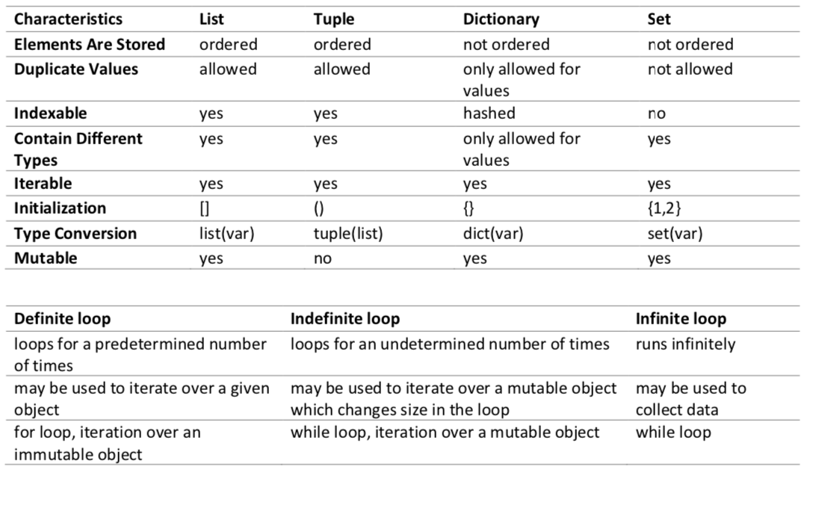ekran görüntüsü içeren bir resim

Açıklama otomatik olarak oluşturuldu