EE 463

STATIC POWER CONVERSION I

TERM PROJECT – FINAL REPORT

DC MOTOR DRIVE



**MIDDLE EAST TECHNICAL UNIVERSITY**

**DEPARTMENT OF ELECTRICAL AND ELECTRONICS ENGINEERING**

Metehan Küçükler 2305068

## INTRODUCTION

In this project, the aim is running and controlling a DC Machine with AC supplied circuitry. While designing the circuitry, it gives an opportunity of gathering experience about use of various power electronics component, datasheet reading and understanding, and basic PCB layout design. In this report, comparison of possible topologies, improvements after simulation report, component selections, PCB layout, thermal analysis and reasons behind the failure of the demo are discussed.

### Comparison of Different Topologies

Possible topologies that can fulfill the project requirement can be these: Half-Full Controlled Bridge Rectifier with Thyristors and Buck Converter, Full Bridge Rectifier and Buck Converter with Diodes, and Dimmer Circuit with high RC filter.

Thyristor Rectifiers are good for high voltage and current applications. They have slightly less losses when compared with diodes. Also, they can make possible phase controlling of the circuitry. However, for each thyristor a control signal is needed which makes the circuit complicated.

Dimmer Circuit are easier than the thyristors for controlling the output voltage level with AC supply and TRIAC. Also, usage of TRIACS can make the four-quadrant operation possible. However, it is mostly utilized in AC applications. Filtering it requires high RC filter which requires more expensive and bigger components.

Diode Rectifiers are easy to construct among these topologies. This topology lacks the controlling part. With the help of the buck converter output voltage can be controlled.

Thus, I have chosen the Full Bridge Diode Rectifier and Buck Converter topology since it does not need complicated control and cheaper than the other topologies. Additionally, a PI controller is utilized in order to have closed-loop feedback for controlling output current. Basically, mentioned buck converter is a Type-A chopper circuitry for DC Machine. Presence of a large inductor in DC Machine makes the filtering section of the Buck converter easier.

### Theoretical Calculations

As a requirement and limit, VOUT must be maximum 180V. Buck converter has input – output voltage relation as , where D is the duty cycle between 0 and 1.

Thus, to get 180V output with highest duty cycle needed input for Buck converter is 180/0.95 = 189V. Additionally, full bridge rectifier gives the output voltage as 1.35 times input line-to-line voltage, rms which results in 189/1.35 = 140V. So, the rated input voltage of this topology is decided as 140V line-to-line rms voltage which gives some spaces for losses.

Since DC Machine has a large inductance, it can keep its current almost constant with low ripple.

Equation above gives minimum inductor current to stay in the CCM as 0.072A when the switching frequency is selected as 25kHz.

Current ripple on a specific inductor can be calculated with equation above. It gives the maximum ripple current value when the duty cycle is 0.5. For armature inductor, current ripple is calculated as 0.15A when switching frequency is 25kHz.

Above equation gives the ratio of output current to its ripple value. For 1% ripple, minimum capacitance of the capacitor is computed as 16.5 µF.

To get the bonus of water heater, the circuitry must have a rated power as 2kW with maximum of 180V output which results with around 11.1A armature current to give some space to losses. Also, if it is assumed that the whole circuit is operating with 75% efficiency, it needs to drain 11A from each phase of the three-phase supply.

### Simulation Results

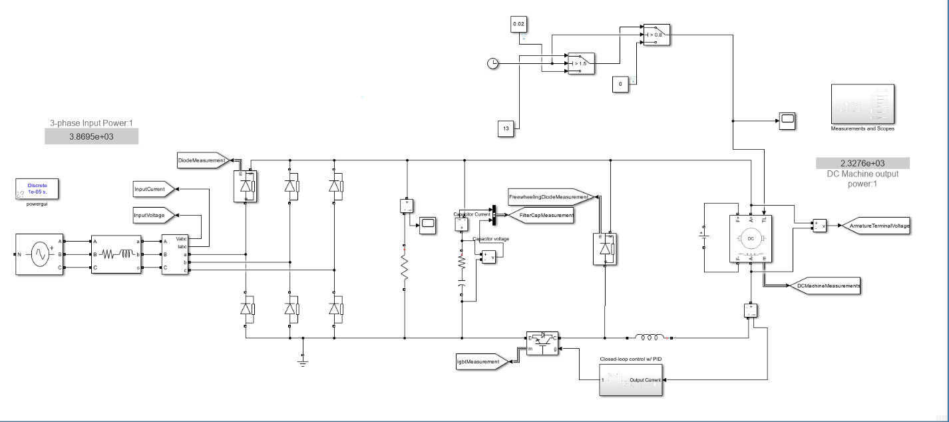

Figure 1: Circuit schematic.

In the circuitry, full-bridge rectifier for three-phase input is used. Resulted output voltage is smoothed with two parallel 470µF electrolytic capacitor to get more regulated DC voltage. Also, a 10µF film capacitor is used to reduce the effect of high ESR of electrolytic capacitors. Additionally, a 6.8kΩ, 11W wire-wound resistor is connected parallel in order to discharge capacitors when circuit turned off.

After rectifier and filter part, Type-A chopper circuit is utilized with an IGBT and freewheeling diode. Gate signal of the IGBT is controlled with a microcontroller which takes an analog input from a current sensor and gives PWM output with respect to errors of PI controller in order to have a closed-loop feedback control on output current. The PWM output of the microcontroller is given to a opto-coupler to isolate and increase the current and voltage because the output of the microcontroller is not enough for opening the gate of the IGBT.

I have simulated the circuit for 2kW rating and no-load operation by changing reference current of the PI controller and with step-by-step increase in input voltage. At the figures below the response of the circuit and each component to those dynamic changes can be seen.

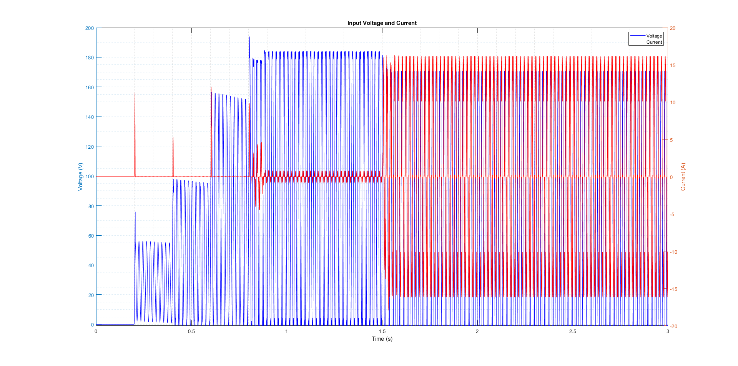

Figure 2: Input voltage and current result.

The PI controller has reference current of 3A and 15A for no-load and 2kW operation simulation, respectively. In the figure above, input currents drained from the source can be seen. Also, the effect of the step-by-step increase in supply voltage can be seen.

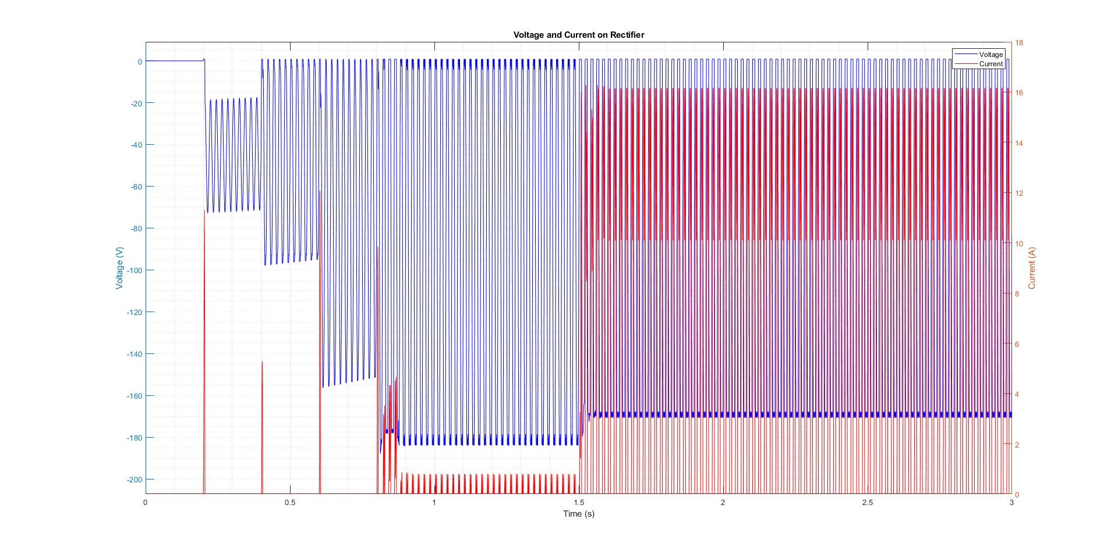

Figure 3: Voltage and current on rectifier diodes.

In the Figure 3, the current and voltage spikes due to capacitor charging can be seen slightly. Thus, rectifier is selected as 40A, 1200V. The market availability also considered.

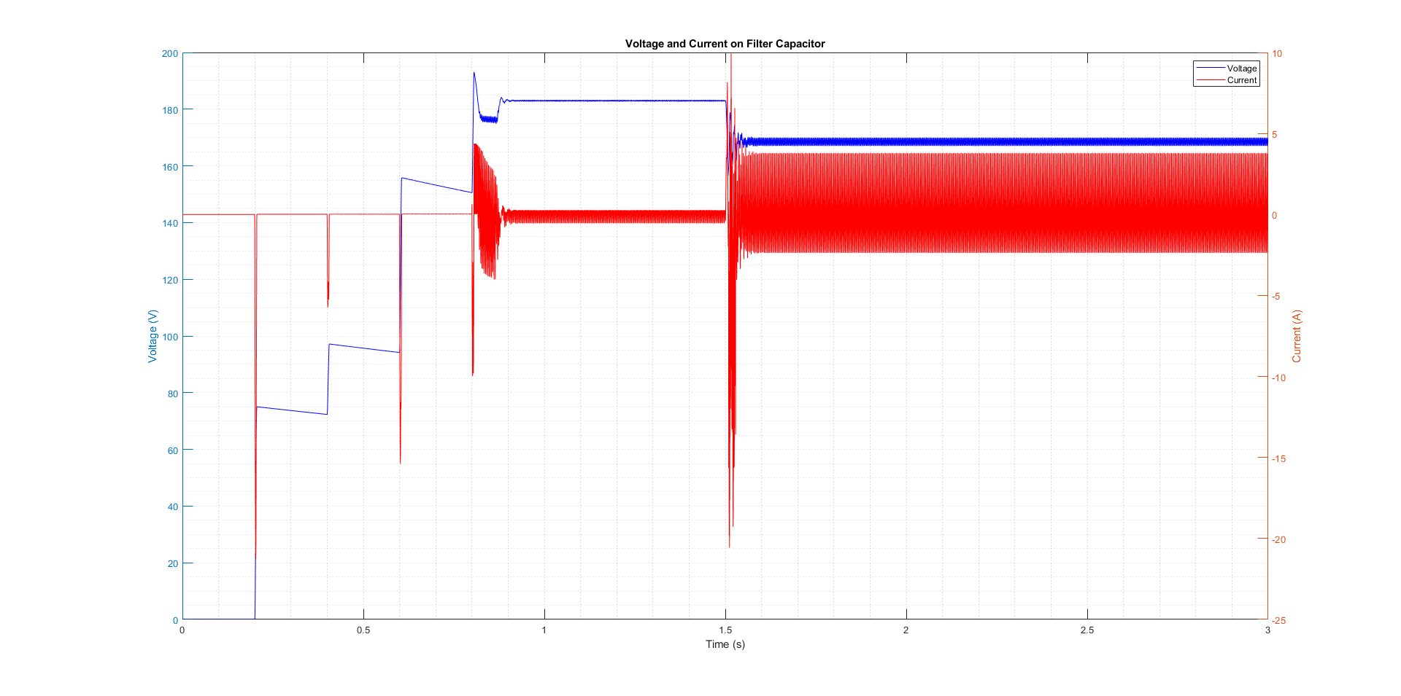

Figure 4: Voltage and current on filter capacitors.

Due to charging and discharging, there are current spikes on capacitors. Also, ESR of the capacitors affects this value of the spikes.

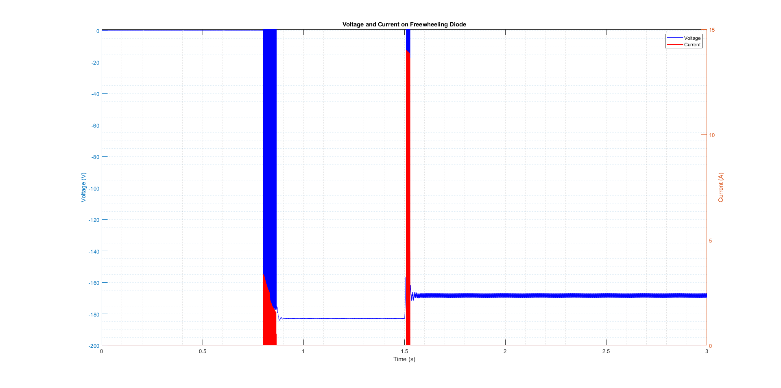

Figure 5: Voltage and current on freewheeling diode.

After the machine reaches the steady state, there are no current passing through diode. Also, its ratings are selected as 30A, 600V.

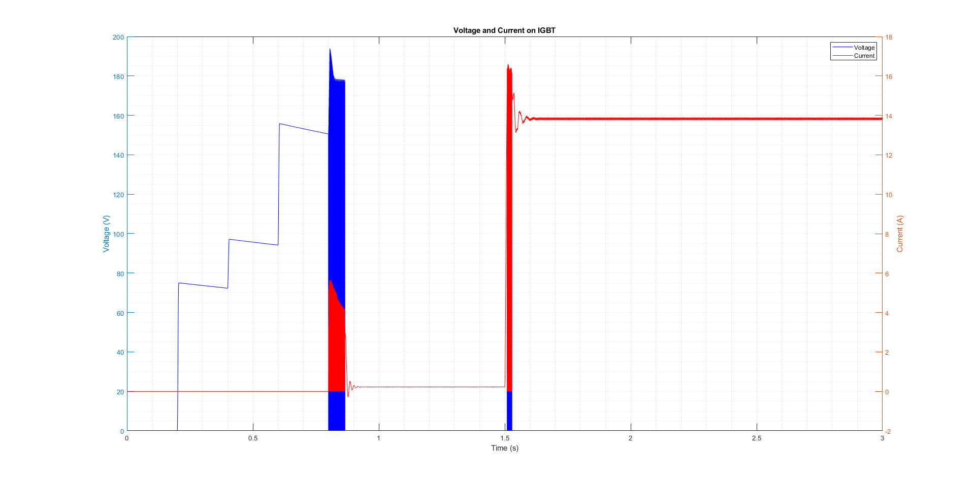

Figure 6: Voltage and current on IGBT.

There are current spikes on the IGBT when the current reference of machine are increased to 3A and 15A. Since back-emf of the machine are initially low when it is starting, there is an inrush current which is higher than the steady state current. In the Simulink simulations the voltage spikes on the IGBT is observed lower; however, there are ringing on the gate of the IGBT due to parasitic effects. This problem can be solved with snubber circuitries but in this application, there are no need to use a snubber. The rated values of the IGBT are selected as 30A and 600V.

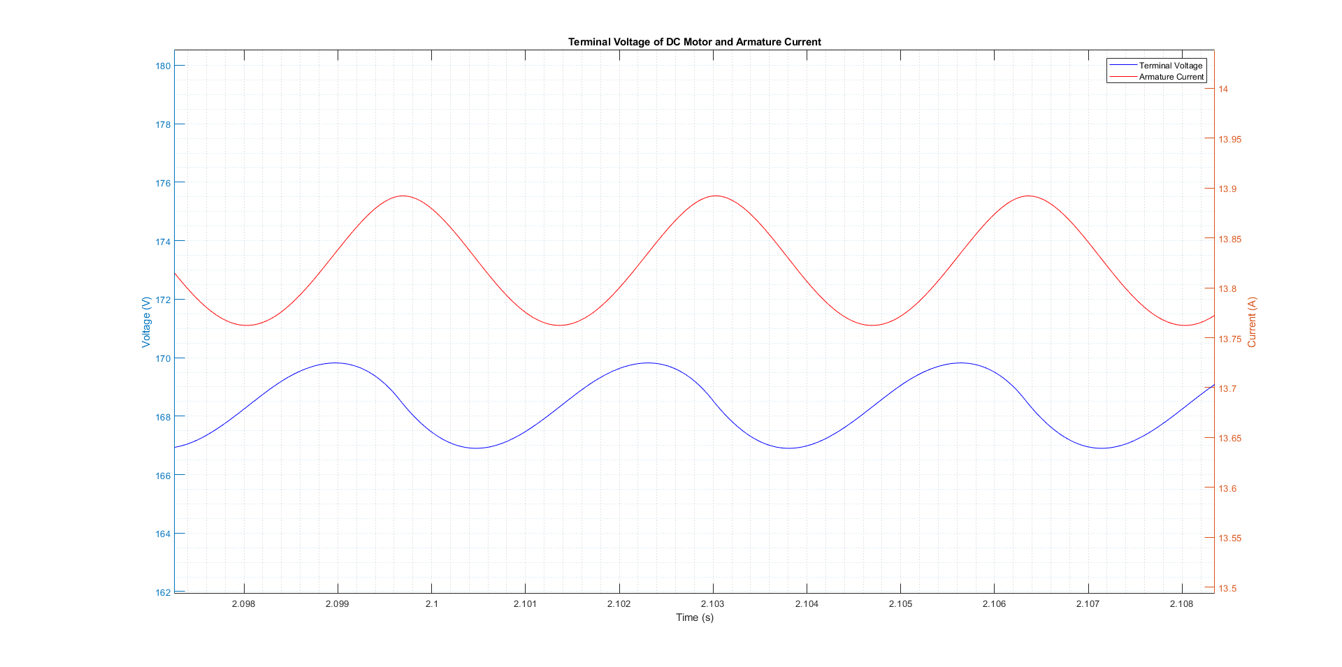

Figure 7: Terminal voltage and armature current of the machine at steady state with 2kW power operation.

In the Figure 7, it can be seen that after machine reaches its steady state parameters, it has low voltage and current ripple.

### Schematic and PCB Layout

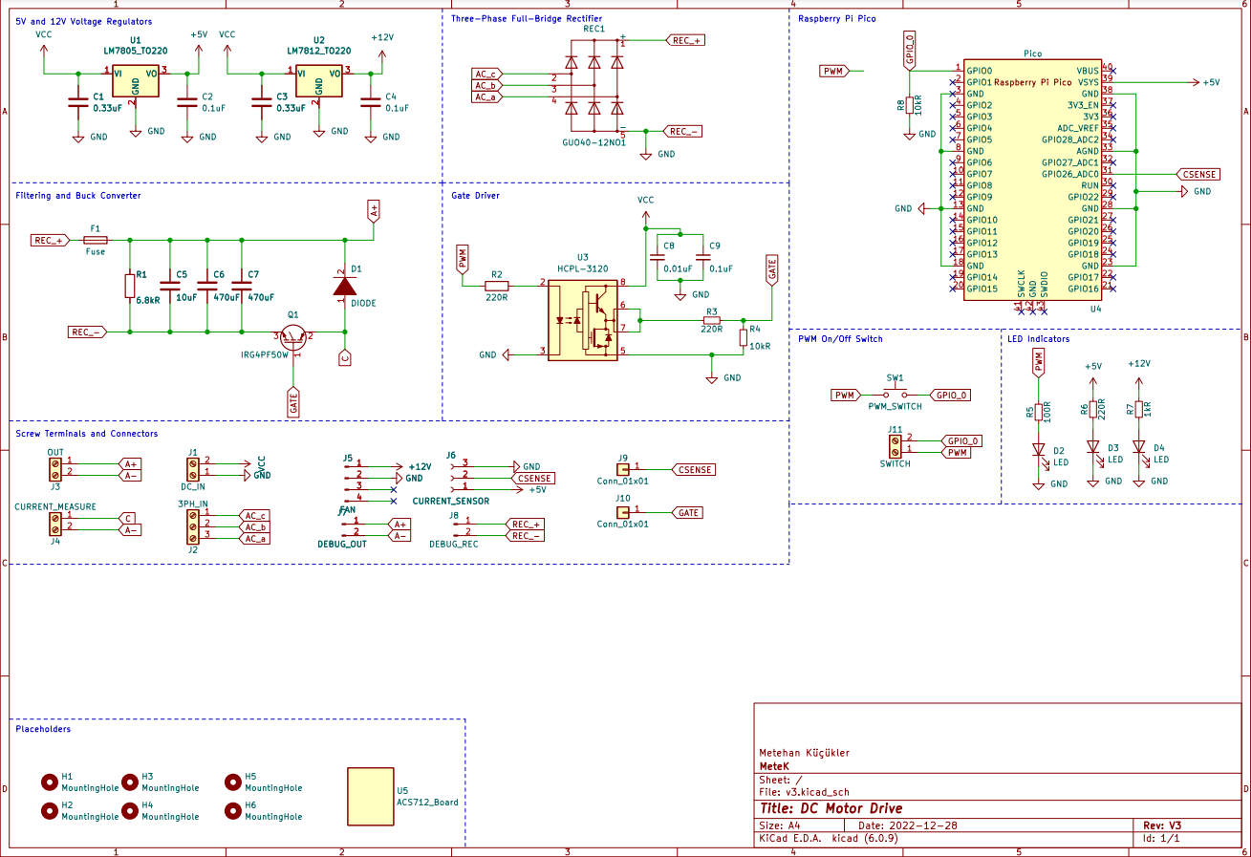

Figure 8: Circuit schematic drawn in KiCad.

Circuit schematic is drawn in KiCad. Different parts of the schematic is connected with net labels and divided into different sections for better readability.

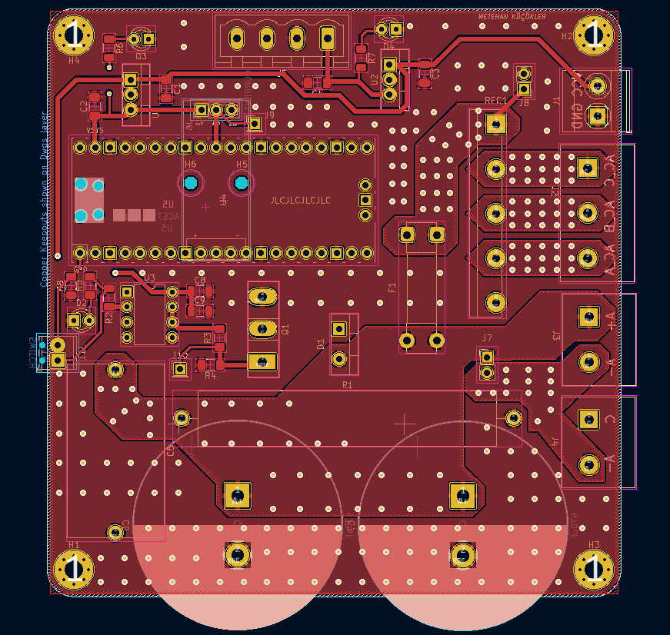

Figure 9: Front layer of PCB layout.

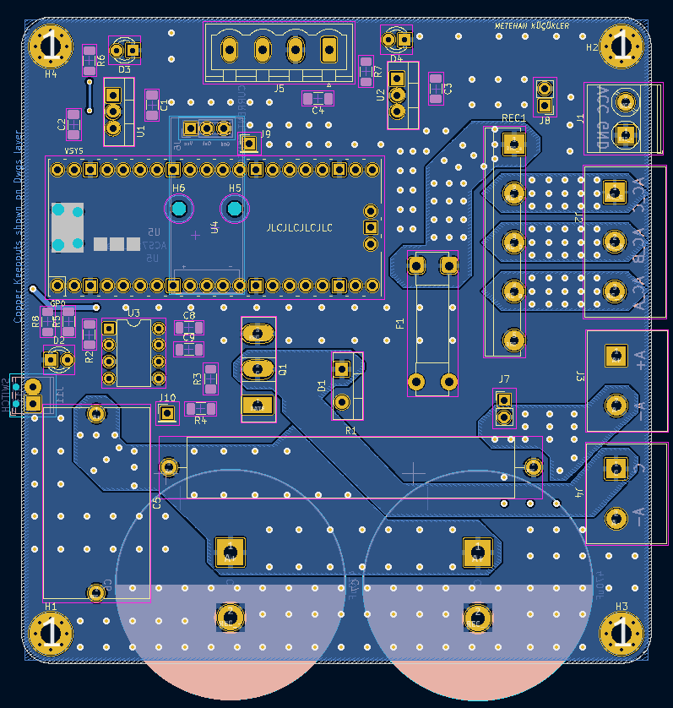

Figure 10: Back layer of PCB layout.

In the PCB layout, high current carrying paths are created with thicker copper pores. Signal carrying paths are created with thinner tracks. Both layers are filled with ground plane. High current carrying paths are mirrored to the other layer and connected with transfer vias. Also, the signal and power parts separated. Panel mounted connector are connected to PCB with screw terminals which are mounted onto PCB. 1.5mm2 cables are used in those connections.

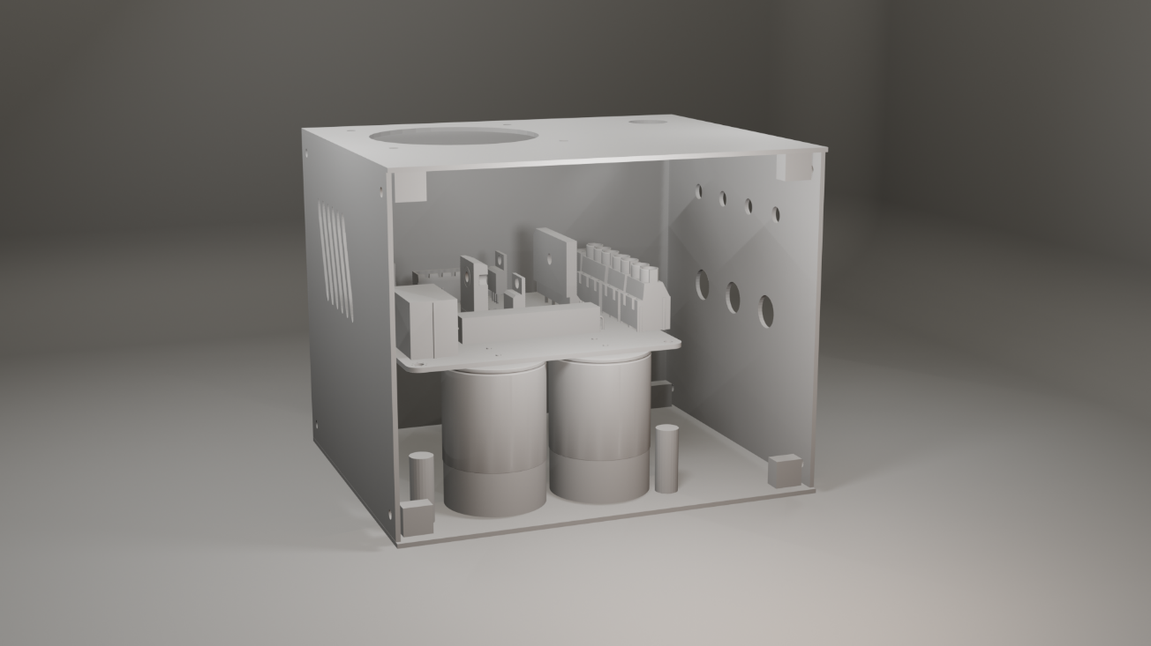

Figure 11: Enclosed case design.

### Component List

* Raspberry Pi Pico – microcontroller
* ACS712 – 30A current sensor
* IXGH24N60C4D1 30A, 600V – IGBT
* GUO40 40A, 1200V - 3-phase, full bridge rectifier
* DHG30I600PA 30A, 600V - Fast diode
* 2 x 470µF Aluminum Electrolytic Capacitor
* 1 x 10µF Film Capacitor
* 2 x 0.33µF SMD 1206 Package Ceramic Capacitor
* 3 x 0.1µF SMD 1206 Package Ceramic Capacitor
* 1 x 0.01µF SMD 1206 Package Ceramic Capacitor
* 6.8kΩ Wire Wound Resistor
* 1 x 100Ω SMD 1206 Package Resistor
* 3 x 220Ω SMD 1206 Package Resistor
* 1x 1kΩ SMD 1206 Package Resistor
* 2 x 10kΩ SMD 1206 Package Resistor
* HCPL-3120 Optocoupler
* LM7805 – 5V linear regulator
* LM7812 – 12V linear regulator
* 1 x 7.54mm pitch 01x03 screw terminal
* 3 x 7.54mm pitch 01x02 screw terminal
* 1 x 2.54mm pitch 01x02 screw terminal
* 2 x button switch
* 3 x green LED
* 5 x 20mm 25A Fuse

### Comments & Conclusion

To sum up, this project required many simulations to decide the rated values of components used. In the simulations, since the non-idealities in the real environment cannot be determined, the results may be not accurate. To properly test and determine the components, these tests must be done in laboratories.

In the laboratory, I was not able to make the circuit work. Thus, I can not get any test results with R and RL loads. Even with giving a PWM signal from another source to IGBT gate. Although, I tested all the components and PCB connections separately, I cannot find and solve the problem. Most probably, there is a problem in the gate connection of the IGBT or opto-coupler.