* Admin can sign in with default email and password

(email: admin@gmail.com, password: 12345)

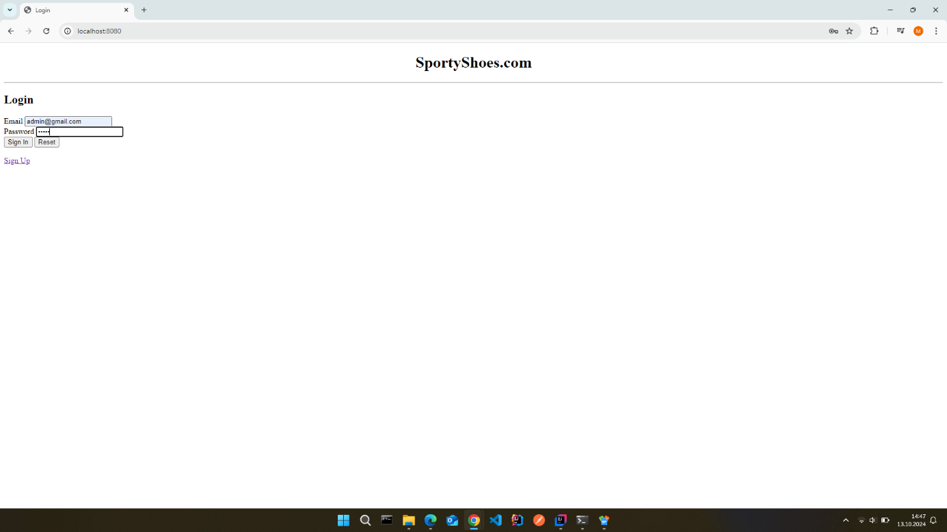

* Admin can manage categories, products and orders.

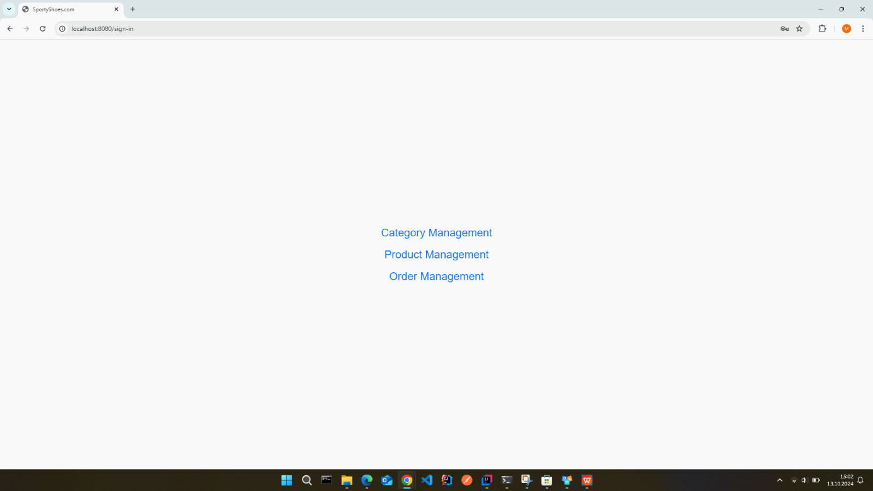

* Admin can add new categories as well as updating or deleting existing ones.

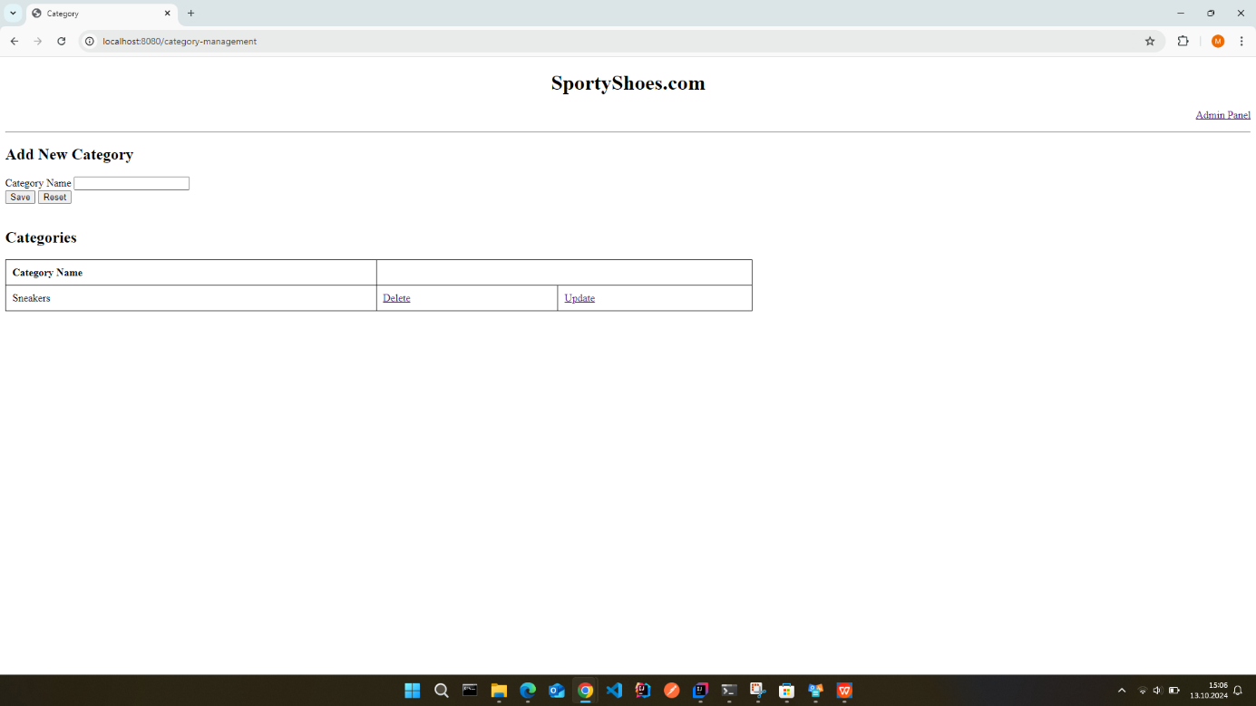

* Admin can add new products and update or delete existing ones.

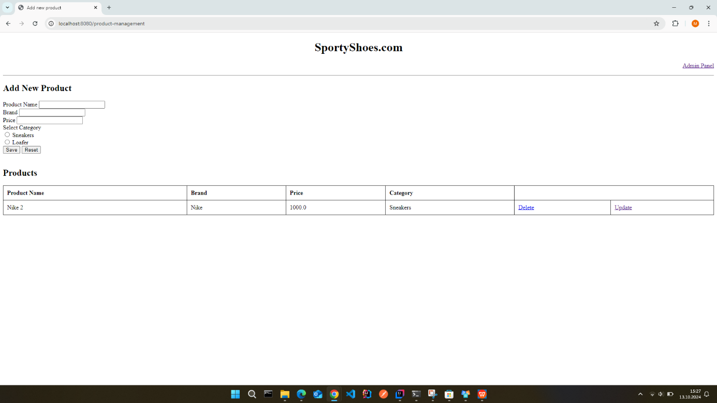

* Admin can view orders, filter them by category and approve or cancel them.

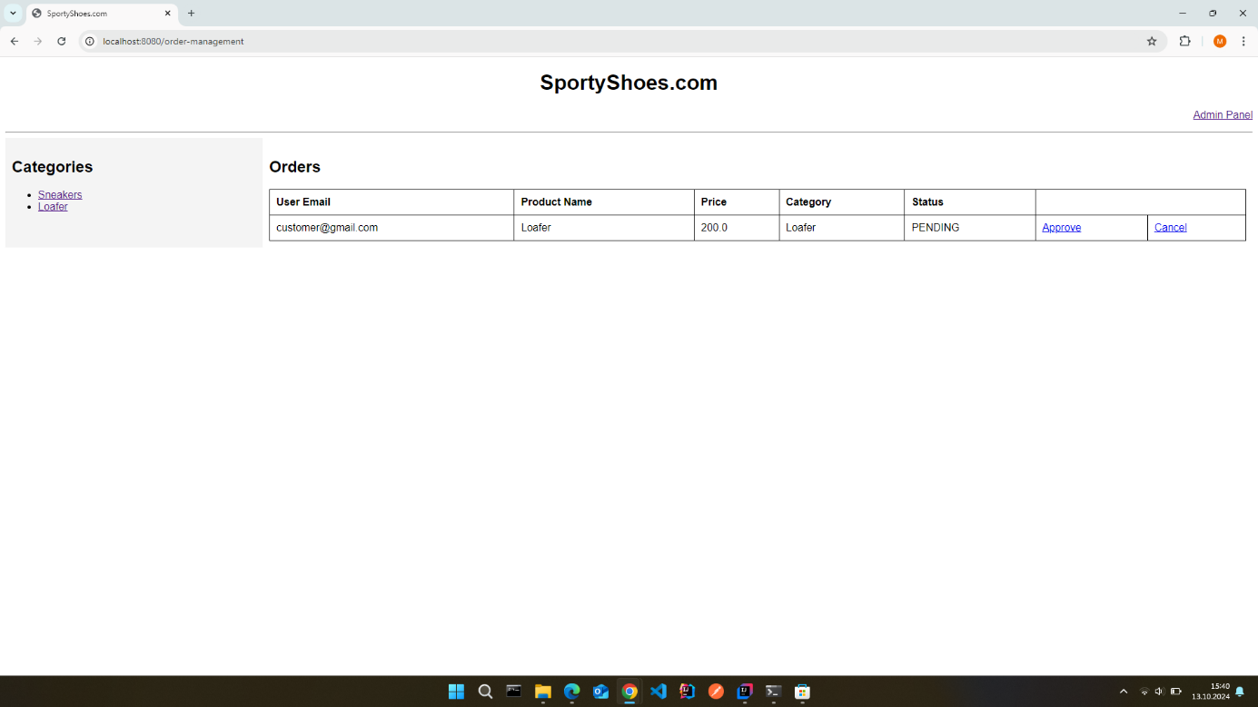

* Users can sign up with unique email and password.

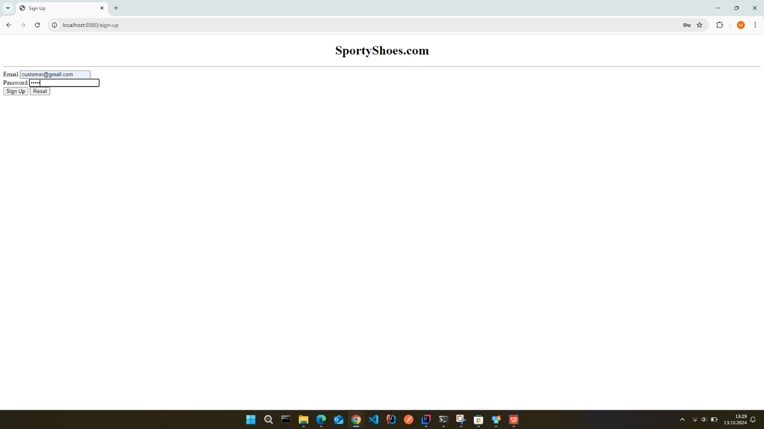

* After sign up, user can sign in with their credentials.

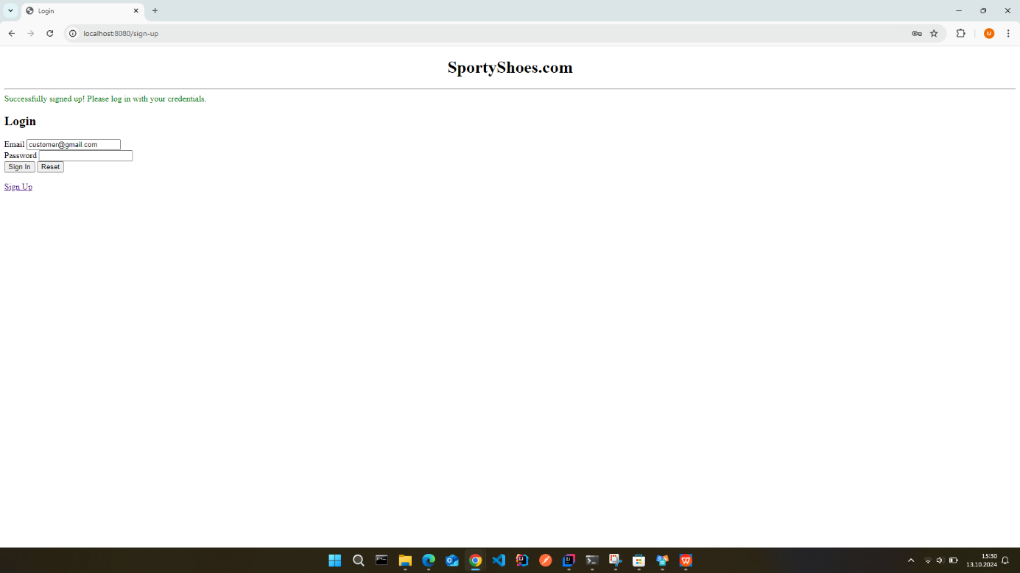

* User can view products, filter them by category and buy any products they want.

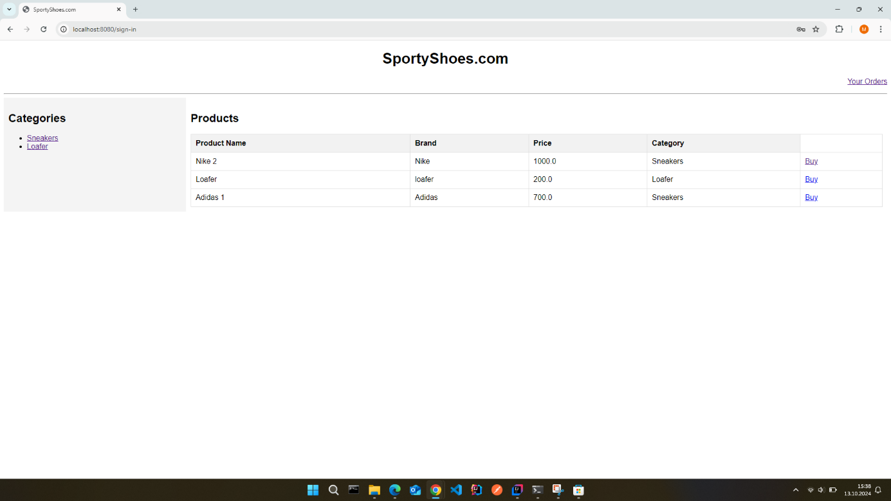

* Users can view their previous orders.

