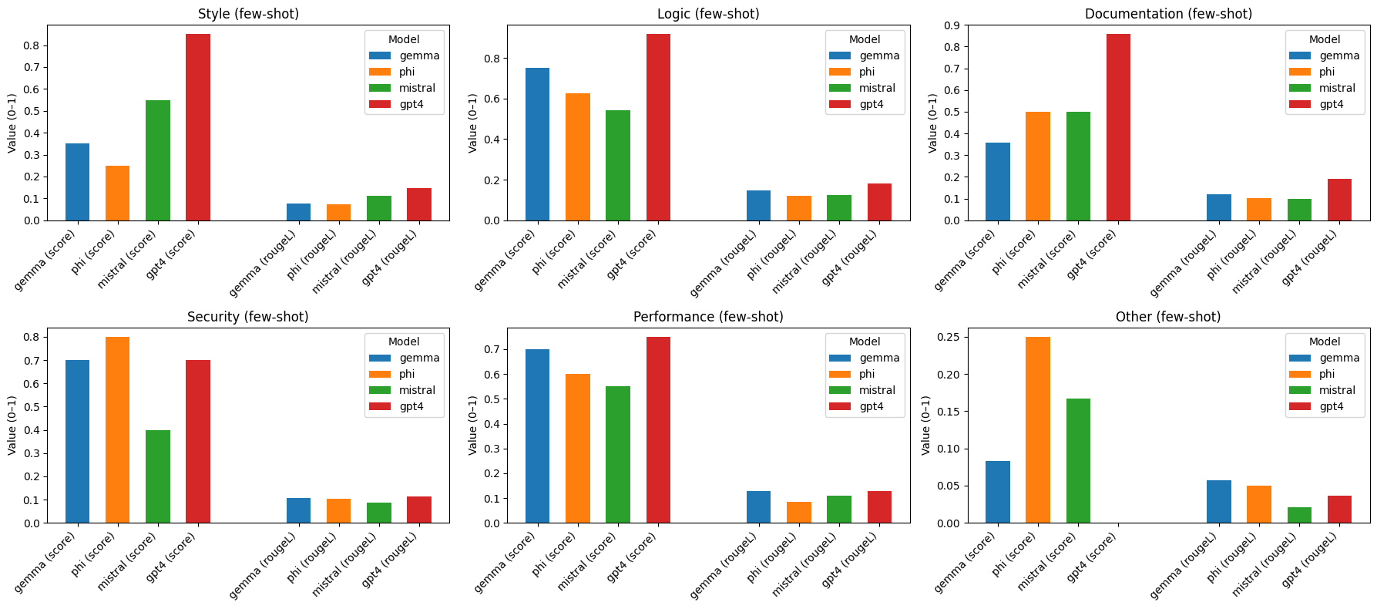
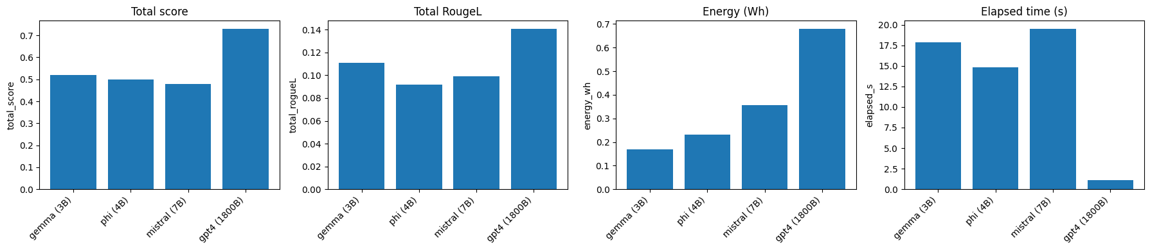
GENERAL

ZERO-SHOT vs FEW-SHOT
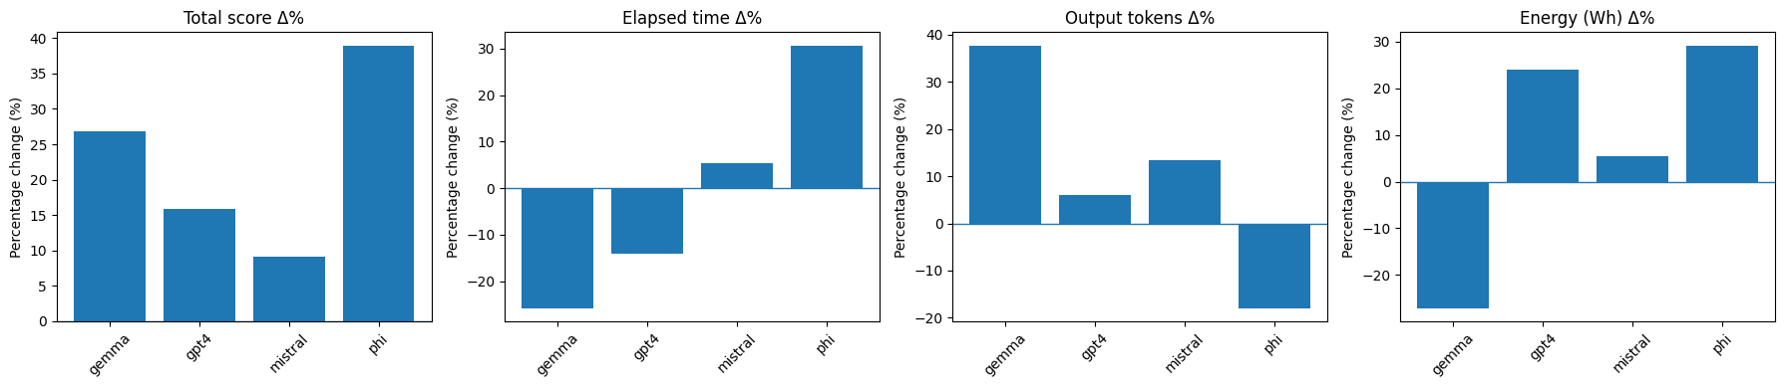
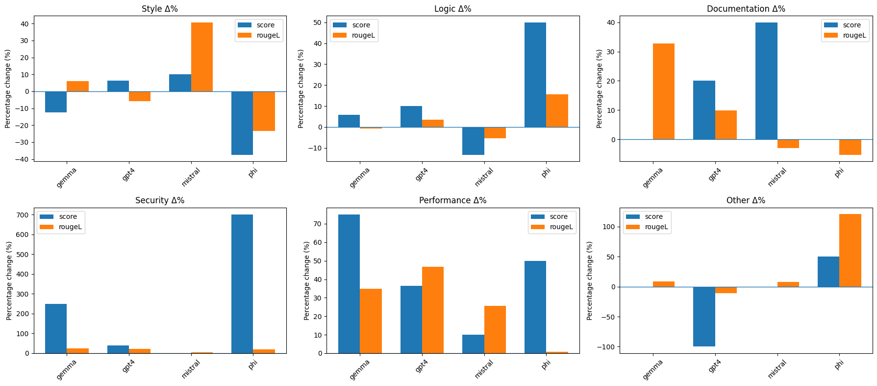

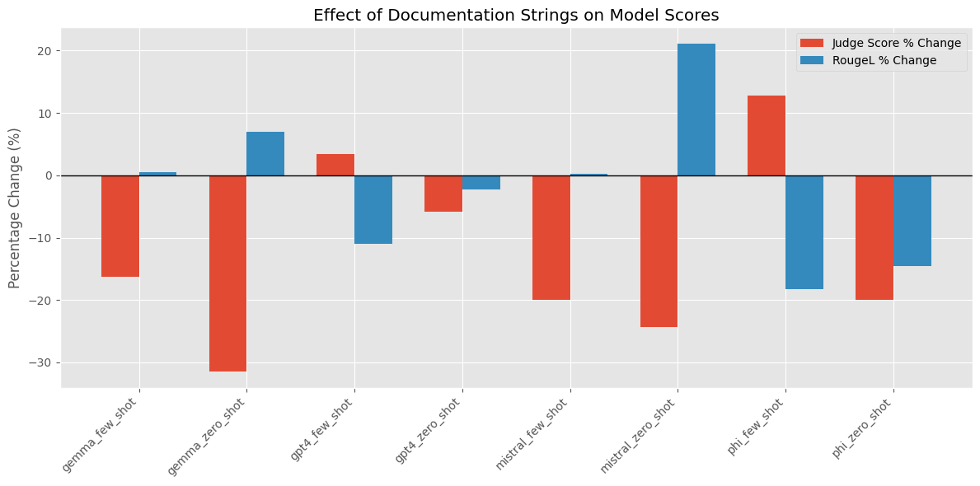
WITH/WITHOUT DOCSTRING

