

CS 319 - Object-Oriented Software Engineering
Design Report

Survivor
Group 2-G
Metehan Kaya
Mehmet Taha Çetin
Ferhat Karaca
Emre Yiğit Kuzhan

1. Introduction
1.1. Purpose of the System
Survivor is a 2D arcade game. The game flow basically goes to finish racecourse without dying. We are influenced from Mario that was popular video game a long time ago. However, we decide to add different properties from Mario such as environmental obstacles. These obstacles affect the player according to the type of it. Some obstacles slow down the player some are kill. Survivor is designed as challenging as possible to maximize the pleasure of player. Survivor aims to improve decision making abilities and cognitive skill of player while having enjoyable time.
1.2. Design Goals
Our design goals inherit from the non-functional requirements that are mentioned in analyses stage. The design goals of our game are described below.
End User Criteria:
Ease of Use: We should offer user to good entertainment because our system is a game. In order to present this entertainment player should not encounter any difficulty during the play our game. Therefore our system will provide user to user-friendly menus that player will reach anything he/she search with ease. Also our system will perform actions according to keyboard input from the user. Our system will use 4 buttons from keyboard. These are directions keys that located on right part of keyboard. This makes it easy to use the system in terms of player.
Ease of Learning: Generally most player are unfamiliar with the game that plays for the first time. So, he/she may not have knowledge about how the game is played, what are the conditions that slowing down the speed of user, the end condition of the game. These are the crucial information to user. Therefore, in order to obtain these information about the game, we will present user to instructive help document. Player can easily understand the game and logic behind it by reading the help document.
Maintenance Criteria:
Extendibility: It’s important to add new components and features to the game in the game software sector. These creative differences makes the game more preferable. Therefore our system will appropriate to add new functionalities such as new obstacle types that affect user easily to our existing game.
Adaptability: Since we will use Java, we will not have to worry about the operating system requirements. Because Java is one of the few programming language that provide user to cross-platform portability. In order to welcome the adaptability feature, we prefer to use Java language instead of C++, C or any another programming languages.
Reliability: Reliability also another important issue in the software development. System will be consistent in the boundary conditions. Even if system encounter with unexpected situations, it should not crash. In order to success this, we will test our game at the each stage of development. Another important thing that we take into consideration is boundary conditions. We will be evaluated carefully to not encounter undesired case that may crash the game.
Efficiency: The game will be responsive and able to run at the high performance. In order to reach optimum performance, we will allocate memory to each individual objects that we will create so that they will be accountable for just their own tasks. This method will improve the performance of the game significantly.
Tradeoffs:
Ease of Use / Learning vs Functionality: In order to reach wide range of customer the game should not be complex to learn and play. We determined that user should be able to learn and play the game easily. So, the priority of usability will be higher than functionality in our game. In other words, the functionality of the game will be basic. In order to entertain user we will focus on the usability rather than functionality of the game. Our system will consist of simple user-friendly interface and well-known instructions to play the game. Thus, player will spend enjoyable time to play rather than struggling to learn it.
Performance vs Memory: The main purpose of our system to provide user smoothness in the movements of the game object. Therefore we will focused on performance of our system. In other words, performance of the game is our priority. In order to achieve this purpose we will sacrificed from memory in order to gain the performance.
1.3. Definitions, Acronyms, and Abbreviations
Cross-platform[1]: Cross-platform refers to ability of software to run in same way on different platforms such as Microsoft Windows, Linux and Mac OS X
Boundary conditions: Conditions of the system which may generate run-time errors. They are exceptional cases according to the normal flow of the program. These conditions must be handled carefully for robustness of the system.
1.4. References
[1] http://www.webopedia.com/TERM/C/cross_platform.html
[2] http://www.klabs.org/history/history_docs/sp-8070/ch4/4p1_design_tradeoffs.htm

2. Software Architecture
2.1. Subsystem Decomposition
Since MVC matches what we desire, we are going to use this system at the implementation stage.
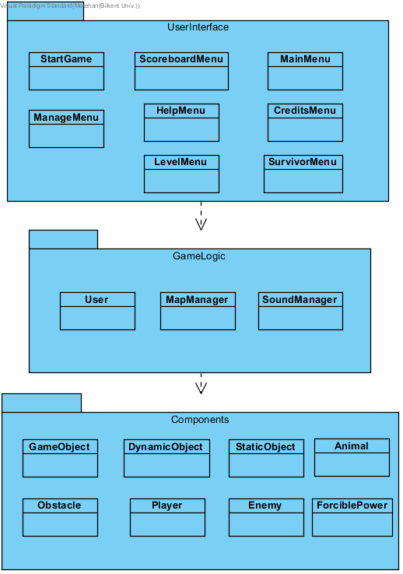
Figure: Layers

Classes of the first layer are responsible for providing an interface between the user and game. For instance, “UserInterface” contains “MainMenu” class that is the first class interacts with the user. “StartGame” is the first class that runs. Scoreboard, credits, help menus are accessible by “MainMenu”. “LevelMenu” is the class that shows the user all locked and unlocked levels.
In the second layer, “Game Logic” has 3 classes called “User” that stores process of the game, “MapManager” that handles with current level that user is playing, and “SoundManager” which is responsible for enabling and disabling sound.
The last layer, “Components” is comprised of utility classes that are for data of component. Main class among these is “GameObject” that have common attributes. Other classes are divided according to whether static (stable) or dynamic (moving).

2.2. Hardware / Software Mapping
The game requires a keyboard to read the player’s movement choices and a mouse to let the user do some choices.
This is a Java game, therefore, it requires the Java Runtime Environment to be executed. Considering graphical requirements of the game, it does not require high level features. Graphics2D class uses GPU acceleration which shows belonging a GPU is an advantage for the user.

2.3 Data Management
Since we won’t use any database, game data will be stored in the user’s hard disk. Images of the game such as character, background, buttons, animals, boss, etc. will be open to change to let the user improve the attractiveness of the game.

2.4 Boundary Conditions
The player has only one live which makes the game harder and more attractive. In case of death, game will return to a screen that shows the levels of chosen environments. If player passes the level, the next level will be unlocked, and game will return to the same screen. Also, scoreboard will be updated according to player’s point. If it is the last level of the environment, the next environment will be unlocked, and game will return to a screen which is a map of environments.

3. Subsystem Services
It is important to comprehend object design with details to understand how the project works. The detailed subsystem descriptions are provided in the next sections.
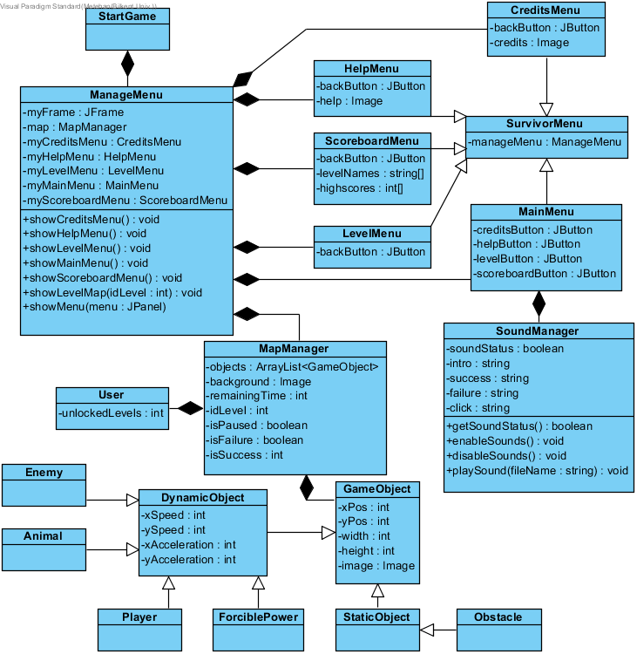
Figure : Class Diagram of project

3.1 User Interface Subsystem
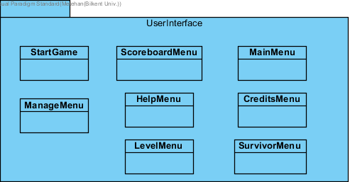
Figure : User Interface Package
As it can be understood from the name, it is responsible for the interaction between the user and game.

3.1.1 StartGame Class
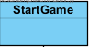
Figure:StartGame Class
First class that runs is “StartGame”.

3.1.2 ManageMenu Class
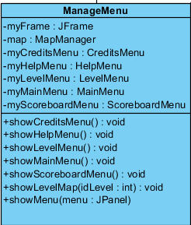
Figure:ManageMenu Class
Responsible for changes between menus according to user’s inputs.
3.1.3 ScoreboardMenu Class
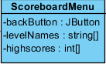
Figure: ScoreboardMenu Class
Displays user’s high scores.

3.1.4 HelpMenu Class
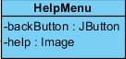
Figure: HelpMenu Class
Shows instructions for the user to play well.

3.1.5 LevelMenu Class
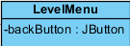
Figure:LevelMenu Class
Shows all locked and unlocked levels.

3.1.6 MainMenu Class
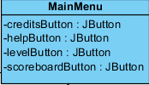
Figure: MainMenu Class
Shows main menu user sees first. It has options to display credits, help, scoreboard, levels.
3.1.7 CreditsMenu Class
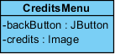
Figure: CreditsMenu Class
Displays members of team 2G.

3.1.8 SurvivorMenu Class
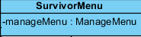
Figure: SurvivorMenu Class
A common Jpanel for menus.

3.2 Game Logic Subsystem
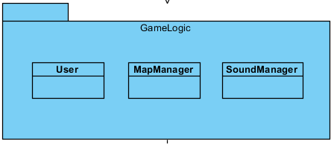
Figure: Game Logic Package
Second, also main, layer of the project. It has 3 classes: “MapManager”, “SoundManager”, and “User”.
3.2.1 MapManager Class
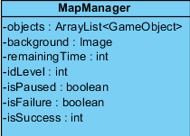
Figure: MapManager Class
Stores all kinds of game objects for each level. Main class of the second layer.
3.2.2 SoundManager Class
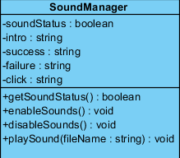
Figure: SoundManager Class
Responsible for enabling and disabling sound.

3.2.1 User Class
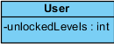
Figure: User Class
Responsible for storing locked and unlocked levels. This is done by storing only one value, number of unlocked levels.

3.3 Components Subsystem
Game component subsystem is the base of the game. By this package, we fill the environments.
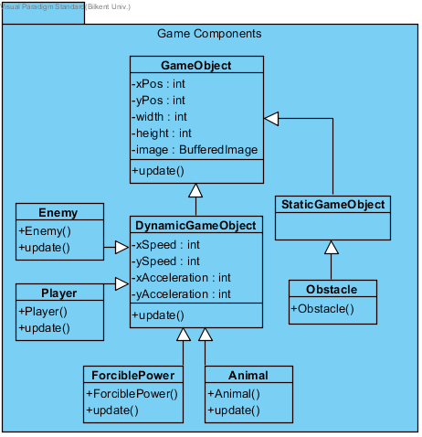
Figure: Components Package

3.3.1 GameObject Class
Game object class is the main part of this package. This class creates whole objects according to the envitonment.
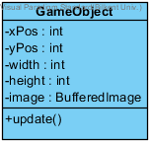
Figure: GameObject Class

3.3.2 DynamicGameObject Class
Dynamic objects will be our objects that have speed and orbit.
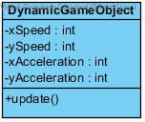
Figure: DynamicGameObject Class

Player class creates the character controlled by the user.
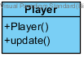
Figure: Player Class
Enemy class creates some different enemies to make game harder.
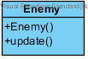
Figure: Enemy Class

Animal class represents some dangerous animals that cost character’s live and non-dangerous animals which make the character slower.
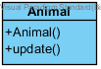
Figure: Animal Class
ForciblePower class represents natural power like wind, electric fields, etc.
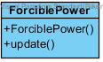
Figure: ForciblePower Class
3.3.3 StaticGameObject Class
StaticGameObject class creates static objects for our game.
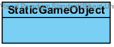
Figure: StaticGameObject Class
Obstacle is a static game object which does not move or change during the game.
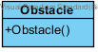
Figure:Obstacle Class

Description of the Interactions between Classes according to the Use Cases
General Description “MainMenu” class will be instantiated at the beginning of the game. It provides all buttons and texts related to user interface for the main menu. Also, MapManager object will be constructed.
PlayGame: When the user clicks on “Play Game” option, an object of MapManager will start running. During the game, this object interacts with classes of Component package. This shows that MapManager is the main unit of the game.
PauseGame: This is a condition of the game which indicates a command that stops the inner game is activated.
ViewHighScores: During this process, a text file will be used.
ViewHelp: HelpMenu is responsible for instructing the user in how to play the game.
ViewCredits: CreditsMenu is responsible for displaying the members of team.

