Data Visualization Week1

Shahab Alami

February 6, 2016

In this document I would like to discuss my expectations for this class. By the end of this paper you will also get to learn some interesting points about me.

### Expectations

When I graduate from this class I expect myself to become:  
1. Well-versed in **telling a compelling** story via proper application of visualizations  
2. Able to **simplify/improve** noisy visualizations  
3. Handson-on with the **best practices**

### Strength

I am a technology professional experienced in creating data-intensive software products. This enables me to quickly understand the requirements, notice bottlenecks and architect an **efficient data pipeline** to foster the data/information flow in a firm.

### Weakness

I tend to focus a lot only on concepts that interest **me** and spend an excessive amount of time on analyzing things that might not deserve that much attention.

### Interesting Tools And Visualizations

1. I am a big fan of [Google Analytics](http://www.google.com/analytics/). It helps website admins, owners, get a good understanding of the traffic on their websites. Its simple design and sophisticated mixture of visualizations and data tables makes it a perfect choice.

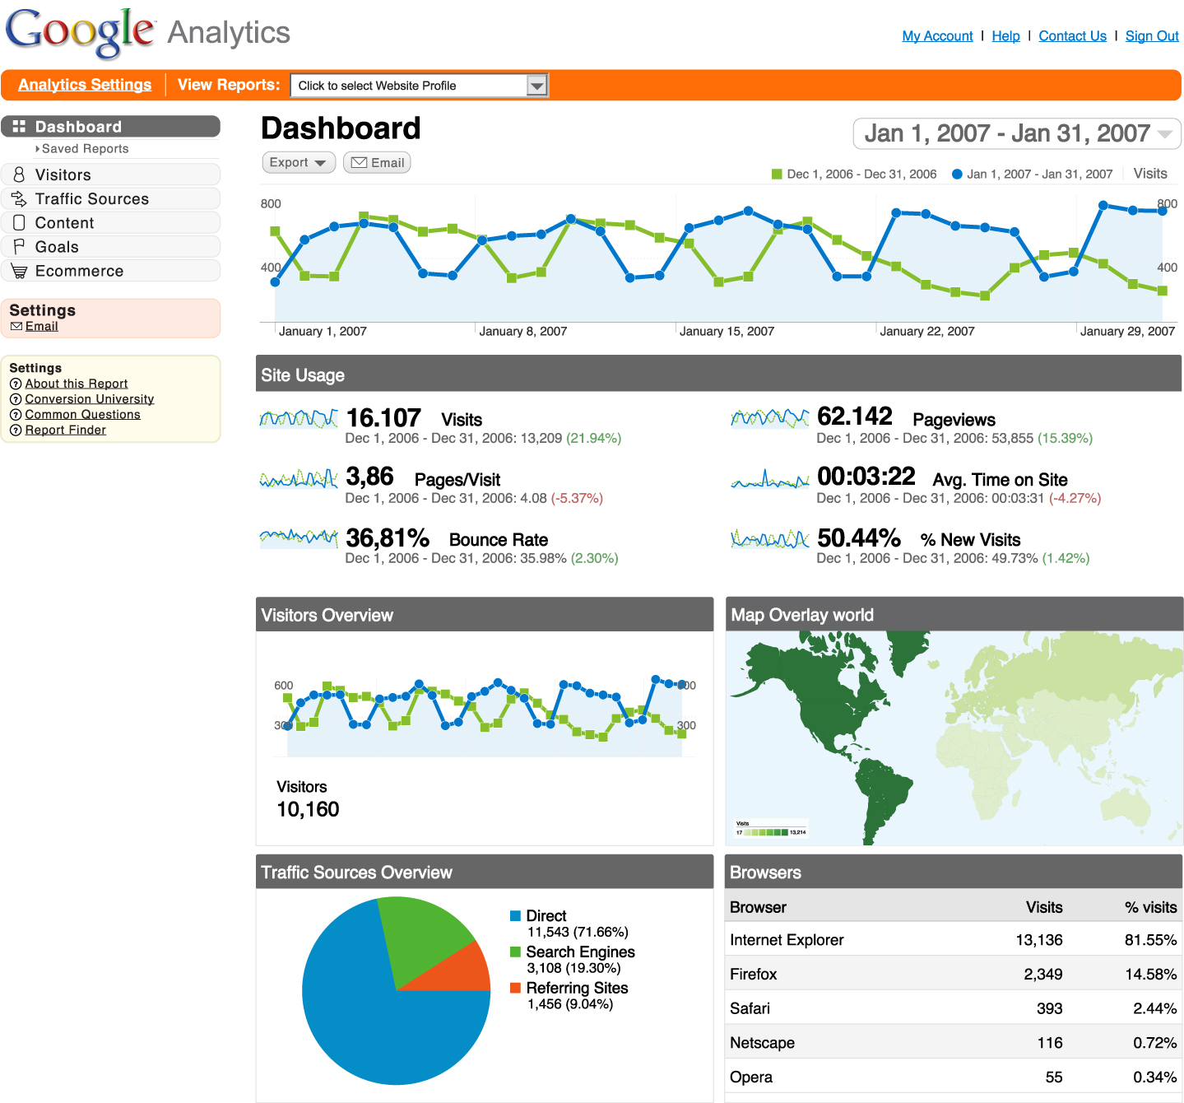

1. [Seaborn](http://stanford.edu/~mwaskom/software/seaborn/) is an interesting tool for statistical data visualization in Python. It is built on top of Python's famous matplotlib and offers a vriety of choices to simplify visuaization in a data-centric python script. I specially enjoy several built-in *themes* that come pre-packaged in this library. Being able to quickly style results saves us a lot of time so that we can better focus on the logic behind our visualizations.

