Comparison to determine time_diff_threshold and cntr2cntr_dist arguments for orbitx
Plan:
- Check number of matchups for whole month of January 2023 (did not work for Jan or June 2024 – got interpolation range error so using just one month for now)
- Using cntr2cntr_dist = 20
Tried the following time_diff_threshold values:
- 300 (5 minutes)
- 900 (15 minutes)
- 1800 (30 minutes)

Time_diff_threshold (tdf) | cntr2cntr_dist | No. of matchups
300 | 20 | 0
900 | 20 | 0
1800 | 20 | 6

Final chosen time_diff_threshold value: 1800 (30 minutes)
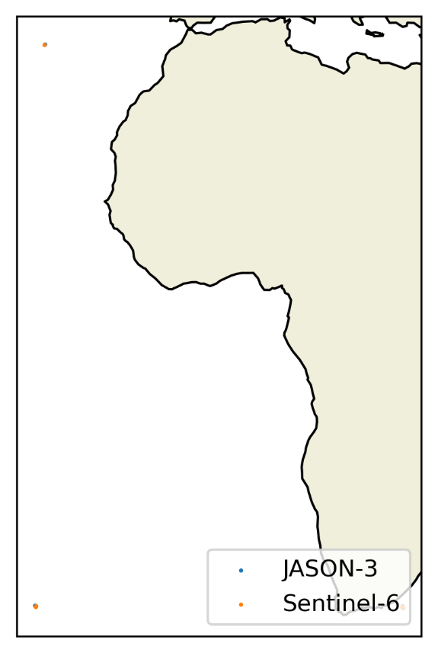(plot for tdf 1800 cntr 20)
Comparison of cntr2cntr_dist
- Check number of matchups for January 2023
- Using time_diff_threshold = 1800
- Testing the following cntr2cntr_dist values:
  - 20
  - 15
  - 10

cntr2cntr_dist | Time_diff_threshold | No. of matchups
20 | 1800 | 6
15 | 1800 | 4
10 | 1800 | 1

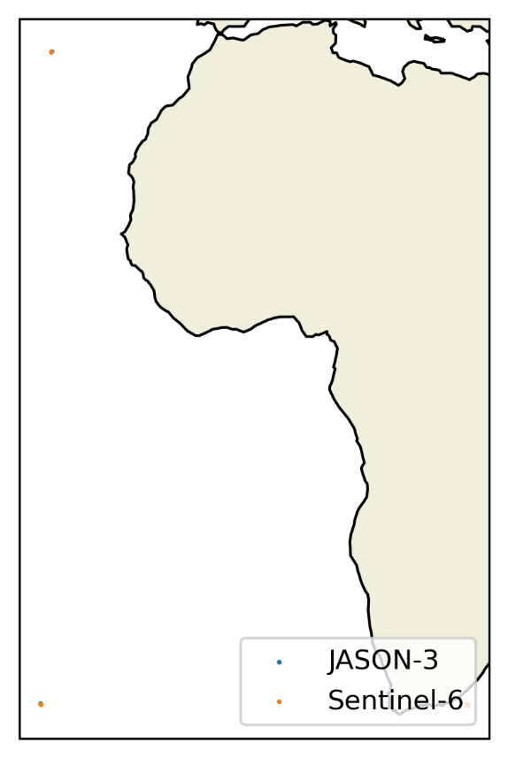c2c 15, tdf 1800

Final argument choice:
Time_diff_threshold = 1800
Cntr2cntr_dist = 20 (15 could also work)

